

Functional Specification
GRI Messenger

Version 0.0.2
Last modified 23 Jun 2017
Number of pages 5
Document History
Date | Description | Author(s)
21-Jun-17 | Version 0.0.1: Created the initial version of the doc. | Albert
22-Jun-17 | Version 0.0.2: Added some functional specifications. | Albert

Table of Contents
1.Introduction 4
1.1.Document identifier 4
1.2.Scope 4
1.3.Definitions of Terms and Acronyms 4
1.4.References 4
2.Problem Statement 4
2.1. Login 4
2.2.Registration 5
2.3.Messenger 5

Introduction

Document identifier
This is a functional specification document for the Messenger.

Scope
This document describes the functional specifications of the project. Details can be found in sub-sections of Problem Statement section.

Definitions of Terms and Acronyms
GRI – Generalized Robust communication Interface

References

Problem Statement

Login
For logging in user must fill login and password fields, then click on Login button. After that main window will be shown and LogIn window will be closed.

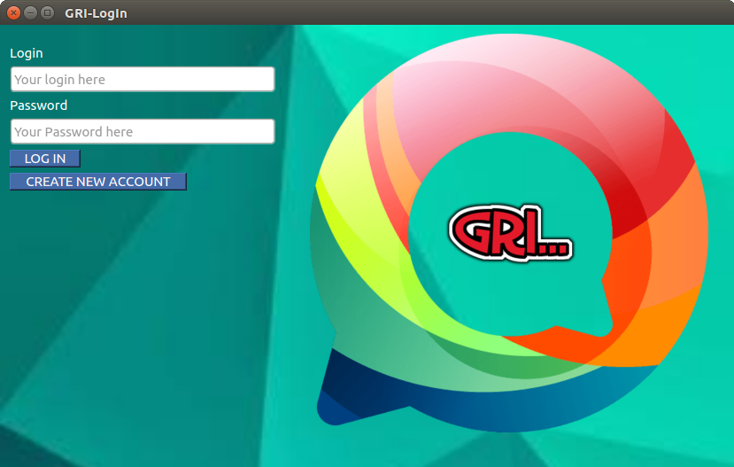

Registration
For registering user must fill login, name, surname, password and repeat password fields, then click on Registration button. After that the registrationWindow will be closed and user will be taken to the LogIn window again.

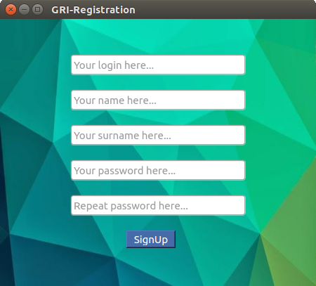

Messenger
In order to send message user must input text in the text box, choose corresponding user from UserList and click on Send button.
