NEM

Ángel QR

2025-04-16

## R Markdown

This is an R Markdown document. Markdown is a simple formatting syntax for authoring HTML, PDF, and MS Word documents. For more details on using R Markdown see <http://rmarkdown.rstudio.com>.

When you click the **Knit** button a document will be generated that includes both content as well as the output of any embedded R code chunks within the document. You can embed an R code chunk like this:

#Cargar librerias ----  
library("gtsummary")  
library("readxl")  
library("bstfun")

## Registered S3 method overwritten by 'bstfun':  
## method from   
## add_n.tbl_likert gtsummary

##   
## Adjuntando el paquete: 'bstfun'

## The following objects are masked from 'package:gtsummary':  
##   
## tbl_likert, trial

library("ggstatsplot")

## You can cite this package as:  
## Patil, I. (2021). Visualizations with statistical details: The 'ggstatsplot' approach.  
## Journal of Open Source Software, 6(61), 3167, doi:10.21105/joss.03167

library("report")  
library("tidyverse")

## ── Attaching core tidyverse packages ──────────────────────── tidyverse 2.0.0 ──  
## ✔ dplyr 1.1.4 ✔ readr 2.1.5  
## ✔ forcats 1.0.0 ✔ stringr 1.5.1  
## ✔ ggplot2 3.5.1 ✔ tibble 3.2.1  
## ✔ lubridate 1.9.4 ✔ tidyr 1.3.1  
## ✔ purrr 1.0.2

## ── Conflicts ────────────────────────────────────────── tidyverse_conflicts() ──  
## ✖ dplyr::filter() masks stats::filter()  
## ✖ dplyr::lag() masks stats::lag()  
## ℹ Use the conflicted package (<http://conflicted.r-lib.org/>) to force all conflicts to become errors

library("ggstats")  
library("ggsci")  
  
#Cargar archivo ----  
control <- read_csv ("control.csv")

## Rows: 38 Columns: 20  
## ── Column specification ────────────────────────────────────────────────────────  
## Delimiter: ","  
## chr (20): apropia1, apropia2, apropia3, contexto4, contexto5, contexto6, con...  
##   
## ℹ Use `spec()` to retrieve the full column specification for this data.  
## ℹ Specify the column types or set `show_col_types = FALSE` to quiet this message.

#ORDENAR LOS VALORES DE RESPUESTA DE LAS SECCIONES: APROPIA, FLEXIBLE,ARTICULA, CONTEXTO, IMPLEMENTA----  
control$apropia1 <- control$apropia1 %>%  
 fct_relevel(  
 "si", "no"  
 )  
control$apropia2 <- control$apropia2 %>%  
 fct_relevel(  
 "si", "no"  
 )  
control$apropia3 <- control$apropia3 %>%  
 fct_relevel(  
 "si", "no"  
 )  
  
control$contexto4 <- control$contexto4 %>%  
 fct_relevel(  
 "si", "no")  
  
control$contexto5 <- control$contexto5 %>%  
 fct_relevel(  
 "si", "no")  
control$contexto6 <- control$contexto6 %>%  
 fct_relevel(  
 "si", "no")  
control$contexto7 <- control$contexto7 %>%  
 fct_relevel(  
 "si", "no")  
control$articula8 <- control$articula8 %>%  
 fct_relevel(  
 "si", "no")  
control$articula9 <- control$articula9 %>%  
 fct_relevel(  
 "si", "no")  
control$articula10 <- control$articula10 %>%  
 fct_relevel(  
 "si", "no")  
control$articula11 <- control$articula11 %>%  
 fct_relevel(  
 "si", "no")  
control$articula12 <- control$articula12 %>%  
 fct_relevel(  
 "si", "no")  
control$articula13 <- control$articula13 %>%  
 fct_relevel(  
 "si", "no")  
control$articula14 <- control$articula14 %>%  
 fct_relevel(  
 "si", "no")  
control$flexible15 <- control$flexible15 %>%  
 fct_relevel(  
 "si", "no")  
control$flexible16 <- control$flexible16 %>%  
 fct_relevel(  
 "si", "no")  
control$implementa17 <- control$implementa17 %>%  
 fct_relevel(  
 "si", "no")  
control$implementa18 <- control$implementa18 %>%  
 fct_relevel(  
 "si", "no")  
control$implementa19 <- control$implementa19 %>%  
 fct_relevel(  
 "si", "no")  
control$implementa20 <- control$implementa20 %>%  
 fct_relevel(  
 "si", "no")  
  
  
  
  
  
  
#Gráfico apropia----  
  
gglikert(control, include = apropia1:apropia3)+  
 scale_fill_jco ( ) +  
 theme_classic()+  
 ggtitle("Gráfico 1.Subdimensión apropiación")+  
 theme(legend.position = "bottom")

## Scale for fill is already present.  
## Adding another scale for fill, which will replace the existing scale.

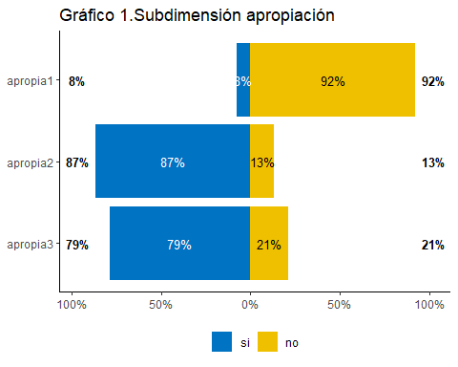

#Gráfico contexto ----  
gglikert (control,  
 include = contexto4:contexto7)+  
 scale_fill_jco()+  
 ggtitle("Gráfico 2.  
Subdimensión contexto")

## Scale for fill is already present.  
## Adding another scale for fill, which will replace the existing scale.

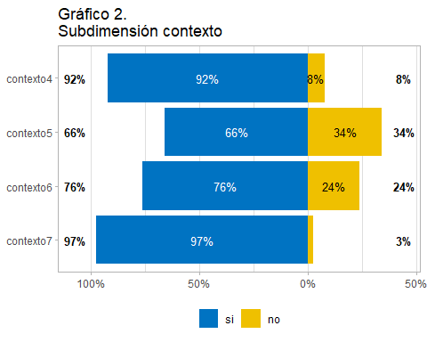

#Gráfico articula----  
gglikert(control, include = articula8:articula14)+  
 scale_fill_jco()+  
 ggtitle("Gráfico 3.  
subdimensión articulación")

## Scale for fill is already present.  
## Adding another scale for fill, which will replace the existing scale.

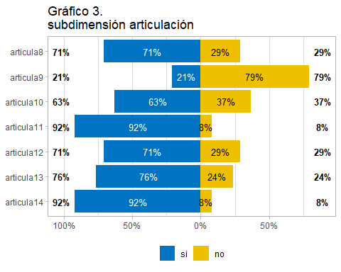

#Gráfico flexible----  
  
gglikert(control, include = flexible15:flexible16)+  
 scale_fill_jco()+  
 ggtitle("Gráfico 4.  
Subdimensión flexibilidad")

## Scale for fill is already present.  
## Adding another scale for fill, which will replace the existing scale.

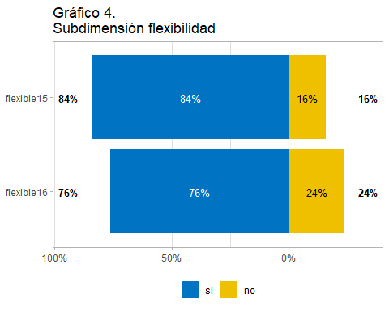

#Gráfico implementa----  
gglikert(control, include = implementa17:implementa20)+  
 scale_fill_jco() +  
 ggtitle("Gráfico 5.  
Subdimensión implementación")

## Scale for fill is already present.  
## Adding another scale for fill, which will replace the existing scale.

