**CIS363—Web Interface Design with Lab**

**Lab Report**

**Professor:** Professor Boulware

**Lab Number:** 5

**Lab Title:** Forms

**Submittal Date:** 8/4/15

**Objectives:** What was the purpose of this lab?

The purpose of this lab was to allow students to familiarize themselves with the different functions involved in creating forms on a graphical user interface or web site. The lab allowed students to demonstrate skills pertaining to creating a site with multiple pages, utilizing different controls such as radio buttons, text boxes and labels, and to demonstrate the ability to validate information that users input into a web site.

**Results:** Post a screenshot of the working web site/page.

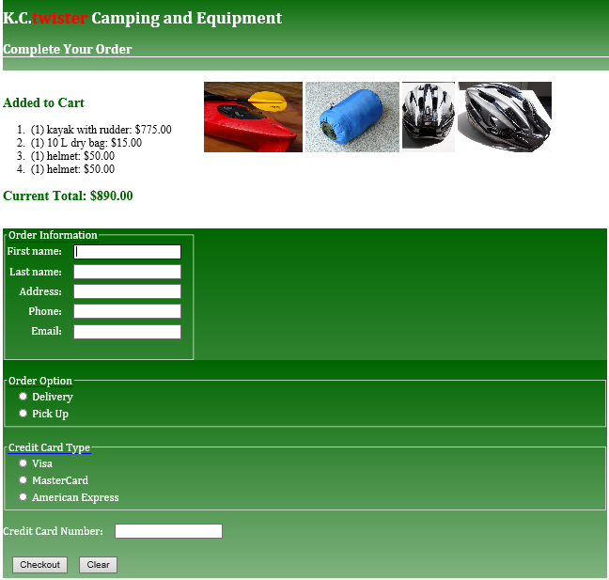

**Conclusions:** What did you learn? Were there any challenges and how did you resolve them? How can what you learned be applied to future Web design projects?

I learned how to create a standard web form in HTML5, how to format it in CSS3, and how to validate user information using HTML5 ‘input’ syntax. The only challenge I really had in implementing this assignment was trying to format my ‘Order Information’ text boxes in a way that is attractive and organized. I know that I will certainly be using forms in the future because users have to have a way to order merchandise over the internet, and since I’ve decided to be a web developer, I will be responsible for organizing interfaces in a way that encourages user business.

|  |  |  |  |  |  |
| --- | --- | --- | --- | --- | --- |
| **Student:** | Kyle Grigsby |  | CIS-363 |  | Kyle Grigsby |
|  | Name |  | Program |  | Signature |