Road quality verification

Problem Introduction
Periodical road surveys are paramount for ensuring the usability and quality of the roads. But there is a dire need of transparency in the process of verification. The contractors based on their power and influence, are manipulating the on-road field workers via bribes, and make them verify only a section of the road, which is pre made up to the standard, keeping the rest compromised.
This occurrence can be attributed to a few factors:
Pain Points
- Pre defined locations are leaked to the contractors, enabling them to develop only that particular section
- Flexible timings of the checks are also susceptible to manipulation
- There may be database level compromises, where the person on the backend can change the data after survey
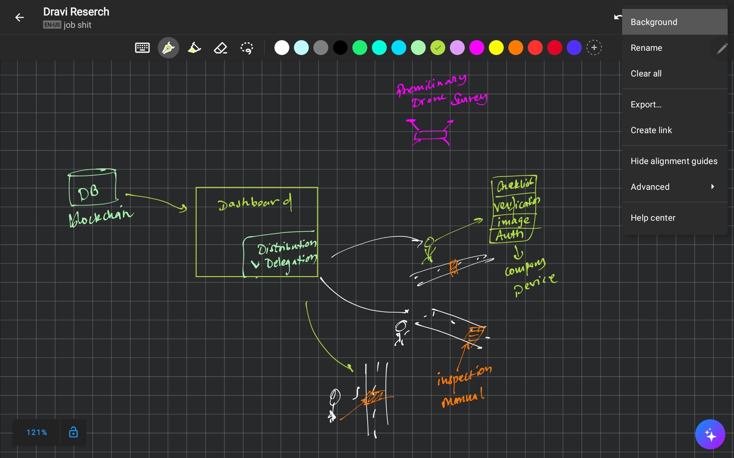
Possible solutions:
- Preliminary survey of the concerned area with drones and hi res satellite images, fed into a DL model, which can give a preliminary idea of the possible damaged areas.
- We can then send the human checkers to the specified locations based on the initial data.
- The company provided survey devices, along with the actual chemical road checking process, can also take a photo of the location to send with the report to be stored on the database chain.
- We can dynamically allocate the waypoints for the worker to follow and geo lock the device preventing them for submitting the inspection report no more than a fixed distance from the pre defined location.
- Use blockchain for immutable data storage, and replay attack prevention

Possible road considerations checklist (City of Homer Road Assessment Report)

References
- Managing Maintenance of Rural Roads [Guidance Note for States] https://pmgsy.nic.in/sites/default/files/GN_GMMR_2014.pdf
- City of Homer Road Assessment Report https://www.cityofhomer-ak.gov/sites/default/files/fileattachments/public_works/page/64221/road_assessment_report-summer_2020_final.pdf
- https://crridom.gov.in/en/automated-road-survey-system

