Canteenly — Business & Subscription Selling Plan
India market • October 2026 • SaaS business model
My recommendation is to position Canteenly as a subscription-based canteen management platform, targeting college canteens, schools, corporate cafeterias, food courts and institutional food-service operators.
Your proposed model is commercially sensible: POS and Dashboard are mandatory in every paid plan, while Kitchen Display System (KDS), Online Mobile Application and AI Dashboards are optional paid add-ons. This gives customers an affordable entry price and allows Canteenly to generate additional recurring revenue as they adopt more features.
1. Product packaging
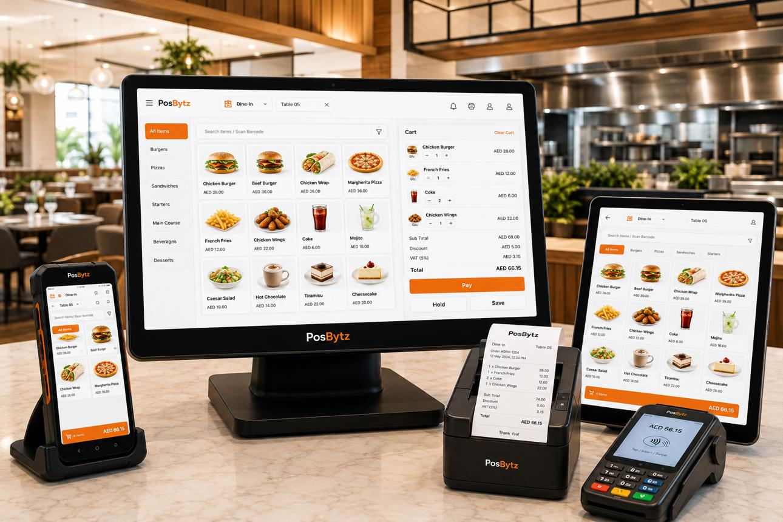
POS — Mandatory
Core billing and order operations
- Menu and category management
- Order entry and billing
- Cash, UPI and card payment recording
- Receipt printing
- Order history and cancellation controls
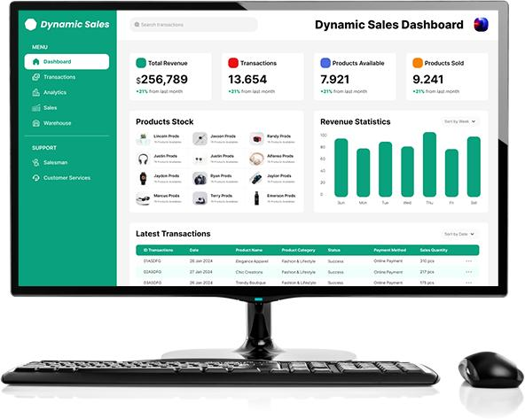
Dashboard — Mandatory
Business visibility and control
- Daily, weekly and monthly sales
- Payment-method breakdown
- Best-selling items
- Order count and average bill value
- Sales report export
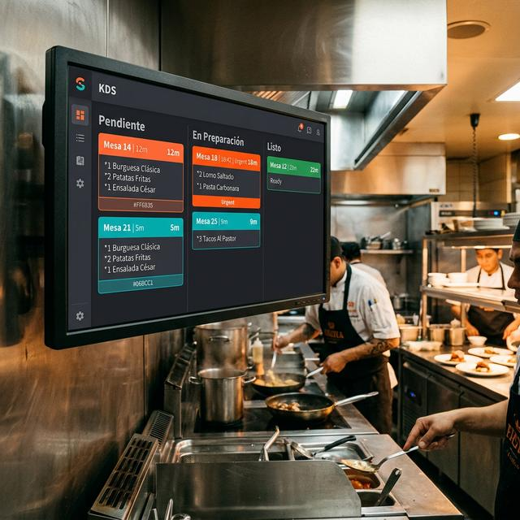
KDS — Paid add-on
Kitchen operations
- Live incoming orders
- Preparing and ready status
- Order prioritisation
- Preparation-time monitoring
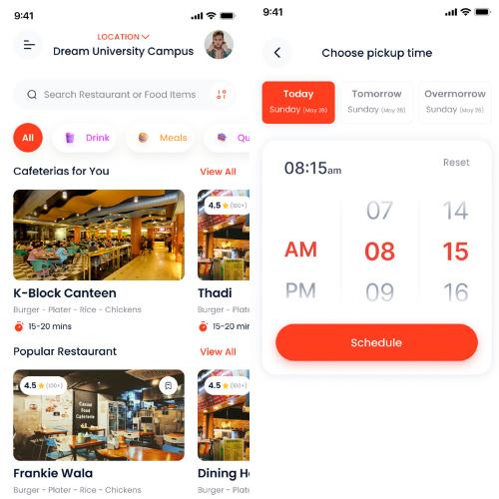
Online Mobile Application — Paid add-on
Digital ordering and queue reduction
- Menu browsing and pre-ordering
- Pickup time slots
- Online payment integration
- Order status and notifications
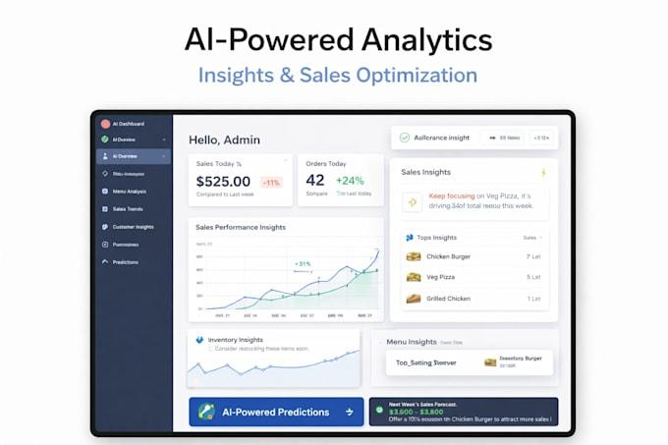
AI Dashboards — Paid add-on
Advanced insights
- Sales and demand forecasting
- Menu performance insights
- Potential wastage alerts
- Sales trends and recommendations
2. Current Indian market pricing benchmark
Public pricing pages provide a useful reference for Canteenly's launch pricing. These are competitor-listed prices, not a guarantee that every feature or service is identical.
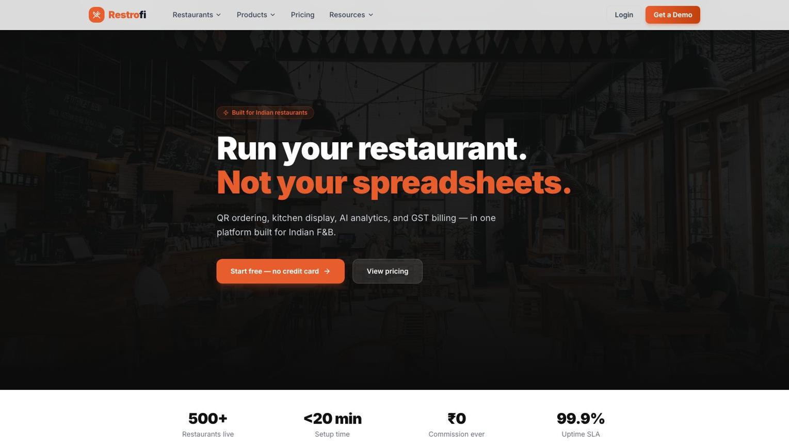
Restrofi
POS, KDS, ordering and AI features
₹699
per month
Its published Premium price is ₹699 per outlet per month, excluding GST.

Restrofi
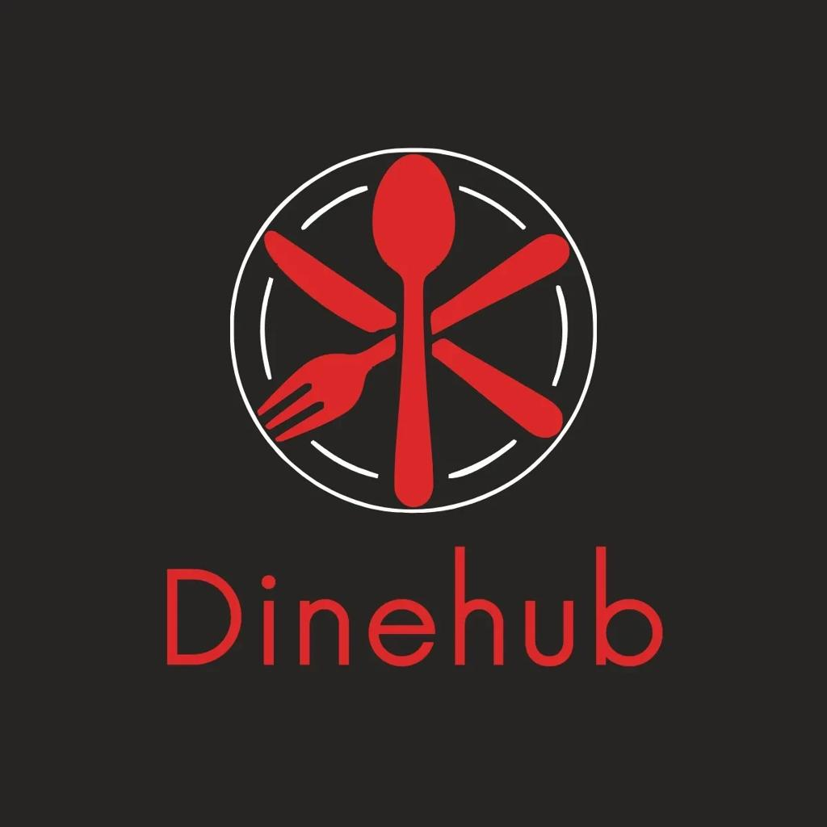
DiningHub
POS, reports, KDS and ordering features
₹899–₹2,499
per month
Its published plans range from ₹899 Basic to ₹2,499 Ultimate per month, excluding GST.
DiningHub
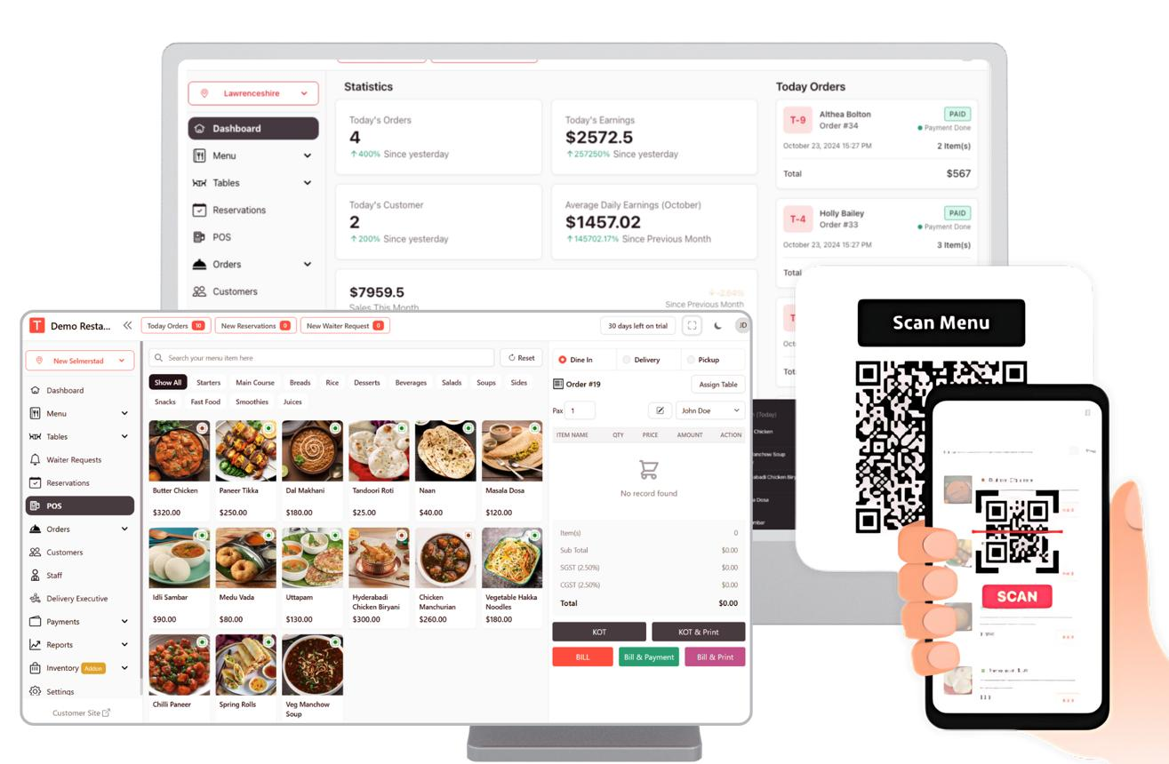
RestoSync
Billing, kitchen, analytics and ordering
₹499–₹2,499
per month
Its published Starter, Growth and Pro plans span ₹499–₹2,499 per month, excluding GST.

Restaurant POS, Delivery & AI Platform
What this means for Canteenly: a launch price around ₹999–₹1,499 per outlet per month for mandatory POS and Dashboard is a reasonable starting hypothesis. Your product should differentiate itself through canteen-specific workflows, ease of use, support and modular add-ons.
3. Recommended Canteenly subscription pricing
These are proposed selling prices for your business, not competitor prices. Charge per outlet per month, with add-ons billed separately.
Canteenly Starter
Launch plan
₹999
/ outlet / month
For small canteens and single-counter operations
Included
- POS billing and menu management
- Basic sales dashboard
- Cash, UPI and card payment recording
- Order history and daily reports
- One outlet and up to 2 billing devices
- Standard email/WhatsApp support
Canteenly Growth
Recommended
₹1,499
/ outlet / month
For busy college and corporate canteens
- Everything in Starter
- Advanced sales and payment reports
- Product/category performance
- Discounts and cancellation controls
- Staff accounts and role permissions
- Export to CSV/Excel
- Up to 5 billing devices
- Priority support
Canteenly Enterprise
₹2,499
/ outlet / month
For larger institutions and multi-counter operations
- Everything in Growth
- Multiple billing counters
- Centralised management for contracted outlets
- Consolidated sales reporting
- Enhanced user permissions
- Priority technical support
- Higher usage limits
All prices above are proposed prices, excluding applicable GST. Finalise device limits, support commitments and enterprise features after testing the software.
4. Paid add-on pricing
The customer must subscribe to one core plan. They can then purchase any of these add-ons independently.
Add-on | Proposed monthly price | Main benefit
Kitchen Display System (KDS) | ₹499/outlet | Live kitchen orders and preparation status
Online Mobile Ordering | ₹999/outlet | Student ordering, pickup slots and order tracking
AI Dashboards | ₹999/outlet | Forecasts, trends and decision-support insights
Advanced AI Forecasting | ₹1,499/outlet | Demand prediction and potential wastage analysis
Additional outlet | ₹799–₹1,499/outlet | Centralised operations, subject to plan
The additional outlet fee should depend on the base plan and whether centralised reporting is included. Avoid charging customers twice for the same functionality.
For Online Mobile Ordering, start with a responsive web application or installable PWA. This can reduce the initial development and distribution costs compared with maintaining separate native Android and iOS apps.
Example: What customers would pay
Configure a sample customer subscription
Starter — ₹999/month
Growth — ₹1,499/month
Enterprise — ₹2,499/month
KDS — ₹499/month
Online Mobile Ordering — ₹999/month
AI Dashboards — ₹999/month
Monthly recurring subscription
₹1,998
Annual equivalent
₹23,976
Before applicable GST, setup fees and third-party charges. Annual equivalent assumes 12 monthly payments at the standard rate.
5. Annual subscription offers
Encourage annual payment to improve cash flow and reduce customer churn.
Plan | Monthly billing | Suggested annual payment
Starter | ₹999/month | ₹9,990/year
Growth | ₹1,499/month | ₹14,990/year
Enterprise | ₹2,499/month | ₹24,990/year
You can use the same annual discount policy for add-ons, such as two months free on annual prepayment, if your margins support it.
6. One-time setup and onboarding charges
Do not assume that subscription revenue will cover every initial customer setup cost.
Service | Suggested fee
Basic onboarding and menu upload | ₹1,500
Advanced menu/data migration | ₹3,000–₹5,000
Multi-counter or multi-outlet setup | ₹5,000–₹15,000
Staff training at customer location | Quoted separately
Thermal printer, tablet or other hardware | Actual cost + disclosed margin
Offer free basic onboarding to the first 5–10 pilot customers in exchange for structured feedback and permission to use their testimonials, subject to their consent.
7. Revenue projection for Canteenly
Here is an illustrative recurring-revenue scenario, assuming a blended core subscription of ₹1,499 per outlet per month and average add-on revenue of ₹500 per outlet per month.
Paying outlets
10
10
250
500
Average revenue per outlet/month
₹1,299
₹999
₹2,499
₹3,999
Estimated monthly operating expenses
₹2,90,000
₹10k
₹1.5L
₹3L
Monthly recurring revenue
₹12,990
Annualised recurring revenue
₹1,55,880
Monthly operating surplus/(shortfall)
₹-2,77,010
Outlets to cover these expenses
224
Illustrative model only. Excludes taxes, payment fees, customer acquisition, one-time setup income, churn and unexpected expenses. Operating surplus is not net profit.
8. Customer acquisition and sales plan
Focus on one market first instead of selling to every kind of restaurant.
- Month 1 — Build the sellable POS
Finish reliable billing, product/menu management, payment recording, basic dashboard, receipt printing, backups and daily sales reports. Test on a real canteen workflow before selling.
- Month 2 — Pilot with 5–10 canteens
Approach college canteens, small food courts and corporate cafeterias. Offer a 14-day trial, import their menus and train the billers. Record bugs and support requests.
- Month 3 — Convert trials into subscriptions
Demonstrate faster billing, accurate sales totals and payment reconciliation. Aim to convert pilot users into paying customers and gather testimonials.
- Months 4–6 — Upsell add-ons
Introduce KDS first, followed by online ordering and then AI Dashboards after enough reliable sales data has accumulated.
Suggested sales channels
- Direct visits to college administrators and canteen contractors.
- Partnerships with POS hardware suppliers and local IT service providers.
- Demonstrations using sample data and a live billing workflow.
- Referral discounts for existing customers who introduce new canteens.
- Short demo videos showing the POS and Dashboard working together.
9. Commercial policies to define before launch
- Free trial: 14 days, with no permanent free tier initially.
- Billing: Monthly or annual, per outlet.
- GST: State clearly whether prices are exclusive of applicable taxes.
- Payments: No percentage-based commission on sales during the initial launch; keep payment-gateway charges separate.
- Data ownership: Customers should be able to export their sales and order data.
- Support: Define response hours and what counts as paid onsite support.
- Cancellations: Explain renewal, cancellation and data retention terms in writing.
- Security: Use role-based access, backups, encrypted connections and secure password storage.
For a POS used in live operations, reliability and data recovery are especially important. A free hosting tier may be useful for development, but don't promise business-critical uptime until your production infrastructure has been tested.
My final recommendation
Launch Canteenly with Starter at ₹999 and Growth at ₹1,499 per outlet per month, making POS and Dashboard mandatory in both. Charge separately for KDS, Online Mobile Ordering and AI Dashboards. Keep pricing simple, avoid transaction commissions at first, and prioritise 5–10 successful pilot installations before investing heavily in AI or native mobile applications.
The goal is not to offer the most features at the lowest price. It is to build a reliable canteen-specific product that customers are willing to renew every month.

