PBO – Project 1

Class pertama

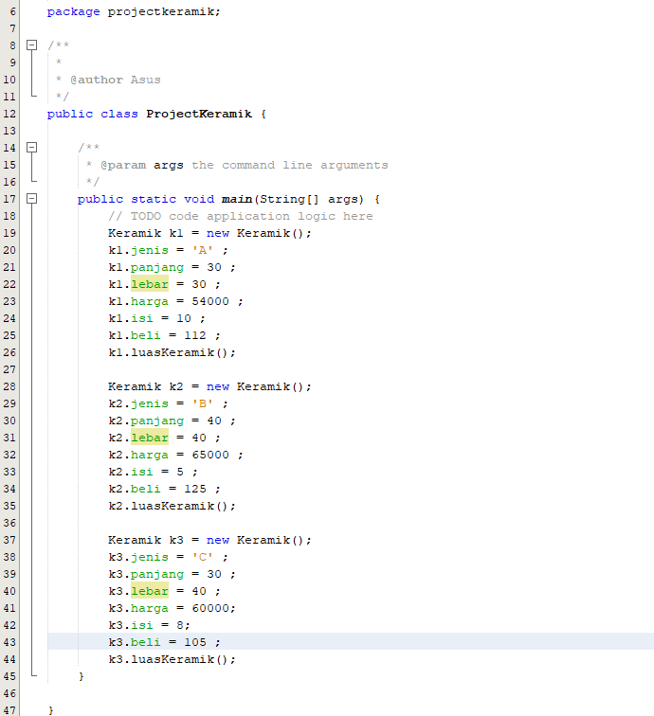

Class kedua

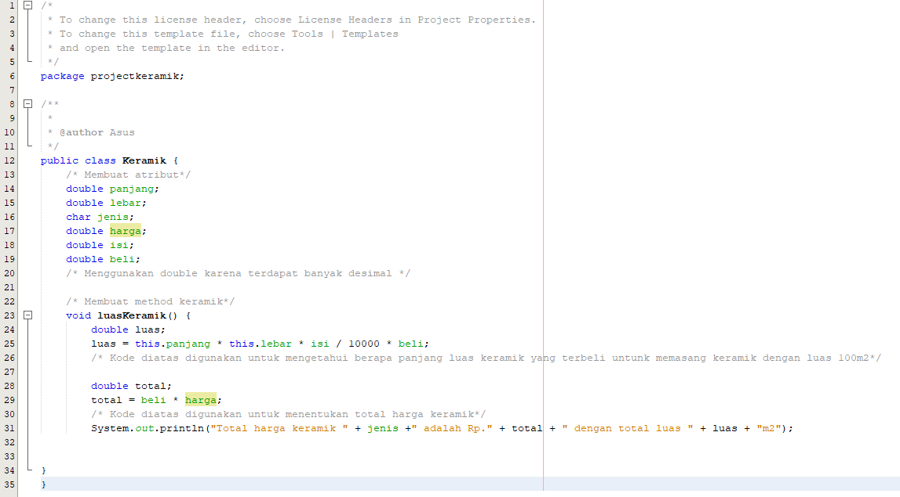

Output

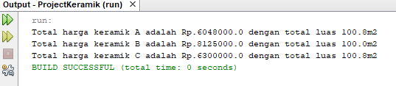

Github Link

https://github.com/grimalvez/PBO/projects