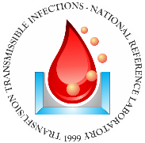

**CERTIFICATE OF PROFICIENCY**

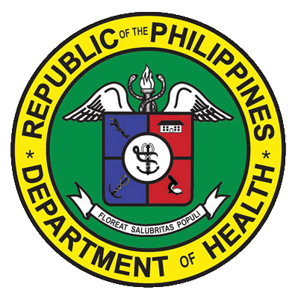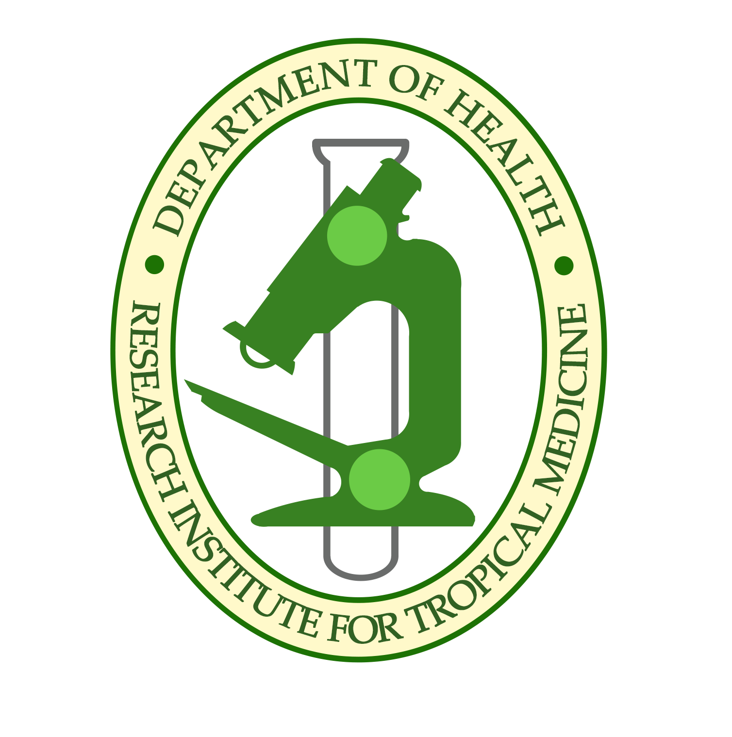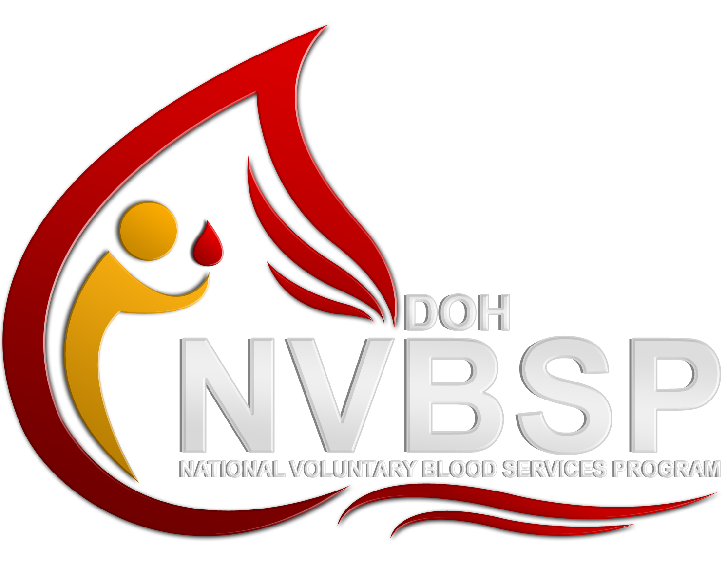

**IS HEREBY AWARDED TO**

SUSAN R. GORDOVEZ, RMT

**SAN JUAN MEDICAL**

**OCCIDENTAL MINDORO PROVINCIAL HOSPITAL**

**CERTIFICATE NO.** **1343B**

VALID UNTIL NOVEMBER 2020

PAMET CPD UNITS: 14

For having satisfactorily completed the

HIV and other TTI (Transfusion Transmissible Infections) Proficiency Testing Training Workshop

(Refresher Course)

Given this 15th of November 2017

at the Hotel Veniz, Baguio City

November 14-15, 2017

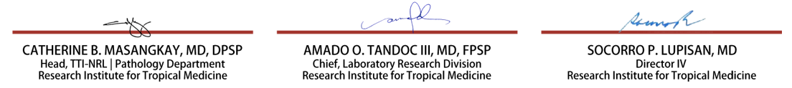

**CATHERINE B. MASANGKAY, MD, DPSP**

**Head, TTI-NRL | Pathology Department**

**Research Institute for Tropical Medicine**

**AMADO O. TANDOC III, MD, FPSP**

**Chief, Laboratory Research Division**

**Research Institute for Tropical Medicine**

**SOCORRO P. LUPISAN, MD**

**Director IV**

**Research Institute for Tropical Medicine**