VRD Meeting

Training Center, Lecture Room 1

January 11, 2018

Attendance:

Zaldy P. Saldo

Daria L. Manalo

Rodolfo P. Perez

Leonardo P. Bilazon

Marc Louie M. Monzon

Criselda T. Bautista

Leilanie B. Nacion

Blyth B. Trigo

1. The meeting was called to order at 1:40 pm with Dr. Fedelino Malbas, Jr. presiding
2. RITM Budget Allocation for 2018

Dr. Malbas presented the Overview of Division Meeting indicating the DOH budget of 2018 amounting to P106,082,096,000. The RITM Budget for maintenance and other operating expenses of P111,000,000 for 2018 has been determined based on the allocation through the General Appropriation Act (GAA) for 2018 and the income projected for 2018 utilization amounting to P34,000,000. Thus, the total budget allocated to the RITM is P145,000,000.

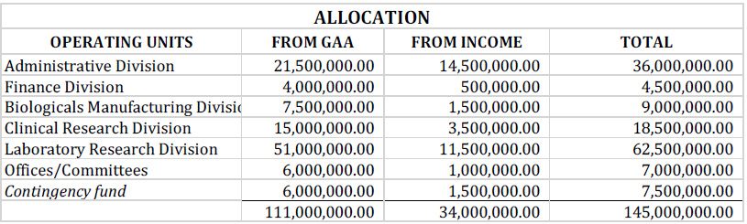

3. VRD Budget

The Veterinary Research Department was given an allocation of budget for 2018 in the amount of P4,000,000.00 (GAA+Income) with ongoing capacity building project for SPL (ASEAN-Canada GPP). It has a 22% reduction from VRD OPLAN 2018 that was submitted in LRD earlier this year.

4. The meeting adjourned at 3:30 pm.

Prepared by: Approved by:

Blyth B. Trigo Fedelino F. Malbas, Jr., DVM, MPH

Science Research Analyst Head, Veterinary Research Department