Early morning of July 10, the MBD Team of Rizal Medical Center Blood Bank headed by Doc Jinalyn Noh of the department of Laboratory Medicine joined the other government and private hospital for the yearly bloodletting activity of ABS-CBN DZMM thru Dugong Alay, Dugtong Buhay Project.



People in all walks of life from PNP, BFP, Army, Air Force, Private and government employees nearby gather together in the spirit of humanitarian act of donating voluntarily their healthy blood. There are first time donor and regular donor like Mr. Julius Babao who donates his blood every time there is bloodletting activity in their company. He also promoted it together with Ms. Bernadette Sembrano-Aguinaldo , the one who really hands on organizing the said event. The whole activity was aired live at Umagang Kay Ganda and DZMM Teleradyo.

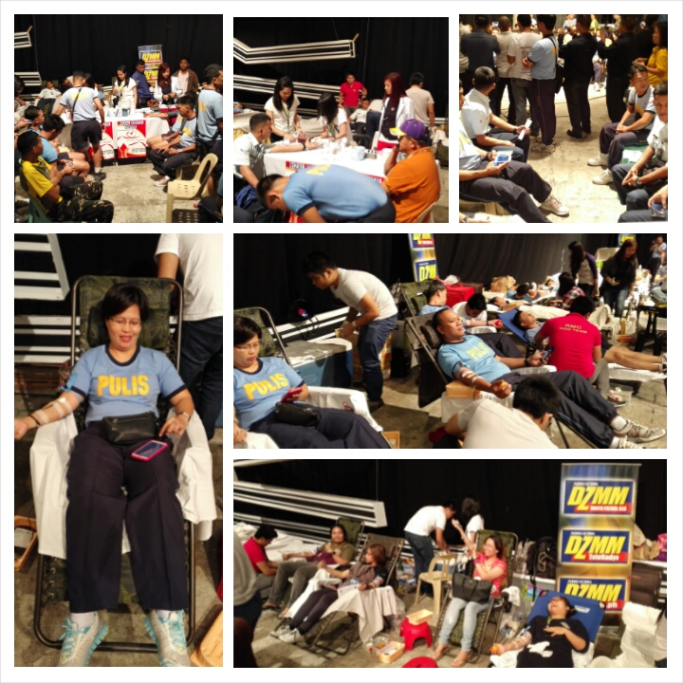   
Donating blood is the act of helping not knowing who give that blood and who is that patient will be saved by the blood that you gave. An act that never expect anything in return, just to saved life of other people. An act of giving not your spare or extra money or any material thing but still you make other people happy because you save their life. Donating not knowing who will be the final recipient of what you give. The act that