To: Our Valued Distributors & Dealers   
From: Management of Shanghai Global Corporation  
Date: 05 March 2018  
Subject: Distribution / Dealership of Chong Coffee Vending Business

*Greetings from Chong!* Thank you for your interest in reselling Chong products for Coffee Vending Business in your area. The Coffee Vending Business is one of the most successful product categories for Negosyong Pangkabuhayan, and we are excited to make you part of this success.

In line with our efforts to provide better business opportunities for every entrepreneurial Filipino, we have also duplicated our successful Chong Coffee Vending Machine format and have come up with the very promising Chong Cold Vending Machine (Vendo Palamig). The Chong Vendo Palamig is guaranteed to also zoom its way to being the top choice for entrepreneurs or for Negosyong Pangkabuhayan enthusiasts.

Please note our updated price list for the coffee vending business:

|  |  |  |  |
| --- | --- | --- | --- |
| **Description** | **Packing** | **Suggested Retail Price (SRP)** | **Distributor Price** |
| Chong Coffee Vendo Package*/** |  | ₱ 15,990.00 | ₱ 13,200.00 |
| Chong Powdered Premixes for Hot Drinks - Coffee 3 in 1, White Coffee, Caramel Macchiato | 1 x 25 kgs | ₱ 190.00 | ₱ 170.00 |
| Paper Cups (Plain or Printed) 6.5 oz | 1 x 1000 cups | ₱ 750.00 | ₱ 585.00 |

* *Each Chong Vendo Package comes with one vending machine, 3 kilos of powders and 600 pcs of cups.   
** Pricing inclusive of freight to your city if destination address is within the delivery zone limits of shipping forwarder used (if outside delivery zones, extra charges may apply)  
*** CWO discount at 1.5%. CWO prices are as follows -* ₱ *13,391.08,* ₱ *167.50 and* ₱ *616.22*  
  
Please note our profitability of each cup below:

|  |  |
| --- | --- |
| DETAILS | Hot Beverages |
| 1 Kg of any flavor = 100 cups per KG | ₱ 1.95 |
| 1 Box of Paper Cups 6.5 oz = 1000 cups; Php 680/box | ₱ 0.69 (6.5 oz) |
| Purified Water Php 30 / bottle of 5 gallon / 150 cups | ₱ 0.20 |
| Electricity Cost Per Cup | ₱ 0.05 |
| **Total cost per cup** | ₱ **2.89** |
| Your Profit If your Selling Price per cup is P5.00 | ₱ **2.11** |
| Profit Percentage | 42% |
| Monthly Profit at 100 Cups Per day (30 days in a month) sold at P5.00 | ₱ **6,330** |
| Monthly Profit at 100 Cups Per day sold at P10.00 | ₱ **12,660** |

Please note below the common features and benefits for both cold vending and hot vending machines:

* P5.00 Peso Coin Operated Vending Machine;
* Can set your selling price to P5.00 (one P5.00 coin) or P10.00 (two 5-Peso Coins) or higher
* Can also set to serve for free (press the button showing flavor of your choice, no coin needed)
* 3-Flavor Vending Machine (3 Canisters)
* Coin Recognition Technology and Coin Rejection System (Vending Machine only accepts P5.00-Peso coins and will return P1.00 peso, P10.00 peso and other coins.
* Each Vending Machine comes with Lock and Key
* Priceless Convenience for Customers, Guests and Employees
* Excellent for entrepreneurs and for Negosyong Pangkabuhayan enthusiasts

**Chong Coffee Vending Machine**

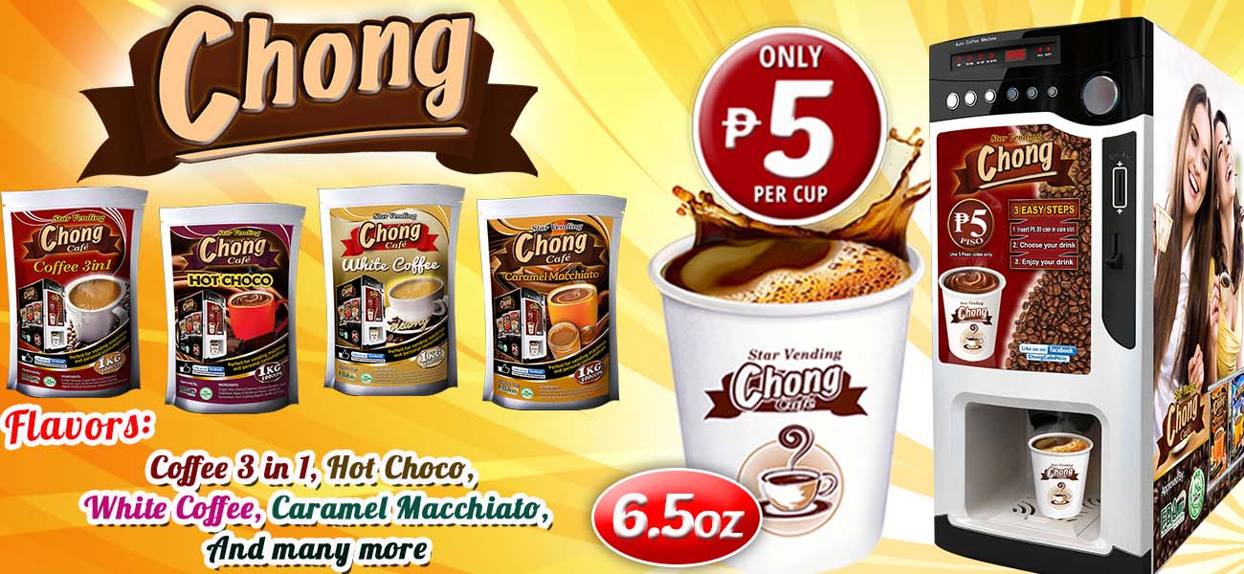

**Marketing Support**

* + One Vendo One Tarp - We will give one tarpaulin for every machine sold to promote brand and visibility
  + Exhibitions and Online Marketing client referrals – We get retail clients very often from our marketing efforts. We will refer them to buy from you.

We look forward to serving you soon. Thank you  
  
Best Regards,

**Hazel – Sales – 0917 897 7704 –** [**sales02@chongcafe.com**](mailto:sales02@chongcafe.com) **Johnny – Director – 0917 1100 752 or 0998 594 9700 –** [**info@shanghaiglobal.com.ph**](mailto:info@shanghaiglobal.com.ph)