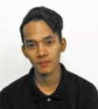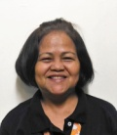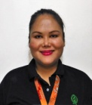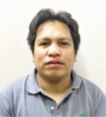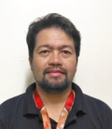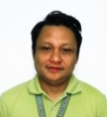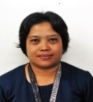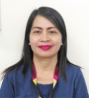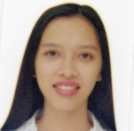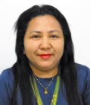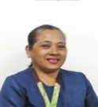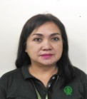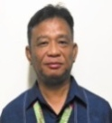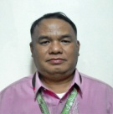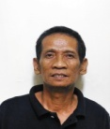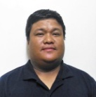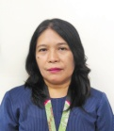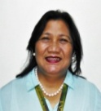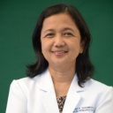

**OUT-PATIENT / DIGITIZATION SERVICES**

**RESEARCH SERVICES**

**ARG SUPPORT SERVICES**

**Releasing Clerk**

**BRYAN ACE CASANO**

**J.O.- ARG**

**Filing & Retrieval Clerk**

**DEAN MICHAEL BADULIS**

**J.O.- ARG**

**ARG Analysis Clerk**

**BETH BERNARDO**

**J.O.- ARG**

**ARG Analysis Clerk**

**VICTOR CHAN**

**J.O.- ARG**

**ARG Filing Retrieval Clerk**

**DIOSDADO M. ESCLAMADO**

**J.O.- ARG**

**ARG Analysis Clerk**

**ROBERT TAMON**

**J.O.- ARG**

**Encoder**

**BRYAN C. TAN**

**J.O.- ARG Encoder**

**Unit Head**

**ELIOSA C. RAMOS**

**Records Management**

**Analyst II**

**Administrative Assistant I**

**HIMD-QA STAFF- SECRETARY**

**Clinical Trial Unit Staff**

**LUCRECIA NABOR**

**Admin Aide I**

**Unit Head**

**MARIDEL GARCIA**

**Statistician I**

**Clinical Trial Unit Staff**

**ERNESTO OCHINANG**

**Administrative Aide IV**

**Equipment Custodian/Digitization**

**JOEL T. ABAD**

**Laboratory Aide II**

**Front liner**

**VIRGINIA A. ACERO**

**Laundry Worker I**

**Front liner**

**ANJANETTE M. ESPINOLA**

**Administrative Aide IV**

**Unit Head**

**ERMINIA V. TORIO**

**Statistician II**

**Analysis Clerk**

**LLOYD ANGELO ARRIOLA**

**Administrative Aide VI**

**Analysis Clerk/ICD-10Coder**

**ELIOSA C. RAMOS**

**Records Management**

**Analyst II**

**Unit Head**

**MA. MEBEL A. MAYGAY**

**Statistician II**

**Unit Head**

**ROEHL D. HERNANDEZ**

**Administrative Officer V**

**Clerk / Encoder**

**GRACE MARIE D. LAGAT**

**J.O.- RITM**

**Clerk / Encoder**

**SHERYL ANN C. OLIZA**

**J.O.- RITM**

**Clerk / Encoder**

**KAZELINE P. RAYOS**

**J.O.- RITM**

**Science Aide**

**Warehouseman /**

**Filing Retrieval Clerk**

**FERDINAND A. VIGAL**

**Laboratory Aide II**

**Filing & Retrieval Clerk**

**BERNARDO M. MIRANDA**

**Laboratory Aide II**

**Filing & Retrieval Clerk**

**TOMMY V. CABANTAC**

**Administrative Aide IV**

**Filing Retrieval Clerk /**

**HIS Retrieval Clerk**

**ROCKET RIKKI T, JUSAYAN**

**Administrative Aide IV**

**OPD Analysis Clerk**

**WILLESA T. MUNCADA**

**Administrative Aide IV**

**Analysis Clerk**

**YOLANDA A. VIGAL**

**Laboratory Technician I**

**Socorro P. Lupisan, M.D.**

Director IV

**SUPPORT SERVICES**

**IN-PATIENT SERVICES**

**Head, Health Information Management Department**

**MYRNA C. BERAMO, MBA/PA**

**Supervising Administrative Officer**

**Chief, Clinical Research Division**

**BEATRIZ P. QUIAMBAO, M.D.**

**Medical Officer V**