Dan Aldreen N. Panlibuton Grade VII – St. Batholomew

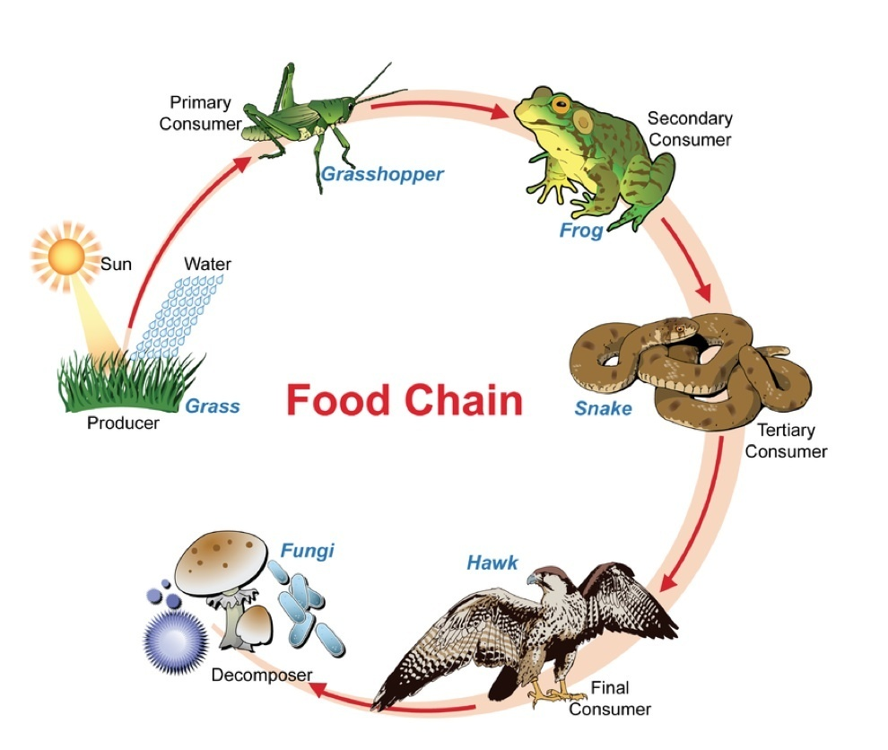**FOOD CHAIN**

Dan Aldreen N. Panlibuton Grade VII – St. Batholomew

