# **Image Denoising with the Non-Local Means Algorithm**

## **Non-Local Means Algorithm**

Non-local means is an image denoising algorithm based on a simple principal – taking the average of similar pixels to that being denoised, this method is a relatively recent development in Image Processing algorithms and techniques, especially in comparison to more traditional local image denoising using kernels (taking weighted averages of directly neighbouring pixels).

Digital photographs incur natural noise as a result of random fluctuations in the generation pixel colour and intensity from differing photon counts over time, hence the measurements of the true intensity form a lambda distribution, this can be approximated by a normal distribution and hence be modelled as gaussian noise. This is demonstrated by the central limit theorem in that the normalised sum of the measurements (being independent random variables in a lambda distribution) tends towards the normal distribution. In general, images taken in the dark are noisy as there is not enough light to lower the distribution variance.

In the same way that sampling pictures (for the same corresponding pixels) would reduce the noise proportional to , non-local means looks to measure pixel samples for each given pixel from a single image to reduce the noise proportional to (hence the search for many similar pixels).

For a continuous image , the non-local means algorithm filter is defined in [1] as

where is the Euclidian distance between the image patches and centred at points and respectively, is a decreasing function usually given by gaussian weighting function (filtering parameter )[2] and is the normalizing factor (to prevent a change in image intensity).

## **Implementations of Non-Local Means**

Non-local means has two main implementations which yield slightly different denoising characteristics: *pixel-wise* and *patch-wise*.

The *neighbourhood* is the area being sampled for similar pixels. The *sample space* is the area containing both the pixel (or patch) being denoised and the potential neighbourhoods.

### **Pixelwise N-L Means**

The pixelwise implementation runs on each pixel of the image within a given sample space. Given image at pixel location , the discrete algorithm as in [1] is

such that

where and is the weight applied between pixel and each pixel that is an element of the neighbourhood being scanned.

### **Patchwise N-L Means**

The patchwise implementation of non-local means differs in that instead of just looking at a single pixel, the area (patch) around the pixel is taken also into account, this effectively applies a local convolution to each patch, as such, while taking an average of more pixels leads to a further reduction in noise, there is strong potential for a loss of detail.

As per [1], for image and a given patch of size centred at , patchwise non-local means is defined for as

where

such that represents a neighbourhood of size centred at and is implemented in the same way as the pixelwise implementation. Applying these for all patches in the image disposes of estimates per pixel. Finally, these estimates can be averaged for each pixel to attain the denoised image

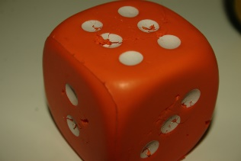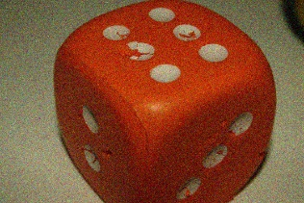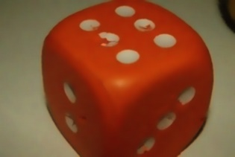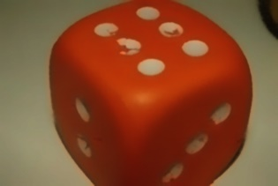

### **Asymptotic Complexity**

For an image with pixels, the original non-local means algorithm runs in time[3] as for each pixel if is roughly having to do a similarity computation for every other pixel (within the sample space), however [2] proposes a simplified algorithm which runs in time.

## **Algorithm Parameters**

The *Method noise* is defined to be the difference between the original image and the denoised image for a given filtering parameter where is the standard deviation.

The effectiveness of non-local means strongly relies on the input parameters of which the three main ones are the search window size (sample space) pixels, the neighbourhood (or patch) size pixels, and the filtering parameter , however, these influence each other when trying to attain meaningful visual results, for example an increase in (linearly proportional to ) requires an increase in to ensure robust patch comparison [1].

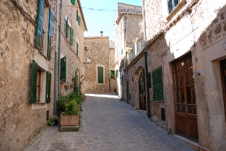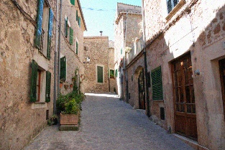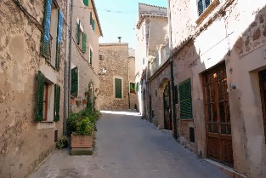

Figure 1: Original, Noisy and Denoised Image

Figure 1 demonstrates the application of non-local means to a slightly noisy image of an alleyway with default parameters , and . Comparing the denoised image to the original, there are positions where detail has clearly been lost, for example, the walls to the left and right appear to be smoother, and the road has mostly lost its texture.

Figure 2: Original, High Noise, Denoised () and Denoised () Image

Figure 2 shows a smooth dice that has had a high amount of noise removed with , and respectively. For both denoised instances an increased (or standard deviation for constant ) causes a blurring effect, as previously mentioned this would require an increase in to enable robust patch comparison, thus keeping edges relatively sharp. The difference between two value images is very subtle, but when comparing each to the original it can be seen that the slight ridge texture on the front-most corner of the dice is more visible for the lower value, this shows that while a larger sample space may decrease noise, in this case it has done so in a way that is detrimental to the texture, and it certainly demonstrates the law of diminishing returns. As mentioned earlier, increasing would increase the blur, taking this into consideration the algorithm has done a relatively good job at removing noise given the amount there was, this is primarily helped by the already naturally smooth texture (whose primary difference between regions is based on the light reflection).

Figure 3 shows some flowers with noise removed with , and respectively. Here, the main point of interest is the comparison between the detail in the petals and the trade off with how well the image has been denoised. For the , example there is a clear reduction in noise compared to the noisy image, but the detail on the petals remain intact, there is however some visible smoothening on the leaves. The , example displays less noise than that of , but produces a much more noticeable blurring effect on the details in the petals. While there is some loss in detail in the background, it is not particularly noticeable since only the foreground is in focus.

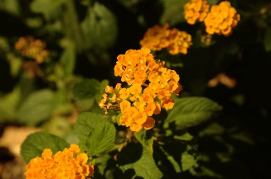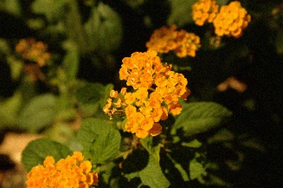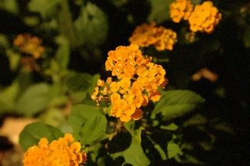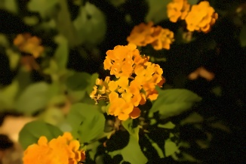

Figure 3: Original, Noisy, Denoised (, ), Denoised (, )

## **Strengths and Limitations**

Unlike conventional convolutional methods such as gaussian or mean blur (which are based on the threshold removal of frequencies), non-local means does not disproportionately affect the frequency space of the image.

As with most discrete algorithms, non-local means is limited to the data it has, as to be expected it cannot add detail to an image, there are however many cases in which detail is removed.

While the simplified algorithm is relatively fast, it comes nowhere near able to run in real-time on conventional hardware at video framerates (even taking upwards of one minute to denoise a image[3]).

The algorithm parameters demonstrate how customisable non-local means is, however this also means it needs to be run and fine-tuned to fit the context, for applications such as videography this means that changes in lighting make one-size-fits-all parameters inconsistent, constantly requiring tinkering to optimal results.

While non-local means produces a net removal of noise, it introduces its own white noise (noise at all frequencies), this is slightly noticeable when viewing the method noise for a given application of the algorithm combined with the noticeable removal of detail in some instances.

## **Modifications of the Main Algorithm**

Better results can be obtained using an affine invariant patch similarity measure[4], unlike the standard exponential similarity function this identifies more similar patches.

A SURE-based (risk estimate based) algorithm has been developed as an extension to non-local means with the aim of monitoring the mean square error to help tune the width of the patch smoothing kernel [5].

Another variation of non-local means allows for rotationally invariant block matching, this aims to increase the number of similar neighbourhood pixels by allowing for rotations, for example, square objects could match as similar on all four corners when allowing rotation without which they would only match on one [6].

There are various proposed modifications which aim to increase the speed of the algorithm, one of which exploits the redundancy property of the Laplacian pyramid by decomposing the image to the pyramid followed by running non-local means at each level[7], this additionally increases speed and efficiency by making use of the Summed Square Image scheme and Fast Fourier Transform algorithm as proposed in [3], this alone increases the speed of the simplified algorithm by approximately fifty times (), but maintains the same asymptotic complexity of .

## **Applications of Non-Local Means**

Aside from the trivial use-case for non-local means in photography and videography as a filter to enhance image / video quality, the algorithm has a few main use cases.

Machine learning uses denoising as part of pre-processing images to improve the continuity (and therefore data quality) before being passed into model training and testing.

Non-local means has also been used in medicine to reduce noise in CT X-ray images and reconstruction[8] as well as in magnetic resonance imaging (MRI)[9], both of which (using electromagnetic spectrum cameras) suffer from lambda-distributed noise.

# **References**

|  |  |
| --- | --- |
| [1] | A. Buades, B. Coll and B. Morel, “Non-Local Means Denoising,” *Image Processing On Line,* vol. I, p. 208–212, 2011. |
| [2] | A. Buades, B. Coll and J.-M. Morel, “A non-local algorithm for image denoising,” in *IEEE Computer Society Conference on Computer Vision and Pattern Recognition*, San Diego, 2005. |
| [3] | J. Wang, Y. Guo, Y. Ying, Y. Liu and Q. Peng, “Fast Non-Local Algorithm for Image Denoising,” in *2006 International Conference on Image Processing*, Atlanta, 2006. |
| [4] | V. Fedorov and C. Ballester, “Affine Non-Local Means Image Denoising,” *IEEE Transactions on Image Processing,* vol. XXVI, no. 5, pp. 2137-2148, 2017. |
| [5] | D. Van De Ville and M. Kocher, “SURE-Based Non-Local Means,” *IEEE Signal Processing Letters,* vol. XVI, no. 11, pp. 973-976, 2009. |
| [6] | S. Zimmer, S. Didas and J. Weickert, “A rotationally invariant block matching strategy improving image denoising with non-local means,” *International Workshop on Local and Non-Local Approximation in Image Processing,* pp. 135-142, 2008. |
| [7] | Y.-L. Liu, J. Wang, Y.-W. Guo and Q.-S. Peng, “A Robust and Fast Non-Local Means Algorithm for Image Denoising,” *Journal of Computer Science and Technology,* vol. XXIII, no. 2, pp. 270-279, 2008. |
| [8] | H. Zhang, D. Zeng, H. Zhang, J. Wang, Z. Liang and J. Ma, “Applications of nonlocal means algorithm in low-dose X-ray CT image processing and reconstruction: A review,” *Medical Physics,* vol. XLIV, no. 3, pp. 1168-1185, 2017. |
| [9] | J. Manjón, J. Carbonell-Caballero, J. Lull, G. García-Martí, L. Martí-Bonmatí and M. Robles, “MRI denoising using Non-Local Means,” *Medical Image Analysis,* vol. XII, no. 4, pp. 514-523, 2008. |

# **Appendix**

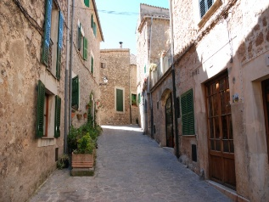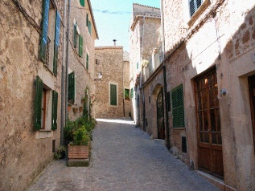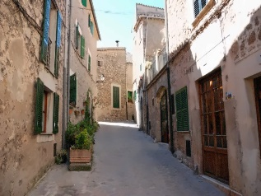

Figure 1 Enlarged

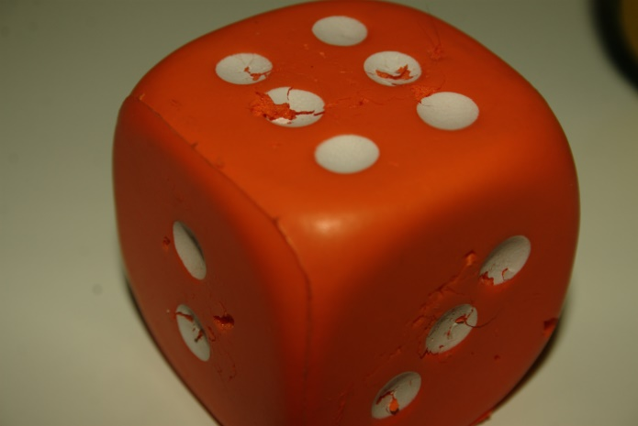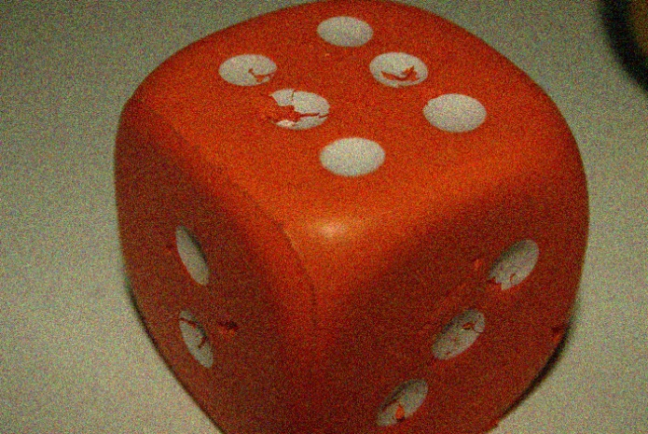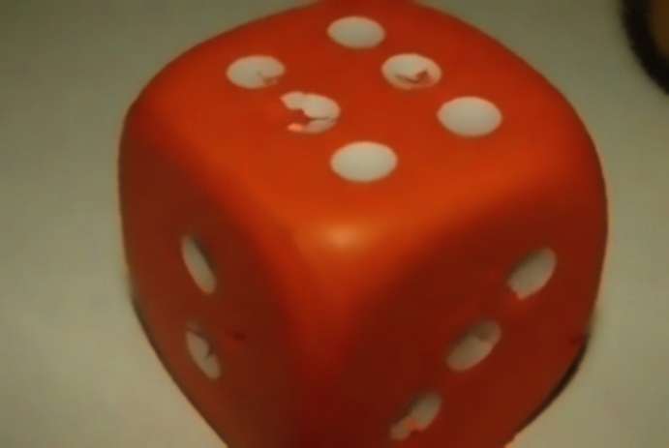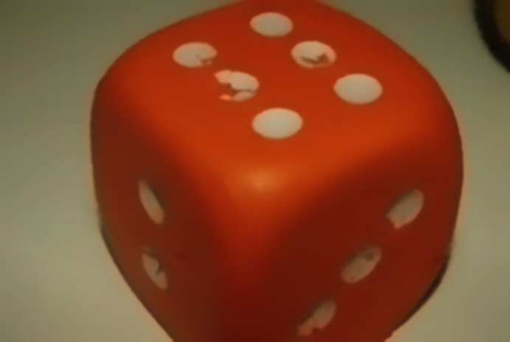

Figure 2 Enlarged

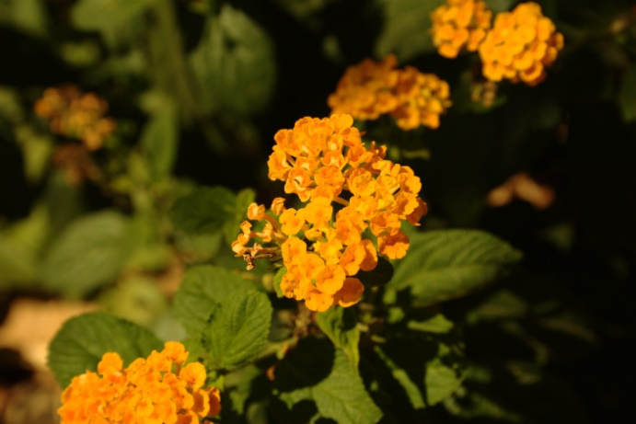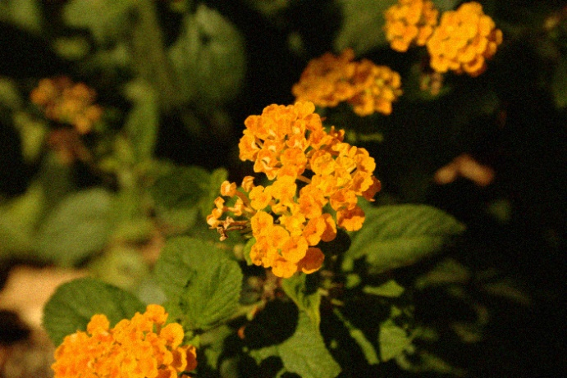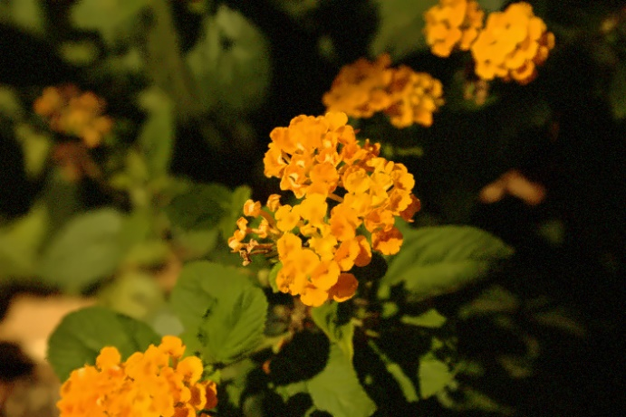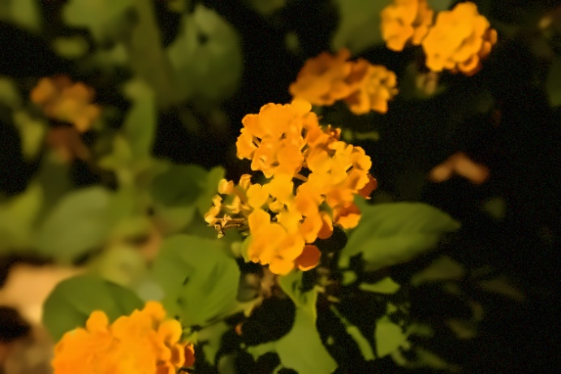

Figure 3 Enlarged