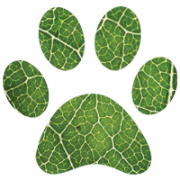Birch Animal Wellness

647 460 0082 [birchanimalwellness@gmail.com](mailto:birchanimalwellness@gmail.com)

I understand that Jesse McCowan does not practice veterinary medicine and cannot diagnose, prescribe treatment, or provide prognosis as part of her scope of practice.

I understand that Jesse McCowan is not a veterinarian and in the event of a health emergency of my pet(s), I agree to seek professional veterinary care for my pet(s) at my regular DVM or closest emergency clinic.

By signing this form, I do hereby agree and understand that Jesse McCowan will not be held liable if I, the owner, decline to seek professional veterinary care for my pet(s) despite her suggestion.

I understand that in some cases of holistic health care, my animal may experience a healing crisis. I realize that their symptoms may get worse before they get better, and that is the natural response of the body. I do not hold Jesse McCowan responsible for any healing crises that my pet(s) may experience.

I have read Birch Animal Wellness’ location policy, cancellation policy, and weather policy. I understand if I live further than the stated distance, I have to pay a fee for gas. I understand that if I don’t provide 24 hours notice for a cancellation, I will have to pay 25% of the value of my appointment.

By checking this box, I consent to Jesse McCowan using photos of my pet on her website, social media platforms (Facebook & Instagram).

_______________________________ _______________________________ __________________

Owner’s Phone Number Owner’s Signature Date