Little Ball Bot
The little ball bot is a robot that balances on top of a ball. The robot balances upright and moves around on a flat surface. The robot is essentially a 3D inverted pendulum, and it shares a lot of its dynamic behavior with the traditional inverted pendulum. A larger version of this design is shown in Figure 1.

My design is intended to be a smaller version of the pictured robot – something that can move around on a desk. My comparatively simple system will consist of:
- a lacrosse ball
- a structure to support the components
- three omni wheels
- three geared DC motors with encoders
- three motor drivers
- at least one inertial measurement unit
- mbed LPC1768 microcontroller
- a battery

The goal of the project is to achieve vertical balance regulation and horizontal position control. The project serves as a fun exercise in control systems and robotics engineering.

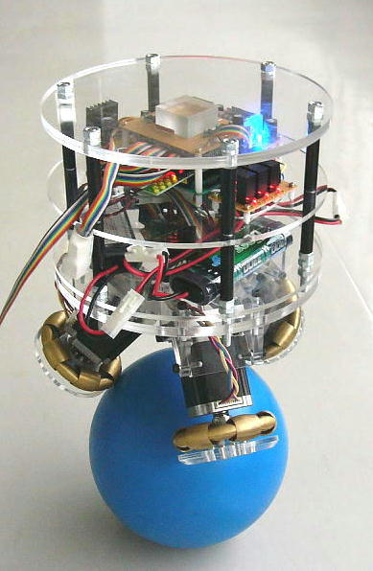Figure 1: Large ball bot developed at Tohoku Gakuin University

Fixed Model Parameters
The following values describe physical characteristics of the robot. These parameters are time-invariant, so they are represented as constants in the dynamical model. They have been assigned dummy values for numerical analysis (real values will be estimated by system identification later).
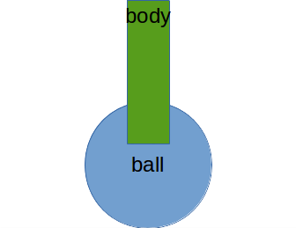

- Mass of ball M = 0.5 kg
- Mall of body m = 0.2 kg
- Length of body c.o.g. to end of body l = 0.1
- Moment of inertia of body I = 0.005 kg-m²
- Coefficient of friction between ball/body/floor b = 0.1 N/m/s
- Gravitational acceleration g = 9.8 m/s/s

Inputs
The motors exert a torque on the ball, which is proportional to linear acceleration of the ball on the surface (X-Y plane). This version of the model assumes perfect control of the linear acceleration of the ball along the x-y plane.
- Linear acceleration of the ball along the x-axis, u_{x} [m/s/s]
- Linear acceleration of the ball along the y-axis, u_{y} [m/s/s]

Outputs
The inertial measurement unit(s) provide 2-dimensional angular tilt measurement of the robot body on top of the ball. The motor encoders provide a measurement of the ball's x-y position.
- Angular tilt about the y-axis, θ [rad]
- Angular tilt about the x-axis, φ [rad]
- Linear position along the x-axis, x [m]
- Linear position along the y-axis, y [m]

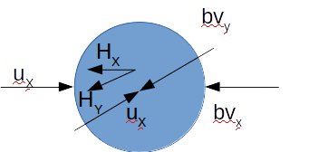
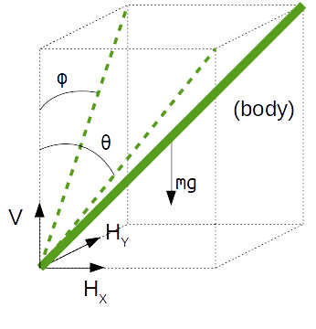
Linearization
The dynamic model can be linearized and simplified by assuming that the robot will operate near the vertical orientation.

Derivation of Motion Equations
Assume that one end of the body is fixed to the ball, so the position of the body depends on the ball position and the tilt angle of the body. Also assume that there is no robot movement along the z-axis. Note: the angular motion of the ball is not included in this version of the model; it will be added later on, along with the conversion of the input accelerations to input torques.

Linear Motion of the Body

Angular Motion of the Body

Linear Motion of the Ball

From the above derivation, the four motion equations that completely describe the dynamics of the robot are:

State Space Model

where
, , ,
Both continuous and discrete state space models require definitions of the accelerations of each of the state variables.

where
With all of this information, we can construct the state space matrices.

Stability, Controllability, and Observability
Given the dummy values, two of the eigenvalues of the process matrix are positive, so the open-loop system is unstable.
The controllability matrix is full rank, so the system is controllable.
The observability matrix is full rank, so the system is observable.

Control Strategy
The inertial measurement units and the motor encoders provide measurements of all state variables. Because of the high measurement coverage a state estimator is unnecessary, but a Kalman estimator can improve noise rejection.

