# Talking Ham Logbook

## System Architecture

There are 2 possible different possible overall system architecture of the system the difference between the two will be 1 works entirely off of a Raspberry pi or split between a Raspberry pi and an Atmel ATSAM3X8E AU, (same MCU on Arduino Due) the advantage between the 2 is the following

Just Raspberry Pi

This requires fewer components as you don’t require an additional MCU  
 No command translation between Raspberry Pi and Arduino

Combined Approach

This allows the code be separated between the two systems and the work load as well.  
 The MCU is more specially designed for use of controlling components  
 I already know how to code Arduinos

The Raspberry pi is needed in order to interface with the NANO VNAs used to monitor the input and output signals

### Version 1

The system architecture for V1 (the one with the Raspberry Pi and Arduino Due MCU) is shown in Figure 1.

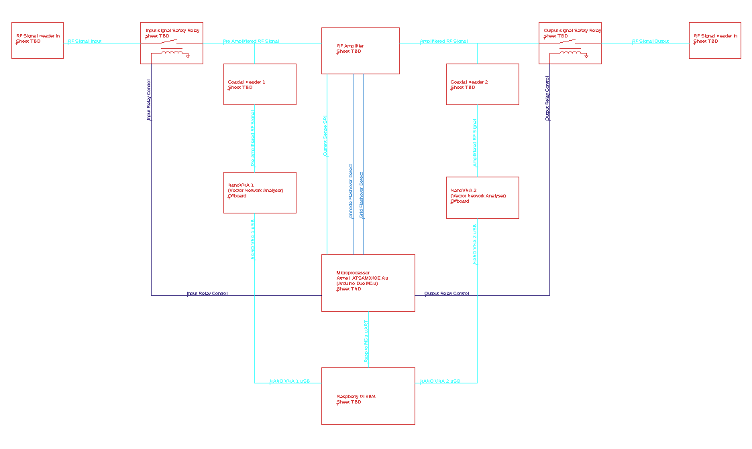

Figure 1- Overall System Arcitecture (With Rasp Pi and MCU)

### Version 2

The system architecture for V2 (the one with just the Raspberry Pi) is shown in Figure 2.

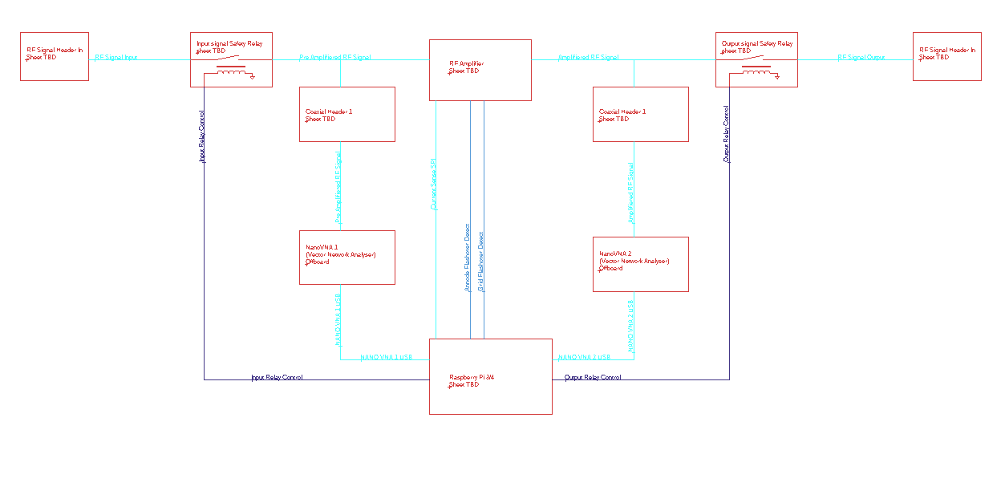

Figure 2- Overall System Architecture (With just Rasp Pi)

### RF Amplifier

The RF Amplifier mentioned in the Overall System Architecture is shown in more detail in Figure 3.

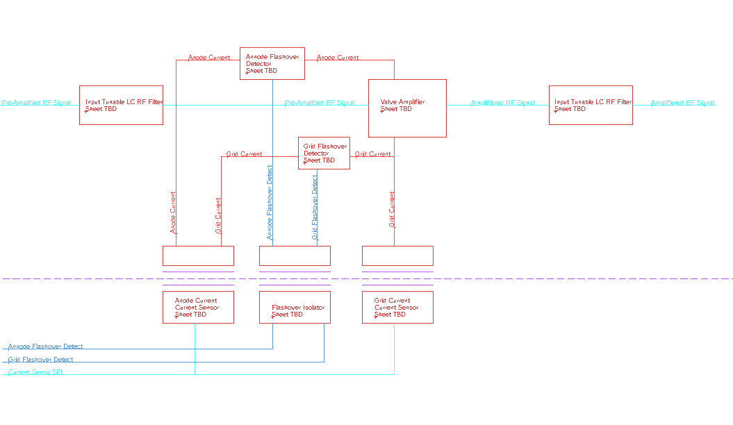

Figure 3- RF Amplifier System Architecture