**Abstract**: - The Online Food Ordering System is a digital platform designed to facilitate the seamless process of ordering food from restaurants and delivering it to customers. The system encompasses various components, including users, restaurants, menus, orders, and items, all interconnected to provide a smooth and efficient experience for both customers and restaurant owners.

**Customers** can register accounts, providing essential information such as their name, email, and address. **Restaurants**, another integral part of the system, are represented as entities offering food items for ordering. Each restaurant has a distinct identity, comprising attributes like name, address, and menu. Restaurant owners have the capability to manage their menus, update item availability, and receive orders placed by customers.

The **menu** serves as a catalog from which users can browse and select items to include in their orders. Items, on the other hand, represent individual food products available for purchase, each characterized by attributes such as name and price.

**Orders** facilitate the transaction process within the OFOS, encompassing details of selected items, total price, and status.

The system aims to streamline the food ordering process, enhance user satisfaction, and foster efficient communication between customers and restaurants.

**CLASS DIAGRAM**

**USER CASE DIAGRAM**

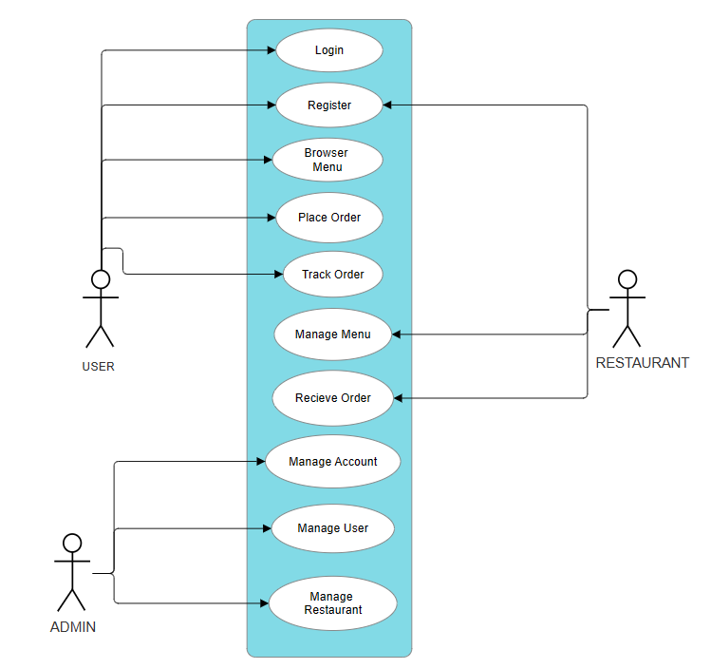

**SEQUENCE DIAGRAM**

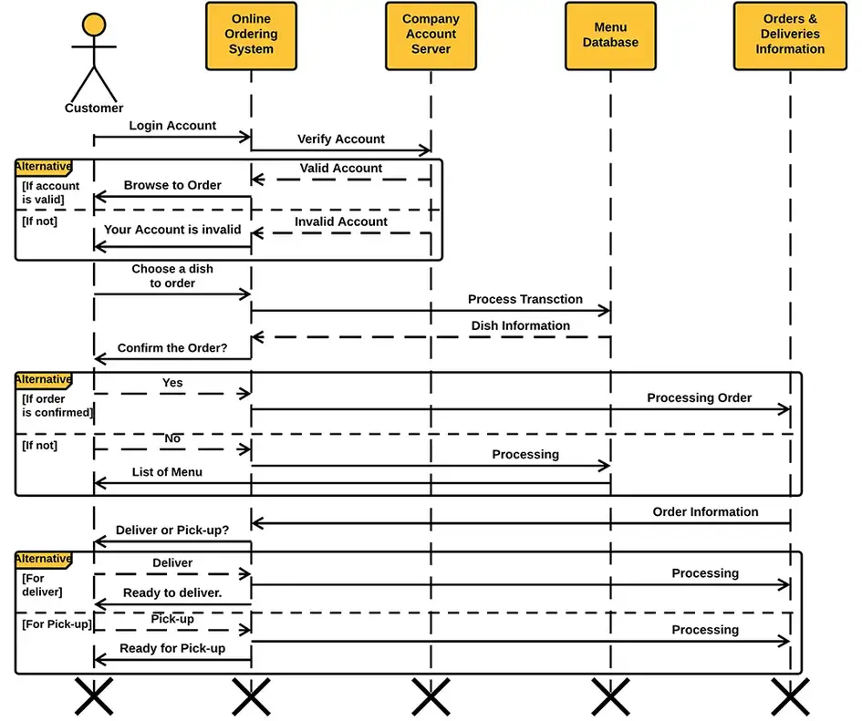

**DATA FLOW DIAGRAMS**

* LEVEL 0 (CONTEXT DIAGRAM)

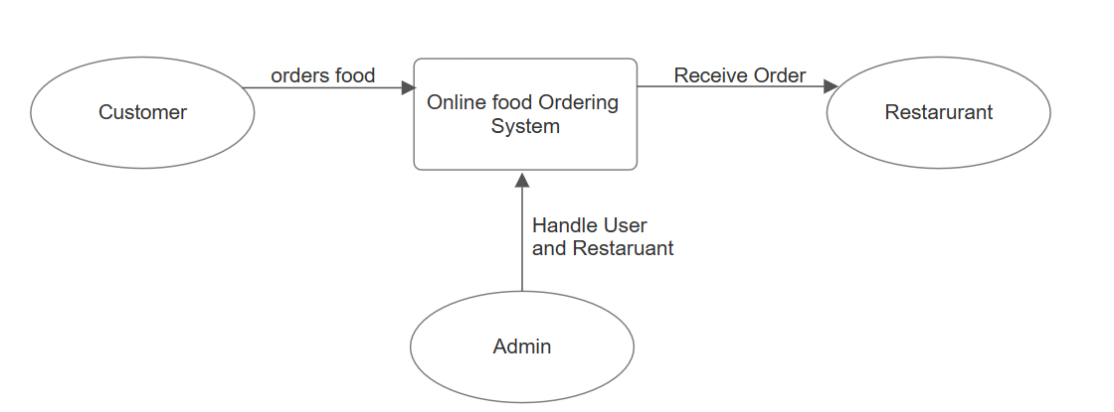

* **LEVEL 1**

**HARDWARE AND SOFTWARE REQUIREMENTS**

**Hardware Requirements:**

* **Server**: Physical or VPS hosting for deployment.
* **Storage**: Adequate space for project files, database, and media files.
* **Memory** **(RAM)**: Minimum 1GB for small-scale applications.
* **Network**: Stable internet connection with sufficient bandwidth.

**Software Requirements:**

* **Python**: Version 3.11 installed.
* **Django** **Framework**: Installed using pip.
* **Database** **Management** **System (DBMS)**: PostgreSQL, MySQL, or SQLite.
* **Integrated** **Development** **Environment** **(IDE**): PyCharm, VS Code, or Sublime Text.
* **Git**: Version control system for managing code.
* **Tech used**: Html, CSS, Bootsrap, a bit JavaScript, Python, Django, SQLite

**By Grishma Gedela**