**Date: ___/___/______**

Practical: **2**

**Aim:** **Create a J2ME Application to demonstrate basic MIDlet Operation by printing “Welcome to CSE Department, BITS edu campus”.**

**Code:**

import javax.microedition.midlet.*;

import javax.microedition.lcdui.*;

public class HelloWorld extends MIDlet implements CommandListener

{

private Display display;

private TextBox textBox;

private Command quitCommand;

public void startApp()

{

display = Display.getDisplay(this);

quitCommand = new Command("Quit", Command.SCREEN, 0);

textBox = new TextBox("Hello World", "Welcome to CSE Department, BITS edu campus", 100, 0);

textBox.addCommand(quitCommand);

textBox.setCommandListener(this);

display.setCurrent(textBox );

}

public void pauseApp()

{}

public void destroyApp(boolean unconditional)

{}

public void commandAction(Command choice, Displayable displayable )

{

if (choice == quitCommand)

{

destroyApp(false);

notifyDestroyed();

}

}

}

**Output:**

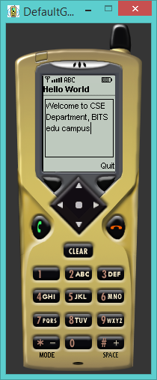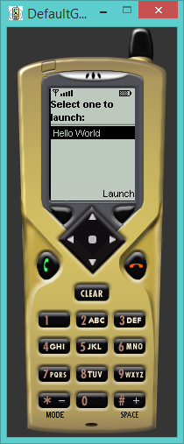

**Conclusion:**

From above practical we understood how to make J2ME application to demonstrate basic MIDlet Operation.