**Date: ___/___/______**

Practical: **3**

**Aim:** **Create a J2ME Application for Login. On successful login, alert user with a Welcome message, else alert user using an Error message. Use Ticker for form title.**

**Code:**

import javax.microedition.midlet.*;

import javax.microedition.lcdui.*;

public class TickerForm extends MIDlet implements CommandListener

{

private Display display;

private TextField usernameTF, passwordTF;

private Command submitCommand, exitCommand;

private Form loginForm;

private Ticker messageTicker;

private Alert statusAlert;

public TickerForm()

{

usernameTF = new TextField("User name:", "", 50, TextField.ANY);

passwordTF = new TextField("Password:", "", 50, TextField.ANY | TextField.PASSWORD);

messageTicker = new Ticker("Welcome to MyPortal");

loginForm = new Form("Sign In");

loginForm.setTicker(messageTicker);

loginForm.append(usernameTF);

loginForm.append(passwordTF);

exitCommand = new Command("Exit", Command.EXIT, 1);

submitCommand = new Command("Submit", Command.SCREEN, 1);

loginForm.addCommand(submitCommand);

loginForm.addCommand(exitCommand);

loginForm.setCommandListener(this);

}

public void startApp()

{

display = Display.getDisplay(this);

display.setCurrent(loginForm);

}

public void pauseApp()

{}

public void destroyApp(boolean unconditional)

{}

public void commandAction(Command choice, Displayable displayable)

{

if(choice == submitCommand)

{

String un = usernameTF.getString();

String pass = passwordTF.getString();

if(un.toLowerCase().equals("hello") && pass.toLowerCase().equals("hi"))

statusAlert = new Alert("Sign In Successful", "Valid User name and Password", null, AlertType.CONFIRMATION);

else

statusAlert = new Alert("Authentication Error", "Invalid User name and Password", null, AlertType.ERROR);

statusAlert.setTimeout(Alert.FOREVER);

display.setCurrent(statusAlert, loginForm);

destroyApp(false);

}

if (choice == exitCommand)

{

destroyApp(false);

notifyDestroyed();

}

}

}

**Output:**

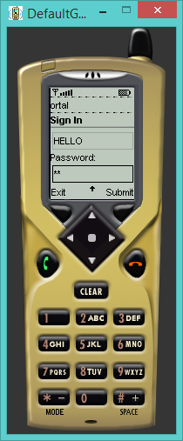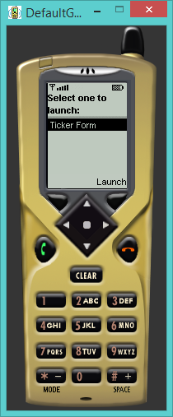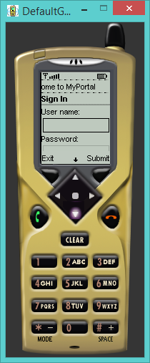

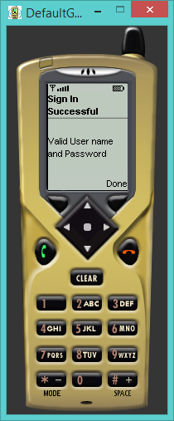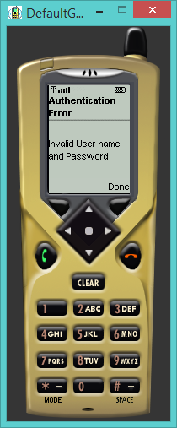

**Conclusion:**

From this practical we performed the implementation of login module making use of various MIDlet programming controls and learnt the use of ticker and alert to display user message.