**Date: ___/___/______**

Practical: **4**

**Aim:** **Create a J2ME Application for Calculator.**

**Code:**

import javax.microedition.midlet.*;

import javax.microedition.lcdui.*;

public class Calculator extends MIDlet implements CommandListener

{

private Display display;

private TextField data1TF, data2TF;

private Command menuCommand, exitCommand, performCommand;

private Form calculatorForm;

private List operationL;

private StringItem res;

public Calculator()

{

data1TF = new TextField("1st Number:", "", 10, TextField.NUMERIC);

data2TF = new TextField("2nd Number:", "", 10, TextField.NUMERIC);

res = new StringItem("", "");

calculatorForm = new Form("Calculator");

calculatorForm.append(data1TF);

calculatorForm.append(data2TF);

calculatorForm.append(res);

exitCommand = new Command("Exit", Command.EXIT, 1);

menuCommand = new Command("Submit", Command.SCREEN, 1);

calculatorForm.addCommand(menuCommand);

calculatorForm.addCommand(exitCommand);

calculatorForm.setCommandListener(this);

performCommand = new Command("Perform", Command.SCREEN, 1);

operationL = new List("Operations", List.IMPLICIT);

operationL.append("Add", null);

operationL.append("Subtract", null);

operationL.append("Multiply", null);

operationL.append("Divide", null);

operationL.addCommand(performCommand);

operationL.setCommandListener(this);

}

public void startApp()

{

display = Display.getDisplay(this);

display.setCurrent(calculatorForm);

}

public void pauseApp()

{}

public void destroyApp(boolean unconditional)

{}

public void commandAction(Command choice, Displayable displayable)

{

if(choice == menuCommand)

{

display.setCurrent(operationL);

destroyApp(false);

}

if (choice == exitCommand)

{

destroyApp(false);

notifyDestroyed();

}

if(choice == performCommand)

{

int selection = operationL.getSelectedIndex();

int d1 = Integer.parseInt(data1TF.getString());

int d2 = Integer.parseInt(data2TF.getString());

String r = "";

switch(selection)

{

case 0: r = d1 + " + " + d2 + " = " + (d1+d2) + "\n";

break;

case 1: r = d1 + " - " + d2 + " = " + (d1-d2) + "\n";

break;

case 2: r = d1 + " * " + d2 + " = " + (d1*d2) + "\n";

break;

case 3: r = d1 + " / " + d2 + " = " + (d1/d2) + "\n";

break;

default: break;

}

res.setText(r);

display.setCurrent(calculatorForm);

}

}

}

**Output:**

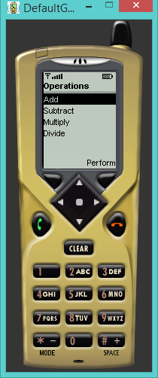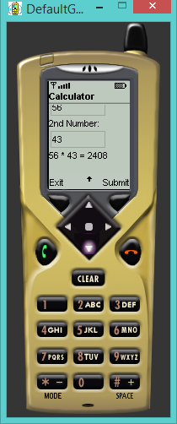

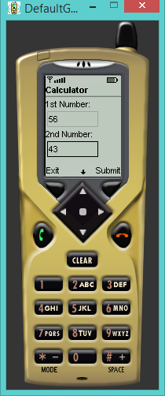

**Conclusion:**

From this practical we performed the implementation of Calculator module implementing basic mathematical operations making use of various MIDlet programming controls and learnt the use of List.