**Лабораторная работа №6**

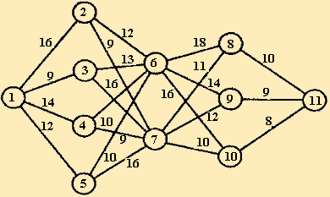

*- min значение

1 Шаг

|  |  |  |  |
| --- | --- | --- | --- |
| i\j | 11 | F1(i) | j |
| 8 | 10* | 10 | 11 |
| 9 | 9* | 9 | 11 |
| 10 | 8* | 8 | 11 |

2 Шаг

|  |  |  |  |  |  |
| --- | --- | --- | --- | --- | --- |
| i\j | 8 | 9 | 10 | F2(i) | j |
| 6 | 18+10 | 14+9* | 16+8 | 23 | 8, 9, 10 |
| 7 | 11+10 | 12+9 | 10+8* | 18 | 8, 9, 10 |

3 Шаг

|  |  |  |  |  |
| --- | --- | --- | --- | --- |
| i\j | 6 | 7 | F3(i) | j |
| 2 | 12+23 | 9+18* | 27 | 6, 7 |
| 3 | 13+23 | 16+18* | 34 | 6, 7 |
| 4 | 10+23 | 9+18* | 27 | 6, 7 |
| 5 | 10+23* | 16+18 | 33 | 6, 7 |

4 Шаг

|  |  |  |  |  |  |  |
| --- | --- | --- | --- | --- | --- | --- |
| i\j | 2 | 3 | 4 | 5 | F4(i) | j |
| 1 | 16+27 | 9+34 | 14+27* | 12+33 | 41 | 11 |

Оптимальный маршрут: 1=>4=>7=>10=>11