**Лабораторная работа №8**

1

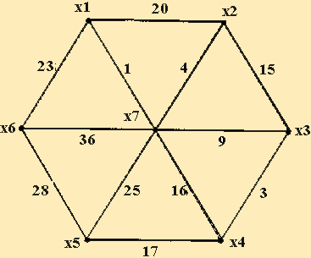

|  |  |  |  |  |  |  |  |
| --- | --- | --- | --- | --- | --- | --- | --- |
|  | X1 | X2 | X3 | X4 | X5 | X6 | X7 |
| X1 |  |  |  |  |  |  |  |
| X2 | 4 |  |  |  |  |  |  |
| X3 |  | 15 |  |  |  |  |  |
| X4 |  |  | 16 |  |  |  |  |
| X5 |  |  |  | 17 |  |  |  |
| X6 | 23 |  |  |  | 28 |  |  |
| X7 | 1 | 4 | 9 | 16 | 25 | 36 |  |

Длина минимального остова равна (x1, x6) + (x1, x7) + (x7, x2) + (x7, x3) + (x7, x4) + (x4, x5) = 1+4+9+16+17+23=70.

2

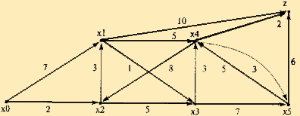

|  |  |  |  |  |  |  |  |
| --- | --- | --- | --- | --- | --- | --- | --- |
|  | X0 | X1 | X2 | X3 | X4 | X5 | Z |
| X0 -> |  | 7 | 2 |  |  |  |  |
| X1 -> |  |  |  | 1 | 5 |  | 10 |
| X2 -> |  | 3 |  | 5 |  |  |  |
| X3 -> |  |  |  |  | 3 | 7 |  |
| X4 -> |  | 8 |  |  |  | 3 | 2 |
| X5 -> |  |  |  |  | 5 |  | 6 |
| Z -> |  |  |  |  |  |  |  |

1. I(X0)=0*

I(X1)=min[inf,0*+7] = 7

I(X2)= min[inf,0*+2] = 2

Min[I(X1), I(X2), I(X3), I(X4), I(X5), I(Z)] = 2*

1. I(X2)

I(X1)=min[7,2*+3] = 5

I(X3)= min[inf,2*+5] = 7

Min[I(X1), I(X3), I(X4), I(X5), I(Z)] = 5*

1. I(X1)

I(X3)=min[7,5*+1] = 6

I(X4)= min[inf,5*+5] = 10

I(Z)= min[inf,5*+10] = 15

Min[I(X3), I(X4), I(X5), I(Z)] = 6*

1. I(X3)

I(X4)=min[10,6*+3] = 9

I(X5)= min[inf,6*+7] = 13

Min[I(X4), I(X5), I(Z)] = 9*

1. I(X4)

I(X5)= min[13,9*+3] = 12

I(Z)= min[15,9*+2] = 11

Min[I(X5), I(Z)] = 11*

Ответ: кратчайший путь X0=> X2=>X1=> X3=> X4=>Z.