# Challenge Project Documentation

## About Me

My name is Grettel Rivera Rojas, I am computer engineer, I finished my studies at ULACIT the last quarter on December, 2015. At University I usually do programming projects, my last project was made for CNET, a software development company. The project was called License Control System and was made in MVC.

The challenge to do this project were that l lost time doing the installation of Visual Studio 2012 and Sql Server 2012 and health problems (allergy symptoms).

## Instructions of installation

1. Verify that Sql Server Agent Sevice and Sql Server Service are running.
2. Create Challenge database with the default values of SQL Server Management Studio.
3. Open the file ***Challenge.sql*** and run the script on SQL Server Management Studio using Challenge DB.
4. Using Visual Studio add a new data connection of SQL Server.

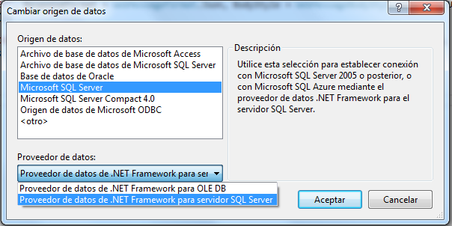

1. Instead of the current connexionString, change the ***connexionString*** in DBConnectClass, getting the new connection String in properties.

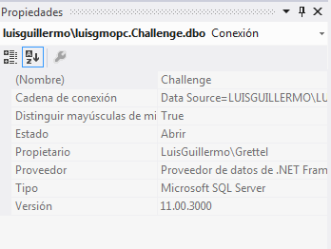

1. Select the debug application.
2. Click on debug button.



1. Verify the IIS Express is running to execute the Web Service.

## Project Description

The project consist in web page that provides solution to the Papers, Rock and Scissors Game, the web page has 4 classes:

DBConnectClass: Contains the InicializaCommand Method and define the connection string.

ListClass: Contains the methods that have direct interaction with the Database, this class inherits from DBConnectClass.

GetListConsult: Contains the logic of the game, one method called “GetNameList”, let exchange data between ListClass and the WebFormGame. It returns

ObjectList: this class represent the component for the game table.

Game Instructions

1. Press button Begin to start the game
2. Write the name of the first player
3. Select the strategy for the player
4. Click send button.
5. Write the name of the second player.
6. Select the strategy for the second player.
7. Click Math Button.

Note: Reset button let do another turn.