FAQ for Android Studio 3.3
We converted the KotlinTutorial project for Android Studio 3.3, and have found a problem when you first use it.
The problem happened now and then with earlier versions of Android Studio, but is now occurring consistently with version 3.3

Fortunately, it's very easy to fix.
After you've extracted the project from the zip file, in the resources for these videos, open it as normal in Android Studio.

You'll find that instead of the project name - KotlinTutorial - at the top of the Project pane, you'll see the path to the project.

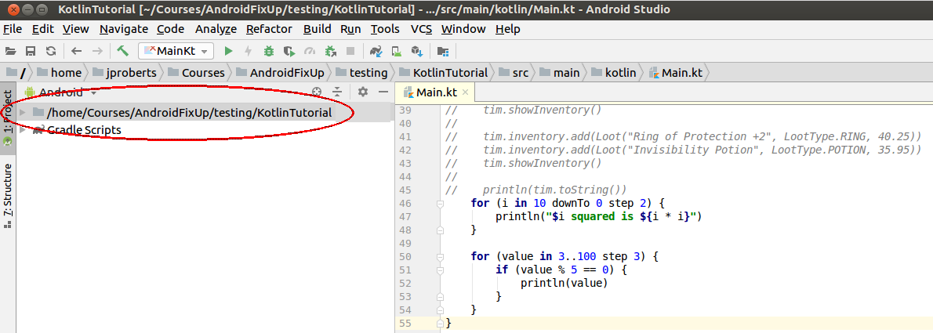

To fix the problem, go into the File menu and choose Sync Project with Gradle Files.
That will fix the problem, and you'll see KotlinTutorial in the Project pane.

You'll still need to rebuild the project before it will run, as Tim describes in the video.

So after following along with Tim, to download and extract the project, remember to go into File > Sync Project with Gradle Files before attempting to run it.

