**ALGORITHM TO FIND THE DIFFICULTY OF A QUESTION**

**SYNOPSIS**

* Formula or Algorithm
* Initial steps to code
* Explanation for Algorithm
* Proof for Algorithm

**Formula or Algorithm**

Difficulty = ((NC / NS) * 40+(M / 30) * 10+ A - (NW / NS) * 10) + K

Percentage, D (%)

Where,

NS-Number of students attended the question

NC-Number of students answered correctly

M-Manually entered level (EASY/MEDIUM/HARD)

A-Average time taken to solve the question

NW-Number of students answered wrongly

K = N + H + F + ((NS - (NU + NP)) / NS) *10)

Where,

N - Number of time compiled/answer changed

H - Number of hints used to solve a question

F – Average feedback rating get from the student

NU – Number of students not-answered the question

NP – Number of students answered partially

By, using the above formula we can calculate the efficiency of the question by 100%.

The above inputs are got from the multiple students who attend the question or take part in the test.

**Initial steps to code**

First get the input required for the formula to calculate.

The inputs are,

NS -Total number of students attending the test

NC-Number of students answered correctly

M-Manually entered level (EASY/MEDIUM/HARD)

A-Average time taken to solve the question

NW-Number of students answered wrongly

N - Number of time compiled/answer changed

H - Number of hints used to solve a question

F – Average feedback rating get from the student

NU – Number of students not-answered the question

NP – Number of students answered partially

QT - Question type

MAX – Maximum mark for the question

Enter the inputs into the Excel sheet.

In web application read the input from the excel sheet and store it in a variable for making calculations.

**EXPLANATION FOR ALGORITHM AND CODE**

Initially check the question type what type of question is it? ( i.e., MCQ , Programming, Fill-ups , Match).

Based on the above type if it is an MCQ question,

* We can compute the difficulty of the item by dividing the number of students who choose the correct answer by the number of total students.
* Using this formula, the difficulty of question (referred to as D) is equal to 2. A rough "rule-of-thumb" is that if the item difficulty is more than -75, it is an easy item; if the difficulty is below -50, it is a difficult item. Given these parameters, this item could be regarded moderately easy -- above (75%) of students got it correct.
* The remaining inputs are used to make the difficulty percentage more accurate like, Number of times complied, time taken, feedback etc…
* Calculate the remaining values and add it to the result, Round the fractional value into the whole number to display it in a graph.

If it is a programming question then,

* The main part is same as MCQ question but some inputs are changed no of time compiled is to be calculated for the question.
* Time taken to solve the problem is also high in compare to MCQ question.
* The remaining calculations are same for like the MCQ question

If it is a fill-up question then,

* The main part is same as other type of question the only thing need to be calculated is Partial output for the question.
* How many times the answered had been changed is also need to be calculated.

If it is a match question then,

* We have to calculate the partial output of the question and max marks allocated for the question.
* The remaining things are same as like the above question.

After getting the difficulty percentage display the result int table.

* Displaying the Question number which is unique for all questions, Question type i.e.) MCQ, Program etc…
* Displaying the number of students attended the question, Percentage of difficulty of the question.
* Displaying the Level

If the difficulty percentage(D),

D > 75 – EASY,

D >=50 && D<75 – MEDIUM and

D <= 50 -EASY.

* Displaying it in the Graphical representation for each question.
* Feedback given by the students are also displayed.

Finally display the Difficulty level of the test in the Pie chart format with three parameters, how many percentages the test contain Easy, Medium and Hard level of questions.

**Proof for Algorithm**

**Manual Calculations**

**Ex:**

**Sample input:**

Q-NO – 1

Q-TYPE - MCQ

NS-50

NC - 20

M - HARD

AT - 60

NW-20

N - 4

H - 40

F – 3

NU – 10

NP – 0

MAX – 1

**Calculations:**

Formula,

Difficulty = ((NC / NS) * 40+(M / 30) * 10+ A - (NW / NS) * 10) + K

Percentage, D (%)

K = N + H + F + ((NS - (NU + NP)) / NS) *10)

#Calculating percentage for N-Number student attended correctly

(NC / NS) * 40= (20/50) *40=16

#Calculating percentage for W-Number student attended wrongly

(NW / NS) * 10= (20/50) *10=4

# Calculating percentage for M-Difficulty for manually Entered

(M / 30) * 10= (10/30) *10=3.33

#Calculating percentage for T-average time taken to solve the question

(60-Avgtime) =(60-65)=5 if(a<20) A=5

#Calculating percentage for C-Number of time answer changed

if(no-c<6)

N=5

#Calculating percentage for H-Average number of hints used

If(h<=(NS/2)

H=5

#Calculating percentage for F-Feedback rating from a student

F=3

#Calculating percentage for U-number students un-attempted

((NS - (NU + NP)) / NS) *10) = ((50-10+0)/50) *10=8

D (%) =16+3.33+5-4+5+5+3+8=41.33%

**Answer**

Difficulty percentage (%) =41.33%

Difficulty level =HARD

**SYSTEM GENERATED OUTPUT**

**SAMPLE SCREENSHOT**

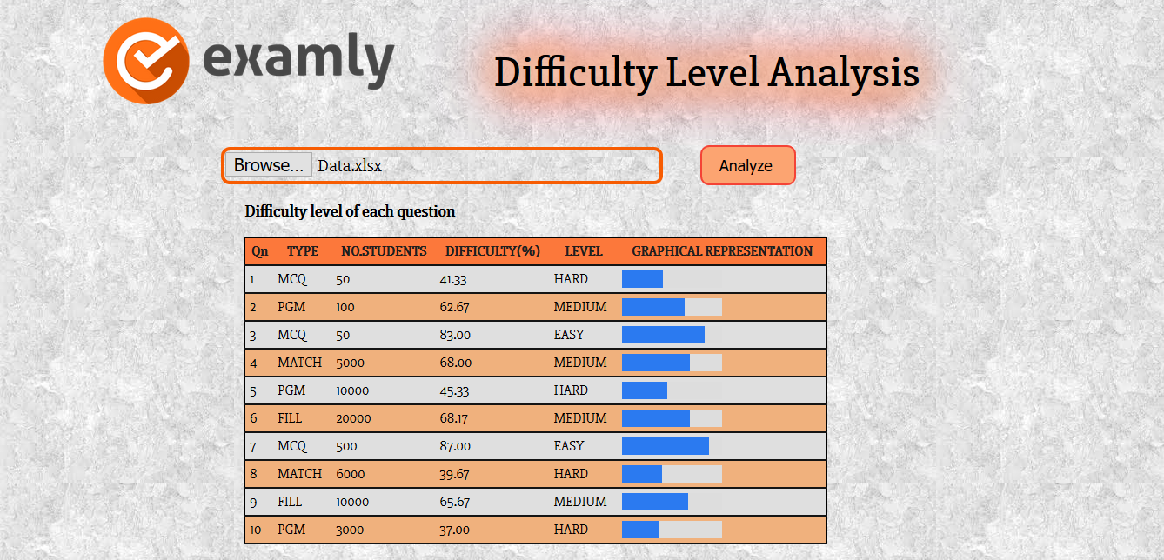

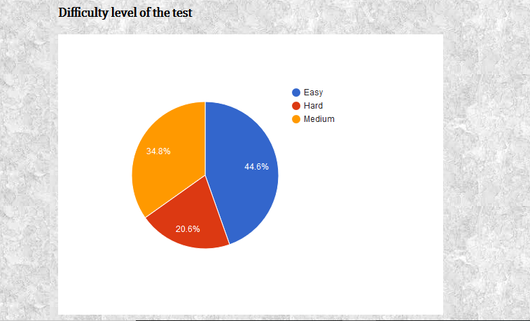

**Project done by**

**Gowtham S**