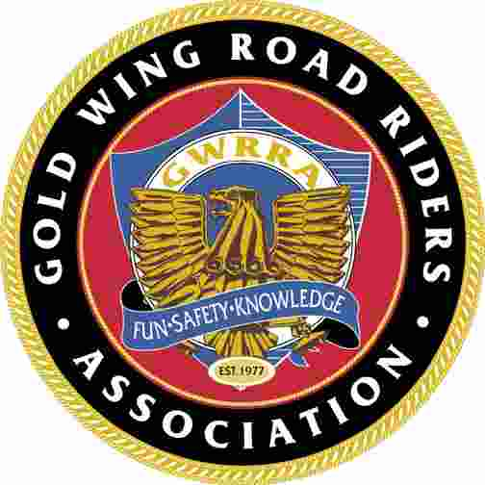
2014 ALABAMA DISTRICT CONVENTION

April 3rd– April 5th
Mobile, Alabama ~ Ashbury Hotel and Suites
District Directors: Robert & Gail Brown
Hotel information will be provided with your registration confirmation.
Send all drop shipments to:
600 West I-65 Service Road South, Mobile, AL 36608 251-344-8030 or 1-800-752-0398

2014 VENDOR INFORMATION
NO INSIDE VENDORS
- Vendor setup Wednesday, April 2nd, 2014 beginning 8:00 AM CDT.
- Questions? Contact Bill & Trina Barden Vendor Coordinators (Contact info listed at bottom of form)
- We can accommodate any size vendor rig or display. Please furnish the complete length and width of your rig including truck/tractor/puller, opened doors of trailers, opened canopies, etc. We need the length of what will be parked on site.
- Electrical hookups are not available.
- Please complete setup and be ready for business by 12:00 PM CDT Thursday.
- Once your unit is set in place, please no moving in and out each day. Please, no holes in pavement.
- Vendors may sleep in their self-contained motor home/rigs/trailers on rally vendor site (self contained).
- One full registration packet included with rally vendor fee. You are welcomed at all and any convention activities.
Please join us Wednesday evening for dinner at TBD around 7:00 PM. Please let us know if you plan to attend.
- Vendors, please wear vendor armbands for identification and entrance through vendor gate.
- Please don’t cut, climb over, or push down the security fencing. Please use the entrance gate. If a member of your party violates these rules, you could be asked to leave. Thanks for your cooperation.
- Vendors are responsible for collection and remitting taxes to the appropriate Alabama tax agencies as applicable (e.g., state, county, city).
- You are part of the Alabama GWRRA Family. We thank you for coming, and look forward to seeing you.
================================================================================================================

Keep top portion for your information.

2014 ALABAMA DISTRICT CONVENTION VENDOR REGISTRATION
  Business Name
  Product/Services
  Contact/Owner
  Business Party (Helpers)
  Rig Length: |  | Rig Width:
  Vendor Fee:
  Up to 20’ - $100 | 21’ to 40’ - $150 |  | 41’ to 60’ - $200
  61’ to 80’ - $250 |  | 81’ to 120’ - $300
  Address
  City | State | ZIP
  Phone
  Cell
  Fax
  Email

RELEASE:
I/We agree to indemnify and hold harmless the Gold Wing Road Riders Association, its officers and agents, and/or property owners from any and all forms of liability, causes of action, claims and demands for loss or damage, including death or injury to self or property in which I/we become involved by reason of participation in the convention. I/We also agree to assume responsibility for any property, which I/we knowingly damage, or cause to be damaged. I have read this vendor agreement and have signed below.

Signed: ________________________________________________________________________ DATE:____________________

Vendor fee balance is due Thursday morning, April 3rd, 2014 ~ Bill Barden ~ Vendor Coordinator, will collect on-site.
Make checks payable to, Alabama GWRRA - Mail Application and Payment/Deposits to: Bill & Trina Barden 275 Anderson Mtn. Dr. Odenville AL. 35120 ~~~ VendorCoordinator@Alabama-gwrra.org

