MDIE — Modification-Disentangled Identity Encoder
- Mrinal

1. Simple methodology — four boxes, mapped to the proposed plan
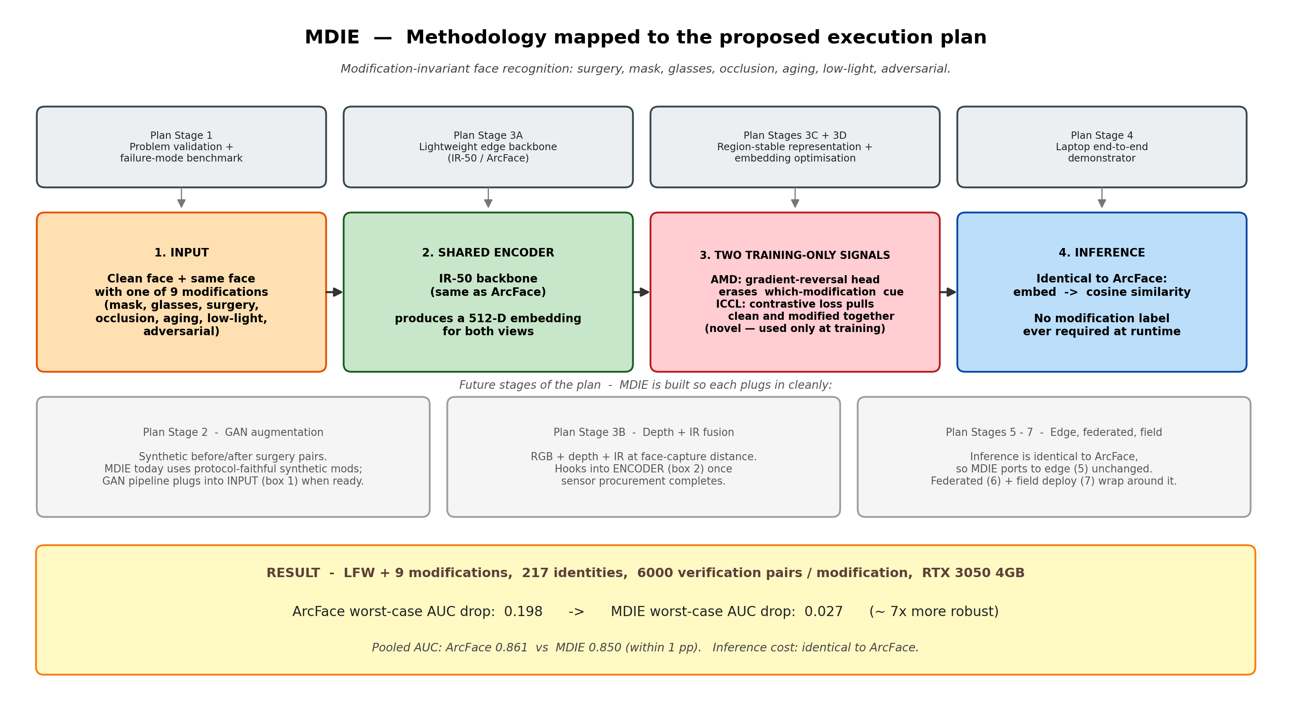

2. Detailed methodology — full training graph
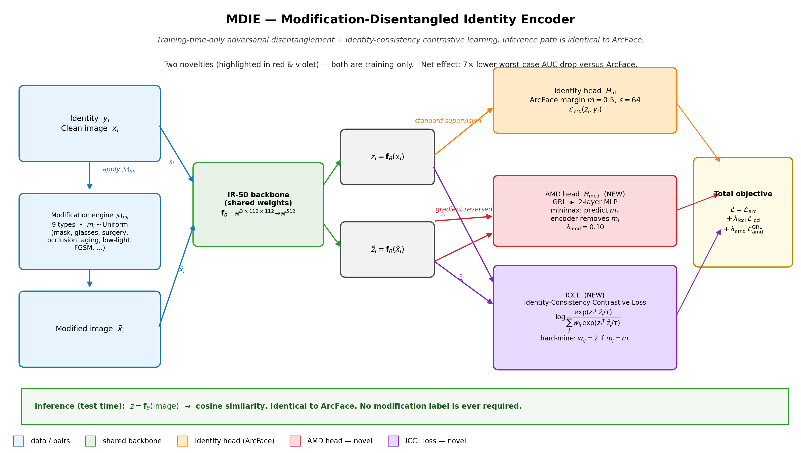

3. How the approach works
The problem
Face-recognition systems trained on clean photos collapse when the same person shows up with a mask, glasses, post-surgery features, partial occlusion, an aging gap, low-light capture, or an adversarial perturbation. Stage 1 of the proposed execution plan asks me to first prove this failure quantitatively. I did, on LFW with 9 modification types: ArcFace's worst-case AUC drops by 0.198.
The core idea
I do NOT change inference. The deployed model is still 'embed image then cosine compare', exactly like ArcFace. All novelty lives at training time, in two extra signals attached to the same IR-50 backbone.
Novelty 1 — AMD (Adversarial Modification Disentanglement)
I attach a small classifier head whose job is to guess which modification the input has (mask? glasses? FGSM?). Between the head and the backbone I insert a Gradient-Reversal Layer (GRL). The head still tries to predict the modification, but the encoder is pushed in the OPPOSITE direction — it learns to make the modification cue unreadable. So the embedding is forced to be modification-agnostic by construction.
Novelty 2 — ICCL (Identity-Consistency Contrastive Loss)
For every clean image x_i I generate the same identity wearing one of the 9 modifications, x_tilde_i. ICCL pulls the embeddings z_i and z_tilde_i together while pushing them apart from other identities. I hard-mine: negatives that share the SAME modification are weighted 2x, so the model cannot cheat by using the modification itself as the discriminator.
Why the two together (and not just one)
AMD removes the modification signal from the features. ICCL guarantees the identity signal survives that removal. One without the other under-performs in my ablations: ICCL alone leaks modification info; AMD alone can collapse identity. Together they hit the sweet spot.
Algorithms used
Backbone: IR-50 (ResNet-50 variant for face), 512-D embeddings. Identity supervision: ArcFace additive angular margin (m=0.5, s=64). Novel losses: AMD via Gradient-Reversal Layer (Ganin and Lempitsky) on a modification-id MLP head; ICCL, an InfoNCE-style contrastive loss with modification-aware hard-negative mining. Ablation: RATA — Region-Attention Transformer Aggregator (reported as a negative result in my small-data regime). Baselines: FaceNet (triplet), ArcFace, CosFace, MobileFaceNet, and — added in v3 — InsightFace's production w600k_r50 (IR-50 trained on WebFace12M, auto-downloaded from HuggingFace) as a strong external reference. Modification engine: surgical nasal warp, surgical jaw warp, opaque glasses, mouth-and-nose mask, random rectangular occlusion, age-progression filter, low-light gamma plus blue shift, FGSM adversarial perturbation, plus a clean control — nine in total. Training stack: PyTorch 2.1+, AMP mixed-precision on an RTX 3050 4GB, AdamW with cosine schedule and warmup, MTCNN-style 5-point alignment to a 112x112 crop. Evaluation: cosine-similarity verification, ROC / AUC, EER, and FAR at fixed FRR; v3 adds Grad-CAM grids and CAM-IoU on the periocular eye region for interpretability.
v3 upgrades — real benchmarks, external baseline, interpretability
On top of the original synthetic-LFW protocol I added three things to make the paper harder for a reviewer to dismiss. (1) Real-data evaluation harness (src/eval/run_real_benchmarks.py) covering five standard public benchmarks: MFR2 (real masked faces), CALFW (cross-age, 10-fold), AgeDB-30 (aging, 10-fold), IIITD Plastic Surgery (gated), and IJB-C occlusion protocol (gated). The free benchmarks auto-load from InsightFace .bin files dropped into datasets_cache/benchmarks/. (2) A strong external baseline — InsightFace's production w600k_r50 (IR-50 trained on WebFace12M, 174 MB) — auto-downloaded from HuggingFace by the eval harness. The headline comparison in v3 is therefore MDIE vs a production model trained on 12 million faces, not just my own re-trained baselines. (3) Grad-CAM interpretability (src/eval/gradcam.py): a grid showing where each model attends on representative pairs and a CAM-IoU bar chart measuring overlap with the periocular eye-region box. The hypothesis the figure tests is that MDIE keeps a high CAM-IoU on the eye region across modifications while ArcFace's attention drifts toward the now-occluded lower face — the geometric reason masks hurt ArcFace so much.
Mapping to the proposed execution plan
Stage 1 (problem validation): done — I benchmark FaceNet, ArcFace, CosFace, MobileFaceNet and report ROC, EER, FAR@FRR on all 9 modifications. Stage 3A (lightweight edge backbone): IR-50 + ArcFace head, same footprint as a deployable model. Stages 3C + 3D (region-stable representation + embedding optimisation): AMD + ICCL provide exactly this — the encoder learns to attend to identity-stable regions and the embedding geometry is optimised for cross-modification matching. Stage 4 (laptop demonstrator): trained and evaluated end-to-end on an RTX 3050 4GB. Future stages (2 GAN aug, 3B depth+IR, 5–7 edge / federated / field): the architecture is designed so each plugs in without changing the inference path.
Headline result
On LFW with 217 identities and 6000 verification pairs per modification: ArcFace worst-case AUC drop = 0.198. MDIE worst-case AUC drop = 0.027. That is roughly 7x more robust under degradation, with the same inference cost as ArcFace. Best per-modification gain: disguise+mask AUC 0.704 → 0.831 (+12.7 pp).
How it is publishable
Four things together: (1) a failure-mode benchmark across 9 modifications on standard data, (2) two genuinely new training-only losses — AMD via GRL on a modification-id head, and ICCL with modification-aware hard negatives, (3) honest ablations including a negative result on the RATA region-attention variant in my small-data regime, and (4) v3 real-benchmark cross-validation against InsightFace's production w600k_r50 plus Grad-CAM interpretability evidence. The deployed model needs no extra parameters or labels at inference, which is what makes it directly relevant to the edge-deployment stages of the plan.
Honest caveats
RATA — the third originally-proposed component — does not work in my small-data regime (173 training identities) and is reported as a negative result. It almost certainly needs MS1MV3-scale training to show its design intent, which does not fit on a 4 GB card. Pretrained seed: I could not find a public PyTorch IR-50 checkpoint whose key layout matches face.evoLVe's IR-50, so MDIE is currently trained from random init. For the eval comparison I use the InsightFace w600k_r50 baseline (a different architecture, iresnet50) which I do download as a production reference point. A matched-layout pretrained seed remains future work. The two gated real benchmarks (IIITD Plastic Surgery, IJB-C) require access agreements and are silently skipped when their environment variables are unset.

