DOCUMENTATION

ASSIGNMENT ASSIGNMENT_2

STUDENT NAME: Grigoruț Dominic-Octavian
GROUP:30423

CONTENTS
DOCUMENTATION 1
ASSIGNMENT ASSIGNMENT_2 1
1. Assignment Objective 3
2. Problem Analysis, Modeling, Scenarios, Use Cases 3
3. Design 5
4. Implementation 7
5. Results 15
6. Conclusions 16
7. Bibliography 16
8. Resources 17

Assignment Objective
• Main objective : Design and implement an application aiming to analyze queuing-based systems by (1) simulating a series of N clients arriving for service, entering Q queues, waiting, being served and finally leaving the queues, and (2) computing the average waiting time, average service time and peak hour .
• Sub-objectives:
• Analyze the problem and identify requirements • Design the simulation application
• Implement the simulation application
• Test the simulation application

Problem Analysis, Modeling, Scenarios, Use Cases
To correctly implement the application we first have to understand the requirements. The non-functional requirements are as follows: the application has to provide an interactive interface which will let the user see the real time evolution of the queues, the application should implement the queues using threads, one thread per queue, the application should be scalable, i.e., should work even if the number of queues or clients are changed.
The app has specific use cases displayed by the diagram in figure 1.
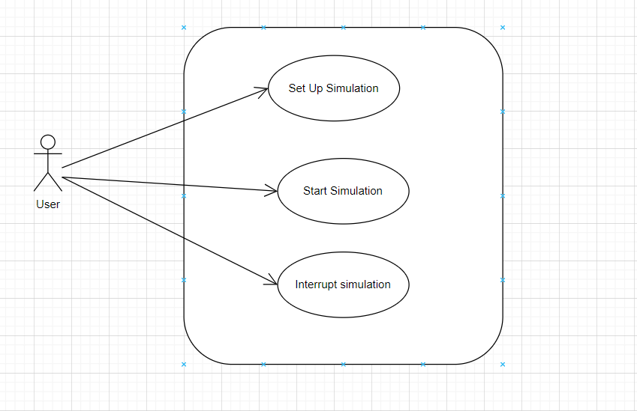
Figure 1: Use-case diagram for the application .

The application must be able to validate the data entered and otherwise signal an error to the user.
The Set Up and start the simulation use case:
- The users enter the simulation time, number of queues, number of clients, minimum arrival time, maximum arrival time, minimum service time, maximum service time
- The “execute” button is used
- If an error occurs an error message is displayed and changes to the input are waited
- Otherwise the application is started
If the application has to be interrupted the “x” button will be pressed.

Design
In order to satisfy the requirements of the application I decided to implement a three layered architecture with the business logic separated from the model and interface. The layers communicate with each other using signals for synchronization purposes. The overall package structure can be seen in
Figure 2.

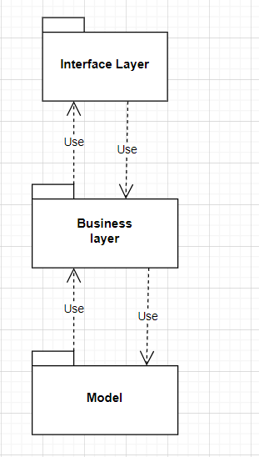
Figure 2: The UML package diagram.

An important decision to be made is how the model would look like, i.e., how the clients and the queue would be abstracted inside the app. The coice made is the queues will be implemented by the class Server and the clients by the class Task. Inside the servers we will have a list of task that represents the clients of that specific queue. Another important aspect that was taken in consideration was how the strategy used to place task inside servers will be implemented. The solution was to have an interface for which we provide different implementations and the user would choose the wanted implementation during the set up stage. Also we needed to have a Scheduler which would make use of the strategy and place the tasks inside the servers at the required time.
The overrall class diagram can be seen in Figure 3 and Figure 4.

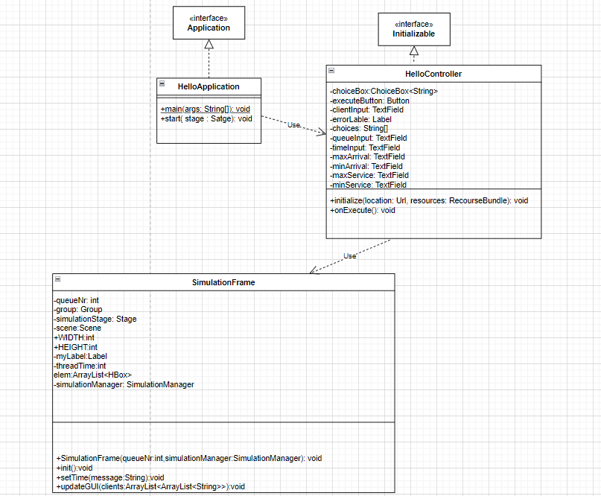
Figure 3. : Class diagram for the interface layer
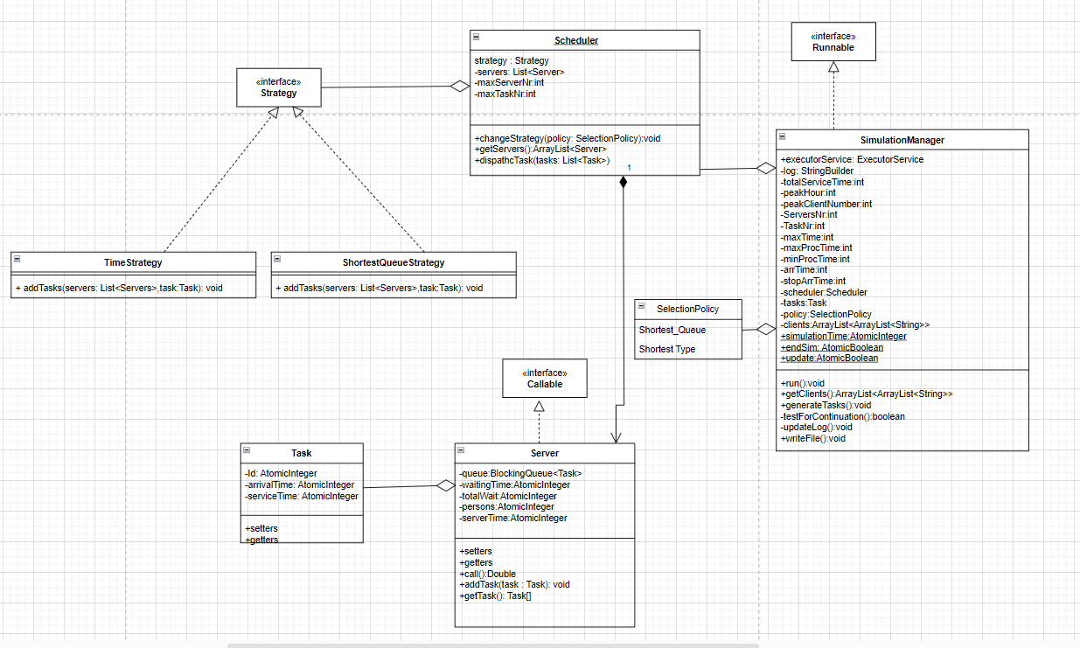
Figure 4: Class diagram for the logic and model

Implementation
To satisfy the requirements that each server should run on its individual thread, a decision has been made to make the class server implement the interface Callable, which in contrast with the interface Runnable allows the thread to return a value, which in our case was helpful since we needed to get information about the average waiting time in each queue. 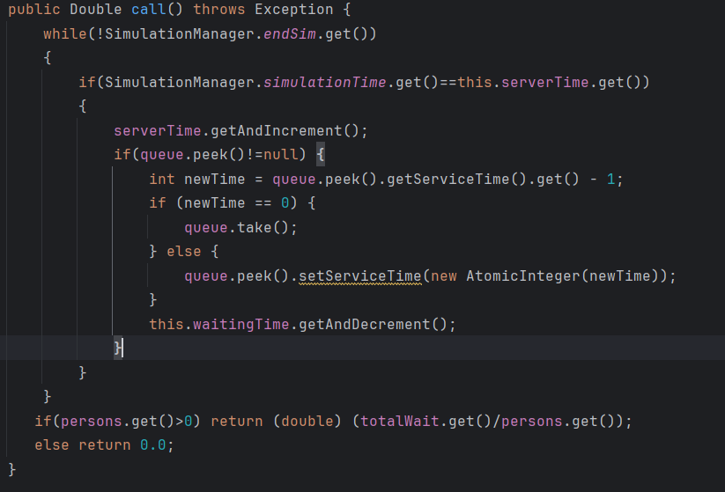
Figure 5. :The call method inside the class Server
The Task class has 3 parameters which specify the clients : id, the id of the client, arrival time, the time at which the client “arrives” in the queues, and the service time, the time it takes for the client to be proccessed if it is at the front of the queue.
The 2 strategies that were used are: Shortest time and Shortest queue. They were implemented in two classes that implement the interface strategy and overide the add tasks method. 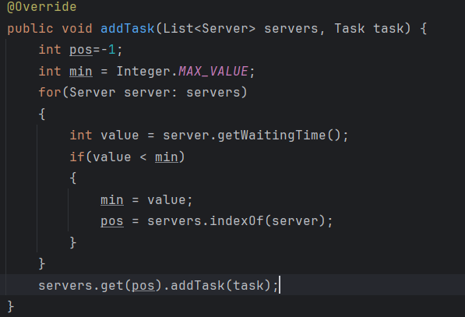
Figure 6:The time strategy implementation
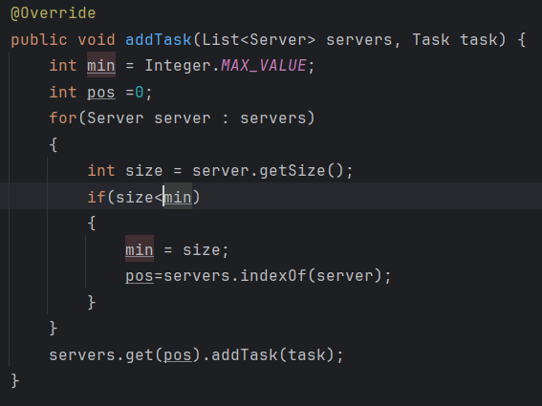
Figure 7: The shortest queue implementation

The SimulationManager is the class that coordinates the servers and synchronizes them, itself runs on a different thread then the servers . After the parameters of the simulation were chosen and the simulation was started the manager first of all has to generate all the tasks. For this it makes use of the method generateTasks() which generates the 3 specific fields for the number of tasks indicated in the set up stage. For the task to be sorted by arrival time the compareTo() ethod of the class Task was overriden.

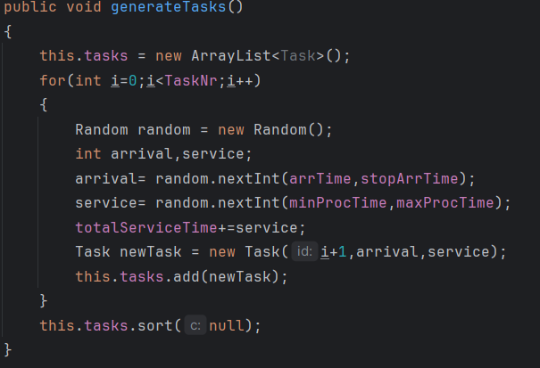
Figure 8: The gerateTasks() method

The thread management was done using the Executor Framework. At the start the executor generates a fixed number of threads and the manager creates the servers and submits them to the executor. The value returned by each server thread will be stored in a list of type Future<Double>. For this reason we have to be very careful when we ask the executor to provide the value. If the simulation is not done the execoutor will block the SimulationManager thread and wait for the value to become available, which in our case will block the thread forever because the SimulationManager thread signals to the other threads when the simulation is done. The communication between the threads is done via flags, which need to be atomic in order to ensure thread safety. One of them is the endSim flag which signals that the simulation is done and the threads have to stop( this flag is modified in the run() method of the manager thread so that’s why asking for a value before the simulation has ended will block the app forever). To synchronize the GUI the update variable is used, which has the role of a thread semaphor.
Each thread has to have a notion of time, and for that a static variable simulationTime is used, which is access by each thread( server or GUI) in order to synchronize their local time. The manager thread test at each time if all the other threads have reached the same time and only if this condition is fullfiled it increments its time.
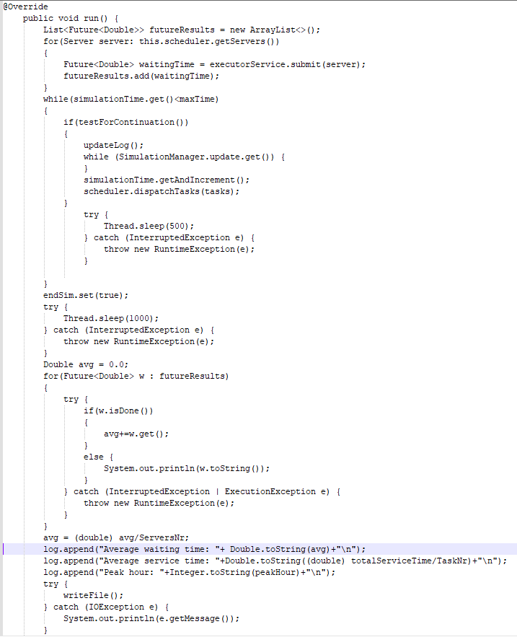
Figure 9: The run() method of the manager
To add new task in the servers a delegator class was used: the Scheduler. At each time its method dispatchTasks() is used to add, if needed new tasks to the servers and also removes them from the witing list.
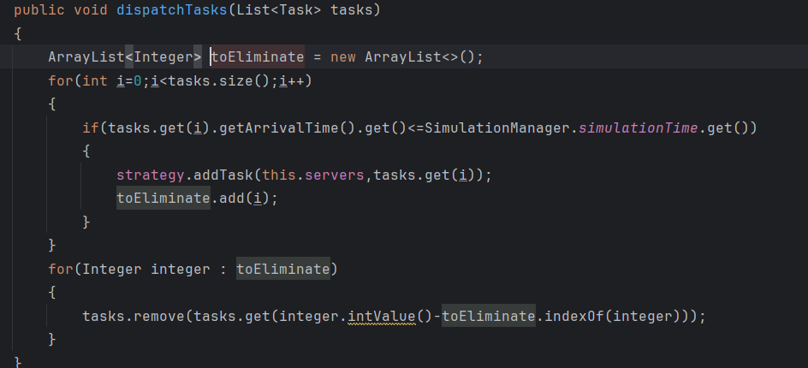
Figure 10: The dispatchTask() method

The log of events has to be listed in a .txt file so at each simulation time an update of the log is performed. The text that has to be printed in the log file is built inside a StringBuilder and then, with the help of the writeFile() method the contents of the string builder are printed inside the file.

The interface was done using JavaFX: the set up scene is present up until the execute button is pressed after which a new scene is created that will display the real time evolution of the queues. The displaying was done using pictures to make the application more user friendly.
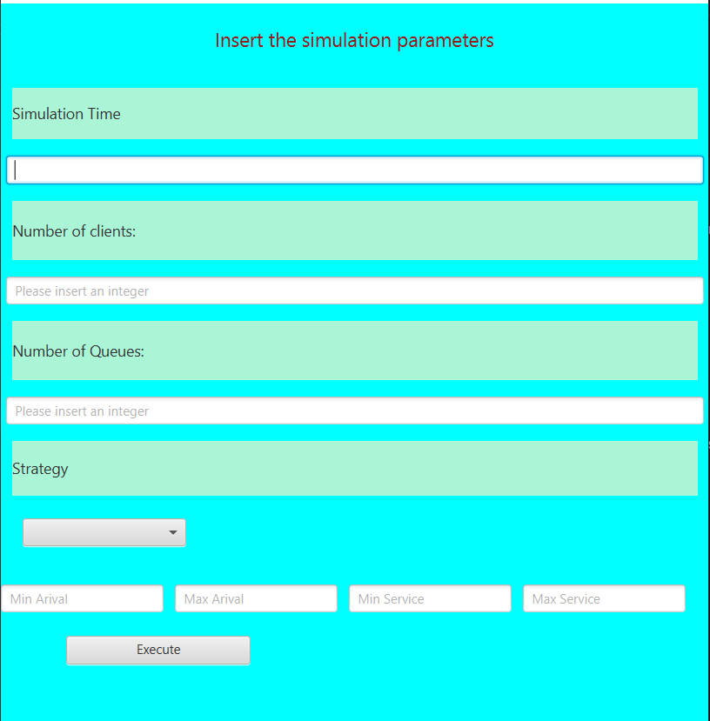
Figure 11: The Set Up scene

In JavaFX only the FX thread can make updates to the interface, and if the application is running on a long or infinite loop the interface freezes. So a mechanism to take into account the sinchronization with the manager was needed. The solution was to implement the synchronization in a new daemon thread and the updates to the interface to be done vis the Platform.runLater() method, which will make that the code specified as argument( usually in a lambda expresion) to be executed by the Fx thread.
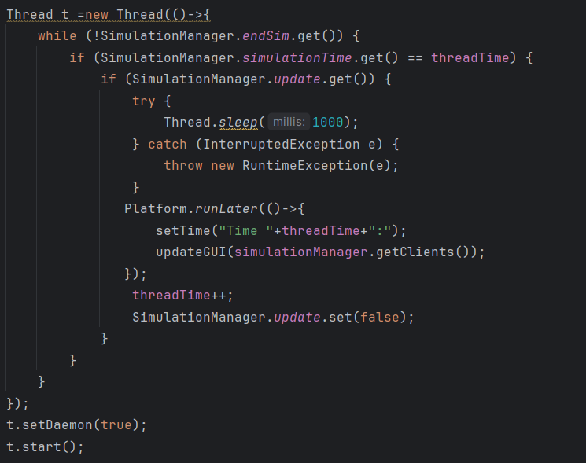
Figure 12: the mechanism to update the interface

Results
The purpose of the application was to show not only the log of events but also the average waiting time, average service time and peak hour. In order to have an application that works these parameters have to be correct. Some ways in which we can tell if they are wrong are if: the average service time is not within the service time limits selected by the user or if the peak hour isn’t a value that is between 1 and maximum simulation time.
In order to test the application a set of tests were run and the results stored inside separate log files. The simulation parameters were taken from the original requirement and after the application was run the following results were obtained:
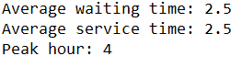
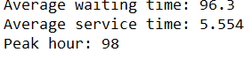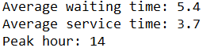
Figure 13: The results of the tests

Conclusions
In conclusion the project was a success, helping me to improve my logic and reasoning, forcing me to take design decisions, structure my reasoning, and improve my overall OOP and application development skills. Also this project helped further improve my knowledge of threads, how they work, how they are synchronized, tips and tricks that you have to know in order to make a successful application. The problems that I encounter along the way of the development process are now things that will be taken into account in the future.
Future enhancements would be to improve the interface, make animations for the queues and the clients.

Bibliography
- https://dsrl.eu/courses/pt/materials/PT_2024_A1_S2.pdf
- https://stackoverflow.com/questions/48888103/java-fx-screen-updates-freezing-during-animation

Resources
- IntelliJ IDEA 2023.2.2
- Draw.io

C.f. https://stackoverflow.com/questions/22772379/updating-ui-from-different-threads-in-javafx
https://dsrl.eu/courses/pt/materials/PT_2024_A1_S2.pdf

