CDI-DVB Project

CDI MS10/MS11

Audio Architecture Proposal

Kapil Singal

Version - 0.3

STMicroelectronics Confidential

CDI DVB Core team, Greater Noida


Table of Contents

Document History 3
Defintions 3
Pre-Requisites 3
1.0 Introduction on MS10 4
2.0 Brief note on existing CDI support for MS10 items 4
3.0 Understanding AD further 5
4.0 STAPI audio chain for MS10 7
5.0 Enhancements required in CDI Specs to support MS10 9
6.0 Introduction on MS11 10
6.1 Main Differences of MS11 with respect to MS10 10
7.0 Proposed CDI Audio Chain (under discussion with NDS) 11
8.0 Audio Encoder 11
9.0 Dolby Volume 12
9.1 ECR 121 raised on staudlx 12
10.0 User Level Mixing Control for Main and AD 14
11.0 Enhancements required in CDI Specs to support MS11 16

Document History

Date | Version | Author | Reviewers | Description
23/02/2012 | V0.1 | Kapil Singal |  | It describes CDI enhancements that will be required for MS10 and MS11
15/03/2012 | V0.2 | Kapil Singal |  | Section 10.0 and 11.0 added
05/04/2012 | V0.3 | Kapil Singal | Patricia Fieldhouse, Praveen Singh | Fig 2 added to explain Pan factors.  Clarification added in fig3.  some minor corrections
Table 1: Document History

Defintions

AD : Audio Description refers to an additional narration track for blind and visually
impaired consumers of visual media.

DD : Dolby Digital

MS10 : Multi Stream 10 reference decoder from Dolby

Pre-Requisites

Reader should have knowledge about:

CDI Audio specifications.
STAudlx chain configuration

1.0 Introduction on MS10

Following Figure shows the basic block diagram for MS10 Multistream reference decoder and AD Mixing support.

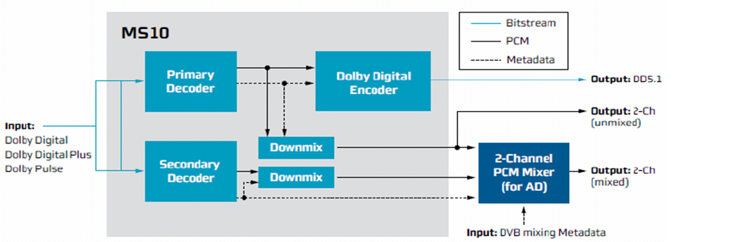
Figure 1 : MS10 Multistream Decode and AD Mixing support

- The Dolby MS10 Multistream Decoder supports simultaneous decoding of main and associated audio e.g.Audio description for Dolby Pulse and Dolby Digital/Dolby Digital Plus, respectively, to support basic two-channel mixing (Dual-Decode mode).

- Fully Supports DD, DD Plus, Dolby Pulse, and any AAC based stream including HE-AAC v2.

- Includes legacy support for SPDIF connections via DD encoder for transcoding streams to DD.

- In case of DD Plus, audio description (AD) can come as a substream with the main audio PES stream itself.

2.0 Brief note on existing CDI support for MS10 items

CDI specs (till Issue17) has no support for Audio Description. Rest all requirements of MS10 can be achieved. Earlier transcoding support to DD for SPDIF was missing which was added in CDI Issue15.
Discussion has been initiated with NDS and Dolby to finalize the CDI specs for ‘AD’ requirements to be fully compliant with MS10.

3.0 Understanding AD further

There are 2 control parameters in AD, "Fade" and "Pan" factor, to control the level of main program sound during a description passage which comes as meta data either in PES header or as part of stream itself.

Fade control

There is a need to provide a way to control the level of main program sound during a description passage and restoring it when the description is over, Fade instruction is provided in AD channel to signal to mixer to fade the main program sound to a suitable level when accompanying AD is active.

Pan control

It enables the programmer to place the 'describer' at any preferred horizontal position within the soundfield e.g. a speech from describer can be placed at one side of the stereo channel)

Transmitted pan value is a byte value, 0x00 representing center front, each increment representing about 1.4 degree clockwise looking down on the listener (see figure below).

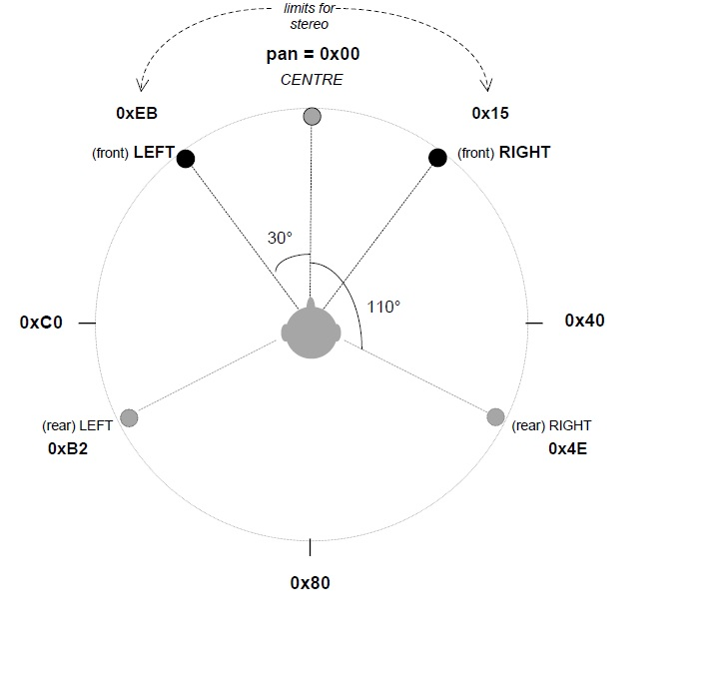
Figure 2: Representation of AD Pan values
Meta data for AD will only be processed by audio driver when it is signaled that the data coming on secondary audio decoder is for AD. We need to pass “STAUD_STREAM_TYPE_PES_AD” as stream type to staudlx.

This demands a new spec enhancement in CDI to detect the secondary audio decoder as ‘AD’ so that driver start parsing ‘fade’ and ‘pan’ factors and provide this meta data info to audio fw for mixing.

4.0 STAPI audio chain for MS10

Note: AD can come as a independent PES on a different PID or it can come as a sub-stream with the main audio only in the same main audio PID. AD as sub stream is generally the case with DD Plus.

MS10 Décode+Transcode, Dual Stream Dual Décode (AD as a separate stream)

CD0
CD1
DEC0
DEC1
Mixer0
(Output 2 Ch)

H/W SPDIF0
PCMP0

(DD / DD+) S/W SPDIF Formatter

PP0
PP1
PP2
ENC0
PCMP1

Main
AD

MS10 Decode+Transcode – Dolby Plus Single stream dual Decode (AD as substream)

CD0
CD1
DEC0
DEC1
Mixer0
(Output 2 Ch)

H/W SPDIF0
PCMP0

(DD / DD+) S/W SPDIF Formatter

PP0
PP1
PP2
ENC0
PCMP1

Main
+ AD on same PID
AD as substream is extracted by CD0 and sent to DEC1
lines represent the connection created at run
time depending on the use-case.

Figure 3: STAUDLx chain for AD handling

Specific chain configuration represented above is for Dolby Plus single stream dual decode. As Dolby Plus has the capability to contain different Independent audio within single streams. Dolby Plus stream can have main audio independent stream ‘I0’ and Associated audio independent stream ‘I1’ within single Dolby Plus PID.

For this one Parser i.e. Parser0 is connected to both Main Decoder and Associated Decoder, disconnecting Parser1 from Associated decoder.

CDI Model for dual audio decoder chain would look like as follows:

Audio
Mixer

Audio Decoder (Main)

SPDIF/HDMI (2Ch)
Elementary Filter

Audio Decoder
( AD )

Elementary Filter

Figure 4: CDI Model for dual audio decoder

There is no granularity at CDI audio decoder level to differentiate between parser and decoder module so unlike STAPI, secondary audio decoder1 can’t be connected to the parser of audio decoder0.
This demands a new spec enhancement for CDI as there is no way to handle substreamID case.

However, at STAPI level we have this API which will attach DEC1 to CD0 for substreamID case.

To tell the Secondary Decoder (Associated Decoder) which stream Independent stream number need to be parsed and Decoded below driver API should be called.

ST_ErrorCode_t STAUD_IPSetADSubStreamID (STAUD_Handle_t Handle,
STAUD_Object_t InputObject,
U32 SubStreamID)

For example if the Associated audio content is Independent stream Index 1 i.e. I1
which to be decoded by Decoder 1

InputObject = STAUD_OBJECT_INPUT_CD0
StreamID = 1

5.0 Enhancements required in CDI Specs to support MS10

- An amendment is required to be able to configure audio decoder as main or secondary decoder.

- DD+ AD substream usecase handling. Options:
  - 2x es filter onto 1x tpid filter. This is rejected as we can’t connect two PES buffers onto a singleslot.

  - 2xA-Dec onto 1xes filter. Could be a possibility.

  - Any other like connecting secondary audio decoder to primary one. NDS shall not favour this.

6.0 Introduction on MS11

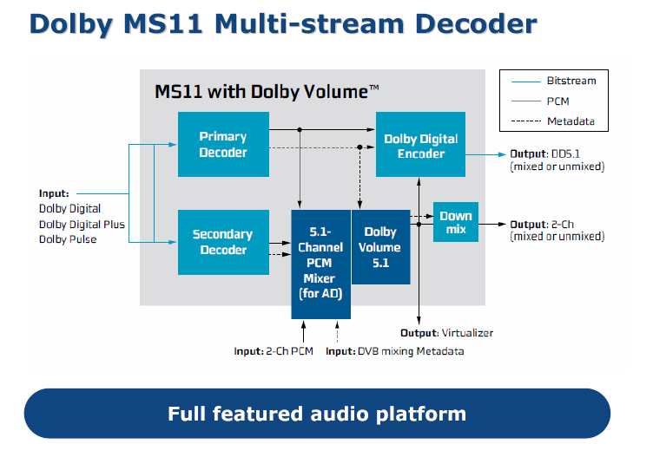

Figure 5: MS11 reference decoder model

6.1 Main Differences of MS11 with respect to MS10

- MS11 enables full multi channel mixing for AD unlike 2 ch in MS10.
- Stereo and 5.1 Volume leveling with DolbyVolume
- Multi channel PCM with or without AD would be possible with MS11 where as with MS10, only 2 ch PCM out is recommended.
- Compressed DD output with or without AD would be possible due to encoder after mixer in MS11.

7.0 Proposed CDI Audio Chain (under discussion with NDS)

Old MS10 Path
New MS11 Option
Elementary Filter
Elementary Filter
Audio Decoder (5.1output selectable)

Audio Decoder (5.1output selectable, AD capable)

PCM Player (Tone generation/PCM data)

Audio
Mixer

Audio Encoder (can either be connected to mixer or decoder)

SetSubStreamID()
SPDIF/HDMI
SPDIF/HDMI/Analogue (2Ch PCM)
SPDIF/HDMI (5.1Ch PCM)
Dolby Volume will be applied

Red Items denote impact due to MS11

Figure 6: CDI MS11 proposed model under discussion with NDS

8.0 Audio Encoder

Currently transcoding is part of audio decoder API specification in CDI but it shall be removed to isolate decoding and encoding. Encoding shall be the responsibility of new CDI device ‘Audio encoder’ only.

9.0 Dolby Volume

There are 3 flavors of volume control interface supported in ST audio driver as per the following volume Managers:
- SRS True Volume
- Dolby Volume
- STIVC (ST’s Proprietary algo)

Purpose of these Volume algorithms is to provide an intelligent volume control that analyzes the perceived volume of audio and adjusts it to maintain an enhanced and uniform listening experience for the end user. The television programs are nowadays much diversified in types and are often mastered at different conditions. For example, the commercials tend to be much louder than news broadcast or conversation in a drama. Intelligent Volume Control eliminates this annoying experience by constantly measuring, analyzing the audio signal and maintaining its perceived loudness at a consistent level.

9.1 ECR 121 raised on staudlx

Volume control is supported in audio driver but currently it is controlled with different API interfaces for different volume managers. Also, each interface expose large set of driver parameters, with client having needed to know too many details which are specific to FW processing parameters. Existing interface is inexplicit for clients who don’t know about the intricacies of these algorithms.
In STB, EPG would be providing simple control for volume control to end user which would result into few parameters to be set from EPG -> MW -> audio driver applicable to any volume manager. Rest all parameters are expected to be filled by driver with default values recommended by FW.
A simple unified API is required that provide Intelligent Volume processing disregarding the underlying implementation details.

Change Description

Dolby Volume specs for STB was taken as a reference but controls specified by Dolby are quite generic and it can be applied to ST-IVC and SRS TruVolume also. It demands:

- Volume on/off switch : To enable/disable intelligent volume control

2) Leveler Amount (dla), Requirement is to provide a couple of presets e.g.
the recommended minimum settings for the Volume Leveler amount control (Weak and strong) E.g. in case of Dolby Volume scale is defined from 0 – 10 which driver can map as follows
Weak leveling: 4
Strong leveling: 9

Driver can think of defining an enum for these presets (e.g. Weak, Medium and strong). The recommended default volume lever shall be High.

3) Digital Volume (dvm): This is to control the reference level for the PCM outputs e.g. -20dBFS for DolbyVolume will mean that the “average program level” will target -20dBFS.

As per my analysis, I see the Volume Control (be it ST-IVC/Tru Vol or Dolby Volume) translation from user control to FW as follows on STB:

STBUser Control Volume Leveler (on/off, dla (low, med, high) )
------------------------------------------
MW Call on CDI Volume Leveler (on/off, dla (low, med, high), dvm (*ref level))
-------------------------------------------
CDI Call PostProcessor-> Volume Leveler (on/off, dla (low, med, high), dvm
(ref level))

Staudlx Query the volume manager(ST-IVC/Tru Vol or DV)
PP-> Volume Leveler (on/off, translate dla on scale (4 - 9), dvm (ref level), other default params)
-------------------------------------------
FW PP -> Process volume control parameters

* Ref level is assumed to be fixed for a project whose control shall not be exposed to user.

This has been proposed to NDS who is yet to confirm the CDI amendment for the same.

10.0 User Level Mixing Control for Main and AD

The association between user-balance and mix weight for Main and AD isn’t clear which is still under discussion with them. One of the requirement for MS11 certification as we understood is as follows:

Provide a user balance control between main and associated audio (-32 dB is full-mute associated audio, 0 is no scaling main / associated, +32 dB is full-mute primary and this can be set in +/- 1 dB steps from 0 to 31 and this will affect either main / associated and not both).

To better understand the mixing issue I want to highlight here with AD, let us consider two mixer view for Main+AD+PCM mixing:

α0
AD Mixer
α1
β0
Main
Mixer
β1
PCM
Main
AD

Where ‘β0+ β1 = 1’ shall be user specified mix weights.

α0 and α1 shown here are mix weight coefficients encoded as meta-data in the stream by the broadcaster itself. So end result after applying mix weights (β0, β1) specified by user on main mixer would be:

β0 * (α0 * Main + α1 * AD) + β1*PCM

I agree that the default mix weight settings have to be 0.5 for the sum of the mixed audio description (that is, on 2 audio mixer inputs) and 0.5 to the 3rd input on audio mixer attached to PCM. User should be able to vary these mix coefficients between 2 primary inputs.

However user should be able to set the balance between main and associated audio on the scale of 1 (applicable only if AD would be available in the stream).
µ
1-µ
Main
AD

+32 db
-32 db

So the above equation would become:

β0 * (α0 * µ*Main + α1 * (1- µ)*AD) + β1*PCM

It can further be expanded as:

β0 * α0 * µ*Main + β0 * α1 * (1- µ) * AD + β1*PCM

So, if we translate this model into single mixer using existing CDI model. I view it as follows:

β0
Main
Mixer
β1
PCM (Primary1)
AD (Seconadry0)
Main (Primary0)
µ
(1- µ)

Where the weights shown are user specified ones.

In Mix configure API, weights shall be passed as follows by MW:

Port index0(Main) : β0 * µ

Port index2(AD) : β0 * (1-µ)

Port index3(PCM) : β1

These weights shall further be provided to staudlx driver who will multiply it with extracted mix coefficients from meta data and then finally mix it with following co-efficients:

β0 * α0 * µ*Main + β0 * α1 * (1- µ) * AD + β1*PCM

α0 and α1 are fade factors extracted from meta-data for AD.

For extreme conditions:

If µ=0 (i.e. only AD) equation would be:
β0 * α1 * AD + β1*PCM
If µ=1 (i.e. only Main) equation would be:
β0 * α0 *Main + β1*PCM

For such extreme conditions where either Main or AD is to be muted, it is not clear if stream meta coeff (α1, α0) should be multipled for the remaining input.

e.g. β0 * α0 *Main + β1*PCM

Now setting the user control to main audio only would still result in quiet main audio, as after multiplying with α0, main would be attenuated and expectation of Dolby could be to mix main audio as it is (if AD is muted).
i.e. If no AD, , stream meta data coeff α0 for fading Main is not taken into account.

β0 * Main + β1*PCM

i.e. If no Main, stream meta data coeff α1 for fading AD is not taken into account.
β0 * AD + β1*PCM

From the STAPI driver standpoint, the AudioMixer exposes the API STAUD_MXSetMixLevel(), to provide the User the desired user mix level for each individual input of the Mixer. These gains are applied on top of the Primary Gain available from the stream (either MPEG PES/Secondary DDPlus Decoder/Dolby Defaults). Hence the job of the Primary Gains is to modulate the Broadcaster provided Gains for AD mixing in case Audio Description is enabled.

i.e. Final Gain = ADGain_from_stream * User_Desired_Mixlevel

Given this knowledge, another API could be required to provide the User control.

THIS WAS UNDER DISCUSSION WITH NDS AND DOLBY AT THE TIME OF WRITING THIS DOCUMENT.

11.0 Enhancements required in CDI Specs to support MS11

1) Audio Encoder
2) Dolby Volume Support
3) Enhancement, if any, in Mixing API for main and AD user control

