MS10 Application Note

Draft

Satya Sheel Pandey
mailto:ss.pandey@st.com

HVD/HEG – Validation

*TABLE OF CONTENT *

1.0 Introduction :: 3
2.0 AUDIO CHAIN – MS10 Decode+Transcode, Dual stream Dual Decode 6
2.1 AUDIO CHAIN – MS10 Decode+Transcode – Dolby Plus Single stream dual Decode 7
2.2 AUDIO CHAIN – MS10 Decode+Transcode – Dolby Pulse/Plus Single 8
3.0 Creating Driver Chain 9
3.1 Driver API’s to be called for MS10 : 10
(1) Module Start and Stop :: 10
(2) Dolby Pulse SBR On/Off :: 10
(3) Configuring the Mixer Output :: 11
(4) Applying the Meta Data :: 11
(5) Disconnecting and Connecting Source and Destination Module :: 12
(6) Dual Decode Dolby Plus through single Stream :: 13
(7) Flags and other Driver settings to be set before Compilation:: 13

1.0 Introduction ::

A New Multiformat Audio Decoding Solution that offers support for both Dolby Digital Plus (including Dolby Digital) and Dolby Pulse decoding in a single package.

The integrated decoder/transcoder and converter combines the ability to decode Dolby Digital, Dolby Digital Plus, and Dolby Pulse within one product. All of these input signals coming into the decoders for the main audio are passed through unaltered for output over HDMI™ and S/PDIF interfaces (Dolby Digital Plus is converted to Dolby Digital;
Transmission of Dolby Pulse streams via HDMI or S/PDIF connections will be enabled in the future as the specifications necessary to transmit the technology across these interfaces are completed.

The signals coming into the decoders for associated audio are not passed through the system but are decoded and sent to the mixing engine instead to support the receiver-mix audio description

At the same time, a two-channel downmix is always created from any of the input formats in order to support decoded output (for example, for analog outputs) of a broadcast device. For maximum compatibility and for connectivity over S/PDIF and HDMI interfaces, a multichannel decoder for Dolby Pulse is integrated to feed an
embedded Dolby Digital encoder with a multichannel signal (up to 5.1 channels),which then outputs a standard Dolby Digital bitstream (up to 5.1 channels) at a fixed bit rate of 640 kbps.

The Dolby MS10 Multistream Decoder supports simultaneous decoding of main and associated audio for Dolby Pulse and Dolby Digital/Dolby Digital Plus, respectively, to support basic two-channel mixing (Dual-Decode mode) in order to meet European broadcast specifications for next-generation audio. Audio will be
mixed in an external mixing module outside of the decoder. However, the system will provide the mixing metadata potentially carried within Dolby Digital Plus as a serial bitstream on one of its outputs. This mixing metadata shall be used to control the mix in the external/system-level mixing module. The implementation of dual
decoding (Dual-Decode mode) is optional but strongly recommended.

Below figure shows the receiver-mix architecture designed to support mixing for audio codecs supported by the Dolby MS10 Multistream Decoder.

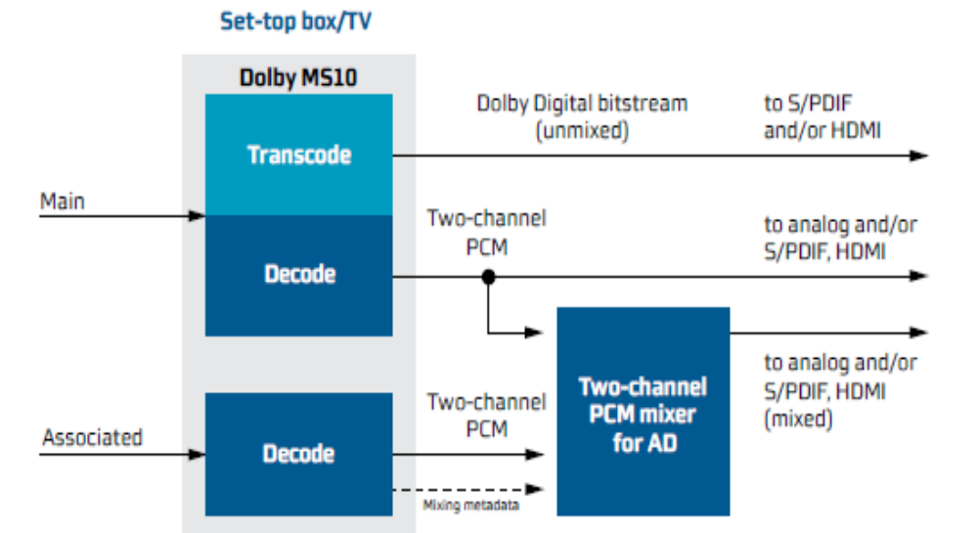

Figure 1:MS10 Multistream Decode and AD Mixing support.

Next shown will be the Audio Driver chain need to be made in order to execute all the functionality of MS10 as shown above.

Also guidelines to configure the audio driver and the API’s that to be called for realizing -

- Dual Decode – Main and Associated, decode and mixing as per the meta data along with Main Transcoding

- Single Decode - Main decode and Main Transcoding.

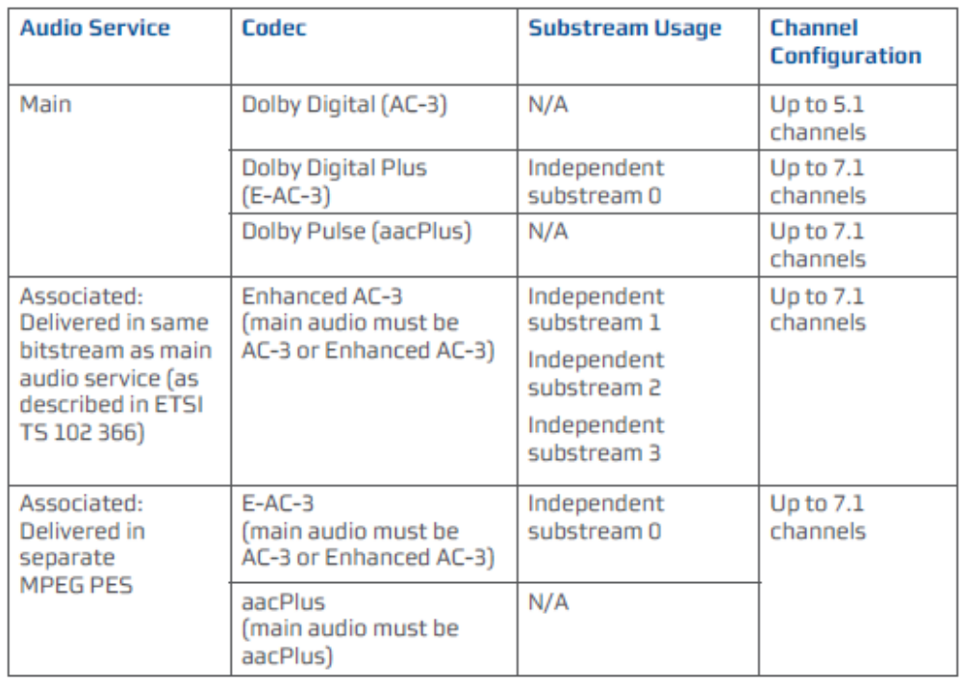

Figure 2: Input format for Main and Associated audio supported by Dolby MS10

2.0 AUDIO CHAIN – MS10 Decode+Transcode, Dual stream Dual Decode

MS10 Pulse/Plus
Decode+Transcode
SBR ON
Meta Data Handling
(Assoc Audio)

POST_PROCESSOR 0
Volume Control

PARSER1
PCM Player 0
(HDMI interface)

MS10 Pulse/Plus
Decode+Transcode
SBR ON
Meta Data Handling
(Main Audio)

POST_PROCESSOR 1

MIXER

PARSER0
PCM Player 1
(Stereo DAC)

Volume Control
Meta Data Apply

SPDIF Player
(Compressed Mode)

Figure 3:Chain No 1 : For Dual Input PULSE, PLUS streams.

2.1 AUDIO CHAIN – MS10 Decode+Transcode – Dolby Plus Single stream dual Decode

MS10
Decode

Meta Data Handling
(AD)

POST_PROCESSOR 0
Volume Control

PARSER1
HDMI
interface

MS10 Plus
Decode
+Transcode (if required)
Meta Data Handling
(Main Audio)

POST_PROCESSOR 1

MIXER

PARSER0
PCM
(Stereo DAC)

Volume Control
Meta Data Apply

POST_PROCESSOR 2
SPDIF Player
(Compressed Mode)
Volume Control

Figure 4: Chain No 2 : For Single Input PLUS streams, Dual Decode

2.2 AUDIO CHAIN – MS10 Decode+Transcode – Dolby Pulse/Plus Single

MS10 Plus
Decode+Transcode

Meta Data Handling
(Assoc Audio)

POST_PROCESSOR 0
Volume Control

PARSER1
PCM Player 0
(HDMI interface)

MS10 Plus
Decode+Transcode

Meta Data Handling
(Main Audio)

POST_PROCESSOR 1

MIXER

PARSER0
PCM Player 1
(Stereo DAC)

Volume Control
Meta Data Apply

SPDIF Player
(Compressed Mode)

Figure 5Chain No 3 : For Single Input PULSE/PLUS streams, Single Decode

3.0 Creating Driver Chain

Figure 1, 2 and 3 shows the different configuration possible to perform all the functionality in MS10.
{
{STAUD_OBJECT_INPUT_CD0, STAUD_OBJECT_DECODER_COMPRESSED0, STAUD_OBJECT_OUTPUT_SPDIF0, OBJECTSET_DONE},
{ STAUD_OBJECT_INPUT_CD1 , STAUD_OBJECT_DECODER_COMPRESSED1, OBJECTSET_DONE},
{ STAUD_OBJECT_DECODER_COMPRESSED0, STAUD_OBJECT_MIXER0, STAUD_OBJECT_OUTPUT_SPDIF0, OBJECTSET_DONE},
{ STAUD_OBJECT_DECODER_COMPRESSED1, STAUD_OBJECT_MIXER0, OBJECTSET_DONE},
{ STAUD_OBJECT_MIXER0, STAUD_OBJECT_OUTPUT_PCMP0, STAUD_OBJECT_OUTPUT_PCMP1, STAUD_OBJECT_OUTPUT_SPDIF0, OBJECTSET_DONE},
{ STAUD_OBJECT_OUTPUT_PCMP0 , OBJECTSET_DONE},
{ STAUD_OBJECT_OUTPUT_SPDIF0 ,OBJECTSET_DONE},
{ STAUD_OBJECT_OUTPUT_PCMP1 , OBJECTSET_DONE},
{ DRIVER_DONE},
},

Chain No 1, is the chain configuration in use when there are two different audio PID’s (Dolby Pulse, Plus) i.e. Main Audio (Multichannel) and Associated Audio (Mono/Stereo).
As shown in figure, different parser is needed to feed these streams, to two instance of Decoder.

Chain No 2, is the specific chain configuration in use to Dolby Plus single stream dual decode. As Dolby Plus has the capability to contain different Independent audio within single streams. These Independent Audio streams are designated as I0, I1, I2 …. i.e. Independent Stream index 0, Index 1 ……..

Hence Dual decode in Dolby Plus stream can be possible as Main Audio Independent stream I0 and Associated audio Independent stream I1 within single Dolby Plus PID.

For this one Parser i.e. Parser0 is connected to both Main Decoder and Associated Decoder, disconnecting Parser1 from Associated decoder.

Above disconnect can be done through Driver API call “STAUD_DisconnectInput “ and “STAUD_ConnectSrcDst “ (will be discus in Driver API section).

Chain No 3, is the chain configuration in use when there is only single stream i.e Single decodes to be performed for Dolby Plus, Dolby Pulse.

With use of driver API “STAUD_MODULE_Start” and “STAUD_MODULE_Stop” specific Module can be started /Stopped without disturbing/ recreating new Driver chain.
This Module start should be used for all above configuration.

In figure Faded Parser1, Associated Decoder1 showing the module not being started to realize Single Decode and module that are effectively working.

3.1 Driver API’s to be called for MS10 :

Module Start and Stop ::

With the use of this API, in driver chain, specific block module can be started and stopped.

ST_ErrorCode_t STAUD_ModuleStart (STAUD_Handle_t Handle,
STAUD_Object_t ModuleObject,
STAUD_StreamParams_t * StreamParams_p)

ST_ErrorCode_t STAUD_ModuleStop (STAUD_Handle_t Handle,
STAUD_Object_t ModuleObject)

For Module start, Driver Object and Streams parameter that to be called are
- STAUD_OBJECT_INPUT_CD0, STAUD_STREAM_TYPE_PES
- STAUD_OBJECT_INPUT_CD1, STAUD_STREAM_TYPE_PES_AD
- STAUD_OBJECT_DECODER_COMPRESSED0, STAUD_STREAM_TYPE_ES
- STAUD_OBJECT_DECODER_COMPRESSED1, STAUD_STREAM_TYPE_PES_AD
- STAUD_OBJECT_POST_PROCESSOR0, STAUD_STREAM_TYPE_ES
- STAUD_OBJECT_POST_PROCESSOR1, STAUD_STREAM_TYPE_ES
- STAUD_OBJECT_OUTPUT_SPDIF0, STAUD_STREAM_TYPE_ES

For other driver Objects
- STAUD_OBJECT_MIXER0
- STAUD_OBJECT_OUTPUT_PCMP0
- STAUD_OBJECT_OUTPUT_PCMP1

Following API should be call to start and stop ::

ST_ErrorCode_t STAUD_GenericStart (STAUD_Handle_t Handle)

ST_ErrorCode_t STAUD_GenericStop(STAUD_Handle_t Handle)

Dolby Pulse SBR On/Off ::

ST_ErrorCode_t STAUD_DRSetInitParams (STAUD_Handle_t Handle,
STAUD_Object_t InputObject, STAUD_DRInitParams_t * InitParams)

Set the SBRFlag = True, to Enable the SBR and Vice-Versa

Above should be set for Both Main and Associated Decoder

Configuring the Mixer Output ::

ST_ErrorCode_t STAUD_MXUpdatePTSStatus(STAUD_Handle_t Handle,
STAUD_Object_t MixerObject,
U32 InputID,
BOOL PTSStatus)

For both Inputs (InputID=0)Main and (InputID=1)Associated, the value of PTS status should set to True i.e.
PTSStatus = True

ST_ErrorCode_t STAUD_MXUpdateMaster(STAUD_Handle_t Handle,
STAUD_Object_t MixerObject,
U32 InputID,
BOOL FreeRun)

This API should be called for Case 2, I,e, Dual Decode Dolby Plus single stream.
In this case InputID = 0
FreeRun = False

Applying the Meta Data ::

ST_ErrorCode_t STAUD_DRApplyMetaData (STAUD_Handle_t Handle,
STAUD_Object_t InputObject, STAUD_ApplyMetadata_t *ApplyMetaData)

Following should be pass to ApplyMetaData fields for Dolby Plus
InputObject = STAUD_OBJECT_MIXER0
ApplyMetadata.PCMMetadata = (U8)0;
ApplyMetadata.MixerMetaData = (U8)1;
ApplyMetadata.EncMetadata = (U8)0;
ApplyMetadata.InputID = (U8)1;

Following should be pass to ApplyMetaData fields Dolby Pulse
InputObject = STAUD_OBJECT_DECODER_COMPRESSED0
ApplyMetadata.PCMMetadata = (U8)1;
ApplyMetadata.MixerMetaData = (U8)0;
ApplyMetadata.EncMetadata = (U8)0;
ApplyMetadata.InputID = (U8)0;

Disconnecting and Connecting Source and Destination Module ::

To Disconnect

ST_ErrorCode_t STAUD_DisconnectInput(STAUD_Handle_t Handle,
STAUD_Object_t Object,
U32 InputId)

In our case 2 for DDPlus Dual decode from Single stream following should be the values
Object = STAUD_OBJECT_DECODER_COMPRESSED1
InputId = 0

To Connect

ST_ErrorCode_t STAUD_ConnectSrcDst (STAUD_Handle_t Handle,
STAUD_Object_t SrcObject,
U32 SrcId,
STAUD_Object_t DestObject,
U32 DstId)

In our case 2 for DDPlus Dual from Single stream following should be the values
SrcObject = STAUD_OBJECT_INPUT_CD0
SrcID = 0
DestObject = STAUD_OBJECT_DECODER_COMPRESSED1
DstId = 0

Coming back to Case 1, Dual Decode dual stream
To Disconnect

Object = STAUD_OBJECT_DECODER_COMPRESSED1
InputId = 0

To Connect

SrcObject = STAUD_OBJECT_INPUT_CD1
SrcID = 0
DestObject = STAUD_OBJECT_DECODER_COMPRESSED1
DstId = 0

Dual Decode Dolby Plus through single Stream ::

As mentioned earlier Doby Plus can have number of independent streams within single stream as I0, I1, I2,……….

To tell the Secondary Decoder (Associated Decoder) which stream Independent stream number need to be parsed and Decoded below driver API should be called.

ST_ErrorCode_t STAUD_IPSetADSubStreamID (STAUD_Handle_t Handle,
STAUD_Object_t InputObject,
U32 SubStreamID)

For example if the Associated audio content is Independent stream Index 1 i.e. I1 which to be decoded by Decoder 1

InputObject = STAUD_OBJECT_INPUT_CD0
StreamID = 1

Flags and other Driver settings to be set before Compilation::

(1)
In the staudlx driver folder location

staudlx\src\mixer\aud_mmeaudiomixer.h

set the Flag

#define FIXED_OUTPUT_NO_SAMPLES 1

(2)
configure parser module to allocate 12 blocks.

(3)
No of Audio channel = 2

