
HED – Home Entertainment & Displays
Backend Drivers Group

MS11 and Canvas Application Document

Document Number : ADCS XXXXXXX A

Authors/Owner : Shashi Gupta

Version : 0.2

Last Modified on 7th Feb 2011

Abstract
This application note is aimed for providing the STAUDLX API usage for MS11 and Canvas to application.

List of the key words
STAUDLX, MS10, MS11

STMicroelectronics Confidential.

This document contains proprietary and confidential information of the STMicroelectronics Group. This document is not to be copied in whole or part.
Information furnished is believed to be accurate and reliable. However, STMicroelectronics assumes no responsibility for the consequences of use of such information nor for any infringement of patents or other rights of third parties which may result from its use. No license is granted by implication or otherwise under any patent or patent rights of STMicroelectronics. Specifications mentioned in this publication are subject to change without notice. This publication supersedes and replaces all information previously supplied. STMicroelectronics products are not authorized for use as critical components in life support devices or systems without express written approval of STMicroelectronics.

The ST logo is a registered trademark of STMicroelectronics.

© 2009 STMicroelectronics - All Rights Reserved

STMicroelectronics GROUP OF COMPANIES
Australia - Brazil - Canada - China - France - Germany - Italy - Japan - Korea - Malaysia - Malta - Mexico - Morocco -The Netherlands - Singapore - Spain - Sweden - Switzerland - Taiwan - Thailand - United Kingdom - U.S.A.

STMicroelectronics Limited is a member of the STMicroelectronics Group.

Contents
Contents 3
1 History 5
2 References 5
3 Introduction 6
3.1 Requirement 6
3.2 Scope 6
3.3 Definitions and abbreviations 6
4 Current STAUDLX API usages for MS10 7
4.1 Use Case-1 ( Single Input, Single Decode, No Mixing) 8
4.2 Use Case-2 ( Dual Input, Dual Decode, Mixing Enable) 10
4.3 Use Case-3 ( Single Input, Dual Decode, Mixing Enable) 13
5 Using new API (STAUD_OPSetModeConfig) 16
6 New Proposed STAUDLX Chain MS11/Canvas 18
7 Proposed STAUDLX API usages for MS11 19
7.1 Use Case-1 ( Single Input, Single Decode, No Mixing) 20
7.2 Use Case-2 ( Dual Input, Dual Decode, Mixing Enable) 22
7.3 Use Case-3 ( Single Input, Dual Decode, Mixing Enable) 24
8 Proposed STAUDLX API usages for CANVAS 27
8.1 Use Case-1 ( Single Input, Single Decode, Mixing With Non Program Sound) 27
8.2 Use Case-2 ( Dual Input, Dual Decode, Mixing With Non Program Sound, Audio Description Mixing) 30
Please refer to Section5 for API usage to change SPDIF OUTPUT MODE at run time 32
8.3 Use Case-3 ( Single Input, Dual Decode, Mixing With Non Program Sound, Audio Description Mixing) 33

Figure 1 : MS10 Multistream Decode and AD Mixing support 7
Figure 2: Recommended Audio driver chain for MS10 7
Figure 3 : Audio Chain Connections for Use Case 1 for MS10 8
Figure 4: Audio Chain Connections for Use Case 2 for MS10 10
Figure 5: Input format for Main and Associated audio supported by Dolby MS10 10
Figure 6 : Audio Chain Connections for Use Case-3 for MS10 13
Figure 7: Audio Driver Chain for MS11/Canvas 18
Figure 8 : Audio Chain Connections for Use Case-1 for MS11 20
Figure 9 : Audio Chain Connections for Use Case-2 for MS11 22
Figure 10 : Audio Chain Connections for Use Case-3 for MS11 24
Figure 11: Audio Chain Connections for Use Case-1 for Canvas 27
Figure 12: Audio Chain Connections for Use Case-2 for Canvas 30
Figure 13: Audio Chain Connections for Use Case-3 for Canvas 33

Table 1: Use cases for MS10 application 8
Table 2 : STAUDLX API call sequence for starting the MS10 in Use Case-1 10
Table 3 : STAUDLX API call sequence for stopping the MS10 in Use Case-1 10
Table 4 : STAUDLX API call sequence for starting the MS10 in Use Case-2 12
Table 5 : STAUDLX API call sequence for stopping the MS10 in Use Case-2 13
Table 6: STAUDLX API call sequence for starting the MS10 in Use Case-3 15
Table 7 : STAUDLX API call sequence for stopping the MS10 in Use Case-3 16
Table 8 : Difference between MS10 and MS11 20
Table 9 : STAUDLX API call sequence for starting the MS11 in Use Case-1 22
Table 10 : STAUDLX API call sequence for stopping the MS11 in Use Case-1 22
Table 11 : STAUDLX API call sequence for starting the MS11 in Use Case-2 24
Table 12 : STAUDLX API call sequence for stopping the MS11 in Use Case-2 25
Table 13: STAUDLX API call sequence for starting the MS11 in Use Case-3 27
Table 14 : STAUDLX API call sequence for stopping the MS11 in Use Case-3 27
Table 15 : STAUDLX API call sequence for starting the Canvas in Use Case-1 29
Table 16 : STAUDLX API call sequence for stopping the Canvas in Use Case-1 30
Table 15 : STAUDLX API call sequence for starting the Canvas in Use Case-2 33
Table 16 : STAUDLX API call sequence for stopping the Canvas in Use Case-2 33
Table 19 : STAUDLX API call sequence for starting the Canvas in Use Case-3 36
Table 20 : STAUDLX API call sequence for stopping the Canvas in Use Case-3 36

History
Version | Date | Authors | Note of main changes
0.1 | 10th Jan 2011 | Shashi Gupta | Initial document.
0.2 | 7th Feb2011 | Shashi Gupta | Updated for Canvas

References
Id | Document | Version | Author(s)
1 | Proposal_doc_for_MS11.pptx |  | Sevanand Singh
2 | MS11/CANVAS Implementation |  | Sevanand Singh

Introduction
This document will cover the following points:
- Current STAUDLX API usages for MS10
- How to use the new API (STAUD_OPSetModeConfig) for current MS10
- Proposed API usages for different cases of MS11 and Canvas

Requirement
To provide the API usage to application for MS11and Canvas.

Scope
Scope of this document is to provide the information to application for API usages for implementing MS11 and Canvas.

Definitions and abbreviations
PCM | Pulse Code Modulation
STB | Set Top Box
LX | ST231 Processor
DV258 | Dolby Volume 258

Current STAUDLX API usages for MS10
Following Figure shows the block diagram for MS10 for Multistream decode and AD Mixing support. 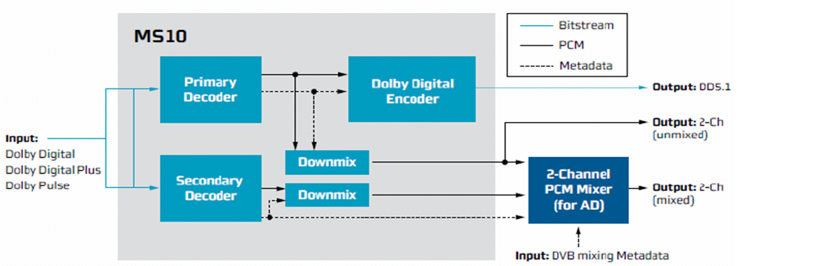
Figure 1 : MS10 Multistream Decode and AD Mixing support

Recommended Audio driver chain for MS10 is as follow:
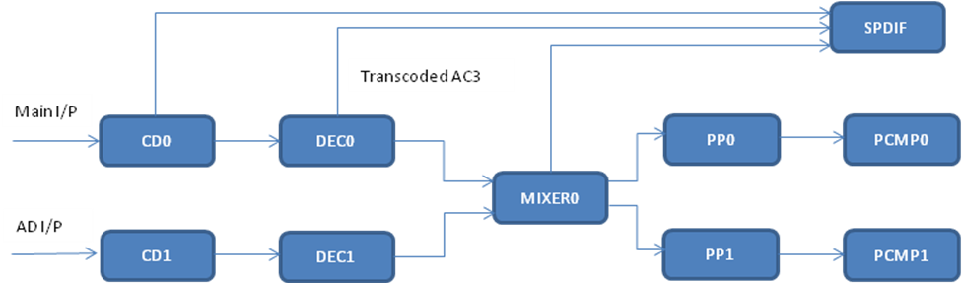
Figure 2: Recommended Audio driver chain for MS10

We will have following possible use cases in MS10 application:
Use Case | Input PID  (Single/Dual) | Input Stream type | Decoding  (Single/Dual) | Mixing  (Disable/Enable)
1 | Single | Dolby Digital  Dolby Digital Plus  Dolby Pulse | Single | Disable
2 | Dual | Dolby Digital  Dolby Digital Plus  Dolby Pulse | Dual | Enable
3 | Single | Dolby Digital Plus | Dual | Enable
Table 1: Use cases for MS10 application

Now we will discuss every use case and sequence of STAUDLX API call proposed for each use case.

Use Case-1 ( Single Input, Single Decode, No Mixing)
Following path is used in this use case

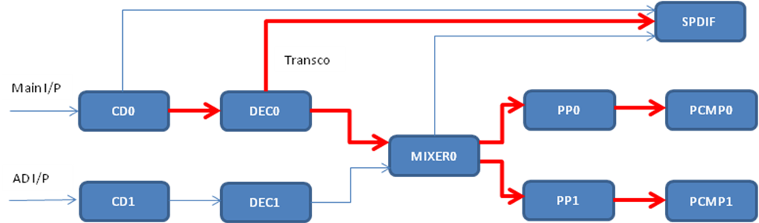

Figure 3 : Audio Chain Connections for Use Case 1 for MS10

- Input stream type can be Dolby Digital,Dolby Digital Plus or Dolby Pulse.
- Transcoded Buffer will be available from Decoder0

The STAUDLX API call sequence for starting the MS10 in Use Case-1 will be as follow:

S.No | API | Description
1 | STAUD_Init | Initialize audio driver
2 | STAUD_Open | Open the audio driver
3 | STAUD_OPSetDigitalMode | Set SPDIF in compressed mode to get DD output (Transcoded o/p)
4 | STAUD_DRSetInitParams | Enable SBR flag for dolby pulse(not required for dolby digital/ dolby digital plus)
5 | STAUD_MXUpdatePTSStatus | Set PTSStatus valid for input 0
6 | STAUD_GenericStart | Start mixer, blockmanager and player modules
7 | STAUD_ModuleStart | Start SPDIF module
8 | STAUD_ModuleStart | Start PP0 module
9 | STAUD_ModuleStart | Start PP1 module
10 | STAUD_ModuleStart | Start DEC0 module
11 | STAUD_ModuleStart | Start CD0 module with stream type STAUD_STREAM_TYPE_PES
Table 2 : STAUDLX API call sequence for starting the MS10 in Use Case-1

The STAUDLX API call sequence for stopping the MS10 in Use Case-1 will be as follow:

S.NO | API | Description
1 | STAUD_ModuleStop | Stop CD0 module
2 | STAUD_ModuleStop | Stop DEC0 module
3 | STAUD_ModuleStop | Stop PP0 module
4 | STAUD_ModuleStop | Stop PP1 module
5 | STAUD_ModuleStop | Stop SPDIF0 module
6 | STAUD_GenericStop | Stop mixer, blockmanger and player modules
7 | STAUD_close | Close Audio Driver
8 | STAUD_term | Terminate the Audio Driver
Table 3 : STAUDLX API call sequence for stopping the MS10 in Use Case-1

Use Case-2 ( Dual Input, Dual Decode, Mixing Enable)
Following path is used in this use case

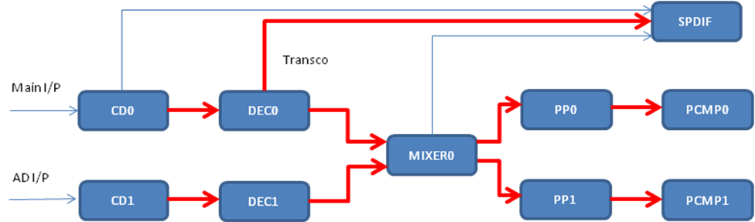
Figure 4: Audio Chain Connections for Use Case 2 for MS10

- Input stream type can be Dolby Digital,Dolby Digital Plus or Dolby Pulse.
- Transcoded Buffer will be available from Decoder0

Input format for Main and Associated audio supported by Dolby MS10 are as follow:

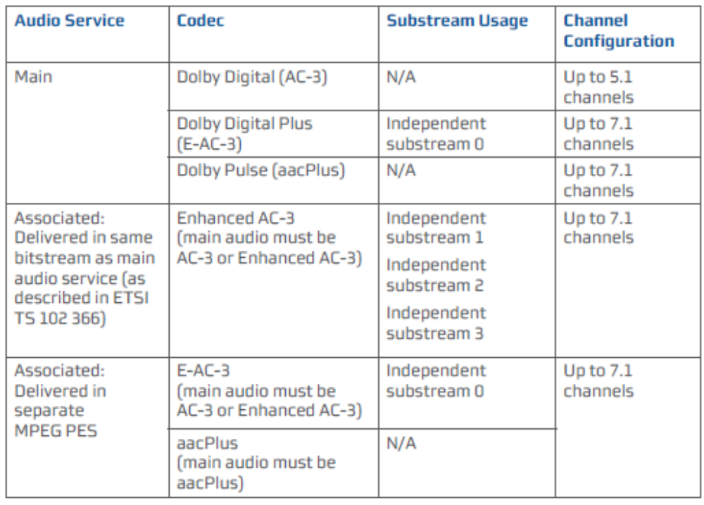
Figure 5: Input format for Main and Associated audio supported by Dolby MS10
The STAUDLX API call sequence for starting the MS10 in Use Case-2 will be as follow:
S.No | API | Description
1 | STAUD_Init | Initialize audio driver
2 | STAUD_Open | Open the audio driver
3 | STAUD_OPSetDigitalMode | Set SPDIF in compressed mode to get DD output (Transcoded o/p)
4 | STAUD_DRSetInitParams | Enable SBR flag for dolby pulse for decoder0 (not required for dolby digital/ dolby digital plus)
5 | STAUD_DRSetInitParams | Enable SBR flag for dolby pulse for decoder1 (not required for dolby digital/ dolby digital plus)
6 | STAUD_MXUpdatePTSStatus | Set PTSStatus valid for input 0
7 | STAUD_MXUpdatePTSStatus | Set PTSStatus valid for input 1
8 | STAUD_GenericStart | Start mixer, blockmanager and player modules
9 | STAUD_ModuleStart | Start SPDIF module
10 | STAUD_ModuleStart | Start DEC0 module with stream type STAUD_STREAM_TYPE_ES
11 | STAUD_ModuleStart | Start DEC1 module with stream type STAUD_STREAM_TYPE_PES_AD
12 | STAUD_ModuleStart | Start PP0 module
13 | STAUD_ModuleStart | Start PP1 module
14 | STAUD_ModuleStart | Start CD0 module with stream type STAUD_STREAM_TYPE_PES
15 | STAUD_ModuleStart | Start CD1 module with stream type STAUD_STREAM_TYPE_PES_AD
Table 4 : STAUDLX API call sequence for starting the MS10 in Use Case-2
The STAUDLX API call sequence for stopping the MS10 in Use Case-2 will be as follow:

S.NO | API | Description
1 | STAUD_ModuleStop | Stop CD0 module
2 | STAUD_ModuleStop | Stop CD1 module
3 | STAUD_ModuleStop | Stop DEC0 module
4 | STAUD_ModuleStop | Stop DEC1 module
5 | STAUD_ModuleStop | Stop PP0 module
6 | STAUD_ModuleStop | Stop PP1 module
7 | STAUD_ModuleStop | Stop SPDIF0 module
8 | STAUD_GenericStop | Stop mixer, blockmanger and player modules
9 | STAUD_close | Close Audio Driver
10 | STAUD_term | Terminate the Audio Driver
Table 5 : STAUDLX API call sequence for stopping the MS10 in Use Case-2

Use Case-3 ( Single Input, Dual Decode, Mixing Enable)
Following path is used in this use case

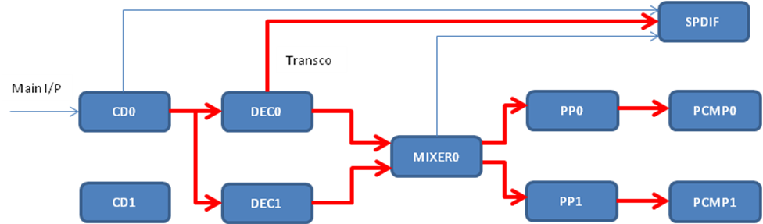
Figure 6 : Audio Chain Connections for Use Case-3 for MS10

- Input stream type can be Dolby Digital Plus only.
- As Input stream type can be Dolby Digital Plus only, so no need to call API STAUD_DRSetInitParams to enable SBR flag (as we did in use case-1 and 2).
In this use case we assume CD0 and DEC0 is used for parsing and decoding main audio and DEC1 is used for decoding secondary audio. Here we are connecting CD1 block manager with CD0 audiomatically through staudlx driver.

Note:
Please Do not start CD1 in this usecase because CD1 blockmanager is internally used for sending data to DEC1.

The STAUDLX API call sequence for starting the MS10 in Use Case-3 will be as follow:

S.No | API | Description
1 | STAUD_Init | Initialize audio driver
2 | STAUD_Open | Open the audio driver
3 | STAUD_OPSetDigitalMode | Set SPDIF in compressed mode to get DD output (Transcoded o/p)
4 | STAUD_MXUpdatePTSStatus | Set PTSStatus valid for input 0
5 | STAUD_MXUpdatePTSStatus | Set PTSStatus valid for input 1
6 | STAUD_IPSetADSubStreamID | Select Dolby Digital Plus SubStream ID for Audio Description
7 | STAUD_GenericStart | Start mixer, blockmanager and player modules
8 | STAUD_ModuleStart | Start SPDIF module
9 | STAUD_ModuleStart | Start DEC0 module with stream type STAUD_STREAM_TYPE_ES
10 | STAUD_ModuleStart | Start DEC1 module with stream type STAUD_STREAM_TYPE_PES_AD
11 | STAUD_ModuleStart | Start PP0 module
12 | STAUD_ModuleStart | Start PP1 module
13 | STAUD_ModuleStart | Start CD0 module with stream type STAUD_STREAM_TYPE_PES_AD
Table 6: STAUDLX API call sequence for starting the MS10 in Use Case-3

The STAUDLX API call sequence for stopping the MS10 in Use Case-3 will be as follow:

S.NO | API | Description
1 | STAUD_ModuleStop | Stop CD0 module
2 | STAUD_ModuleStop | Stop DEC0 module
3 | STAUD_ModuleStop | Stop DEC1 module
4 | STAUD_ModuleStop | Stop PP0 module
5 | STAUD_ModuleStop | Stop PP1 module
6 | STAUD_ModuleStop | Stop SPDIF0 module
7 | STAUD_GenericStop | Stop mixer, blockmanger and player modules
8 | STAUD_close | Close Audio Driver
9 | STAUD_term | Terminate the Audio Driver
Table 7 : STAUDLX API call sequence for stopping the MS10 in Use Case-3

Please refer to Appendix A for usage of STAUD_IPSetADSubStreamID API.

Using new API (STAUD_OPSetModeConfig)
STAUDLX driver has provided new API’s for SET/GET the output Mode configuration for the specified module.

API’s declaration is as follow:
ST_ErrorCode_t STAUD_OPSetModeConfig
(STAUD_Handle_t Handle,
STAUD_Object_t Object,
STAUD_OPModeConfig_t *OPModeConfig_p)

ST_ErrorCode_t STAUD_OPGetModeConfig
(STAUD_Handle_t Handle,
STAUD_Object_t Object,
STAUD_OPModeConfig_t *OPModeConfig_p)

Description of parameters used is as follow:
Handle : Audio Driver Handle
Object : Module
OPModeConfig_p : Mode Configuration parameter

STAUD_OPModeConfig_s
{
STAUD_DigitalMode_t Mode;
STAUD_Object_t SourceObject;
U8 SourceOPID;
}STAUD_OPModeConfig_t;

Mode : Output Module mode
SourceObject : Source module from where output module is connected
SourceOPID : Source module output index

Note : Output Mode used can be as follow :
STAUD_DIGITAL_MODE_OFF
STAUD_DIGITAL_MODE_NONCOMPRESSED
STAUD_DIGITAL_MODE_COMPRESSED
STAUD_DIGITAL_MODE_COMPRESSED_ENC

Now application can also make use of this API is current design of MS10 too, instead of STAUD_OPSetDigitalMode API.

For Example:
In all Use Cases discussed above SPDIF will be connected to Decoder to get the transcoded output and will be configured in compressed mode.
(ie. STAUD_DIGITAL_MODE_COMPRESSED)

Now new API (STAUD_OPSetModeConfig) can be used to connect the SPDIF to decoder in compressed mode as follow:
Parameter will be set as follow:

Handle : Audio Driver Handle
Object : SPDIF
OPModeConfig_p : Mode Configuration parameter
{
Mode : STAUD_DIGITAL_MODE_COMPRESSED
SourceObject : STAUD_OBJECT_DECODER_COMPRESSED0 SourceOPID : STAUD_AUX_OUT
}

Note:
Following new enum is defined in STAUDLX Driver
typedef enum STAUD_ModuleOPIndex_e
{
STAUD_MAIN_OUT = 0 << 28, // Used for main Audio
STAUD_AUX_OUT = 1 << 28, // Used for Auxiliary O/P, Transcoded
STAUD_DIGITAL_OUT = 2 << 28, // Digital Stereo Output
STAUD_HDMI_OUT = 3 << 28, // HDMI output (Not supported till now)
STAUD_MODULE_MAX_OUT = 4 << 28;
}STAUD_ModuleOPIndex_t;

AUDIO driver will support multiple outputs on Mixer also along with decoder. Application can select which output to be used by informing the output ID to STAUDLX Driver as per the above enum.

For MS10 case we need transcoded output from Decoder, so application needs to select STAUD_AUX_OUT as output ID.

New Proposed STAUDLX Chain MS11/Canvas

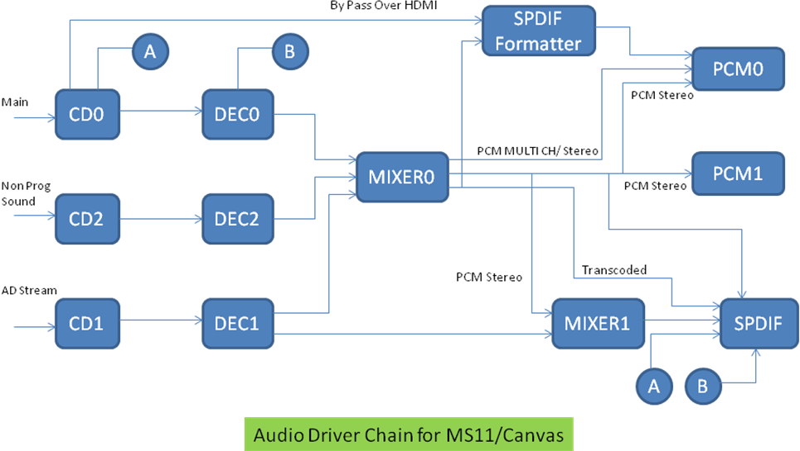
Figure 7: Audio Driver Chain for MS11/Canvas

This Chain can be used for both MS11 and Canvas.

Note:
- Application doesn’t need to inform the Audio Driver about MS10/MS11 or Canvas application. It will be taken care by Audio Driver as per the capability of the Audio FW.
- The same chain can be used for MS10 also.
- As there is only one Stereo and one transcoded buffer allocated, that can be moved at run time.
So before moving the transcoded or stereo buffer, application should set the following modules in stop state.

Source Module for the buffer.
Destination Module for the buffer .
Module which was connected previously with that buffer.

Proposed STAUDLX API usages for MS11
Major differences between the MS10 and MS11 are as follow:

Feature/Parameter | MS10 | MS11
Channel Supported | Stereo | MultiChannel
No of Output | ByPass over HDMI  Trancoded DD  Stereo PCM | ByPass Over HDMI  Transcoded DD  Multichannel PCM  Stereo PCM
Sampling Frequency  (in KHz) | 32  44.1  48  Transcoding supported  only for 48KHz | 32  44.1  48  Transcoding supported  for all sampling frequencies
Transcoded Output | Transcoding will be applied at  primary decoder(Before mixing) | Transcoding will be applied after mixing + DV
Table 8 : Difference between MS10 and MS11

Note:
Use cases for MS11 are same as discussed for MS10 in Table1.

Now we will discuss the STAUDLX API call sequence for each use case.

Use Case-1 ( Single Input, Single Decode, No Mixing)
Following path is used in this use case

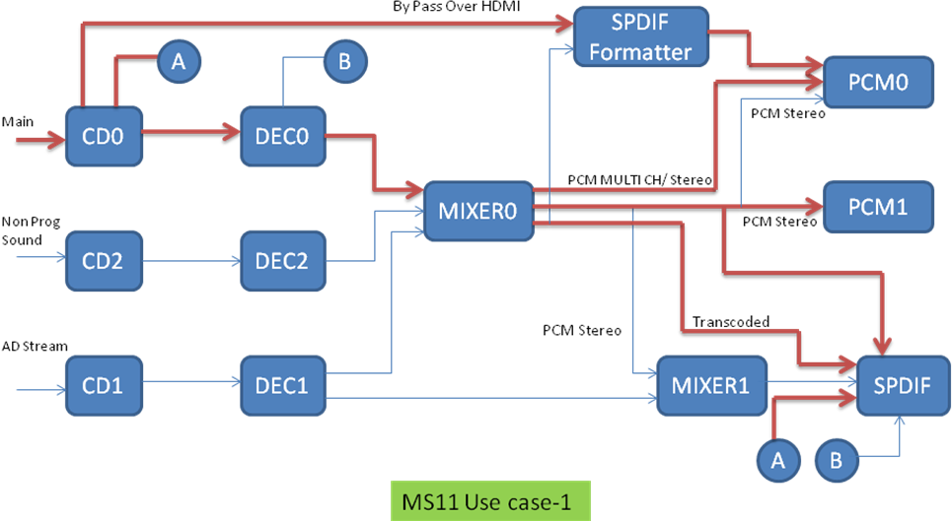
Figure 8 : Audio Chain Connections for Use Case-1 for MS11

- Input stream type can be Dolby Digital,Dolby Digital Plus or Dolby Pulse.
- Transcoded Buffer will be available from Mixer0
- For Bypass over HDMI, need to use SPDIF Formatter

The STAUDLX API call sequence for starting the MS11 in Use Case-1 will be as follow:

S.No | API | Description
1 | STAUD_Init | Initialize audio driver
2 | STAUD_Open | Open the audio driver
3 | STAUD_OPSetModeConfig | Set SPDIF in compressed mode to get DD output (Transcoded o/p) , Connect it with Mixer0 at output id STAUD_AUX_OUT( As discussed in section5)
4 | STAUD_OPSetModeConfig | Set PCMP1 in non-compressed mode to get stereo output , Connect it with Mixer0 at output id STAUD_DIGITAL_OUT ( As discussed in section5)  Note :  No need to call this API for PCMP1 , in case Audio Driver is initialized in strero Mode.
5 | STAUD_MXUpdatePTSStatus | Set PTSStatus valid for input 0 for Mixer0
6 | STAUD_GenericStart | Start mixer, blockmanager and player modules
7 | STAUD_ModuleStart | Start SPDIF module
8 | STAUD_ModuleStart | Start DEC0 module with stream type STAUD_STREAM_TYPE_ES
9 | STAUD_ModuleStart | Start CD0 module with stream type STAUD_STREAM_TYPE_PES
Table 9 : STAUDLX API call sequence for starting the MS11 in Use Case-1

The STAUDLX API call sequence for stopping the MS11 in Use Case-1 will be as follow:
S.NO | API | Description
1 | STAUD_ModuleStop | Stop CD0 module
2 | STAUD_ModuleStop | Stop DEC0 module
5 | STAUD_ModuleStop | Stop SPDIF0 module
6 | STAUD_GenericStop | Stop mixer, blockmanger and player modules
7 | STAUD_close | Close Audio Driver
8 | STAUD_term | Terminate the Audio Driver
Table 10 : STAUDLX API call sequence for stopping the MS11 in Use Case-1

Please refer to Section5 for API usage to change SPDIF OUTPUT MODE at run time.

Use Case-2 ( Dual Input, Dual Decode, Mixing Enable)
Following path is used in this use case

Figure 9 : Audio Chain Connections for Use Case-2 for MS11

- Input stream type can be Dolby Digital,Dolby Digital Plus or Dolby Pulse.
- Transcoded Buffer will be available from Mixer0

Input format for Main and Associated audio supported by Dolby MS11 are same as shown in Figure5 for MS10

The STAUDLX API call sequence for starting the MS11 in Use Case-2 will be as follow:

S.No | API | Description
1 | STAUD_Init | Initialize audio driver
2 | STAUD_Open | Open the audio driver
3 | STAUD_OPSetModeConfig | Set SPDIF in compressed mode to get DD output (Transcoded o/p) , Connect it with Mixer0 at output id STAUD_AUX_OUT( As discussed in section5)
4 | STAUD_OPSetModeConfig | Set PCMP1 in non-compressed mode to get stereo output , Connect it with Mixer0 at output id STAUD_DIGITAL_OUT ( As discussed in section5)  Note :  No need to call this API for PCMP1 , in case Audio Driver is initialized in strero Mode.
5 | STAUD_MXUpdatePTSStatus | Set PTSStatus valid for input 0 for Mixer0
6 | STAUD_MXUpdatePTSStatus | Set PTSStatus valid for input 1 for Mixer0
7 | STAUD_GenericStart | Start mixer, blockmanager and player modules
8 | STAUD_ModuleStart | Start SPDIF module
9 | STAUD_ModuleStart | Start DEC0 module with stream type STAUD_STREAM_TYPE_ES
10 | STAUD_ModuleStart | Start DEC1 module with stream type STAUD_STREAM_TYPE_PES_AD
11 | STAUD_ModuleStart | Start CD0 module with stream type STAUD_STREAM_TYPE_PES
12 | STAUD_ModuleStart | Start CD1 module with stream type STAUD_STREAM_TYPE_PES_AD
Table 11 : STAUDLX API call sequence for starting the MS11 in Use Case-2

The STAUDLX API call sequence for stopping the MS11 in Use Case-2 will be as follow:
S.NO | API | Description
1 | STAUD_ModuleStop | Stop CD0 module
2 | STAUD_ModuleStop | Stop CD1 module
3 | STAUD_ModuleStop | Stop DEC0 module
4 | STAUD_ModuleStop | Stop DEC1 module
7 | STAUD_ModuleStop | Stop SPDIF0 module
8 | STAUD_GenericStop | Stop mixer, blockmanger and player modules
9 | STAUD_close | Close Audio Driver
10 | STAUD_term | Terminate the Audio Driver
Table 12 : STAUDLX API call sequence for stopping the MS11 in Use Case-2

Please refer to Section5 for API usage to change SPDIF OUTPUT MODE at run time.

Use Case-3 ( Single Input, Dual Decode, Mixing Enable)
Following path is used in this use case

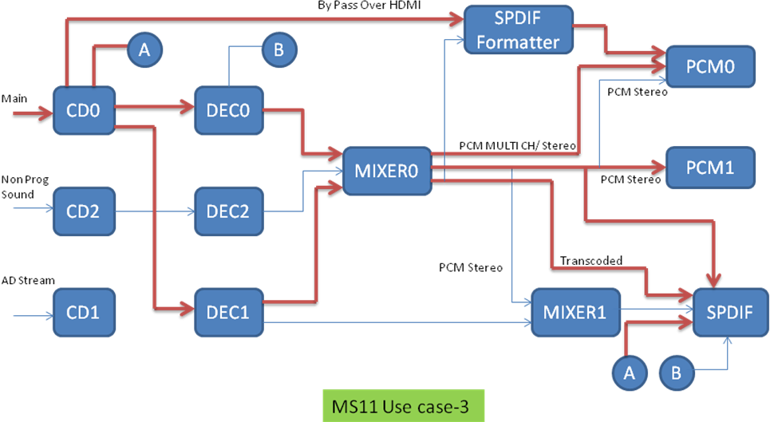
Figure 10 : Audio Chain Connections for Use Case-3 for MS11

- Input stream type can be Dolby Digital Plus only.
- Transcoded Buffer will be available from Mixer0

In this use case we assume CD0 and DEC0 is used for parsing and decoding main audio and DEC1 is used for decoding secondary audio. Here we are connecting CD1 block manager with CD0 audiomatically through staudlx driver.

Note:
Please Do not start CD1 in this usecase because CD1 blockmanager is internally used for sending data to DEC1.

The STAUDLX API call sequence for starting the MS11 in Use Case-3 will be as follow:
S.No | API | Description
1 | STAUD_Init | Initialize audio driver
2 | STAUD_Open | Open the audio driver
3 | STAUD_OPSetModeConfig | Set SPDIF in compressed mode to get DD output (Transcoded o/p) , Connect it with Mixer0 at output id STAUD_AUX_OUT( As discussed in section5)
4 | STAUD_OPSetModeConfig | Set PCMP1 in non-compressed mode to get stereo output , Connect it with Mixer0 at output id STAUD_DIGITAL_OUT ( As discussed in section5)  Note :  No need to call this API for PCMP1 , in case Audio Driver is initialized in strero Mode.
5 | STAUD_MXUpdatePTSStatus | Set PTSStatus valid for input 0 for Mixer0
6 | STAUD_MXUpdatePTSStatus | Set PTSStatus valid for input 1 for Mixer0
7 | STAUD_IPSetADSubStreamID | Select Dolby Digital Plus SubStream ID for Audio Description
8 | STAUD_GenericStart | Start mixer, blockmanager and player modules
9 | STAUD_ModuleStart | Start SPDIF module
10 | STAUD_ModuleStart | Start DEC0 module with stream type STAUD_STREAM_TYPE_ES
11 | STAUD_ModuleStart | Start DEC1 module with stream type STAUD_STREAM_TYPE_PES_AD
12 | STAUD_ModuleStart | Start CD0 module with stream type STAUD_STREAM_TYPE_PES_AD
Table 13: STAUDLX API call sequence for starting the MS11 in Use Case-3
The STAUDLX API call sequence for stopping the MS11 in Use Case-3 will be as follow:

S.NO | API | Description
1 | STAUD_ModuleStop | Stop CD0 module
2 | STAUD_ModuleStop | Stop DEC0 module
3 | STAUD_ModuleStop | Stop DEC1 module
4 | STAUD_ModuleStop | Stop SPDIF0 module
5 | STAUD_GenericStop | Stop mixer, blockmanger and player modules
6 | STAUD_close | Close Audio Driver
7 | STAUD_term | Terminate the Audio Driver
Table 14 : STAUDLX API call sequence for stopping the MS11 in Use Case-3

Please refer to Appendix A for usage of STAUD_IPSetADSubStreamID API
Please refer to Section5 for API usage to change SPDIF OUTPUT MODE at run time.

Proposed STAUDLX API usages for CANVAS

Use Case-1 ( Single Input, Single Decode, Mixing With Non Program Sound)

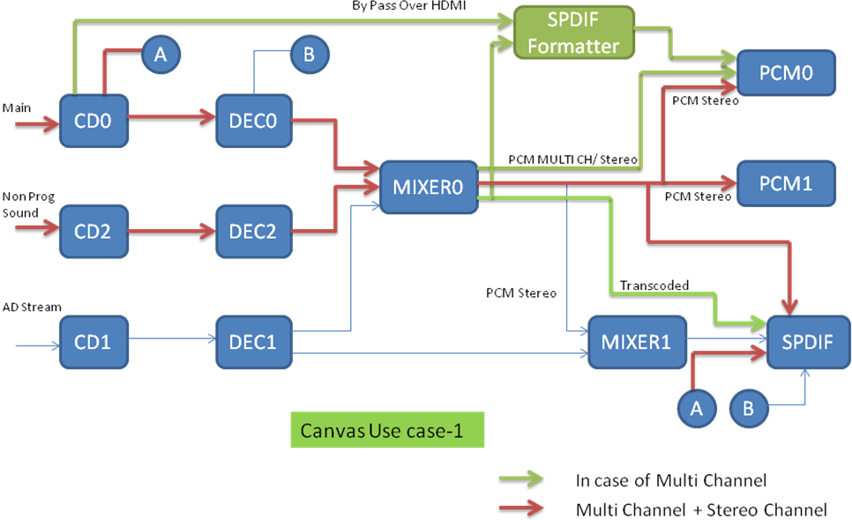
Figure 11: Audio Chain Connections for Use Case-1 for Canvas

- Input stream type can be Dolby Digital,Dolby Digital Plus or Dolby Pulse, MPEG1 Layer2, MPEG1 Layer3, HEAAC, AAC.
- Transcoded Buffer will be available from Mixer0
- For Bypass over HDMI, need to use SPDIF Formatter
- Non-Program sound is assumed to be premixed stereo PCM

The STAUDLX API call sequence for starting the Canvas in Use Case-1 will be as follow:
S.No | API | Description
1 | STAUD_Init | Initialize audio driver
2 | STAUD_Open | Open the audio driver
3 | STAUD_OPSetModeConfig | Set SPDIF in compressed mode to get DD output (Transcoded o/p) , Connect it with Mixer0 at output id STAUD_AUX_OUT( As discussed in section5)  Note :  In case Audio Driver is initialized in strero Mode, SPDIF should start in non comressed mode and connected to STAUD_MAIN_OUT of Mixer0.
4 | STAUD_OPSetModeConfig | Set PCMP1 in non-compressed mode to get stereo output , Connect it with Mixer0 at output id STAUD_DIGITAL_OUT ( As discussed in section5)  Note :  No need to call this API for PCMP1 , in case Audio Driver is initialized in strero Mode.
5 | STAUD_MXUpdatePTSStatus | Set PTSStatus valid for input 0 on Mixer0
6 | STAUD_MXUpdatePTSStatus | Set PTSStatus valid for input 2 on Mixer0
7 | STAUD_GenericStart | Start mixer, blockmanager and player modules
8 | STAUD_ModuleStart | Start SPDIF module
9 | STAUD_ModuleStart | Start DEC2 module with stream type STAUD_STREAM_TYPE_ES and stream content as PCM
10 | STAUD_ModuleStart | Start DEC0 module with stream type STAUD_STREAM_TYPE_ES
11 | STAUD_ModuleStart | Start CD2 module with stream type STAUD_STREAM_TYPE_ES
12 | STAUD_ModuleStart | Start CD0 module with stream type STAUD_STREAM_TYPE_PES
Table 15 : STAUDLX API call sequence for starting the Canvas in Use Case-1

The STAUDLX API call sequence for stopping the Canvas in Use Case-1 will be as follow:
S.NO | API | Description
1 | STAUD_ModuleStop | Stop CD0 module
2 | STAUD_ModuleStop | Stop CD2 module
3 | STAUD_ModuleStop | Stop DEC0 module
4 | STAUD_ModuleStop | Stop DEC2 module
7 | STAUD_ModuleStop | Stop SPDIF0 module
8 | STAUD_GenericStop | Stop mixer, blockmanger and player modules
9 | STAUD_close | Close Audio Driver
10 | STAUD_term | Terminate the Audio Driver
Table 16 : STAUDLX API call sequence for stopping the Canvas in Use Case-1

Please refer to Section5 for API usage to change SPDIF OUTPUT MODE at run time

Use Case-2 ( Dual Input, Dual Decode, Mixing With Non Program Sound, Audio Description Mixing)

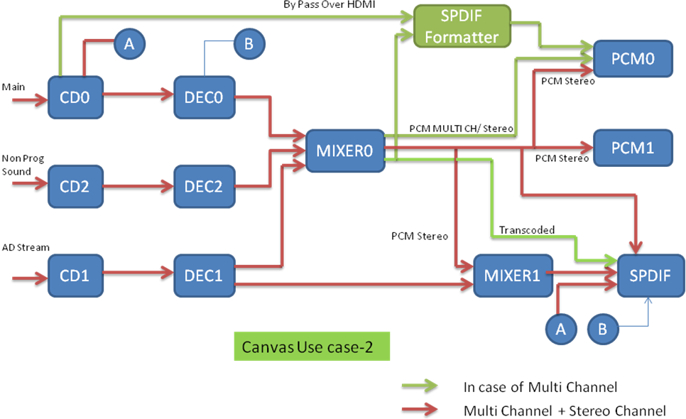
Figure 12: Audio Chain Connections for Use Case-2 for Canvas

- Input stream type can be Dolby Digital,Dolby Digital Plus or Dolby Pulse, MPEG1 Layer2, MPEG1 Layer3, HEAAC, AAC.
- Transcoded Buffer will be available from Mixer0
- For Bypass over HDMI, need to use SPDIF Formatter
- Non-Program sound is assumed to be premixed stereo PCM
- Application can mix Audio description using Mixer0 or Mixer1
- Mixer1 will only mix Stereo buffers, so application needs to downmix the DEC1 output.

The STAUDLX API call sequence for starting the Canvas in Use Case-2 will be as follow:
S.No | API | Description
1 | STAUD_Init | Initialize audio driver
2 | STAUD_Open | Open the audio driver
3 | STAUD_OPSetModeConfig | Set SPDIF in compressed mode to get DD output (Transcoded o/p) , Connect it with Mixer0 at output id STAUD_AUX_OUT( As discussed in section5)  Note :  In case Audio Driver is initialized in strero Mode, SPDIF should start in non comressed mode and connected to STAUD_MAIN_OUT of Mixer0.
4 | STAUD_OPSetModeConfig | Set PCMP1 in non-compressed mode to get stereo output , Connect it with Mixer0 at output id STAUD_DIGITAL_OUT ( As discussed in section5)  Note :  No need to call this API for PCMP1 , in case Audio Driver is initialized in strero Mode.
5 | STAUD_MXUpdatePTSStatus | Set PTSStatus valid for input 0 on Mixer0
6 | STAUD_MXUpdatePTSStatus | Set PTSStatus valid for input 1 on Mixer0
7 | STAUD_MXUpdatePTSStatus | Set PTSStatus valid for input 2 on Mixer0
8 | STAUD_MXUpdatePTSStatus | Set PTSStatus valid for input 0 on Mixer1
9 | STAUD_MXUpdatePTSStatus | Set PTSStatus valid for input 1 on Mixer1
10 | STAUD_GenericStart | Start mixer, blockmanager and player modules
11 | STAUD_ModuleStart | Start SPDIF module
12 | STAUD_ModuleStart | Start DEC2 module with stream type STAUD_STREAM_TYPE_ES and stream content as PCM
13 | STAUD_ModuleStart | Start DEC1 module with stream type STAUD_STREAM_TYPE_PES_AD
14 | STAUD_ModuleStart | Start DEC0 module with stream type STAUD_STREAM_TYPE_ES
15 | STAUD_ModuleStart | Start CD2 module with stream type STAUD_STREAM_TYPE_ES
16 | STAUD_ModuleStart | Start CD1 module with stream type STAUD_STREAM_TYPE_PES_AD
17 | STAUD_ModuleStart | Start CD0 module with stream type STAUD_STREAM_TYPE_PES
Table 17 : STAUDLX API call sequence for starting the Canvas in Use Case-2

The STAUDLX API call sequence for stopping the Canvas in Use Case-2 will be as follow:
S.NO | API | Description
1 | STAUD_ModuleStop | Stop CD0 module
2 | STAUD_ModuleStop | Stop CD1 module
3 | STAUD_ModuleStop | Stop CD2 module
4 | STAUD_ModuleStop | Stop DEC0 module
5 | STAUD_ModuleStop | Stop DEC1 module
6 | STAUD_ModuleStop | Stop DEC2 module
7 | STAUD_ModuleStop | Stop SPDIF0 module
8 | STAUD_GenericStop | Stop mixer, blockmanger and player modules
9 | STAUD_close | Close Audio Driver
10 | STAUD_term | Terminate the Audio Driver
Table 18 : STAUDLX API call sequence for stopping the Canvas in Use Case-2

Note :
For switching Audio Description to Mixer0, application should call the mute at Mixer1 and vice-versa.

Please refer to Section5 for API usage to change SPDIF OUTPUT MODE at run time

Use Case-3 ( Single Input, Dual Decode, Mixing With Non Program Sound, Audio Description Mixing)

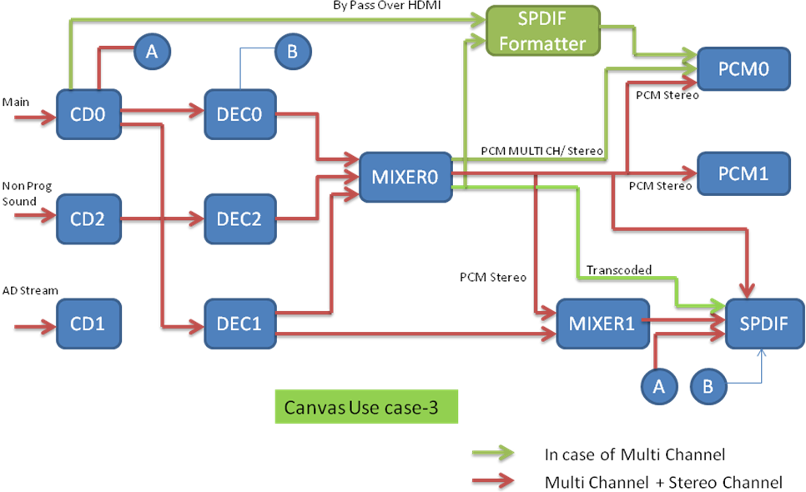
Figure 13: Audio Chain Connections for Use Case-3 for Canvas

- Input stream type can be Dolby Digital Plus only.
- Transcoded Buffer will be available from Mixer0
- For Bypass over HDMI, need to use SPDIF Formatter
- Non-Program sound is assumed to be premixed stereo PCM
- Application can mix Audio description using Mixer0 or Mixer1
- Mixer1 will only mix Stereo buffers, so application needs to downmix the DEC1 output
In this use case we assume CD0 and DEC0 is used for parsing and decoding main audio and DEC1 is used for decoding secondary audio. Here we are connecting CD1 block manager with CD0 audiomatically through staudlx driver.

Note
Please Do not start CD1 in this usecase because CD1 blockmanager is internally used for sending data to DEC1.

The STAUDLX API call sequence for starting the Canvas in Use Case-3 will be as follow:
S.No | API | Description
1 | STAUD_Init | Initialize audio driver
2 | STAUD_Open | Open the audio driver
3 | STAUD_OPSetModeConfig | Set SPDIF in compressed mode to get DD output (Transcoded o/p) , Connect it with Mixer0 at output id STAUD_AUX_OUT( As discussed in section5)  Note :  In case Audio Driver is initialized in strero Mode, SPDIF should start in non comressed mode and connected to STAUD_MAIN_OUT of Mixer0.
4 | STAUD_OPSetModeConfig | Set PCMP1 in non-compressed mode to get stereo output , Connect it with Mixer0 at output id STAUD_DIGITAL_OUT ( As discussed in section5)  Note :  No need to call this API for PCMP1 , in case Audio Driver is initialized in strero Mode.
5 | STAUD_MXUpdatePTSStatus | Set PTSStatus valid for input 0 on Mixer0
6 | STAUD_MXUpdatePTSStatus | Set PTSStatus valid for input 1 on Mixer0
7 | STAUD_MXUpdatePTSStatus | Set PTSStatus valid for input 2 on Mixer0
8 | STAUD_MXUpdatePTSStatus | Set PTSStatus valid for input 0 on Mixer1
9 | STAUD_MXUpdatePTSStatus | Set PTSStatus valid for input 1 on Mixer1
10 | STAUD_IPSetADSubStreamID | Select Dolby Digital Plus SubStream ID for Audio Description
11 | STAUD_GenericStart | Start mixer, blockmanager and player modules
12 | STAUD_ModuleStart | Start SPDIF module
13 | STAUD_ModuleStart | Start DEC2 module with stream type STAUD_STREAM_TYPE_ES and stream content as PCM
14 | STAUD_ModuleStart | Start DEC1 module with stream type STAUD_STREAM_TYPE_PES_AD
15 | STAUD_ModuleStart | Start DEC0 module with stream type STAUD_STREAM_TYPE_ES
16 | STAUD_ModuleStart | Start CD2 module with stream type STAUD_STREAM_TYPE_ES
17 | STAUD_ModuleStart | Start CD0 module with stream type STAUD_STREAM_TYPE_PES
Table 19 : STAUDLX API call sequence for starting the Canvas in Use Case-3

The STAUDLX API call sequence for stopping the Canvas in Use Case-3 will be as follow:
S.NO | API | Description
1 | STAUD_ModuleStop | Stop CD0 module
2 | STAUD_ModuleStop | Stop CD2 module
3 | STAUD_ModuleStop | Stop DEC0 module
4 | STAUD_ModuleStop | Stop DEC1 module
5 | STAUD_ModuleStop | Stop DEC2 module
6 | STAUD_ModuleStop | Stop SPDIF0 module
7 | STAUD_GenericStop | Stop mixer, blockmanger and player modules
8 | STAUD_close | Close Audio Driver
9 | STAUD_term | Terminate the Audio Driver
Table 20 : STAUDLX API call sequence for stopping the Canvas in Use Case-3

Note :
For switching Audio Description to Mixer0, application should call the mute at Mixer1 and vice-versa.
Please refer to Section5 for API usage to change SPDIF OUTPUT MODE at run time
Appendix A: Usage of STAUD_IPSetADSubStreamID API

STAUD_IPSetADSubStreamID(): Used to select AD substream ID. In this function STAUDLX driver will internally connect CD0 with DEC0 and DEC1. Application need not to use STAUD_ConnectSrcDst() and STAUD_DisconnectInput() function for it.

Value of substreamID is retained in the parser module even after parser is stopped (means no need to call STAUD_IPSetADSubStreamID() for selecting same stream ID at re-start).
If application want to use dual PID case then application need to call STAUD_IPSetADSubStreamID() with Substream ID "0". In this case STAUDLX will reconnect CD1 with DEC1 and break connection between CD0 and DEC1.

