DOKUZ EYLUL UNIVERSITY
ENGINEERING FACULTY
DEPARTMENT OF COMPUTER ENGINEERING

CME1252 PROJECT BASED LEARNING – II
FINAL REPORT
PROJECT – II

Star Trek Warp Wars

by
Gürkan Bıyık
Mustafa İzzet Yumuşak
Eren Çiçek
Abdulkadir Öksüz

Lecturers
Assoc.Prof.Dr Semih UTKU
Res.Asst. Fatih Dilmaç

CHAPTER ONE
PROGRESS DESCRIPTION
The game is played in a 23*55 game field including walls. There are two competitors: Player (P) and Computer (C). There are some treasures/numbers in the game, which the players collect to increase their scores. The aim of the player who has 5 lives during the game is to get the maximum score at the end of the game.
In the first week of the project, file operations, printing the maze, and creating some classes and data structures were completed. In addition to these, the controls of player movements have been started. In the second week, the timing and backpack were integrated into the code, the input queue was created and the necessary functions were defined, and the player movements were completed. In the third week randomly moving elements and static elements adjusted. In the 4th week of the project, necessary functions for computer movements, warp device and trap device were created. And in the last week, debug operations were made and the project was completed.

CHAPTER TWO
TASK SUMMARY

Completed Tasks
Gürkan Bıyık : I created public variables for game settings like game speed, player energy, player lives, etc. I implemented timer , key bindings such as arrow keys and WASD keys. I took part in designing classes, player movement, general game functions, and backpack implementation. Additionally, I was interested in testing/debugging.

Mustafa İzzet Yumuşak : I took part in some of the general game functions, in game field filling and printing on the screen. I also fixed some bugs in computer movements and the function created for trap device.

Eren Çiçek : I mainly took part in the creation of some classes, file operations, assigning the elements to the map according to certain ratios and getting the elements from the backpack. I also developed algorithms for computer movements and defined the necessary functions.
Abdulkadir Öksüz : I took part in designing element class and attributes in it, game speed adjustment, filling the queue , movements of 4&5, updating game info.In addition,I created the necessary functions for trap and warp devices

Incomplete Tasks: Reasons and Explanations
Every part of the project has been successfully completed.

Additional Improvements to the Project
No extra improvements were made in the project other than the requested tasks.

CHAPTER THREE
EXPLANATION of algorıthms

Screenshot
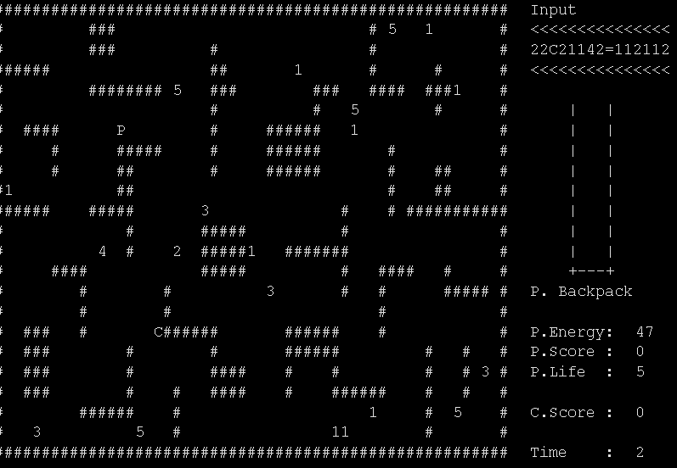
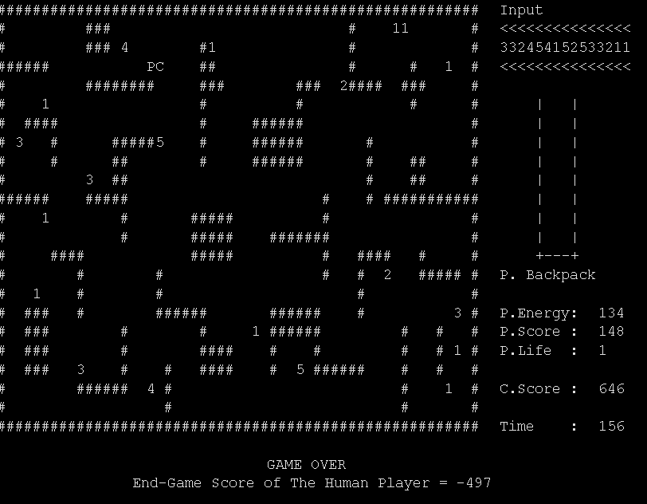

Functions
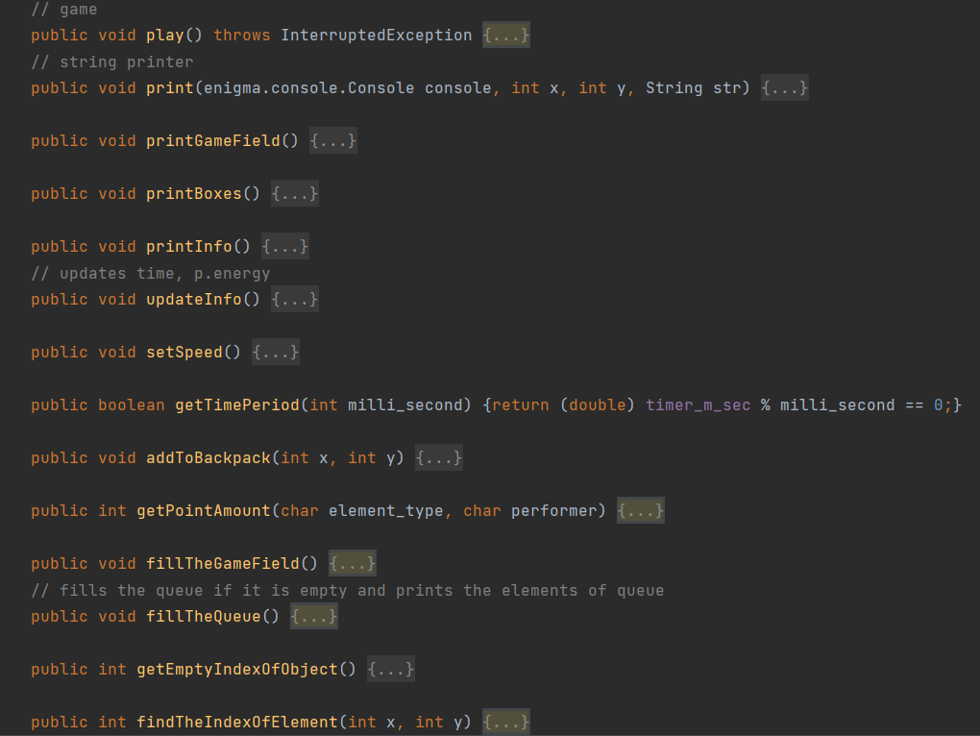
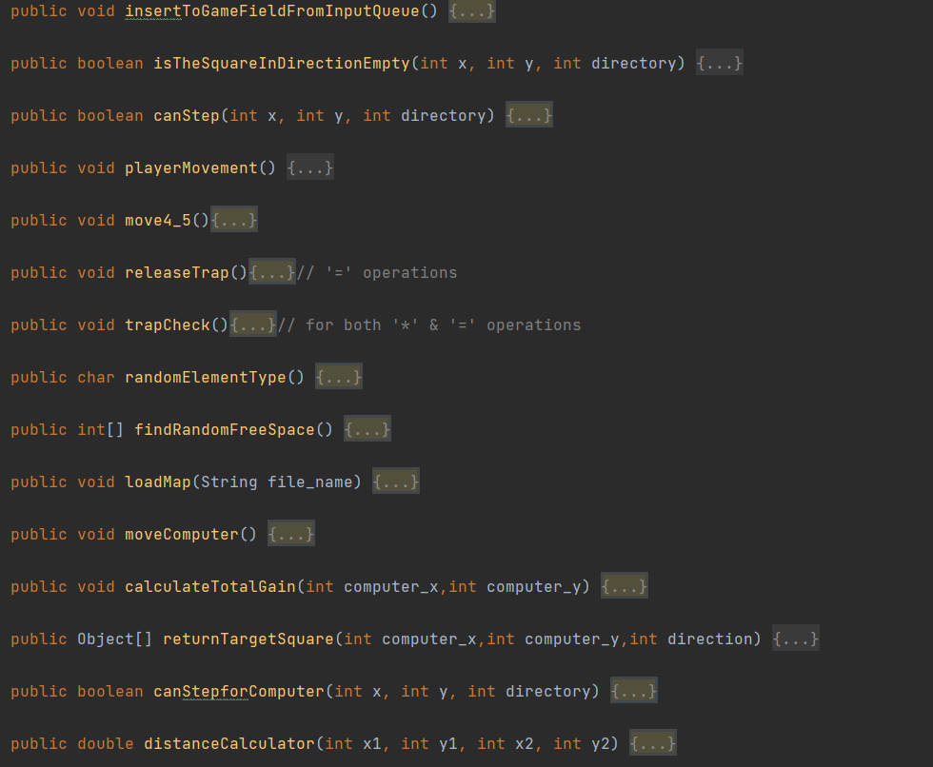

Algorithms and Solution Strategies
Gürkan Bıyık : A superclass with the name of Element was created. It keeps the element type, coordinates, whether is moving and activation time. Also, player class is inherited from this superclass. An array of that superclass Element whose length is 29(one for the beginning C robot and the other elements) was used to increase the performance of the program. The program takes coordinates from that array instead of the game field array. So, the program does not have to check the entire game field to find the coordinates of the element.
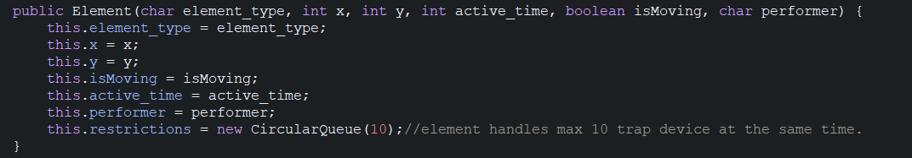
Mustafa İzzet Yumuşak :

Eren Çiçek : In the computer move, the algorithm aims to make the most profitable move in one step. First of all, element and distance gains are made over the directions that the computer can go. The primary goal is to approach the player, the next goal is to collect points. An object in Target Square class is created to hold the coordinates and total gain of the controlled point. These objects are added to the array named computer gains, which is also in Target Square. Then, by navigating this array, the maximum winning move is found and that move is performed. When there are moves with the same gain, one of these moves randomly played.
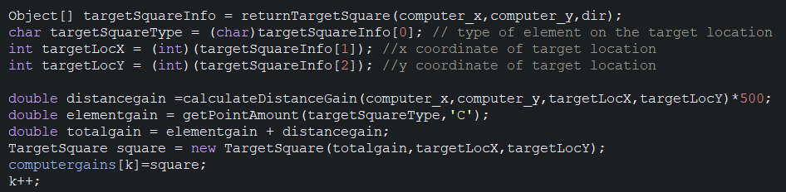
Abdulkadir Öksüz : All the trap operations are executed by using 2 procedures. The first one is necessary to release trapped elements. Its algorithm is checking all the elements which are under restriction. We can find out is the element is under a restriction by checking its queue. If there is a trap index in the queue the program checks this trap’s presence. If the trap is alive, the program checks other elements in the queue. If the trap is not alive, the program dequeues trap’s index from the queue of the element affected by the trap and sets the element’s moving status from false to true(moving status is an attribute of element class, if the status is true the element moves). The second procedure is necessary for trapping. It works on all the neighbor elements of each trap in a 3x3 area and turns the element’s moving status from true to false. The other procedure is the warping procedure. It only assigns null all the surrounding elements after the player got the element’s score. A null assignment is enough to delete an element in our game. 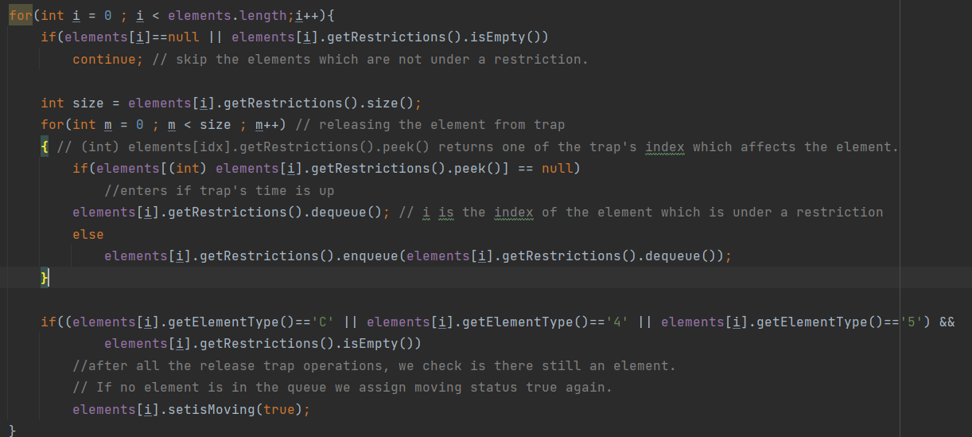

CHAPTER FOUR
PROBLEMS ENCOUNTERED

Errors such as teleporting computers from one point to another were seen during computer movements. While navigating the array where the coordinates of the points where the computer can go and the total gains are kept, this problem is solved by assigning null to the entire array elements at the end of each move.
We have used excessive static variables. To prevent losing memory, we re-assigned all non-static fields by carrying all the main to another class (Game class).

CHAPTER FIVE
conclusıon
Together with the task sharing and cooperation, the goals of the project were completed every week and successfully overcome.

REFERENCES
(These references are examples, write yours in these formats.)
Andersen H., Stirling C., & Winskel G. (1994). A compositional proof system for the modal mu-calculus. In Proceedings of 9th LICS. IEEE Computer Society Press.

Java Pathfinder (n.d) Retrieved Feb , 2006 from http://javapathfinder.sourceforge.net

Modern cellular automata-live color cellular automata (n.d) Retrieved Feb 7, 2006 from http://www.collidoscope.com/modernca/

Paulson L. C. (1988). Isabelle: The next seven hundred theorem provers. In E. Lusk and R. Overbeek, editors. Proceedings of 9th International Conference on Automated Deduction (CADE), Argonne, IL, LNCS vol. 310, pp. 772-773.

Stirling C. (1995). Local model checking games. Proceedings of Concur’95 LNCS vol. 962, pp. 1-11.

AppendIx A
Poster/Web page of the Project
(Give Picture Of Poster Or Some Key Screens From Web Page.)
