DOKUZ EYLÜL UNIVERSITY
ENGINEERING FACULTY
DEPARTMENT OF COMPUTER ENGINEERING

CME 2210
Object Oriented Analysis and Design

HOSPITAL MANAGEMENT SYSTEM

by
Can Çelenay 2020510134
Gürkan Bıyık 2020510019
Abdulkadir Öksüz 2020510083

CHAPTER ONE
INTRODUCTION
- Project Scope:
In today's healthcare environment, effective hospital management is critical for providing high-quality care to patients. Hospital Management Systems have become essential tools for managing hospital operations efficiently and effectively. Our proposed Hospital Management System is designed to meet the complex needs of modern healthcare environments by streamlining patient care, improving medication management, and enhancing hospital efficiency.
- Project Description:
The system provides a comprehensive solution for hospital staff to manage patients and medication orders. It allows for the efficient admission of new patients, assignment of doctors and nurses to patients, and ordering of medications from the pharmacy. Additionally, pharmacy staff can receive medication orders and prepare and dispense medications to patients in the hospital. With its efficient workflows, the system enhances hospital efficiency.
- Technical Requirements:
The system is developed using object-oriented programming principles and Java as the programming language. The system utilizes polymorphism, inheritance, and encapsulation to ensure modularity, reusability, and maintainability of the code. The system also includes a user-friendly interface, which facilitates easy navigation for hospital staff. The database system stores all relevant data and can generate logs on hospital operations data, including medication inventory levels.
- Summary:
Overall, the system is a critical tool for managing hospital operations effectively and efficiently. By utilizing object-oriented principles, efficient workflows, and user-friendly interfaces, the system streamlines patient care and medication management, leading to improved patient outcomes. Additionally, the system aids in hospital management by providing valuable data on hospital operations and medication inventory levels.

CHAPTER TWO
REQUIREMENTS
The system should have a package called "model" with a "Datasource" class that has methods for loading, storing, and deleting data from the hospital database tables. The system should also have a package called "UI" with a "LoginController" class that allows users to log in and change their passwords. Additionally, the system should have classes for different staff roles (e.g. Doctor, Nurse, Pharmacist) and a class for managing the staff (Manager). Finally, there should be classes for Patient, Medicine, and MedicineSupply, and utility classes for the priority queue, and list data structures to implement.

Package model:
- Class Datasource:
  - Datasource instance = new Datasource ()
  - private constructor with no parameters
  - Datasource getInstance(), returns the Datasource instance to call the class methods
  - boolean loadData()
  - boolean storeData()
  - boolean deleteData(Object dataToDelete)
- Database hospital.db
  - Table hospital_logs
  - Table patient_logs
  - Table medicine_invetory
  - Table staff_list
  - Table patient_list

Package ui:
- Class LoginController
  - String username
  - String password
  - void login(), after successfully login, opens the relevant panel according to the job
  - void changePassword(String username, String newPassword), checks the given password matches with the old password. Then, changes the password
  - void showManagerPanel(), opens up the managemer panel if the logged in used is a manager
  - void showDoctorPanel(), opens up the doctor panel if the logged in used is a doctor
  - void showNursePanel(), opens up the nurse panel if the logged in used is a nurse
  - void showPharmacistPanel(), opens up the pharmacist panel if the logged in used is a pharmacist
  - void showRecepsionistPanel(), opens up the recepsionist panel if the logged in used is a recepsionist
- Class ManagerController
  - Manager manager
  - addStaff(), adds new sraff to the database
  - deleteStaff(), removes staff from the database
  - editInfo(), edits information of the existing staff
  - listStaff(), lists the staff
- Class DoctorController
  - Doctor doctor
  - listPatients(), lists the patients
  - sortPatients(key),
  - showPatientInfo(), displays the detailed information of the patient
  - prescribe(), calls doctor.prescribe
  - getPatientLogs(), gets patient logs
  - openQueueWindow(), displays the queue
- Class NurseController
  - Nurse nurse
  - listPatients(), lists the patients
  - sortPatients()
  - showPatientInfo(), displays the detailed information of the patient
  - getPatientLogs(), gets patient logs
- Class RecepsionistController
  - Recepsionist recepsionist
  - makeAppointment(), creates an appointment
  - checkAvailability(), checks if a doctor is available
  - listAvailableDoctors(), lists avaible doctors
  - searchForPatient(), searches patient
  - listSchedules(), lists schedules
- Class PharmacistController
  - Pharmacist pharmacist
  - checkPrescription(): void
  - supplyMedicine(): void
  - giveMedicine(),
- FXML mainScene, layout for main screen and login screen
- FXML doctorScene, doctor panel layout
- FXML nurseScene
- FXML pharmacistScene
- FXML managerScene

Enum Gender:
- MALE
- FEMALE

Abstract Class Person:
- Integer id
- String name
- String surname
- Gender gender
- Integer age
- Get / Set methods
- toString method returns String

Enum EmergencyState:
- URGENT
- HALF-URGENT
- ORDINARY
- …

Enum Priority:
- OLD
- YOUNG
- BABY
- TRAUMATISM
- UNCONSCIOUS
- …

Enum BloodType:
- 0-
- 0+
- A-
- A+
- B-
- B+
- AB-
- AB+

Class Patient extends Person:
- String complaint
- BloodType blood
- LocalDateTime date
- EmergencyState emergency_state
- Priority priority
- HashMap<Medicine, Integer> receipt
- One constructor method which receives emergency state, priority, registered documents, and other fields inherited from the Person superclass
- Get / Set methods
- toString method returns String

Abstract Class Staff extends Person:
- String username
- String password
- Get / Set methods

Class Manager extends Staff:
- List<Staff> getStaffList()
- void addStaff(Staff staff)
- boolean deleteStaff(Staff staff)
- boolean editStaff(Staff oldStaff, Staff newStaff)

Class Doctor extends Staff:
- List<Patient> patients
- List<Patient> getPatientList()
- void prescribe(int patientId)
- void getPatientInfo(int patientId)
- One constructor method which receives required fields from the Staff superclass

Class Nurse extends Staff:
- List<Patient> patients
- List<Patient> getPatientList()
- void getPatientInfo(int patientId)
- One constructor method which receives required fields from the Staff superclass

Enum MedicineType:
- SYRUP
- PILL
- PAIN_KILLER
- CREAM
- …

Class Medicine:
- String name
- MedicineType type
- @Override int hashCode()

Class MedicineSupply:
- Hashmap<Medicine, Integer> stock
- MedicineSupply instance = new MedicineSupply()
- private constructor with no parameters
- MedicineSupply getInstance(), returns the instance to call the class methods
- HashSet<Medicine, Integer> getInventory()
- int getStock(Medicine medicine)
- boolean checkStock(Medicine medicine)
- void supplyStock(Medicine medicine, Integer stock)
- void consumeStock(Medicine medicine, Integer stock)

Class Pharmacist extends Staff:
- boolean checkReceipt(Integer patientId)
- HashSet<Medicine, Integer> getReceiptMedicine(patientId)
- boolean giveMedicine(String medicineName)
- boolean requestMedicine(String medicineName)
- One constructor method which receives required fields from the Staff superclass
Class Receptionist extends Staff
- One constructor method which receives required fields from the Personal superclass

Package util:
- Class Stack<T>
  - int top
  - Array<T> elements
  - One constructor method which receives capacity.
  - void push(T data)
  - T pop()
  - T peek()
  - boolean isEmpty()
  - boolean isFull()
  - int size()
- Class PriorityQueue<T>
  - int length
  - Array<T> elements
  - One constructor method which receives capacity.
  - void queue(T data)
  - T dequeue()
  - T peek()
  - boolean isEmpty()
  - boolean isFull()
  - int size()
- Class List<T>
  - int size
  - Array<T> elements
  - One constructor
  - void add(T data)
  - void append(T data)
  - T get(int index)
  - T remove(int index)
CHAPTER THREE
UML DIAGRAMS
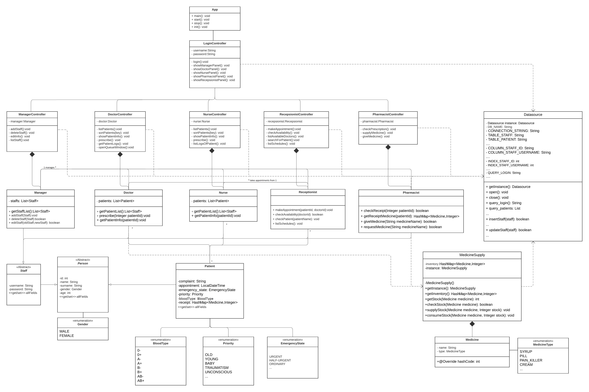
This class diagram shows the relationships between classes in hospital management system. In this diagram login panel opens relevant windows according to the job type. Most of the information comes from database as shown dependency in the diagram. Person is the superclass of the staff and patient. Staffs abstracted from the abstract staff class. All staff has permission to open window composited relevant controller and associated the patient class. Enums are associated with relevant classes. Medicine supply associated to the doctor and pharmacist. Overall, diagram shows the design of the code.
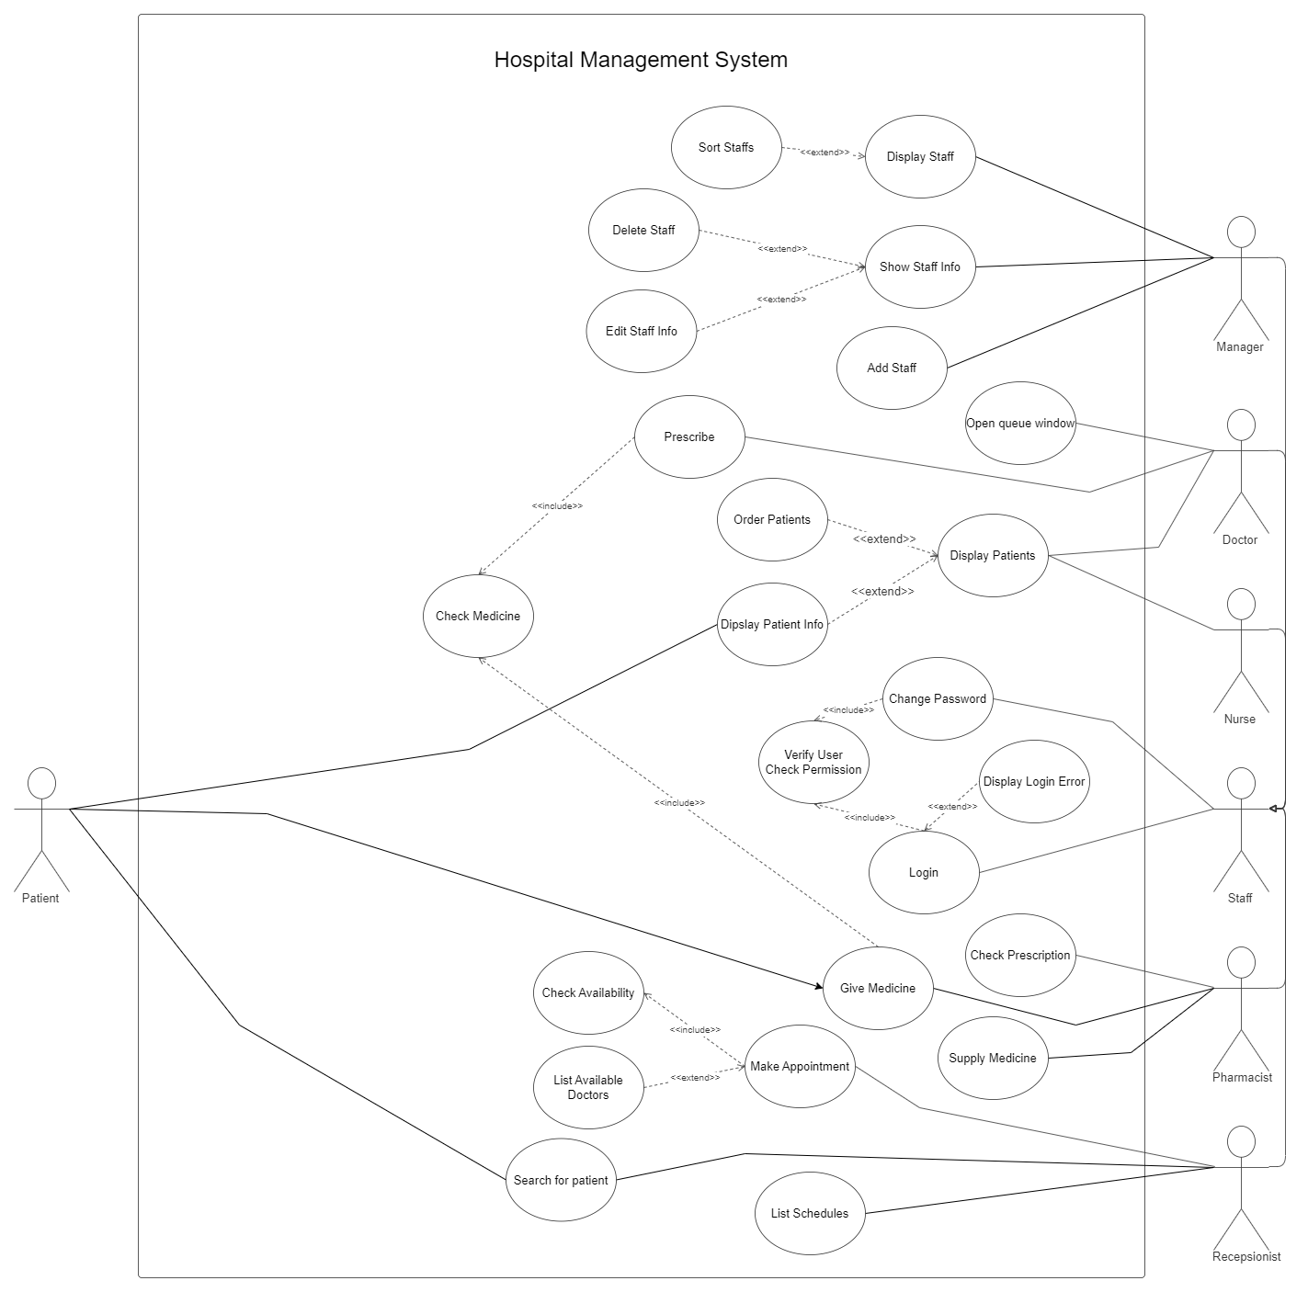

In the use case diagram shown that possible use cases with the relevant actors. There is lots of use cases for the hospital management system like make appointment, prescription, controlling medicine supply, managing staff, etc. In every use case, if needed the include and extend situations added. Covered all use cases to make the system user-friendly.

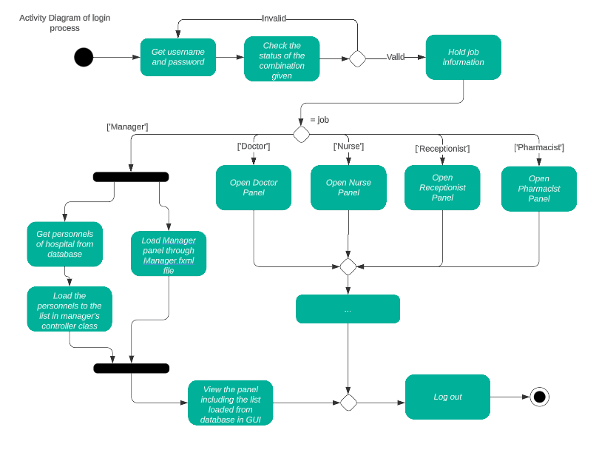
This activity diagram shows the main flow of how our GUI works while logging in/out. As mentioned in the homework description, we kept the diagram simple by showing the manager part only. However, the main idea is similar. Firstly, we check the login combination. If the combination is present, the program opens the related panel according to the user’s profession. When the user presses the log-out button, he/she will be directed to the login panel again.

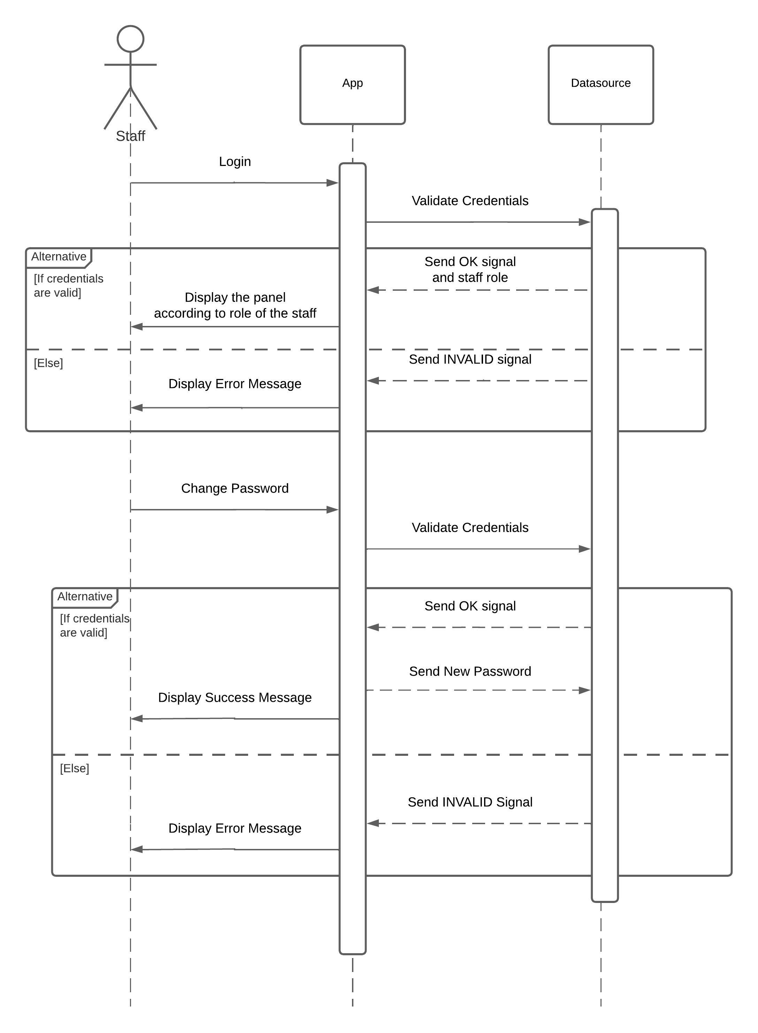
The sequence diagram above shows the login and password changing process in the newly opened application. The Datasource class represents our database and is a singleton, thus it will always be active as long as the application is active.

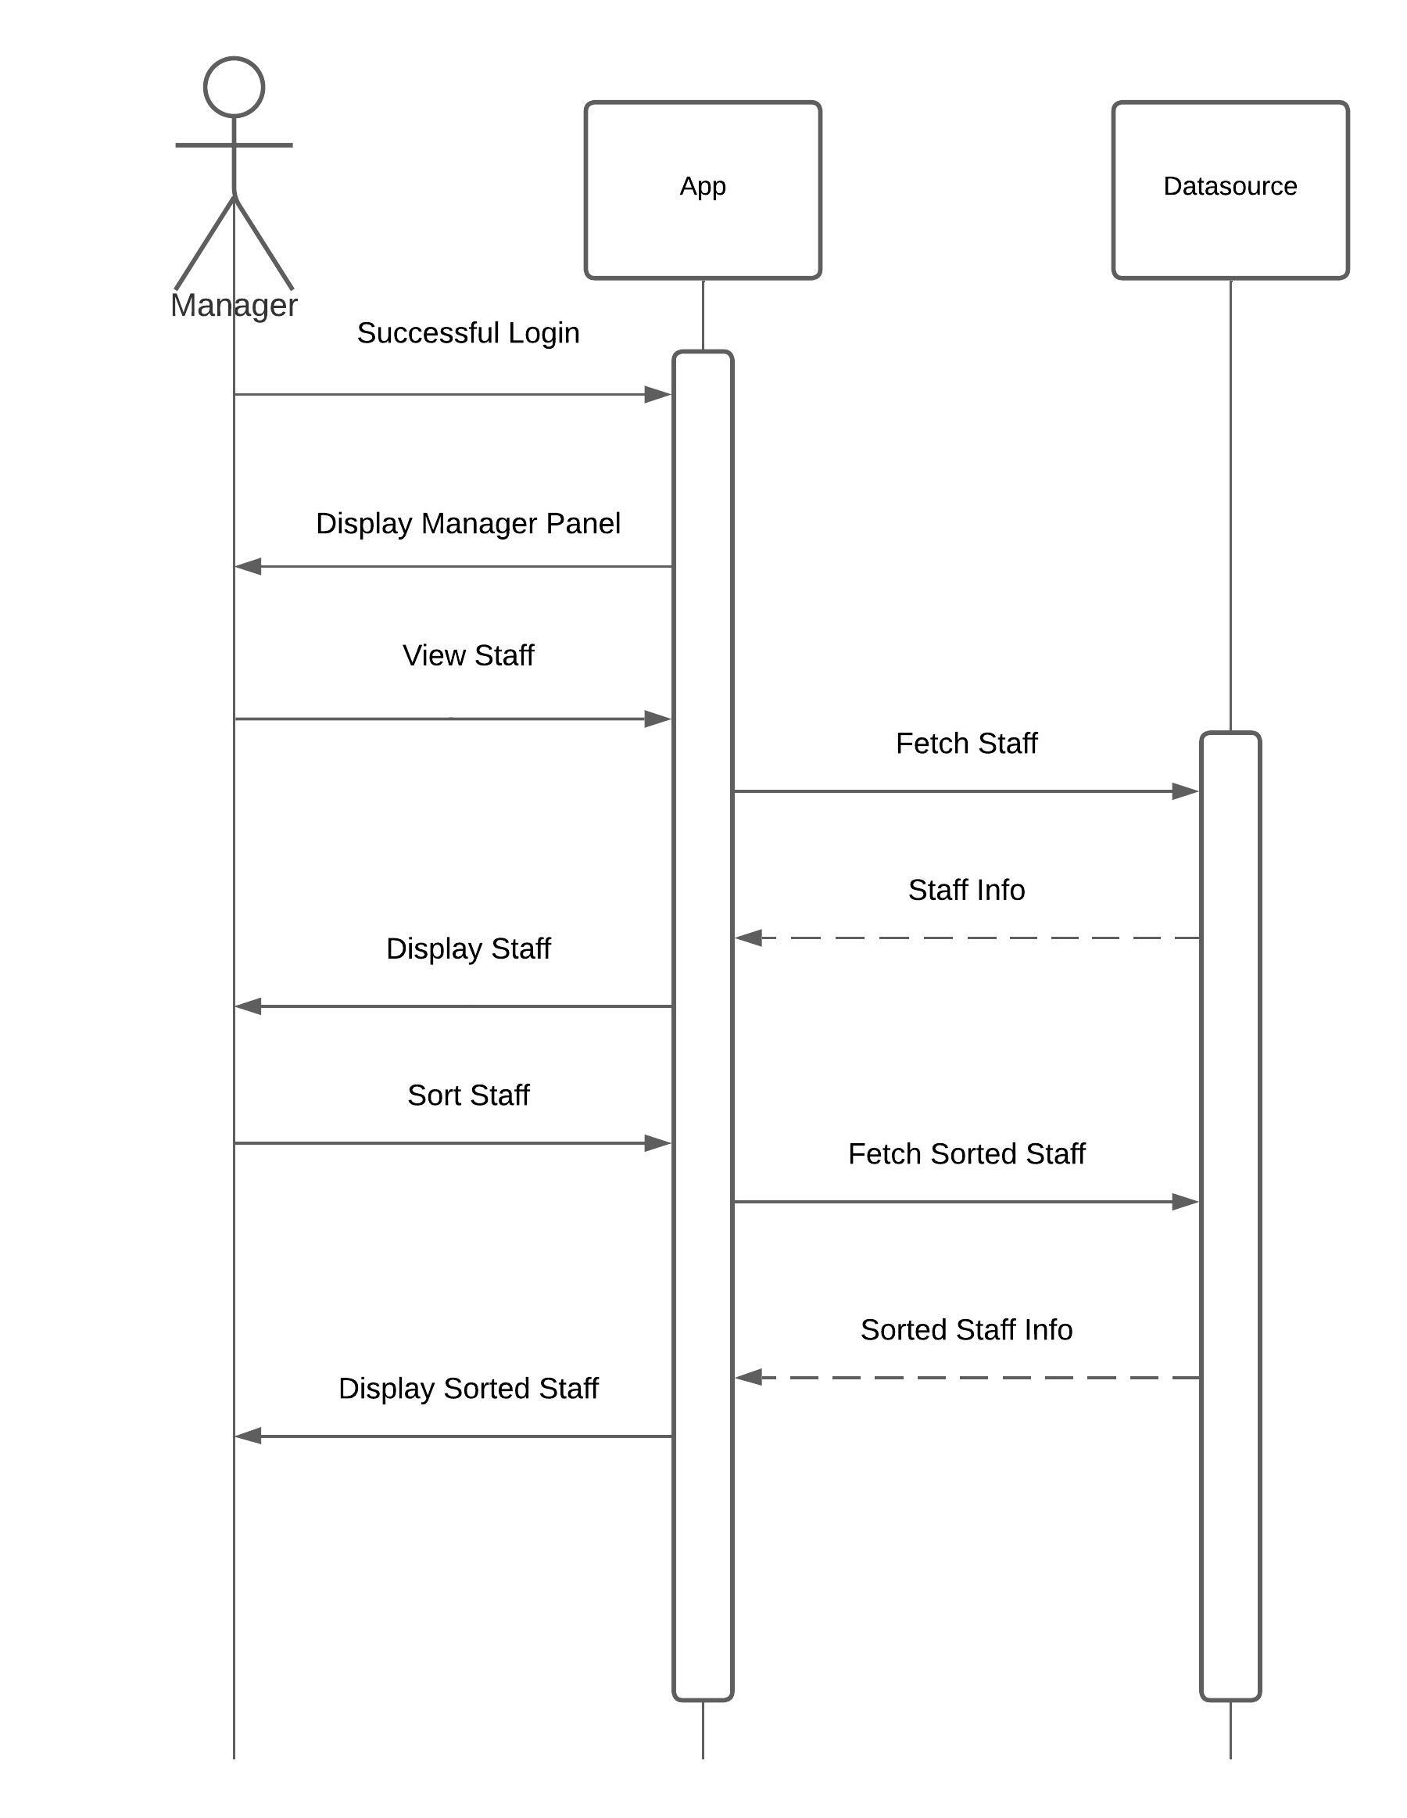
The sequence diagram above shows the steps to display the staff information to the manager. The application can list the staff and sort them for the given criteria.

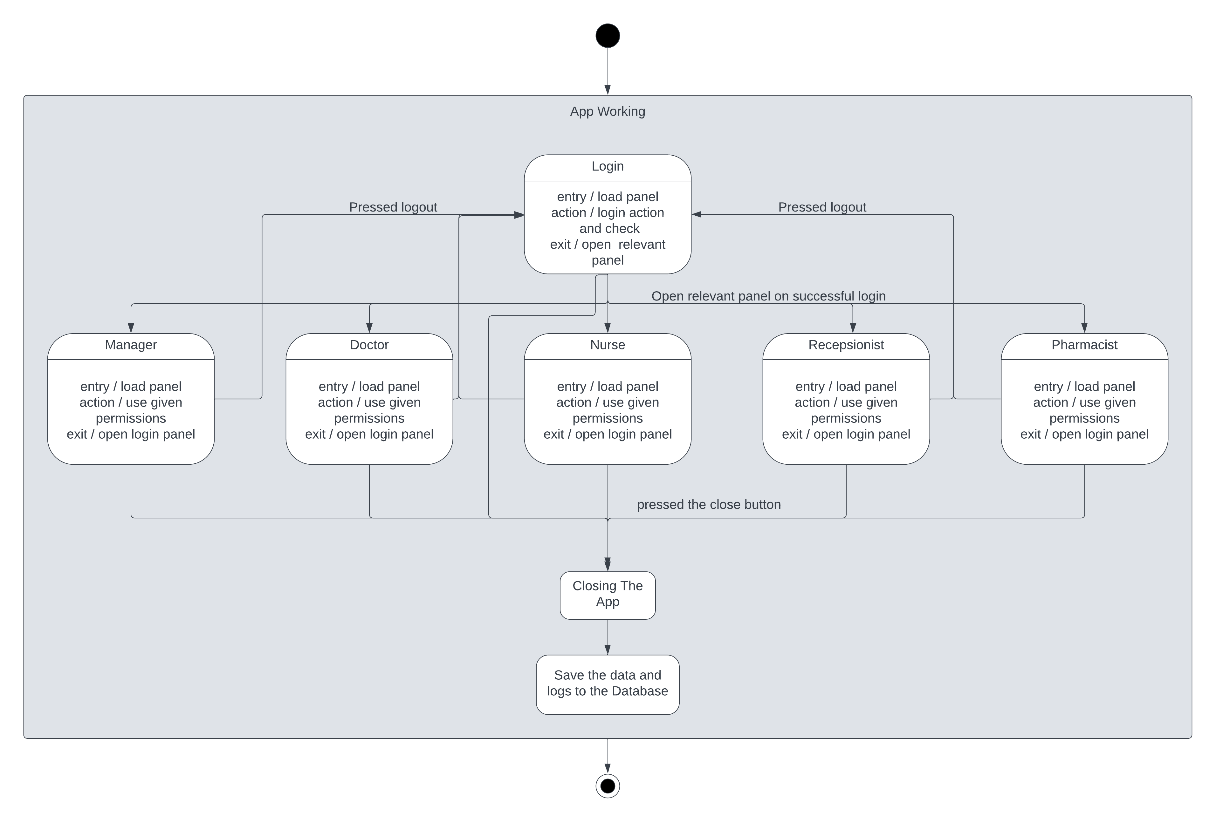
This diagram shows the state diagram. Every state showed while app working in the diagram from initialization to the termination of the program. Indicated every following state with the arrows with the required event. Specified every action in each state with entry, action, exit tags.

CHAPTER FOUR
IMPLEMENTATION
In this chapter, all interfaces and background codes should be explained in detail.

CHAPTER FIVE
CONCLUSION AND FUTURE WORKS
In this chapter, a summary and future works must be written.

