DOKUZ EYLÜL UNIVERSITY
ENGINEERING FACULTY
DEPARTMENT OF COMPUTER ENGINEERING

CME 2210
Object Oriented Analysis and Design

HOSPITAL MANAGEMENT SYSTEM

by
Can Çelenay 2020510134
Gürkan Bıyık 2020510019
Abdulkadir Öksüz 2020510083

CHAPTER ONE
INTRODUCTION
- Project Scope:
In today's healthcare environment, effective hospital management is critical for providing high-quality care to patients. Hospital Management Systems have become essential tools for managing hospital operations efficiently and effectively. Our proposed Hospital Management System is designed to meet the complex needs of modern healthcare environments by streamlining patient care, improving medication management, and enhancing hospital efficiency.
- Project Description:
The system provides a comprehensive solution for hospital staff to manage patients and medication orders. It allows for the efficient admission of new patients, assignment of doctors and nurses to patients, and ordering of medications from the pharmacy. Additionally, pharmacy staff can receive medication orders and prepare and dispense medications to patients in the hospital. With its efficient workflows, the system enhances hospital efficiency.
- Technical Requirements:
The system is developed using object-oriented programming principles and Java as the programming language. The system utilizes polymorphism, inheritance, and encapsulation to ensure modularity, reusability, and maintainability of the code. The system also includes a user-friendly interface, which facilitates easy navigation for hospital staff. The database system stores all relevant data and can generate logs on hospital operations data, including medication inventory levels.
- Summary:
Overall, the system is a critical tool for managing hospital operations effectively and efficiently. By utilizing object-oriented principles, efficient workflows, and user-friendly interfaces, the system streamlines patient care and medication management, leading to improved patient outcomes. Additionally, the system aids in hospital management by providing valuable data on hospital operations and medication inventory levels.

CHAPTER TWO
REQUIREMENTS
The system should have a package called "model" with a "Datasource" class that has methods for loading, storing, and deleting data from the hospital database tables. The system should also have a package called "UI" with a "LoginController" class that allows users to log in and change their passwords. Additionally, the system should have classes for different staff roles (e.g. Doctor, Nurse, Pharmacist) and a class for managing the staff (Manager). Finally, there should be classes for Patient, Medicine, and MedicineSupply, and utility classes for the priority queue, and list data structures to implement.

Package model:
- Class Datasource:
  - Datasource instance = new Datasource ()
  - private constructor with no parameters
  - Datasource getInstance(), returns the Datasource instance to call the class methods
  - boolean loadData()
  - boolean storeData()
  - boolean deleteData(Object dataToDelete)
- Database hospital.db
  - Table hospital_logs
  - Table patient_logs
  - Table medicine_invetory
  - Table staff_list
  - Table patient_list

Package ui:
- Class LoginController
  - String username
  - String password
  - void login(), after successfully login, opens the relevant panel according to the job
  - void changePassword(String username, String newPassword), checks the given password matches with the old password. Then, changes the password
  - void showManagerPanel(), opens up the managemer panel if the logged in used is a manager
  - void showDoctorPanel(), opens up the doctor panel if the logged in used is a doctor
  - void showNursePanel(), opens up the nurse panel if the logged in used is a nurse
  - void showPharmacistPanel(), opens up the pharmacist panel if the logged in used is a pharmacist
  - void showRecepsionistPanel(), opens up the recepsionist panel if the logged in used is a recepsionist
- Class ManagerController
  - Manager manager
  - addStaff(), adds new sraff to the database
  - deleteStaff(), removes staff from the database
  - editInfo(), edits information of the existing staff
  - listStaff(), lists the staff
- Class DoctorController
  - Doctor doctor
  - listPatients(), lists the patients
  - sortPatients(key),
  - showPatientInfo(), displays the detailed information of the patient
  - prescribe(), calls doctor.prescribe
  - getPatientLogs(), gets patient logs
  - openQueueWindow(), displays the queue
- Class NurseController
  - Nurse nurse
  - listPatients(), lists the patients
  - sortPatients()
  - showPatientInfo(), displays the detailed information of the patient
  - getPatientLogs(), gets patient logs
- Class RecepsionistController
  - Recepsionist recepsionist
  - makeAppointment(), creates an appointment
  - checkAvailability(), checks if a doctor is available
  - listAvailableDoctors(), lists avaible doctors
  - searchForPatient(), searches patient
  - listSchedules(), lists schedules
- Class PharmacistController
  - Pharmacist pharmacist
  - checkPrescription(): void
  - supplyMedicine(): void
  - giveMedicine(),
- FXML mainScene, layout for main screen and login screen
- FXML doctorScene, doctor panel layout
- FXML nurseScene
- FXML pharmacistScene
- FXML managerScene

Enum Gender:
- MALE
- FEMALE

Abstract Class Person:
- Integer id
- String name
- String surname
- Gender gender
- Integer age
- Get / Set methods
- toString method returns String

Enum EmergencyState:
- URGENT
- HALF-URGENT
- ORDINARY
- …

Enum Priority:
- OLD
- YOUNG
- BABY
- TRAUMATISM
- UNCONSCIOUS
- …

Enum BloodType:
- 0-
- 0+
- A-
- A+
- B-
- B+
- AB-
- AB+

Class Patient extends Person:
- String complaint
- BloodType blood
- LocalDateTime date
- EmergencyState emergency_state
- Priority priority
- HashMap<Medicine, Integer> receipt
- One constructor method which receives emergency state, priority, registered documents, and other fields inherited from the Person superclass
- Get / Set methods
- toString method returns String

Abstract Class Staff extends Person:
- String username
- String password
- Get / Set methods

Class Manager extends Staff:
- List<Staff> getStaffList()
- void addStaff(Staff staff)
- boolean deleteStaff(Staff staff)
- boolean editStaff(Staff oldStaff, Staff newStaff)

Class Doctor extends Staff:
- List<Patient> patients
- List<Patient> getPatientList()
- void prescribe(int patientId)
- void getPatientInfo(int patientId)
- One constructor method which receives required fields from the Staff superclass

Class Nurse extends Staff:
- List<Patient> patients
- List<Patient> getPatientList()
- void getPatientInfo(int patientId)
- One constructor method which receives required fields from the Staff superclass

Enum MedicineType:
- SYRUP
- PILL
- PAIN_KILLER
- CREAM
- …

Class Medicine:
- String name
- MedicineType type
- @Override int hashCode()

Class MedicineSupply:
- Hashmap<Medicine, Integer> stock
- MedicineSupply instance = new MedicineSupply()
- private constructor with no parameters
- MedicineSupply getInstance(), returns the instance to call the class methods
- HashSet<Medicine, Integer> getInventory()
- int getStock(Medicine medicine)
- boolean checkStock(Medicine medicine)
- void supplyStock(Medicine medicine, Integer stock)
- void consumeStock(Medicine medicine, Integer stock)

Class Pharmacist extends Staff:
- boolean checkReceipt(Integer patientId)
- HashSet<Medicine, Integer> getReceiptMedicine(patientId)
- boolean giveMedicine(String medicineName)
- boolean requestMedicine(String medicineName)
- One constructor method which receives required fields from the Staff superclass
Class Receptionist extends Staff
- One constructor method which receives required fields from the Personal superclass

Package util:
- Class Stack<T>
  - int top
  - Array<T> elements
  - One constructor method which receives capacity.
  - void push(T data)
  - T pop()
  - T peek()
  - boolean isEmpty()
  - boolean isFull()
  - int size()
- Class PriorityQueue<T>
  - int length
  - Array<T> elements
  - One constructor method which receives capacity.
  - void queue(T data)
  - T dequeue()
  - T peek()
  - boolean isEmpty()
  - boolean isFull()
  - int size()
- Class List<T>
  - int size
  - Array<T> elements
  - One constructor
  - void add(T data)
  - void append(T data)
  - T get(int index)
  - T remove(int index)
CHAPTER THREE
UML DIAGRAMS
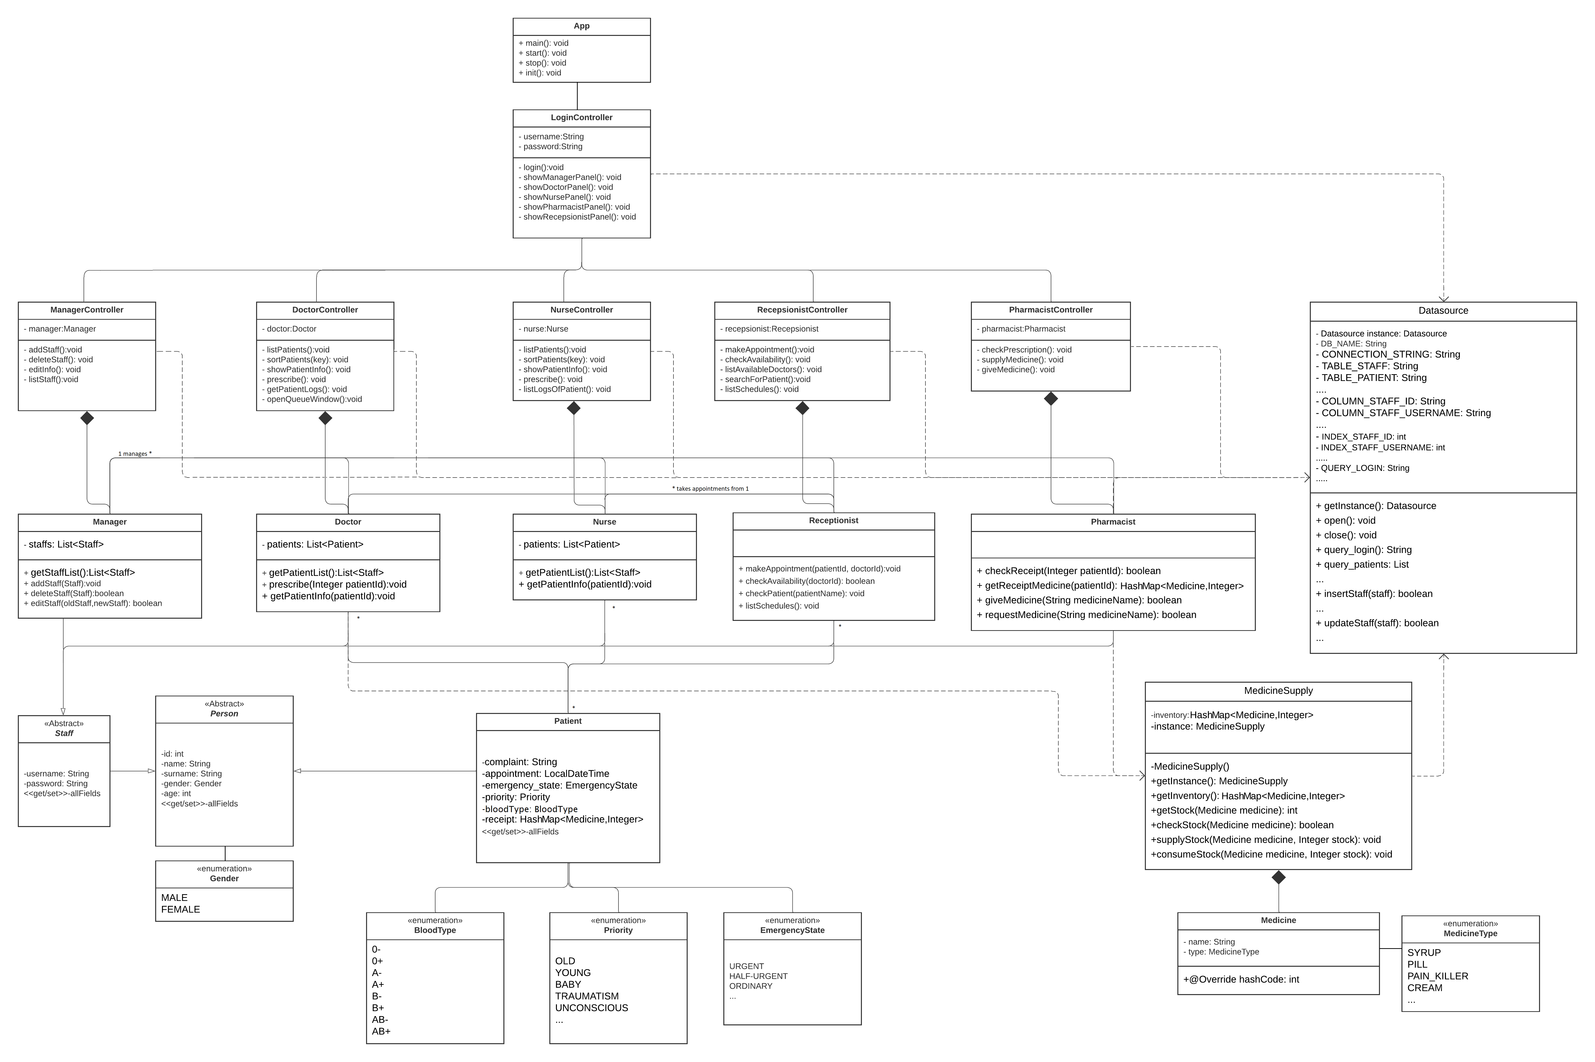
This class diagram shows the relationships between classes in hospital management system. In this diagram login panel opens relevant windows according to the job type. Most of the information comes from database as shown dependency in the diagram. Person is the superclass of the staff and patient. Staffs abstracted from the abstract staff class. All staff has permission to open window composited relevant controller and associated the patient class. Enums are associated with relevant classes. Medicine supply associated to the doctor and pharmacist. Overall, diagram shows the design of the code.
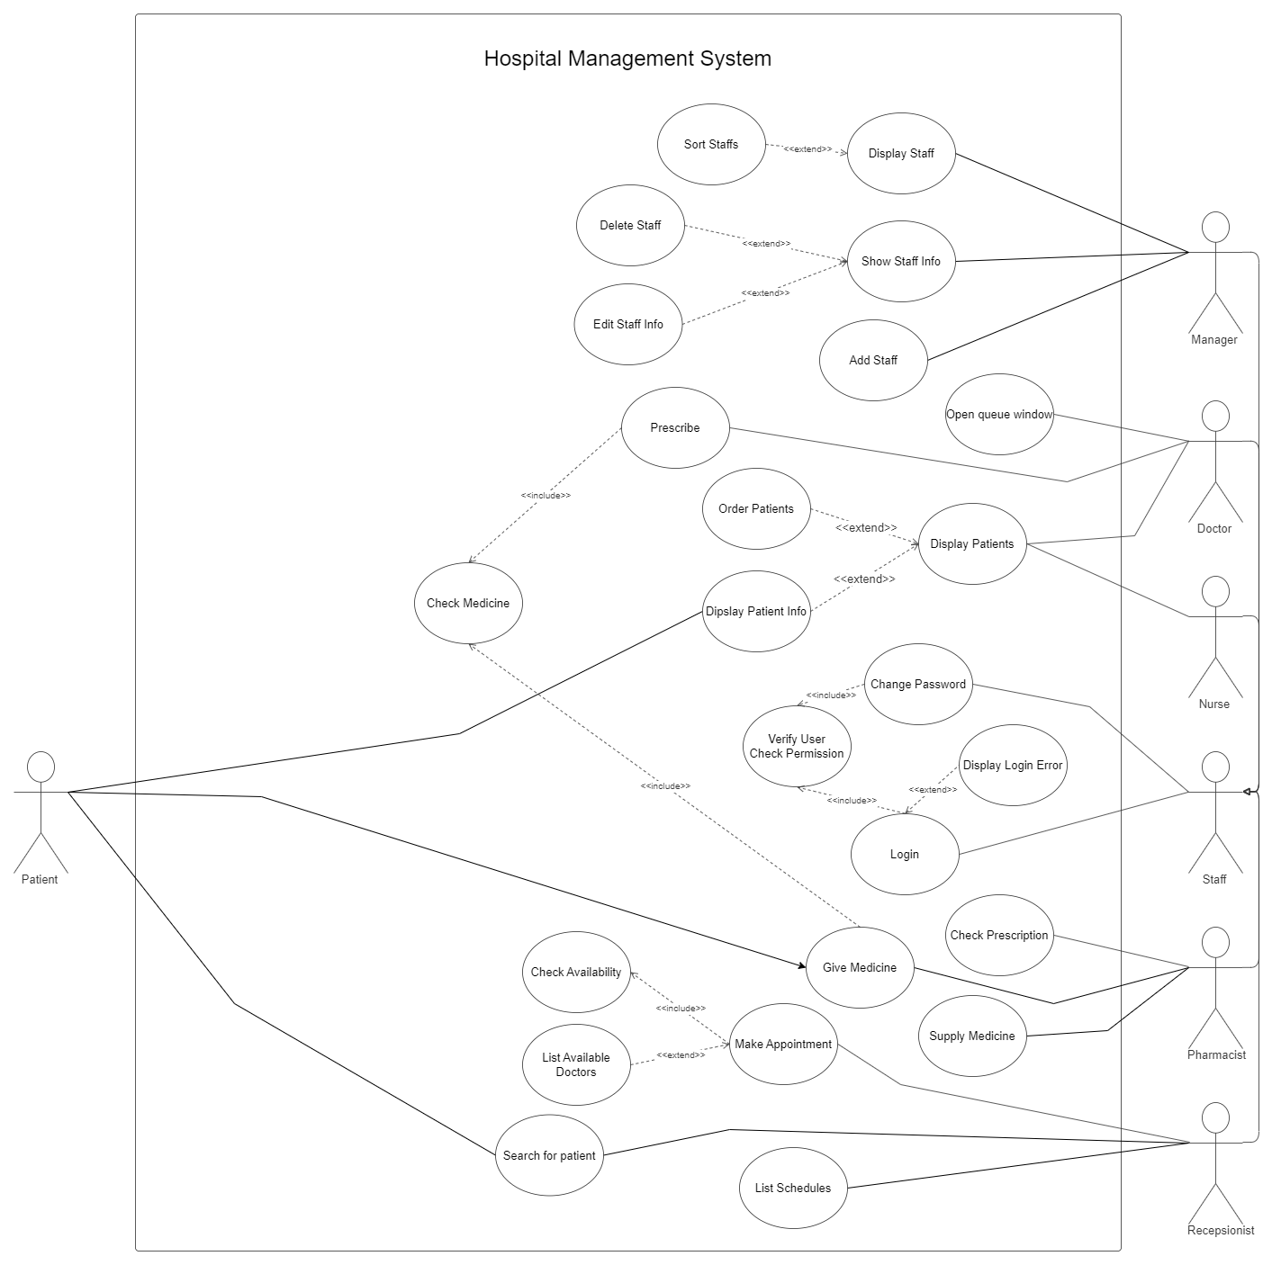

In the use case diagram shown that possible use cases with the relevant actors. There is lots of use cases for the hospital management system like make appointment, prescription, controlling medicine supply, managing staff, etc. In every use case, if needed the include and extend situations added. Covered all use cases to make the system user-friendly.

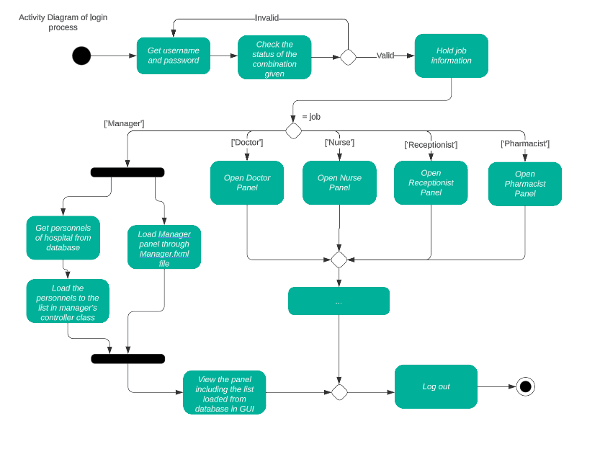
This activity diagram shows the main flow of how our GUI works while logging in/out. As mentioned in the homework description, we kept the diagram simple by showing the manager part only. However, the main idea is similar. Firstly, we check the login combination. If the combination is present, the program opens the related panel according to the user’s profession. When the user presses the log-out button, he/she will be directed to the login panel again.

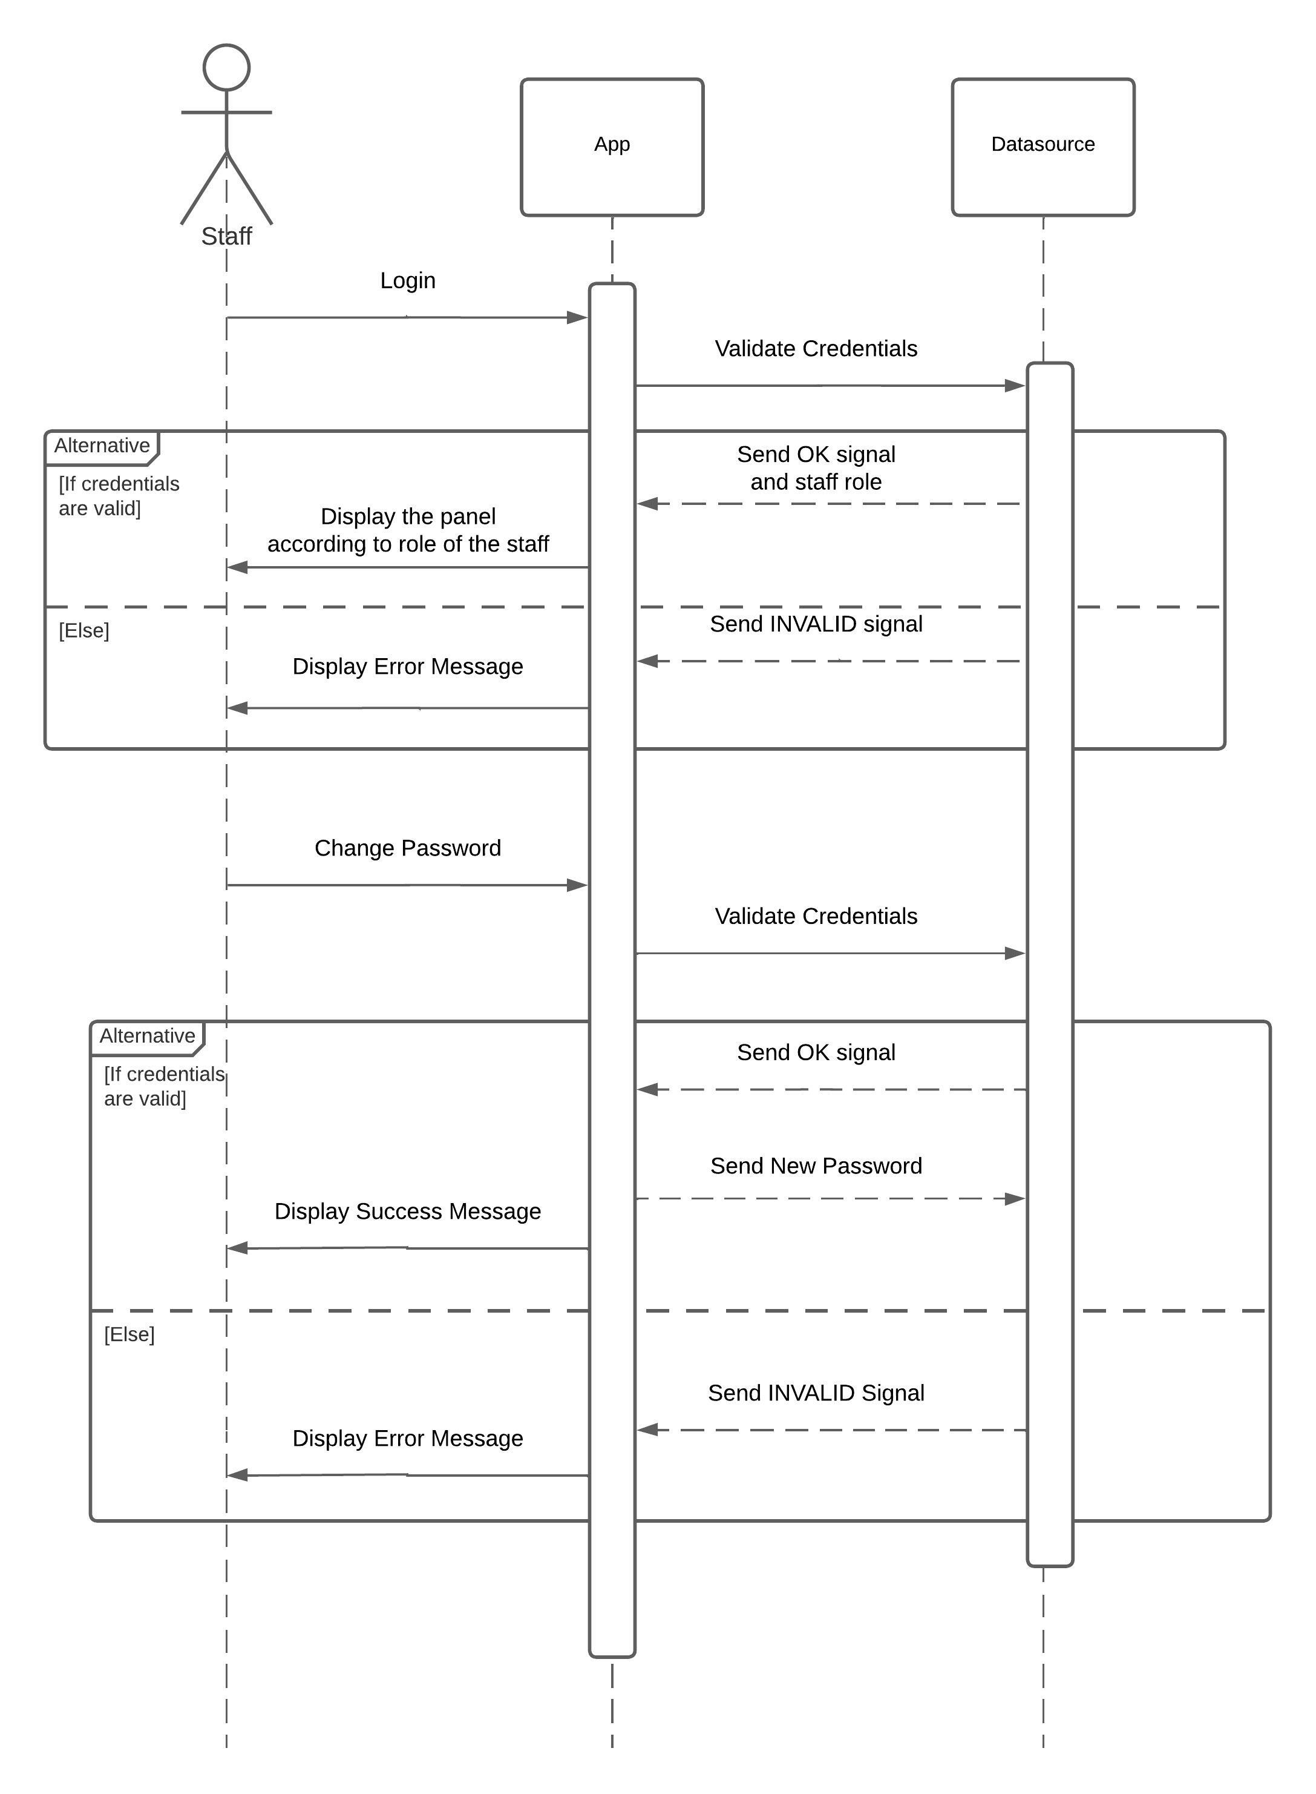
The sequence diagram above shows the login and password changing process in the newly opened application. The Datasource class represents our database and is a singleton, thus it will always be active as long as the application is active.

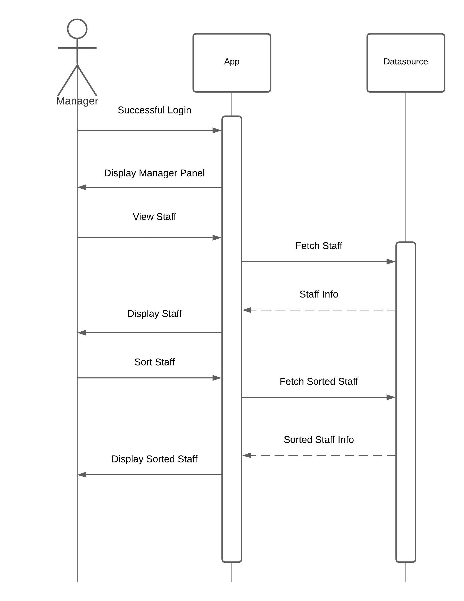
The sequence diagram above shows the steps to display the staff information to the manager. The application can list the staff and sort them for the given criteria.

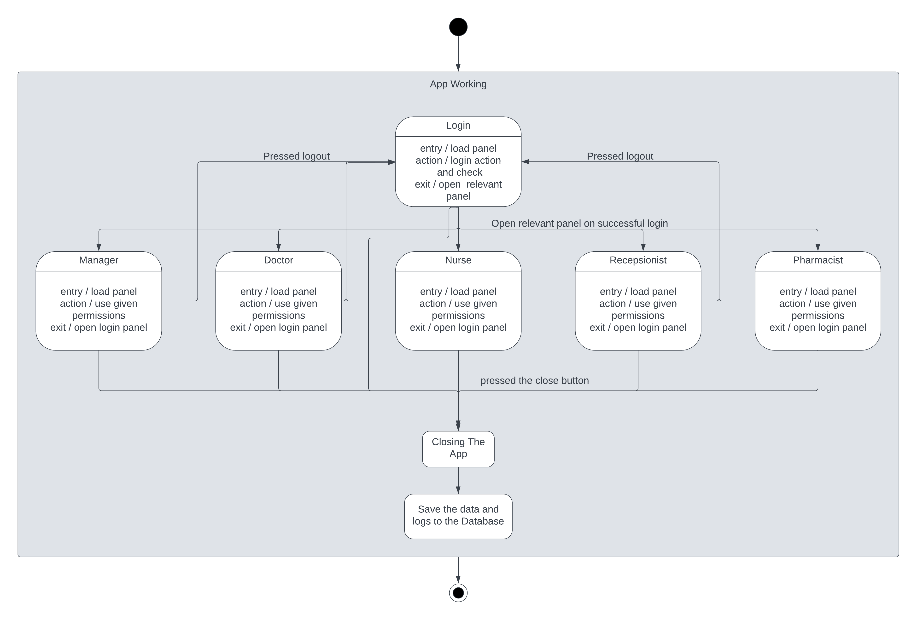
This diagram shows the state diagram. Every state showed while app working in the diagram from initialization to the termination of the program. Indicated every following state with the arrows with the required event. Specified every action in each state with entry, action, exit tags.

CHAPTER FOUR
IMPLEMENTATION

We used JavaFX library for the GUI (Graphical User Inteface) and SQLite for the database.

Data Types:
Every data that is stored in the database have their own classes in the Java code. Every class that represents a person, such as the Staff and Patient, inherits the Person abstract class. And every class that represents a staff member, such as the Doctor and Nurse, inherits the Staff abstract class, which also inherits the Person abstract class. For the data that can only have specific values, such as blood type and gender have their own enums, and some of them contain logic operations.
Datasource object is a singleton, and it handles the connection to the database and other database operations, such as searching, modifiying, and adding data. SQLite library is used for these operations.
MedicineSupply object is also a singleton, and it handles the operations for the medicine inventory. The data is stored in a TreeMap, which holds Medicine as key and SupplyItem as value. SupplyItem is an inner class of the MedicineSupply and holds a Medicine and the medicine amount in the stock as its values. It is created to make representing the MedicineSupply in a TableView easier.
Receipt class represents a receipt prescribed by a doctor. Even though it represents something different, its inner workings are similar to the MedicineSupply. The data is stored in a TreeMap, which holds Medicine as key and ReceiptItem as value. ReceiptItem is an inner class of the Receipt and holds a Medicine and the medicine amount as its values. It is created to make representing a Receipt in a TableView easier.
Medicine class represents a medicine. It has an id, type, and name.
Patient class represents a patient and inherits the Person abstract class. It has extra fields such as the blood type and priority on top of the existing ones in the Person.
Contact represents the contact information of a staff member.
Manager represents a manager of the hospital.
Doctor represents a doctor of the hospital.
Nurse represents a nurse of the hospital.
Pharmacist represents a pharmacist of the hospital.
Receptionist represents a receptionist of the hospital.

Graphical User Interface and Logic:
For every panel we have a controller class and a scene FXML file. For example, for a doctor panel we have a DoctorController.java file and a DoctorScene.fxml file. While FXML files describe how a scene looks, the controller classes describe how a scene acts. Items in a scene file have an id and they are linked to their counterparts in the controller classes with an @FXML tag.
We used TableViews to display lists of items and CellValueFactroys to display their fields. In all TableViews, an ObservableList is passes to them. ObservableList allow us to update the TableView whenever the list changes.
Our main function is in the App class and it calls the launch function that is inhereted from the Application class from the JavaFX library. launch calls the init and start functions, which are inherated and overriden by the App class, from the Application class. init initializes the Datasource and the start sets up the GUI.
Initial scene of our application is the LoginScene, it has two TextFields and and Login Button. When the Login Button is pressed Datasource looks up if the inputs in the TextFields match to a registered staff member. If it does, it opens the panel according to the user’s job; if it does not match to a registered staff member, then an error message will be displayed.
Every staff scene has a Log out and a Profile item at their MenuBar. Log out calls the logout function, which logs out and loads the LoginScreen. Profile calls showProfileDialog function, which creates a ProfileViewBuilder object and calls its showProfileView function. showProfileView creates and displays a Dialog object that shows the details of the logged in staff member. The logic of this Dialog is handled by the ProfileController class. If the user clicks the Edit Button on the Dialog a new Dialog filled with TextField will open up. This new Dialog allows the user to change their account details, and also is controlled by the ProfileController. If the user chooses to apply their changes, then the changes will be applied to the database via the Datasource object.
The ManagerScene displays all staff members of the hospital via a TableView. Different staff members of different roles are displayed under separate tabs via a TabPane. Manager can add new staff members and modify their information with the MenuBar items. The menu for adding new staff members is displayed in a Dialog, it has TextFields for the information that must be entered manualy, Spinner for integer values, and ComboBoxes for predefined values. The menu for adding modify staff information is displayed in a Dialog similar to one for adding new staff members, it has TextFields for the information that must be entered manualy, Spinner for integer values, and ComboBoxes for predefined values.
The DoctorScene displays the patients that are assigned to them via a TableView. Doctors can view the details of the patients and prescribe medicine to them via the items at the MenuBar. Patient details are displayed with a Dialog; its design is in the PatientData.fxml and its logic is in the PatientDataController.java. Prescribe menu is also a Dialog, whose design is in the PatientPrescribe.fxml and logic is in the PatientPrescribeController.java. Prescribe menu has ComboBoxes that allow the doctor to select the medicine they want, a Spinner with integer values, a Button to add the selected medicine and its amount as a ReceiptItem, and a TableView to view the added ReceiptItems. Receipts are added to the database via the Datasource.
The NurseScene displays the patients that are assigned to them via a TableView. Nurses can view the details of the patients. Patient details are displayed the same way they are displayed to a doctor.
The PharmacistScene displays the medicine in the stock and the receipts via TableViews in two different tabs of a TabPane. Pharmacists can add new medicine to the inventory, supply stock, decrease stock, view receipts, and dispense medicine to prescribed patients. All of these options open a new Dialog that wants the user to enter values and have their own controller classes. The changes that are made to the stock are updated in the MedicineSupply and the Datasource.
The ReceptionistScene displays the patients that are not assigned to a doctor yet via a TableView. The receptionist can register new patients, assign doctors to patients that are not assigned to a doctor yet, or deny them. Also can preview selected patient data.

Design Patterns Used:
Singleton:
    - The Datasource object is the one that communicates with the database and is a singleton.
    - The MedicineSupply object is the one that stores and organizes the medicine inventory and is a singleton.
Observer:
    - All TableView objects are updated with the use of an ObservableList.

CHAPTER FIVE
CONCLUSION AND FUTURE WORKS
In conclusion, and for next projects, there are a number of system improvements that might be done, including the incorporation of a mobile application. Patients, physicians, and pharmacists may all have access to a number of useful features by integrating a mobile app into the system. These characteristics might include, among others:
Appointment management: Patients may make, change, or cancel appointments with doctors via the mobile app. Patients may manage their healthcare on the road thanks to this function, which would provide them freedom.
Limit on the number of patients a doctor can see each day: The mobile app may have a feature that allows doctors to establish a daily cap on the number of patients they may see. This guarantees the best possible patient care while assisting doctors in successfully managing their workload.
Medication management and prescription reminders: Patients can use the mobile app to get reminders to take their prescription prescriptions on time. They may use the app to remember to take their meds, follow dose recommendations, and receive refill notifications.
Online consultations and virtual appointments: Patients may schedule virtual visits with doctors thanks to the smartphone app, which can ease online consultations. Patients who have trouble physically attending the healthcare center would benefit most from this service.
Integration of a secure payment system: The mobile app may have a payment system that enables users to pay for goods and services directly from their mobile devices. This makes the payment procedure easier and gives patients a practical choice.
The system can provide a complete and user-friendly solution for patients, physicians, and pharmacists by incorporating these functions into a mobile application. It would create a cohesive healthcare experience, improve accessibility, increase patient participation, and streamline administrative processes.

