#Creating combined dataframe

x_train = train_data.drop(['Survived', 'Died'], axis=1)

y_train = train_data['Survived']

x_test = test_data

#cobining the dataframes

df_combined = x_train.append(x_test)

df_combined.shape

train_data = pd.read_csv("/kaggle/input/titanic/train.csv")

test_data = pd.read_csv("/kaggle/input/titanic/test.csv")

train_data["Age"] = train_data["Age"].fillna(train_data.describe()["Age"]["mean"])

test_data["Age"] = test_data["Age"].fillna(test_data.describe()["Age"]["mean"])

train_data['Age']=train_data['Age'].astype(np.float64)

train_data["Fare"] = train_data["Fare"].fillna(train_data.describe()["Fare"]["mean"])

test_data["Fare"] = test_data["Fare"].fillna(test_data.describe()["Fare"]["mean"])

train_data['Fare']=train_data['Fare'].astype(int)

train_data.head(5)

#women survival

**women = train_data[train_data.Sex == 'female']["Survived"]**

#men survival

**men = train_data[train_data.Sex == 'male']["Survived"]**

print("Survival rate for women is {:.2f} and for men is {:.2f}".format((sum(women)/len(women))*100, (sum(men)/len(men))*100))

train_data = pd.read_csv("/kaggle/input/titanic/train.csv")

data = train_data

data['Died'] = 1 - data['Survived']

fig = go.Figure(data=[

go.Bar(name='Survived', x=data['Sex'], y=[data[data.Sex==data['Sex'][0]]['Survived'].agg(sum), data[data.Sex==data['Sex'][1]]['Survived'].agg(sum)], marker_color='#EB89B5', opacity=0.75),

go.Bar(name='Died', x=data['Sex'], y=[data[data.Sex==data['Sex'][0]]['Died'].agg(sum), data[data.Sex==data['Sex'][1]]['Died'].agg(sum)], marker_color='#330C73', opacity=0.75)

])

fig.update_layout(barmode='stack', width=600, title_text='Survivors categorized as Male/Female', xaxis_title_text='Sex', yaxis_title_text='Number of passangers')

fig.show()

metin içeren bir resim

Açıklama otomatik olarak oluşturuldu

facet_data = data[['Sex', 'Survived', 'Embarked', 'Pclass', 'Fare']].groupby(['Sex', 'Survived', 'Embarked', 'Pclass']).agg('sum').reset_index()

fig = px.bar(facet_data, x='Sex', y='Fare', facet_row='Survived', facet_col='Pclass', color='Embarked', barmode='group')

fig.update_layout(title_text='Different view of Passenger survival with respect to Fare, Embarked and Pclass')

fig.show()

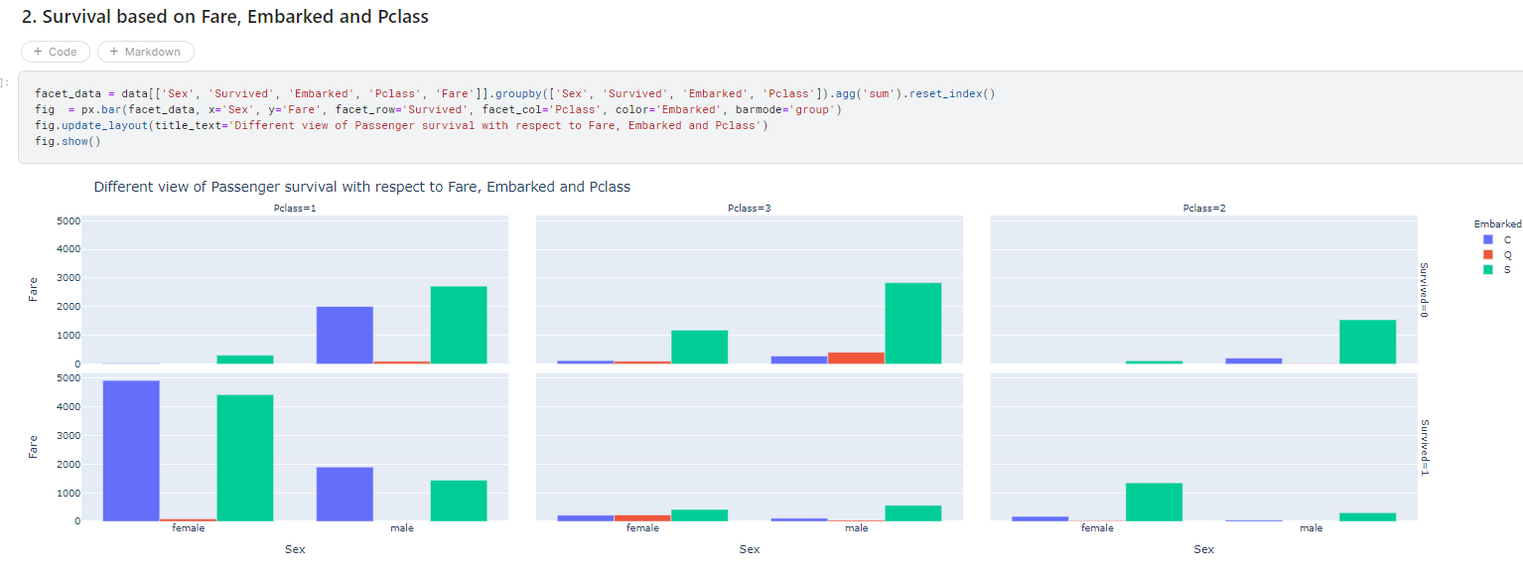

fig = go.Figure()

fig.add_trace(go.Violin(x=data['Sex'][data['Survived']==1], y=data['Age'][data['Survived']==1],

name='Survived', side='negative', legendgroup='Survived', scalegroup='Survived', line_color='blue'))

fig.add_trace(go.Violin(x=data['Sex'][data['Died']==1], y=data['Age'][data['Died']==1],

name='Died', side='positive', legendgroup='Died', scalegroup='Died', line_color='dark orange'))

fig.update_traces(meanline_visible=True, width=1)

fig.update_layout(violingap=0, violinmode='overlay', width=700, title_text='Survivors categorized as Male/Female related to their Age', xaxis_title_text='Sex', yaxis_title_text='Age of passangers')

fig.show()

data['Survived'] = data['Survived'].astype(str)

fig_scatter = px.scatter(data, x='Fare', y='Age', color='Survived', facet_col='Sex')

fig_scatter.update_layout(width=800, title_text='Survivors categorized as Male/Female', yaxis_title_text='Age of passangers')

fig_scatter.show()

data['Survived'] = data['Survived'].astype(int)

fig_scatter_plane = go.Figure()

fig_scatter_plane.add_trace(go.Scatter(x=data[data['Survived']==1]['Age'], y=data[data['Survived']==1]['Fare'],

mode='markers', name='Survived', marker=dict(size=data[data['Survived']==1]['Fare']/8)))

fig_scatter_plane.add_trace(go.Scatter(x=data[data['Died']==1]['Age'], y=data[data['Died']==1]['Fare'],

mode='markers', name='Died', marker=dict(size=data[data['Died']==1]['Fare']/8)))

fig_scatter_plane.update_layout(title_text='Scatter representing relation between Fare and Age of passangers',

xaxis_title_text='Age', yaxis_title_text='Fare')

fig_scatter_plane.show()

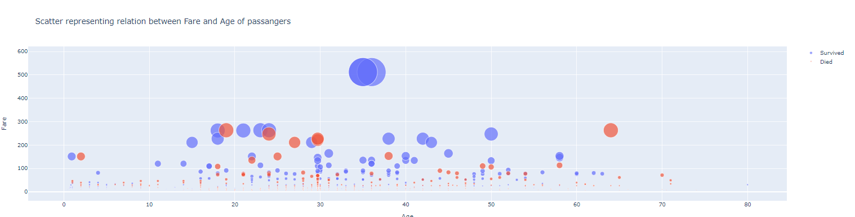

#Creating combined dataframe

x_train = train_data.drop(['Survived', 'Died'], axis=1)

y_train = train_data['Survived']

x_test = test_data

#cobining the dataframes

df_combined = x_train.append(x_test)

df_combined.shape

#creating funtion for creating categories based on family size

def family_size():

global df_combined

df_combined['FamilySize'] = df_combined['Parch'] + df_combined['SibSp'] + 1

#feature to decide family size

df_combined['Singleton'] = df_combined['FamilySize'].map(lambda s: 1 if s == 1 else 0)

df_combined['SmallFamily'] = df_combined['FamilySize'].map(lambda s: 1 if 2 <= s <= 4 else 0)

df_combined['LargeFamily'] = df_combined['FamilySize'].map(lambda s: 1 if 5 <= s <= 8 else 0)

return df_combined

df_combined = family_size()

df_combined.head()

#Separating the train and test dataframes

x_train = df_combined[:891].copy()

x_test = df_combined[891:].copy()

x_test.reset_index(inplace=True, drop=True)

x_train.shape, x_test.shape

random_forest = RandomForestClassifier()

random_forest.fit(x_train, y_train)

y_pred_random_forest = random_forest.predict(x_test)

random_forest_accuracy = round(random_forest.score(x_train, y_train)*100, 2)

log_regres = LogisticRegression()

log_regres.fit(x_train, y_train)

y_pred_log_regres = log_regres.predict(x_test)

log_regres_accuracy = round(log_regres.score(x_train, y_train)*100, 2)

knn = KNeighborsClassifier(n_neighbors=3)

knn.fit(x_train, y_train)

y_pred_knn = knn.predict(x_test)

knn_accuracy = round(knn.score(x_train, y_train)*100, 2)

gaussian = GaussianNB()

gaussian.fit(x_train, y_train)

y_pred_gaussian = gaussian.predict(x_test)

gaussian_accuracy = round(gaussian.score(x_train, y_train)*100, 2)

perceptron = Perceptron()

perceptron.fit(x_train, y_train)

y_pred_perceptron = perceptron.predict(x_test)

perceptron_accuracy = round(perceptron.score(x_train, y_train)*100, 2)

tree = DecisionTreeClassifier()

tree.fit(x_train, y_train)

y_pred_tree = tree.predict(x_train)

tree_accuracy = round(tree.score(x_train, y_train)*100, 2)

train_df[['Pclass', 'Survived']].groupby(['Pclass'], as_index=False).mean().sort_values(by='Survived', ascending=False)

Out[9]:

train_df[["Sex", "Survived"]].groupby(['Sex'], as_index=False).mean().sort_values(by='Survived', ascending=False)

Out[10]:

train_df[["SibSp", "Survived"]].groupby(['SibSp'], as_index=False).mean().sort_values(by='Survived', ascending=False)

Out[11]:

*# grid = sns.FacetGrid(train_df, col='Pclass', hue='Survived')*

grid = sns.FacetGrid(train_df, col='Survived', row='Pclass', size=2.2, aspect=1.6)

grid.map(plt.hist, 'Age', alpha=.5, bins=20)

grid.add_legend();

*# grid = sns.FacetGrid(train_df, col='Embarked', hue='Survived', palette={0: 'k', 1: 'w'})*

grid = sns.FacetGrid(train_df, row='Embarked', col='Survived', size=2.2, aspect=1.6)

grid.map(sns.barplot, 'Sex', 'Fare', alpha=.5, ci=None)

grid.add_legend()

X_train = train_df.drop("Survived", axis=1)

Y_train = train_df["Survived"]

X_test = test_df.drop("PassengerId", axis=1).copy()

X_train.shape, Y_train.shape, X_test.shape

*# Logistic Regression*

logreg = LogisticRegression()

logreg.fit(X_train, Y_train)

Y_pred = logreg.predict(X_test)

acc_log = round(logreg.score(X_train, Y_train) * 100, 2)

acc_log

coeff_df = pd.DataFrame(train_df.columns.delete(0))

coeff_df.columns = ['Feature']

coeff_df["Correlation"] = pd.Series(logreg.coef_[0])

coeff_df.sort_values(by='Correlation', ascending=False)

*# Support Vector Machines*

svc = SVC()

svc.fit(X_train, Y_train)

Y_pred = svc.predict(X_test)

acc_svc = round(svc.score(X_train, Y_train) * 100, 2)

acc_svc

knn = KNeighborsClassifier(n_neighbors = 3)

knn.fit(X_train, Y_train)

Y_pred = knn.predict(X_test)

acc_knn = round(knn.score(X_train, Y_train) * 100, 2)

acc_knn

*# Gaussian Naive Bayes*

gaussian = GaussianNB()

gaussian.fit(X_train, Y_train)

Y_pred = gaussian.predict(X_test)

acc_gaussian = round(gaussian.score(X_train, Y_train) * 100, 2)

acc_gaussian

*# Perceptron*

perceptron = Perceptron()

perceptron.fit(X_train, Y_train)

Y_pred = perceptron.predict(X_test)

acc_perceptron = round(perceptron.score(X_train, Y_train) * 100, 2)

acc_perceptron

*# Linear SVC*

linear_svc = LinearSVC()

linear_svc.fit(X_train, Y_train)

Y_pred = linear_svc.predict(X_test)

acc_linear_svc = round(linear_svc.score(X_train, Y_train) * 100, 2)

acc_linear_svc

*# Decision Tree*

decision_tree = DecisionTreeClassifier()

decision_tree.fit(X_train, Y_train)

Y_pred = decision_tree.predict(X_test)

acc_decision_tree = round(decision_tree.score(X_train, Y_train) * 100, 2)

acc_decision_tree

*# Random Forest*

random_forest = RandomForestClassifier(n_estimators=100)

random_forest.fit(X_train, Y_train)

Y_pred = random_forest.predict(X_test)

random_forest.score(X_train, Y_train)

acc_random_forest = round(random_forest.score(X_train, Y_train) * 100, 2)

acc_random_forest

for dataset **in** combine:

dataset['Title'] = dataset.Name.str.extract(' ([A-Za-z]+)\.', expand=False)

pd.crosstab(train_df['Title'], train_df['Sex'])

for dataset **in** combine:

dataset['Title'] = dataset['Title'].replace(['Lady', 'Countess','Capt', 'Col',\

'Don', 'Dr', 'Major', 'Rev', 'Sir', 'Jonkheer', 'Dona'], 'Rare')

dataset['Title'] = dataset['Title'].replace('Mlle', 'Miss')

dataset['Title'] = dataset['Title'].replace('Ms', 'Miss')

dataset['Title'] = dataset['Title'].replace('Mme', 'Mrs')

train_df[['Title', 'Survived']].groupby(['Title'], as_index=False).mean()

title_mapping = {"Mr": 1, "Miss": 2, "Mrs": 3, "Master": 4, "Rare": 5}

for dataset **in** combine:

dataset['Title'] = dataset['Title'].map(title_mapping)

dataset['Title'] = dataset['Title'].fillna(0)

train_df.head()

train_df = train_df.drop(['Name', 'PassengerId'], axis=1)

test_df = test_df.drop(['Name'], axis=1)

combine = [train_df, test_df]

train_df.shape, test_df.shape

for dataset **in** combine:

dataset['Sex'] = dataset['Sex'].map( {'female': 1, 'male': 0} ).astype(int)

train_df.head()

*# grid = sns.FacetGrid(train_df, col='Pclass', hue='Gender')*

grid = sns.FacetGrid(train_df, row='Pclass', col='Sex', size=2.2, aspect=1.6)

grid.map(plt.hist, 'Age', alpha=.5, bins=20)

grid.add_legend()

for dataset **in** combine:

for i **in** range(0, 2):

for j **in** range(0, 3):

guess_df = dataset[(dataset['Sex'] == i) & \

(dataset['Pclass'] == j+1)]['Age'].dropna()

*# age_mean = guess_df.mean()*

*# age_std = guess_df.std()*

*# age_guess = rnd.uniform(age_mean - age_std, age_mean + age_std)*

age_guess = guess_df.median()

*# Convert random age float to nearest .5 age*

guess_ages[i,j] = int( age_guess/0.5 + 0.5 ) * 0.5

for i **in** range(0, 2):

for j **in** range(0, 3):

dataset.loc[ (dataset.Age.isnull()) & (dataset.Sex == i) & (dataset.Pclass == j+1),\

'Age'] = guess_ages[i,j]

dataset['Age'] = dataset['Age'].astype(int)

train_df.head()

train_df['AgeBand'] = pd.cut(train_df['Age'], 5)

train_df[['AgeBand', 'Survived']].groupby(['AgeBand'], as_index=False).mean().sort_values(by='AgeBand', ascending=True)

for dataset **in** combine:

dataset.loc[ dataset['Age'] <= 16, 'Age'] = 0

dataset.loc[(dataset['Age'] > 16) & (dataset['Age'] <= 32), 'Age'] = 1

dataset.loc[(dataset['Age'] > 32) & (dataset['Age'] <= 48), 'Age'] = 2

dataset.loc[(dataset['Age'] > 48) & (dataset['Age'] <= 64), 'Age'] = 3

dataset.loc[ dataset['Age'] > 64, 'Age']

train_df.head()

train_df = train_df.drop(['AgeBand'], axis=1)

combine = [train_df, test_df]

train_df.head()

for dataset **in** combine:

dataset['FamilySize'] = dataset['SibSp'] + dataset['Parch'] + 1

train_df[['FamilySize', 'Survived']].groupby(['FamilySize'], as_index=False).mean().sort_values(by='Survived', ascending=False)

for dataset **in** combine:

dataset['IsAlone'] = 0

dataset.loc[dataset['FamilySize'] == 1, 'IsAlone'] = 1

train_df[['IsAlone', 'Survived']].groupby(['IsAlone'], as_index=False).mean()

train_df = train_df.drop(['Parch', 'SibSp', 'FamilySize'], axis=1)

test_df = test_df.drop(['Parch', 'SibSp', 'FamilySize'], axis=1)

combine = [train_df, test_df]

train_df.head()

for dataset **in** combine:

dataset['Age*Class'] = dataset.Age * dataset.Pclass

train_df.loc[:, ['Age*Class', 'Age', 'Pclass']].head(10)

for dataset **in** combine:

dataset['Embarked'] = dataset['Embarked'].fillna(freq_port)

train_df[['Embarked', 'Survived']].groupby(['Embarked'], as_index=False).mean().sort_values(by='Survived', ascending=False)

for dataset **in** combine:

dataset['Embarked'] = dataset['Embarked'].map( {'S': 0, 'C': 1, 'Q': 2} ).astype(int)

train_df.head()

test_df['Fare'].fillna(test_df['Fare'].dropna().median(), inplace=True)

test_df.head()

train_df['FareBand'] = pd.qcut(train_df['Fare'], 4)

train_df[['FareBand', 'Survived']].groupby(['FareBand'], as_index=False).mean().sort_values(by='FareBand', ascending=True)

for dataset **in** combine:

dataset.loc[ dataset['Fare'] <= 7.91, 'Fare'] = 0

dataset.loc[(dataset['Fare'] > 7.91) & (dataset['Fare'] <= 14.454), 'Fare'] = 1

dataset.loc[(dataset['Fare'] > 14.454) & (dataset['Fare'] <= 31), 'Fare'] = 2

dataset.loc[ dataset['Fare'] > 31, 'Fare'] = 3

dataset['Fare'] = dataset['Fare'].astype(int)

train_df = train_df.drop(['FareBand'], axis=1)

combine = [train_df, test_df]

train_df.head(10)