Lesson Plan Structure: The Physics of Motion

Goal: To understand the relationship between distance, time, and speed. Duration: 30–40 minutes. Materials: A tape measure (or a ruler), a stopwatch (phone app), a small toy car or ball, and a notebook/tablet for data.

1. Introduction (5 minutes)
- Define Terms Simply:
  - Distance: How far something travels.
  - Time: How long it takes.
  - Speed: How fast the object is moving (Speed=Distance÷Time).
- Visual Anchor: Show a video or picture of something they are interested in (e.g., a high-speed train, a fast-moving animal, or a character from a game) and ask: "How do we know if this is going fast?"

2. The Experiment: "The Hallway Race" (15–20 minutes)
(See details below)

3. Data Processing (10 minutes)
- Structure: Create a simple 3-column table: Distance | Time | Speed.
- Calculations: Guide them through the division. If math is a source of frustration, use a calculator and focus on the relationship (e.g., "If the time gets smaller, the speed gets bigger").

4. Reflection (5 minutes)
- Ask: "What happened when we pushed the car harder?" (Increased force = increased speed).
- Ask: "Is it easier to measure speed if the distance is very short or very long?"

At-Home Experiment: "The Constant Velocity Track"
This experiment focuses on consistency, which helps build a sense of logic and predictability.
Setup:
- Mark the Track: Use masking tape to mark a straight line on the floor. Mark a "Start" line and an "End" line exactly 2 meters apart.
- The Constant Push: Teach the student to give the toy car a consistent "push" (you can even use a slanted cardboard ramp to ensure the push is identical every time).
The Process:
- Trial 1: Push the car. Record the time it takes to travel from Start to End.
- Trial 2: Repeat with the exact same push. Record the time.
- Trial 3: Push the car much harder. Record the time.
The "Aha!" Moment: Compare the times.
- The Logic: Even though the distance stayed the same (2 meters), the time changed because the speed changed.
- The Visualization: Use a piece of string to represent the "time" of the slow trial and the "time" of the fast trial. Laying them side-by-side makes the abstract concept of "velocity" visible.

Teaching Tips for Success
- Reduce Sensory Overload: If the stopwatch sound is distracting, use a silent digital timer or a visual countdown app.
- Allow for Repetition: If the student finds the predictability of the car moving at the same speed calming, lean into that! Repetition is a fantastic tool for learning.
- Focus on the "Why": If they are analytical, talk about Friction. Ask: "Why did the car eventually stop? What would happen if we did this on a carpet instead of a wood floor?" This introduces a new variable that changes the outcome in a logical way.

This adjustment focuses on the physical, tactile, and visual experience of motion. By moving away from immediate number-crunching and toward sensory engagement, we allow the learner to "feel" the physics before analyzing it.

Revised Lesson Plan: The Sensory Physics of Motion
Goal: To observe and feel how force and surface friction change the way an object moves. Duration: 30–40 minutes. Materials: Toy car, cardboard ramp (to provide a consistent starting push), and three different floor surfaces (e.g., bare floor, a yoga mat/rug, and a towel).

1. Sensory Introduction (5 minutes)
- Tactile Check: Before starting the experiment, have the student touch the three different surfaces.
- Discussion: Ask, "Which one feels rough? Which one feels smooth?" Explain that this feeling is called Friction, and it is like "invisible hands" trying to slow the car down.

2. The Experiment: "The Surface Challenge" (20 minutes)
- The Setup: Place the ramp at a fixed height. Use the tape to mark the "Start" (bottom of the ramp) and the "End" (where the car stops).
- Observe:
  - Push the car down the ramp onto the hard floor. Watch how far it goes.
  - Push the car down the ramp onto the rug. Watch how it stops faster.
  - Push the car down the ramp onto the towel. Watch the difference in motion.

3. Sensory Recording (10 minutes)
Instead of a table of numbers, create a "Motion Map":
- Draw a line representing the car's path for each surface.
- Use a long, thin line for the hard floor (fast/far).
- Use a shorter, thicker, or "jiggly" line for the towel (slow/short).
- Why: This uses visual and kinesthetic memory to represent speed and friction.

4. Reflection (5 minutes)
- Ask: "Which surface 'grabbed' the car the most?"
- Ask: "If the car were a person in running shoes, which surface would be the easiest to run on?"

Sensory-Focused Experiment: "The Stop-Motion Feel"
This experiment focuses on the sensation of motion.
The Setup:
- The "Push" Test: Have the student push the car with their own hand.
- Sensory Focus: Ask the student to focus on the resistance they feel in their hand when pushing the car on the towel vs. the floor.
- The "Slow-Motion" Observation: Record a 5-second video on your phone of the car rolling on the towel, then play it back in slow motion.
Why this works for sensory learners:
- Visual Processing: Playing the video in slow motion removes the "blur" of fast movement and lets the student see exactly how the wheels interact with the surface.
- Kinesthetic Feedback: Feeling the friction in their own hand helps them understand that "speed" is not just a number, but a relationship between force and resistance.
- Removing Pressure: By focusing on the feeling and the visual rather than the math, you reduce the anxiety that can sometimes come with "test-like" schoolwork.

Tips for a Sensory-Friendly Environment:
- Control the Input: If the car makes a loud sound on the hard floor, you can place a thin cloth under the track to dampen the noise while still allowing the car to move.
- Narrate the Physics: Use descriptive language like: "Look how the rough towel creates friction and pulls the car to a stop," or "The smooth floor lets the car glide without resistance."
- Respect the Interest: If the student enjoys the sensation of the car moving, let them explore the motion for as long as they need before moving to the observation phase.

To help visualize how motion works, we can use a "Factors of Motion" box diagram. This is a simple, logical way to see how different "inputs" combine to create the "output" (movement).

The "Factors of Motion" Diagram
Think of motion as a system. If you want to change how something moves, you have to adjust the parts of this system.
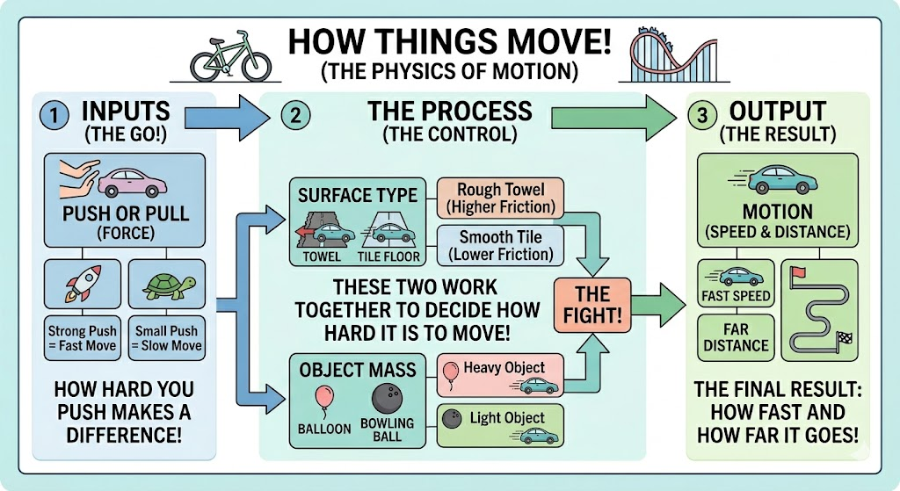

Step-by-Step Reasoning
Here is the logic behind the diagram, broken down simply:
- The Input (Force): This is the "Go" button. The harder you push or pull the object, the more energy you give it to start moving.
- The Modifiers (Friction & Mass): These are the "Controllers." They decide how easy or hard that movement is:
  - Friction (Surface Type): Think of this as "invisible hands" on the ground. A carpet has "stronger" hands (high friction) than a smooth floor, so it grabs the object and slows it down more.
  - Mass (Weight): Heavier objects have more "laziness" (inertia). They are harder to get moving and harder to stop once they are going.
- The Output (Motion): This is the final result. If your Input is strong and your Modifiers are smooth (low friction), the Motion will be fast and long.

How to use this for teaching:
- Logical Interaction: Explain that you can play with the diagram. Ask: "What happens if we keep the same Push, but change the Surface from floor to carpet?" The student can visualize that the Friction box gets "bigger," which forces the Motion box to get "smaller."
- Visualizing the Box: You can draw this on paper using sticky notes. Use different colored notes for each input. If she wants to make the car go faster, have her move the "Push" sticky note higher or swap the "Carpet" note for a "Smooth Floor" note.
- Internal Components:
  - Force acts as the engine.
  - Friction acts as the brake.

  - Mass acts as the anchor.

