Lesson Plan: The Balancing Act of Electricity
Goal: To understand how Voltage (V), Current (I), and Resistance (R) work together to control a circuit. Duration: 40–50 minutes.

1. The "Big Three" Definitions (10 minutes)
Keep these analogies consistent so they become "mental anchors":
- Voltage (V - Volts): The "Push." Imagine it as the pressure from a water pump.
- Current (I - Amps): The "Flow." How much water is actually moving through the pipe.
- Resistance (R - Ohms): The "Brake." How much the pipe narrows to slow the water down.

2. The Interactive Puzzle (10 minutes)
Draw the Ohm’s Law Triangle (V at the top, I and R at the bottom).
- Visual Logic: Cover one letter with your finger to see what you need to find. If you want to find Current (I), you have Voltage (V) divided by Resistance (R).
- Sensory Note: Use different colors for each variable to help her distinguish them.

3. The Experiment: "The Dimmer Switch Challenge" (20 minutes)
(See details below)

4. The Logic Check (10 minutes)
- Ask: "What happens to the light if we keep the same battery (Voltage) but add more resistance?" (Answer: The light gets dimmer/Flow slows down).
- Ask: "What happens if we increase the battery size (Voltage)?" (Answer: The light gets brighter/Flow increases).

At-Home Experiment: The Dimmer Switch Challenge
This experiment makes the "invisible" math of Ohm’s Law visible and tactile.
Materials:
- A 3V coin battery (CR2032).
- An LED light.
- Two different resistors: One low-ohm (e.g., 100$\Omega$) and one high-ohm (e.g., 1k$\Omega$). You can buy a cheap variety pack online.
- Alligator clip wires (optional, but very helpful for "hands-off" testing).

The Process:
- Baseline: Connect the LED directly to the battery. Note how bright it is.
- Add the Low Resistance (R): Place the 100$\Omega$ resistor in the path. The light will stay bright, but maybe a tiny bit dimmer.
- Add the High Resistance (R): Swap in the 1k$\Omega$ resistor. The light will become significantly dimmer.
- The "Aha!" Moment: Explain that the battery provided the same "Push" (Voltage), but the resistor acted like an "invisible hand" (Resistance) squeezing the path, which forced the "Flow" (Current) to drop.

Teaching Tips for Success
- Use the "System" Perspective: Autistic learners often thrive when they see how parts of a system interact. Use the diagram provided in the previous interaction as a base: explain that Resistance is a new "Factor Fighting Motion" for electricity.
- Low-Pressure Math: Don't start with long-form division. Use a calculator to confirm the results of the experiment. If she predicts "The light will be dimmer," and the calculation (I=V/R) shows a smaller number, she gets the satisfaction of matching math to reality.
- Sensory-Friendly Environment: If she finds the brightness of the LED overwhelming, use a piece of translucent tape over the bulb to diffuse the light.
- Respect the "Debug": If the light doesn't change as expected, don't worry! This is the best part of science. Use the checklist from the previous lesson to check the "path" before investigating the math.

Ohm’s Law Cheat Sheet: The Balancing Act
Letter | Represents | Icon | What it means
V | Voltage | 🔋 | The Push (Pressure from the battery)
I | Current | 🌊 | The Flow (How fast energy moves)
R | Resistance | 🚧 | The Brake (Anything slowing the flow)

Ohm’s Law Triangle as a visual map
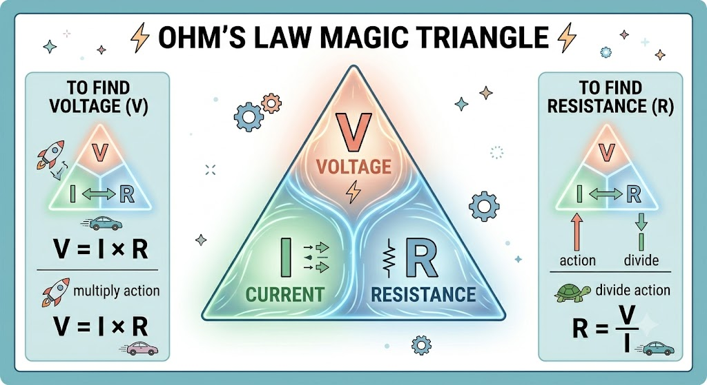
How to read the map:
- Want to find V? Cover V. You are left with I×R (Flow × Brake).
- Want to find I? Cover I. You are left with V÷R (Push ÷ Brake).
- Want to find R? Cover R. You are left with V÷I (Push ÷ Flow).

🧠 Logic "Rules of Thumb"
- If Push (V) stays same, but Brake (R) gets BIGGER: The Flow (I) gets smaller (Light gets dimmer).
- If Push (V) gets BIGGER: The Flow (I) gets faster (Light gets brighter).

