
Leap Motion ControllerTM

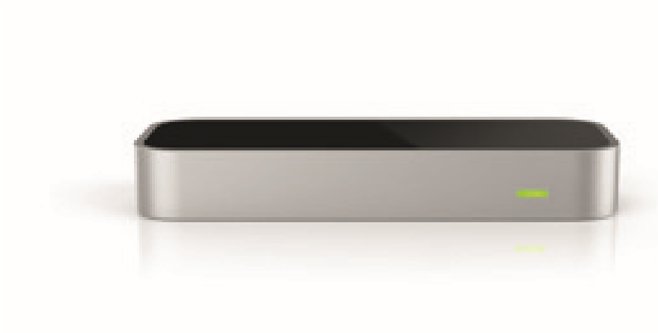
The world’s leading hand tracking technology
The Leap Motion Controller from Ultraleap is an optical hand tracking module that captures the movement of users’ hands and fi ngers so they can interact naturally with digital content. Small, fast, and accurate, the Leap Motion Controlle can be used for productivity applications with Windows computers, integrated into enterprisegrade hardware solutions or displays, or attached to virtual/augmented reality headsets for AR/VR/XR prototyping, research, and development.
The controller is capable of tracking hands within a 3D interactive zone that extends up to 60cm (24”) or more, extending from the device in a 120×150° fi eld of view. Leap Motion‘s software is able to discern 27 distinct hand elements, including bones and joints, and track them even when they are obscured by other parts of the hand. With a 120Hz refresh rate and low-latency software, the time between motion and photon falls beneath the human perception threshold.
An accessory component, the VR Developer Mount, allows for easy, reliable, and consistent attachment of the device to virtual reality headsets such as the Oculus Rift and HTC Vive. The Leap Motion App Gallery features 75+ legacy desktop applications and a demo suite for virtual reality.
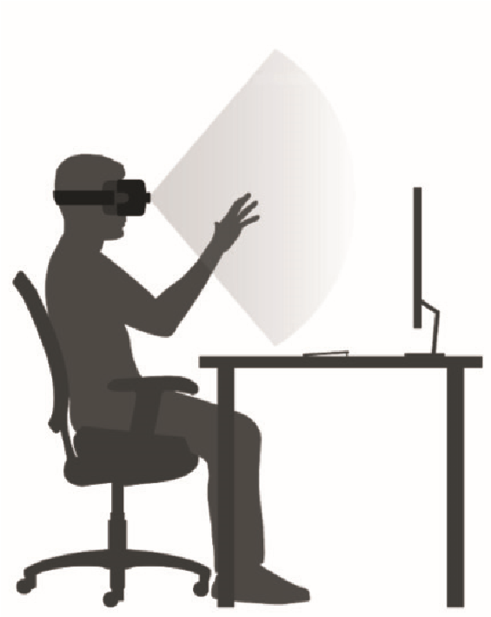
Example applications
 | • | Robotics (bomb disposal, telepresence, robotic controls, AI-
The Leap Motion Controller features a 120×150° fi eld of view and an interactive tracking range of more than 2 feet (60cm). | • | assisted teaching)  Global team collaboration
- Entertainment (location-based VR/AR experiences, arcades, amusement parks)
- Healthcare (stroke rehabilitation, training, mirror, medical imaging, lazy eye treatment)
- Therapy and Education (anatomic visualizations, hands-on learning)
- Personnel training (fl ight simulators, complex computer systems)
- Industrial design and engineering (automotive, assembly lines, facilities management)

Robust and safety compliant
The Leap Motion Controller is certifi ed compliant to safety and electrical regulatory standards. Its robustness and external certifi cation enable commercial projects, including sterile environments.

Easy to integrate and use
The Leap Motion Controller is designed for simple integration into customer applications and can be retro-fi tted to existing concepts or hardware. Plugins for Unity and Unreal enable developers working with two leading 3D development platforms to incorporate hand tracking into their established workfl ow. The Unity integration features:
- Powerful Interaction Engine enabling natural hand/object interactions
- Example scenes with interactive scripts and menus
- Optimized rigged hand models and auto-rigging pipeline for custom hand designs

Specifi cations
 | Height Width Depth Weight
Metric | 13mm | 80mm | 30mm | 32g
Imperial | 0.5" | 3.2" | 1.2" | 1.15oz
Product category: | Specialized sensor
Description: | Leap Motion Controller for hand tracking
Power supply: | USB
Data connection: | USB 2.0 (packaged with USB 2/3 hybrid cable, but can be used with any certifi ed USB cables with the Hi-Speed USB 2.0 logo featured on the packaging)
Ingress protection: | Splash resistant
Mounting methods: | May be placed on a desktop, mounted on a VR headset using the Leap Motion VR Developer Mount, or recessed into a larger hardware installation
Interaction zone: | 60cm (24") or more, extending from the device in a 120×150° fi eld of view  (approximately 8 cubic feet or 0.2 cubic meters of interactive space)
Cameras: | Two 640x240-pixel near-infrared cameras; spaced 40 millimetres apart; with infrared-transparent window, operate in the 850 nanometre +/-25 spectral range; typically operates at 120Hz but hardware is capable of 240+; capable of image capture within 1/2000th of a second
Camera interface: | Experimental Universal Video Class (UVC) release provides access to low-level controls such as LED brightness, gamma, exposure, gain, resolution, etc.; examples in C, Python, and Matlab, as well as OpenCV bindings
LEDs: | Three, spaced on either side and between the cameras, baffl ed to prevent overlaps
Range: | Arm’s length, up to roughly 80 cm; varies depending on hand perspective conditions
Construction: | Aluminium and scratch-resistant glass
Ambient operating temperature: | 32º to 113º F (0º to 45ºC)
Storage temperature: | 14º to 122º F (-10º to 50º C)
Relative Humidity: | 5% to 85% (non-condensing)
Operating Altitude: | 0 to 10,000 feet (0 to 3048 meters)
Compliance: | CE, FCC, CAN ICES-3
Minimum system requirements (desktop): | Windows® 7+ or Mac® OS X 10.7 (note that OSX is no longer formally supported); AMD Phenom™ II or Intel® Core™ i3/i5/i7 processor; 2 GB RAM; USB 2.0 port
Minimum system requirements (VR): | Windows 7 SP1 64 bit or newer; Intel® Core™ i5-4590 equivalent or greater; 8GB+ RAM; 3x USB 3.0 port; NVIDIA GTX 970 / AMD R9 290 equivalent or greater with compatible HDMI 1.3 video output
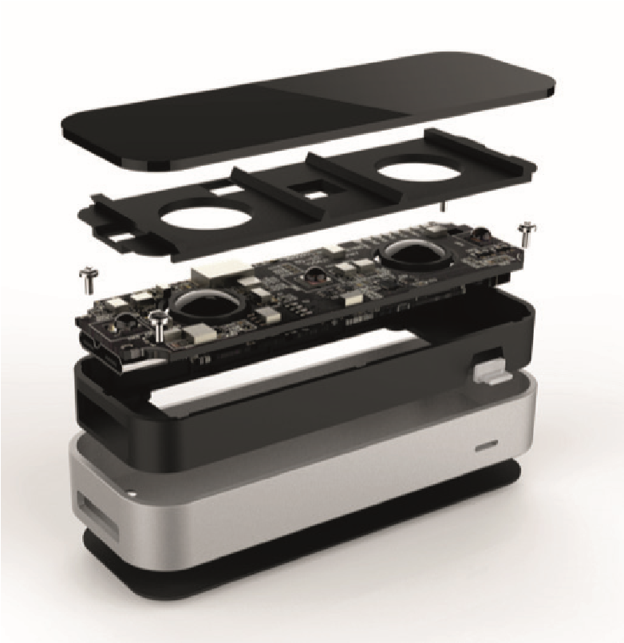
Where to buy it
For a list of authorized retailers, visit www.ultraleap.com Some applications, including those distributed for more than US$500 or designed for use with or control of industrial, commercial or medical equipment, require a separate license from Ultraleap.
w/ https://www.ultraleap.com o/ UK: +44 117 325 9002 e/ info@ultraleap.com o/ US: +1 650 600 9916
UH-003206-TC Issue 2 LeapMotion Controller Data Sheet | Ultrahaptics Ltd., The West Wing, Glass Wharf, Bristol, BS2 0EL, United Kingdom | info@ultrahaptics.com | www.ultrahaptics.com
Leap Motion Controller Datasheet.indd 2 15/12/2019 18:16

Internal benchmarking tests have determined that the Leap Motion version software is capable of sub-millisecond image processing, though this varies by environmental conditions and number of hands. The camera framerate imposes 8 milliseconds of latency (1/120 seconds). Note that game engines, GPUs, and display systems are also factors in total system latency. Leap Motion Controller Datasheet.indd 1 15/12/2019 18:16

