CPFR Data Platform and Chewy Partner Hub Portal Project Entitlement

Executive Summary
Chewy’s CPFR program is transforming how supply-chain data is shared and understood. Today, weekly emailed reports—each built from multiple queries—and parallel VDS processes, fragment visibility, duplicate effort, and limit scalability.
This initiative unites two complementary components: a centralized data platform in Snowflake that delivers governed, daily CPFR data at scale, and a CPFR Vendor Portal within Chewy Partner Hub (CPH), that offers vendors secure, always-on access through a modern interface. Together, these capabilities create a shared, consistent foundation that strengthens vendor collaboration and focus, simplifies access, and positions the organization for sustained collaborative growth. The combined annual benefit is projected at roughly $1.5–1.7 million, driven by improved efficiency, reduced reconciliation effort, faster vendor alignment, and deeper vendor participation. Beyond measurable savings, this platform also establishes CPFR as a cornerstone for cross-team collaboration and future AI-driven insight.

Context and Current State
Across Chewy’s supply chain, CPFR activities span multiple processes and workstreams that depend on parallel data pulls, manual coordination, and frequent reconciliation. These distributed practices create friction that limits scale and consistency.
Today, CPFR distributes weekly inventory and forecast reports to more than 2,300 vendors. While some steps are automated, each cycle still depends on semi-manual initiation, recurring adjustments to contact and report configurations, and frequent re-sends. These repetitive tasks—along with the corrective work that follows minor data discrepancies—inflate otherwise avoidable effort and consume time that could be redirected toward proactive vendor engagement. This cycle also introduces the risk of version drift, when teams or vendors reference slightly different report iterations and data.
VDS currently provides on-demand dashboards for a smaller premium vendor group. Its session-based model is effective for deep exploration and security isolation, yet scales poorly to thousands of concurrent vendors and complicates historical comparisons. In parallel, the Vendor Compliance (VC) team and Replen Tech are developing a portal on CPH. This presents a timely opportunity to align CPFR modernization with an existing, funded initiative. Through co-development, CPFR contributes governance and data design, while leveraging Replen Tech’s product management, engineering, and EDS security resources.

Entitlement Overview — Classes of Benefit
1. Operational Cohesion and Efficiency
A unified platform eliminates redundant action and manual reconciliations. Internal teams and vendors will draw from the same governed data sources, ensuring consistent interpretation of fill rate, PDP, forecast, and other key metrics. Automated refresh and role-based access—ensuring each vendor sees only their own data—replace brittle report assembly for both outbound reports and internal analyses. This increases analytical capacity by focusing instock staff on critical decision making, spending less time compiling data and more time on planning, root-cause analysis, and vendor collaboration.
2. Vendor Enablement and Partnership Expansion
Within CPH, vendors gain continuous, self-service access to accurate daily data filtered to their specific SKUs. They will also be able to update contact details and communication preferences directly—streamlining simple administrative tasks without changing oversight or control by ISMs or leadership. This model supports thousands of concurrent vendor tenants and provides a scalable path toward future API connectivity. The result is stronger collaboration, faster issue resolution, and smoother onboarding of new vendor partners—reducing friction so ISMs can focus on substantive planning conversations rather than routine data delivery.
3. Enterprise Data Alignment and Future Readiness
The platform establishes a single governed source of CPFR data shared across CPFR, VC, Merch, and related teams. Standardized definitions and lineage reduce planning risk and eliminate conflicting extracts. Daily immutable snapshots ensure consistency, auditability, and historical traceability. To support additions or updates to collaborative data, changes can be made at the single source, flowing immediately and uniformly to all users. The structured design also lays the groundwork for advanced analytics, machine learning, and AI-driven automation, minimizing the preparation traditionally required. What began as operational reporting becomes a durable enterprise asset supporting Chewy’s digital evolution.
4. Strategic Growth Enablement
By combining broad vendor access with governed data consistency, Chewy extends data-driven collaboration across its entire vendor network while maintaining VDS’s role for advanced analytics. The same architecture can readily expand to include Vendor Compliance (VC) and related datasets, providing a unified environment for vendor-specific information. This shared platform reduces duplication, simplifies vendor engagement, and establishes a foundation for future cross-program dashboards and enterprise-wide visibility.

[WIP] Quantitative Snapshot
Benefit Category | Estimation Basis | Appx. 1st-Yr Value | Key Assumption(s)
Operational Cohesion & Efficiency | 36 team members × 2 hours/week reallocated to higher-value work | $ 608 k | Capacity redirected from manual prep to analysis
Vendor Enablement & Partnership Expansion | 2,350 vendors × avg $ 300 value / vendor | $ 706 k | Faster vendor decisions, reduced friction
Enterprise Data Alignment & Future Readiness | Fewer data inconsistencies & rework | $ 375 k | Improved accuracy across teams
Strategic Growth Enablement | Synergy benefits and shared infrastructure reuse | $ 625 k* | Multi-program applicability
 | Total Conservative Estimate | ≈ $ 1.7 M per year | Recurring post-stabilization
* Not included in current entitlement claim. This represents value of road-mapped future phases of expansion

Dependencies, Risks & Mitigations
Risk / Dependency | Mitigation
Data consistency across systems | Centralized governance and shared change-management process
Vendor adoption of portal | Co-branded rollout with VC and Replen Tech; vendor education and support
Inter-team alignment | Defined data charters and joint implementation roadmap
Platform sustainment | Ownership by Supply-Chain B.I. with ongoing support from Replen Tech and EDS

Entitlement Benefit
The CPFR Platform and Portal initiative advances Chewy’s goals of operational excellence and partner enablement by transforming manual reporting into a governed, always-available data capability. In partnership with VC and Chargeback, it enables consistent, data-driven collaboration across connected supply-chain functions. The initiative yields an estimated $1.7 million in recurring annual benefit specific to CPFR—building on and amplifying the value generated by VC and Chargeback integration. This combined momentum directly supports Chewy’s digital modernization strategy and represents a pragmatic, low-risk investment in sustained growth and data confidence.

[WIP] Appendix:
- Valuation Basis: Summary of entitlement basis and projected Chewy benefit
- Case Studies: Examples of quantitative or qualitative opportunities, with fiscal and/or operational basis and detail.
- Architecture Summary: Snowflake data platform → governed views → CPH portal.
- Implementation Plan: Phase 1 – Platform build & internal tools; Phase 2 – Portal integration & vendor onboarding.
- Next Steps: Coordinate with B.I. and Replen Tech to confirm ownership and implementation roles. Confirm approval.

Appendix 1: Valuation Basis

[1] Operational Efficiency Calculations
Factor |  | Value |  | Notes
ISM Cohort |  | 36 |  | Includes Consumables, Health/Science, EFE, Hard Goods,
Hours per person/week |  | 2 |  | Survey sample of cohort and adjust
Rate |  | 64.90 |  | C5 average (likely higher IRL)
Weeks |  | 52 |  | Burden rate does not stop during PTO/Holidays
FBLR |  | 2.5 |  | Inflation factor for fringe, overhead, G&A--based on GAO guidelines and ACEC/AEC project estimators for white-collar roles
Annual Op Ex |  | 607500
[2] Vendor Enablement & Partnership Expansion
Factor |  | Value |  | Notes
Vendor Cohort |  | 2350 |  | Enrolled CPFR tenants only
Avg Annual Sales |  | 10000 |  | Compute from cohort
COE incremental lift |  | 0.1 |  | Annual avg pct of lift from COE. Survey sample of cohort and adjust
Percent encumbered |  | 0.3 |  | Annual avg pct of cohort involved. Survey ISMs and adjust
Annual Op Ex |  | 705600
[3] Enterprise Data Alignment & Future Readiness
Factor |  | Value |  | Notes
Annual Deep-dive Events (Lift) |  | 24 |  | Annual incremental revenue from throughput improvements
Lift per event |  | 45000 |  | Average across In-Stock
Annual Deep-dive Events (COE) |  | 60 |  | Operational efficiency gains, COE, Spoilage avoidance, NOP improvement
Cost Avoidance per event |  | 45000 |  | Average across In-Stock
Annual Deep-dive Events (NPI) |  | 10 |  | NPI/Catalog additions and product line unlocks.
Incremental SKU revenue |  | 45000 |  | Average across In-Stock
Impact rate of data inconsistency |  | 0.1 |  | Percent of time that more data consistency or visibility was impactful
Annual Op Ex |  | 375000
[4] Strategic Growth Enablement
Factor |  | Value |  | Notes
Analytic Opportunity |  | 150000 |  | Pro rata value of program contribution: future analytics opportunities
AI/ML Opportunity |  | 375000 |  | Pro rata value of program contribution: future AI/ML opportunities
Lean / 6σ |  | 100000 |  | Pro rata value of program contribution : future Lean / 6σ opportunities
Annual Cap Ex Conversion |  | 625000

Appendix 2: Case Studies

[WIP—placeholder]

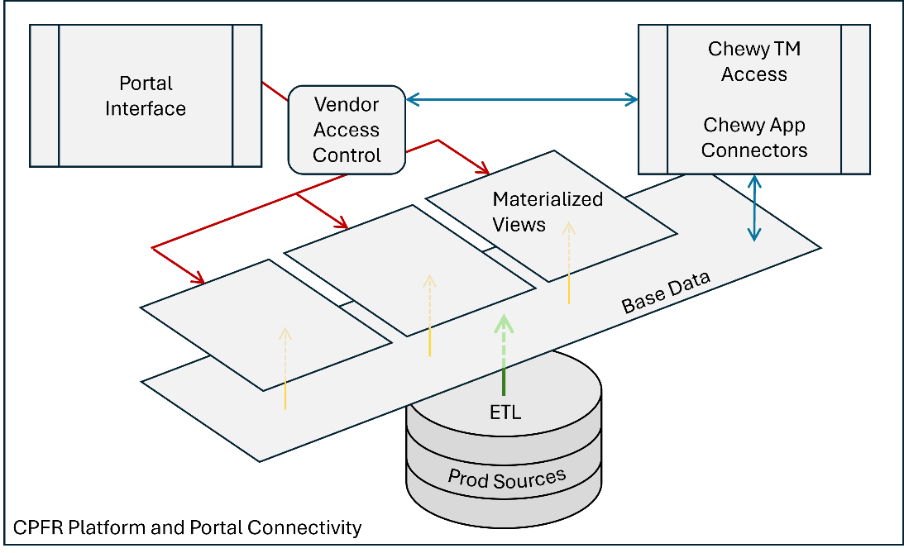
Appendix 3: Architectural Summary (Platform)
- Illustration is representational-only.
- Segregating Portal access and Chewy TM access allows clear separation of access scopes while maintaining synchronization to single-source data.

Appendix 4: Implementation Plan
Build & Rollout Strategy:
The rollout will follow a phased approach that balances speed with control.
- Phase 1 establishes the data platform foundation in Snowflake and deliver internal tools for In-Stock and B.I. teams.
- Phase 2 will extend capabilities to the CPFR Vendor Portal within Chewy Partner Hub (CPH), enabling secure vendor access and self-service.
While these phases are sequential, a degree of overlap between late-stage Phase 1 and early-stage Phase 2 is expected and even desirable. This approach minimizes disruption and allows technical, training, and communication activities to proceed in parallel as readiness milestones are met.
Additional measures to ensure a smooth transition:
- In-Stock staff will receive pre-release training and reference documentation prior to portal enablement.
- Early rollout will focus on a smaller initial vendor group (e.g. Tier 1 vendors followed by Tier 2, etc.), allowing Chewy to validate workflows and resolve any early issues before broad release.
- Lessons learned from this initial onboarding will inform subsequent vendor activation waves.
Communication Strategy:
Throughout build and rollout, progress and reference materials will be tracked in a shared collaboration space (e.g., Confluence). Communication to internal and external users will be staged to align with the two primary phases:
- Pre-launch notifications: sent 30 days prior to each rollout milestone, specifying go-live timing and hypercare period.
- Orientation sessions: offered for internal users and early vendor adopters during the hypercare window (≈ 30 days post-launch). Additional sessions may be added based on adoption needs.
- Awareness updates: periodic “coming soon” highlights during development to prepare teams for upcoming functionality.
Hypercare:
A defined period of elevated service attention will follow each rollout milestone to ensure stable adoption:
- Externally, hypercare maintains Chewy’s commitment to partnership by providing responsive support and encouraging early adoption success.
- Internally, it delivers fast feedback loops for support and engineering teams to implement quick fixes and optimizations.
Email Backup:
An email feed capability will be available for vendors unable or with inopportune access to the portal. This will be activated at portal rollout to send the same data-view shown to the vendor in the portal based on the metric configuration chosen by the vendor’s ISM and selections the vendor makes in the portal for their recipients. Legacy email automation will be available as a back-up facility for CPFR reporting during rollout, but will be gradually deactivated in favor of portal-based systems.

