CPFR in CPH: MVP Scope, User Stories & Acceptance Criteria
Document Type: | MVP-Scoped User Stories with Acceptance Criteria — LOE Spike Preparation
Last Updated: | 2026-04-02
Status: | Draft R2.2 — For review (Phanindher, Steven, CPH Engineering, Nathan Nelson)
Scope: | CPFR module in Chewy Partner Hub — MVP for engineering LOE spike
Author: | Nathan Miles
Review note: | Steven Palmer 3/31 comment to exclude ISM-facing context from MVP was superseded same day: Phanindher directed Chewy TM/ISM CPFR admin (tier + contacts) into CPH MVP because vendor admin plus multi-vendor TM workflows reuse most backend work.

Document Purpose

What is CPFR?
CPFR (Collaborative Planning, Forecasting & Replenishment) is Chewy's program for sharing weekly inventory and forecast data with approximately 3,200 vendor partners to support joint supply chain planning. Today this data reaches vendors via scheduled email reports — sent every Monday — generated from a governed Snowflake data platform (the CPFR SSOT) maintained by the SC-BIE team. The CPFR in CPH initiative modernizes this into an on-demand, self-service experience through the Chewy Partner Hub (CPH), Chewy's vendor-facing portal analogous to Amazon Vendor Central. Vendors gain governed, direct access to the same data their ISMs reference, without waiting for the weekly send and without ISM intervention.
This document defines the MVP scope for the CPFR module in CPH, expressed as user stories with acceptance criteria for a CPH engineering LOE spike. It is derived from the full-scope CPFR Problem Definition & User Stories and the BRD. Relevant BRD requirements are brought inline with each user story to eliminate the need to cross-reference a separate document during the spike.

Full Product End-State (Phase 2 — Full Scope)
The complete CPFR in CPH product delivers the following capabilities, to be built incrementally. While this MVP document scopes the first increment the full end-state vision for CPFR in CPH includes:
- CPFR data viewer: vendor-facing scorecard with KPI tiles and metric detail, plus a Tableau-embedded grid view; multi-report selector; date-indexed historical report access.
- Vendor self-service user management: vendors manage their own personnel's CPH access and report subscriptions within boundaries set by Chewy TMs.
- Chewy TM admin panel in CPH: tier selection per vendor, template and metric configuration, ISM-level customization for high-touch vendor relationships.
- VC/Chargeback coexistence: the CPFR module sits alongside the VC/Chargeback module within CPH's Vendor Scorecard navigation structure, per the unified vendor experience mandate established by Sr. Director Richard Neely (Retail I.T. Product Management). VC scoping and delivery are managed separately by the VC workstream.

MVP Scope (This Document)
MVP delivers vendor self-service CPFR data access plus Chewy TM/ISM administration in CPH. Scorecard KPI view and multi-report selector remain deferred to full scope (not MVP).
- CPFR data viewer: a single embedded Tableau table view per vendor, accessible via CPH (iframe). Interactive controls are Tableau-native (SC-BIE). Scorecard view and multi-report selector are not in MVP. (See Figure 2.)
- Vendor self-service user management: vendors view and manage their own personnel's CPH access and report subscriptions via CPH's existing 'Edit User' interface; CPFR subscription maps to the CPFR product checkbox (legacy wireframes may still label it 'Demand Forecast'). (See Figure 3.)
- Chewy TM / ISM CPFR administration in CPH (MVP): CPH screens for Chewy personnel to assign CPFR tier per vendor and to manage CPFR distribution/contact data. While TM workflows support multi-vendor search/selection, vendor admin remains single-vendor isolated. Both connect to the same Snowflake tier and contact tables as the automated email generator. A Streamlit-in-Snowflake tool also reads/writes those tables today; this document does not prescribe long-term disposition of that tool once CPH admin ships.

Value Case (Summary)
The CPFR SSOT (governed Snowflake semantic layer for CPFR data, daily refresh, vendor isolation at the data layer) was delivered by SC-BIE on 3/31/2026.
The CPFR reporting program serves approximately 3,200 vendor partners today, with line-of sight to about 4,180 eligible vendors in total. The CPH module is the vendor-facing on-ramp to that platform. Without it, vendors lack self-service access — the ISM-as-manual-intermediary model continues, and the primary vendor-facing value of the platform investment goes unrealized.
- ~$1.4M annual capacity recapture from ISM time currently spent on manual data delivery, validation, and responding to vendor data requests.
- On-demand mid-week access resolves a specific vendor pain point the current system cannot address: when a vendor makes a supply chain change and needs to verify its impact before the following Monday's report, today their only option is to contact their ISM directly. For complex or multi-step changes, this creates date-time versioning confusion as files pass back and forth. Portal access provides a time-stamped immutable daily snapshot as the definitive reference for any discussion.
- 96% unweighted vendor approval rating (sample-based). The underlying survey was oriented to vendor engagement and program sentiment.
- Major vendors (Blue Buffalo, Mars, Nestle Purina) have explicitly requested portal/API access to CPFR data.
Success measures: Delivery of the MVP stories in §2 (including TM-1 and VD-1) is expected to produce the following trackable outcomes:
- ISM capacity recapture: reduction in ad-hoc CPFR data requests from vendors and in manual data delivery tasks performed by ISMs. Baseline from Entitlement Rev4 (~$1.4M annual equivalent); measured by request/ticket volume and ISM time tracking.
- Vendor portal adoption: percentage of the 3,200-vendor base logging into CPH for CPFR data within 90 days of launch; feature-level usage (tab views, downloads, date selections) via CPH usage analytics.
- VPP ticket reduction: baseline ~90 vendor administration tickets per month (contact list corrections and updates), currently processed with Cognizant contractor support. Vendor self-service contact management is expected to reduce this volume measurably; contractor hours currently allocated to parsing VPP tickets are a candidate for repurposing. Measured via VPP ticket system.
- Contact management hygiene: reduction in data disclosure incidents (vendor data sent to wrong recipients under the current TM-managed model) and in contact-update support tickets attributable to CPFR distribution. Both trackable against current support ticket logs.
Full entitlement document: reproduced in Appendix B (Rev4 text). PDF/Word originals in project repository.

Context for Engineering Reviewers
- The CPFR SSOT (Snowflake semantic layer, daily refresh, vendor isolation at the data layer) was delivered by SC-BIE and is available as of 3/31/2026. This document scopes only the CPH-side module that consumes it.
- Email report distribution continues via the existing parallel CPFR report generator, pointed at the same Snowflake source. The CPH module does not replace or manage email delivery for MVP.
- The BRD (CPH Portal & Platform: Business Requirements — CPFR & Vendor Compliance, 2026-02-03) is the canonical full requirements reference, available in the project repository. Key requirements are brought inline with each user story below.
- Open technical questions for the LOE spike are tracked in a separate companion file (see §3 Reference Documents) with section references back to this document — they are not embedded here.
- Vendor metadata shown in the CPH page shell (e.g., vendor number, vendor name, parent company) must align with fields available in the SSOT/Tableau context; confirm with SC-BIE before hard-coding display assumptions.
- Visual references embedded in this document: (1) CPFR in CPH Wireflow MVP — navigation and user flow; (2) CPH Viewport Wireframe — MVP CPFR data viewer; (3) Vendor Admin Screen — shared VC/CPFR user management modal.

Figure 1: CPFR in CPH Wireflow — MVP
- Vendor path: CPH navigation → CPFR → Admin or Reports fork → Reports → CPFR Data Viewer (Tableau iframe). Admin → Vendor Admin (role-based), single-vendor scope.
- Chewy TM / ISM path (MVP): CPFR TM administration in CPH — tier assignment and CPFR contact/distribution management with multi-vendor search/selection; writes the same Snowflake tier and vendor-contact sources as the automated report generator.
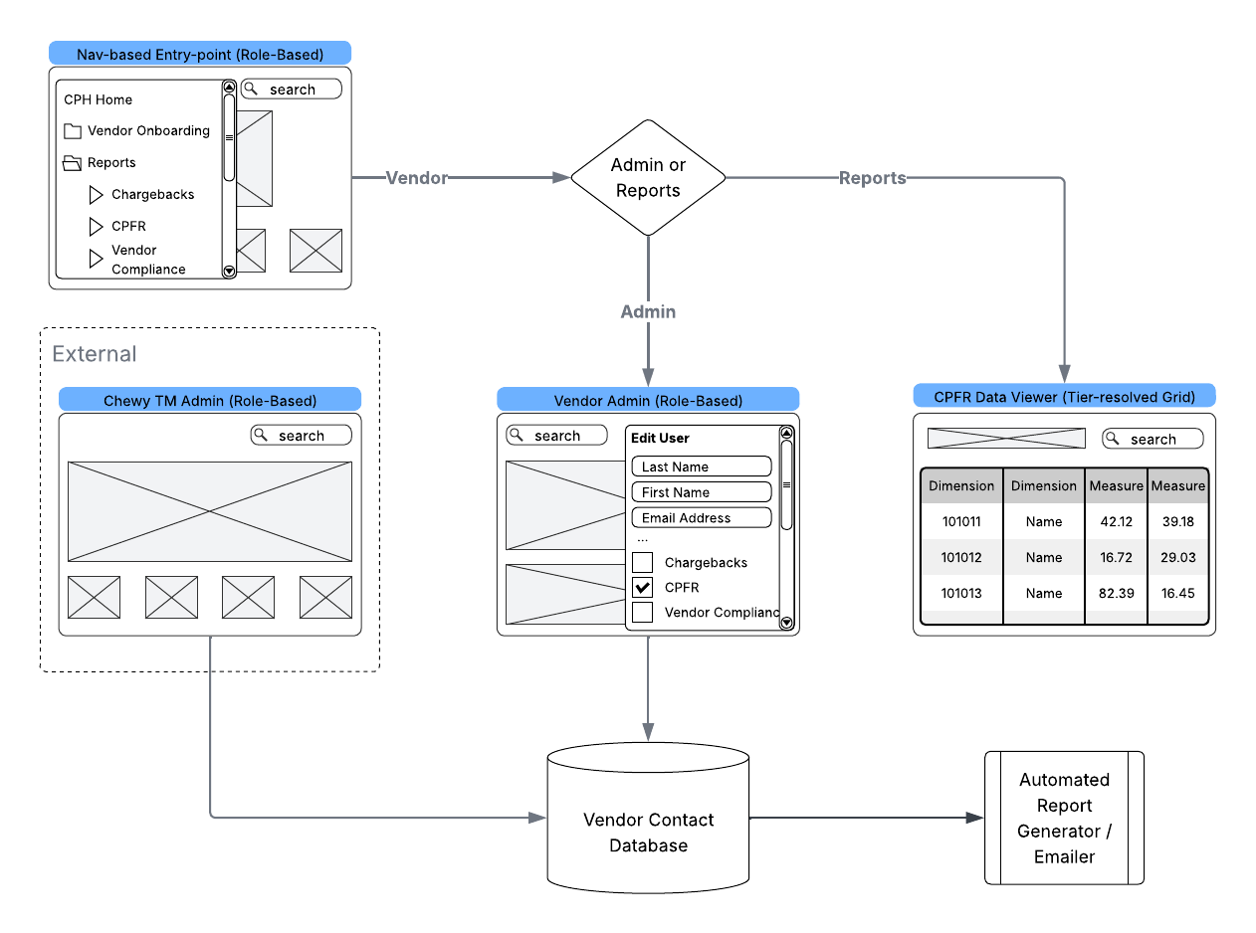
Figure 1 — CPFR in CPH Wireflow (MVP scope)

Figure 2: CPH Viewport Wireframe (MVP CPFR Data Viewer)
The MVP CPFR viewer is a dedicated CPH page that iframes a Tableau dashboard published by SC-BIE. CPH renders the page shell and vendor metadata display (Vendor Number | Vendor Name | Tier Level). All interactive controls — date selector (daily calendar picker matching SSOT date grain), search field, column-level sort and filter, and Download (.xlsx export preserving Inventory and Forecast as separate tabs for Tier 2 vendors) — are native Tableau dashboard elements configured by SC-BIE. Tab visibility (Forecast, or Inventory + Forecast) is determined by the vendor's assigned tier and enforced within the Tableau workbook. Historical date depth is also managed by SC-BIE within the published workbook.
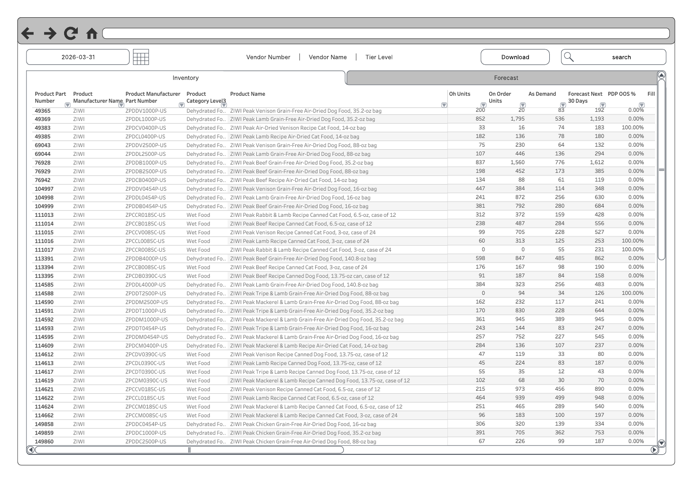
Figure 2 — CPH Viewport Wireframe (MVP CPFR data viewer with Tableau table)

Figure 3: Vendor Admin Screen — CPH 'Edit User' Modal
This modal permits a logged-in vendor to add or remove staff from approved access to their VC, Chargeback, or CPFR documents as well as the CPFR iframe viewport, on a per-user basis. Vendors will not have access to tier assignments, and their options will be governed as a subset of the features enabled by Chewy TMs. The joint VC/CPFR configuration extends CPH's existing user management pattern and supports non-fragmentation with VC. Additionally, the vendor admin screen should leverage existing CPH patterns to ensure consistency and reduce custom configuration requirements.
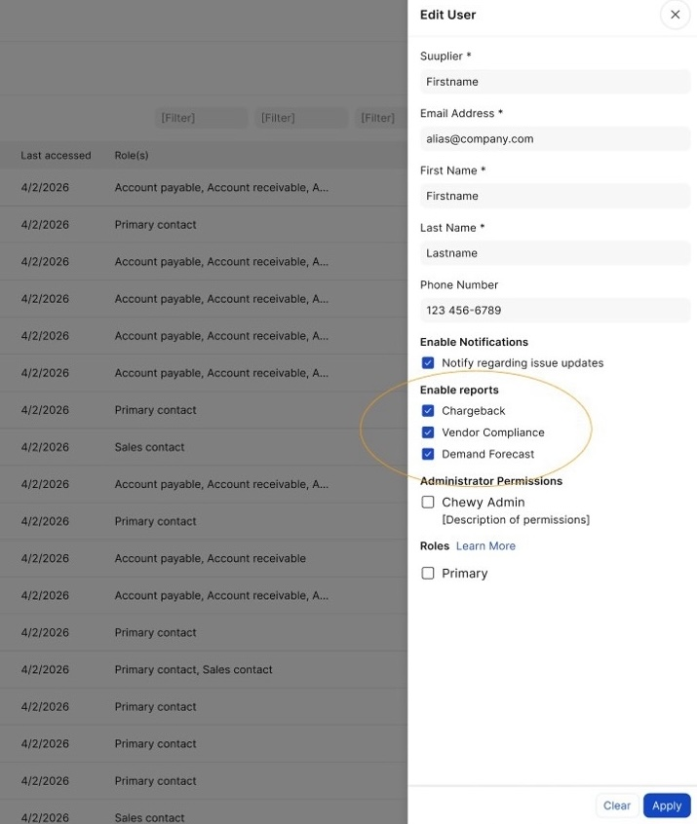
Figure 3 — Vendor Admin 'Edit User' modal (CPFR subscription control

1. MVP Scope Boundary

What MVP Delivers
MVP delivers: (1) vendor-facing CPFR data viewer — CPH page iframing SC-BIE Tableau; interactive controls are Tableau-native; (2) vendor self-service user management via existing Edit User (Figure 3), including CPFR subscription mapping; (3) Chewy TM/ISM CPFR administration in CPH — tier assignment and CPFR contact/distribution with multi-vendor TM workflows and single-vendor vendor workflows (TM-1). Scorecard KPI view is not in MVP.
Engineering surface includes: Navigation routing, iframe shell, vendor metadata display, TM admin screens for tier/contacts, subscription/provisioning extension for CPFR, and integration to existing Snowflake tier/contact tables. Email distribution mechanics stay as-is; CPH does not become the email orchestration UI for MVP.

What MVP Does Not Deliver
- Scorecard view with KPI tiles and metric detail (included in full scope — not MVP)
- Multi-report selector and batch downloads (included in full scope)
- Cross-vendor aggregation or analytics views
- ISM-customizable metric selection per vendor
- Email delivery management through CPH
- API access for vendors
- Advanced analytics or ML-readiness features
- VC/Chargeback module features (scoped and delivered separately by the VC workstream — referenced here only because CPFR and VC share CPH infrastructure and a unified admin surface)

Design Constraint: Non-Fragmentation of Vendor Experience
This constraint is stated here because it has direct implications for CPH architectural decisions — specifically, which navigation structure, UI components, and data isolation mechanisms the CPFR module must use — making it directly relevant to LOE estimation. The constraint: per Sr. Director Richard Neely's directive, the CPFR module must be built using CPH's existing patterns so the VC/Chargeback module can sit alongside it without rework or vendor experience fragmentation.
Evidence: Figure 3 shows the shared Edit User pattern for VC and CPFR subscriptions. Figure 1 places CPFR alongside VC under Vendor Scorecard. The CPFR module should inherit existing CPH patterns rather than inventing parallel ones, which constrains LOE.

REQ-4.2 — Unified Vendor Experience / Non-Fragmentation: Ensure a unified vendor experience across VC, Chargeback, and CPFR modules within CPH: consistent navigation, data access patterns, and user interface. Avoid vendor experience fragmentation (critical requirement established by Sr. Director of Retail I.T. Product Management).
REQ-4.1 — CPH Integration: Integrate all CPFR and VC capabilities seamlessly within existing Chewy Partner Hub (CPH) infrastructure; portal development must align with CPH architecture and Replen Tech resources.

2. MVP User Stories & Acceptance Criteria (LOE Estimation Input)
These seven stories define the CPH engineering ask for the MVP LOE spike. Acceptance criteria are written at engineering precision. BRD requirements are included below vendor-facing stories and TM-1. Open technical questions are tracked in the companion file listed in §3 (not in this document).

V-1: Access CPFR Data On-Demand via Portal
As a vendor partner, I want to access my CPFR data on-demand, 24/7, through the Chewy Partner Hub, so that I can proactively identify and address supply chain issues without waiting for scheduled email reports or requesting data from my ISM.

Acceptance Criteria:
- Vendor can log into CPH and navigate to the CPFR module via Vendor Navigation → CPFR (per Figure 1 wireflow).
- Initial CPFR data displayed reflects the most recent daily refresh from the CPFR SSOT (Snowflake). Data is no more than one business day old.
- Vendor sees only data for their own vendor entity (vendor isolation enforced at both the CPH layer and within the Tableau workbook). Vendor identity handoff into the iframe is a spike topic — see companion Open Questions file.
- Portal access operates independently of the existing email report distribution. Email reports continue via the existing parallel CPFR report generator consuming the same Snowflake source.
- Portal availability inherits CPH's existing uptime SLA (confirm with CPH TPM / engineering).

Excludes: API access; data export beyond report download (see V-5); custom query capabilities; email delivery management, vendor scorecard.

BRD Requirements:
REQ-10.1 — Vendor-Facing CPFR Module with Embedded Viewer: Provide vendor-facing CPFR module within CPH: access to CPFR reports (e.g., last 30 days), report selector, and embedded viewer (Tableau- or Plotly-based) for filtering and basic real-time aggregation; CPFR data is time-based with many performance metrics at SKU and location grain. [Note: report selector is deferred to full scope in MVP; viewer is the embedded Tableau table per Figure 2.]
REQ-10.3 — On-Demand Vendor Access Without ISM Intervention: Enable vendors to access CPFR data on-demand, 24/7, without ISM intervention, via portal and email based on vendor preferences.
REQ-4.1 — CPH Integration: Integrate all CPFR and VC capabilities seamlessly within existing CPH infrastructure; portal development must align with CPH architecture and Replen Tech resources.

V-2: View Consistent Data with ISM
As a vendor partner, I want to see the same CPFR data that my ISM references when we discuss performance, so that our conversations focus on actions rather than reconciling conflicting numbers.

Acceptance Criteria:
- CPFR data displayed in the vendor's portal view is sourced from the same Snowflake SSOT that ISM tools (direct queries, Streamlit, internal Tableau) consume.
- Data version consistency is guaranteed by the daily immutable snapshot mechanism — vendor and ISM reference the same snapshot for any given date.
- No transformation, aggregation, or filtering occurs between the semantic layer and the portal display that would cause the vendor's view to diverge from what an ISM sees when querying the same vendor's data for the same date.

Excludes: Real-time or intra-day synchronization. The 'same data' guarantee operates at daily snapshot granularity.

BRD Requirements:
REQ-6.1 — Daily Immutable Snapshots: Provide daily, immutable data snapshots that eliminate time-of-day drift.
REQ-6.2 — Consistent Data Version Across All Access Methods: Ensure all stakeholders (internal and external) reference the same data version across all access methods (portal, email, direct queries).

V-3: Access Appropriate Data Depth (Two-Template Model)
As a vendor partner, I want to access my CPFR data at the depth that matches my business relationship with Chewy, so that I can make informed planning decisions at the right level of detail.

Acceptance Criteria:
- Two data templates are available, patterned after the existing CPFR tier structure:
  - Tier 3 — Demand Forecast: 6-month demand forecast at SKU/Day grain. Vendors assigned this tier see the Forecast tab in the viewer.
  - Tier 2 — Inventory + Forecast: inventory metrics (On Order [OO], On Hand [OH], PDP OOS %, Autoship Demand [AS Demand], Fill Rate, Days of Supply [DoS]) plus the same 6-month demand forecast as Tier 3. Vendors assigned this tier see both the Inventory and Forecast tabs in the viewer.
- Template (tier) assignment per vendor is stored in the existing tier-selection tables in Snowflake (same as email reports). Chewy TMs assign or change tier via CPH TM administration (TM-1); vendors cannot view or edit tier.
- Vendor sees only the tab(s) and columns corresponding to their assigned tier. Tier assignment is not visible to or configurable by the vendor.
- The Tableau table presents all assigned columns with native column-level sort and filter. Date selector controls which report period is displayed (one period at a time).

Excludes: More than two templates. ISM-configurable metric customization per vendor (full scope). Vendor-visible tier controls.

BRD Requirements:
REQ-7.1 — Tier-Based Analytical Depth Templates: Support multiple analytical depth levels (tier structure) as templates with customization capability, accommodating different vendor needs from high-level forecasts to granular SKU/fulfillment-center/region breakdowns.
REQ-10.2 — TM-Controlled Tier Assignment — Not Vendor-Visible: CPFR tier/config per vendor is set by Chewy personnel via the combined administration capability; not visible to vendors.

V-4: Manage CPFR Access Among Vendor Personnel (Vendor Self-Service Admin)
As a vendor partner, I want to manage which of my personnel have access to CPFR reports and data within CPH, so that the right people on my team receive relevant information without requiring Chewy TM intervention for administrative changes.

Acceptance Criteria:
- Vendor admin can view the list of contacts/logins associated with their vendor entity within CPH's existing user management interface.
- Vendor admin can add or remove contacts from their CPFR access list.
- Vendor admin can enable or disable the CPFR report subscription for each contact via the 'Enable reports' section of the existing 'Edit User' modal (Figure 3).
- Changes made by the vendor admin take effect without Chewy TM involvement.
- While Chewy TMs may perform optional administrative assistance, it is necessary for them to intervene in the vendor contact management workflow for CPFR.

Excludes: Full parity of every future VC/TM admin affordance in one release (full scope). Notification preference management beyond access assignment unless required by BRD.

BRD Requirements:
REQ-1.4 — Expand CPH's Existing User Self-Service Admin Facility: Use and expand CPH's existing user self-service admin facility to encompass CPFR (and VC). CPH already has a user self-service admin page that, when opened by Chewy personnel, shows a view across all vendors; when opened by a vendor, shows only that vendor. It lists individuals, email address, and role (e.g., EDI User, Warehouse User) via a pop-out menu; role drives visibility to links/pages, permissions, and triggers for reporting including the outbound email module. The BRD requires expansion of this facility so that CPFR and VC contact, distribution, and reporting are managed through the same facility.
REQ-1.2 — Vendor Self-Service Contact and Report Distribution Preferences: Provide a single vendor self-service experience for contact management and report distribution preferences, with distinct areas or sections for CPFR report recipients and preferences and VC/Chargeback report recipients and preferences.
REQ-1.3 — CPFR and VC Recipient Lists as Separate Manageable Elements: Require that CPFR and VC contact/recipient lists be manageable as separate elements. They may appear on the same page. Many recipients for a given vendor may receive both CPFR and VC content; the system must support assigning specific contacts to CPFR only, VC only, or both, as needed.
REQ-3.1 — Vendor Isolation: Enforce vendor isolation so that vendors access only their own data in CPH and in the CPFR platform; complete access logging for security and compliance.

VD-1: Vendor Data Self-Service MVP
As Chewy TMs, we need vendors to own their CPFR recipient lists so that manual administration conducted by Chewy TMs, whether conducted manually or in batches cannot introduce errors that would route one vendor's CPFR data to another vendor's contacts — a failure mode that domain-matching heuristics cannot fully prevent.

Production incident (evidence): Malformed data ingested during a routine batch-load of new vendors (new to CPFR) led to an unauthorized release of vendor inventory and forecast information to a 3rd party. Because Chewy’s vendor population makes frequent use of contractors or public email domains, it’s not pragmatic to validate email addresses without direct vendor involvement. The only way to meaningfully mitigate this risk is to shift responsibility to vendors by enabling self-service vendor contact administration.

Acceptance Criteria:
- Vendor contact administration and edits are scope-limited to the org corresponding to their vendor ID number.
- Vendor may select report access (visibility and/or ability to download) from within a set of options established by their ISM or an authorized Chewy TM (TM-1).
- MVP explicitly reduces Chewy-batch-driven contact setup as the default path: vendor-facing contact administration (V-4) plus TM tooling in CPH (TM-1) align ownership of recipient data with the vendor organization.
- Risk narrative and incident class are referenced in entitlement and value case (contact hygiene / unauthorized disclosure); post-MVP metrics track ticket volume and disclosure-related incidents.
- Vendor cannot see or alter tier settings (TM-1)
- No new metric scope is required to satisfy this story — it is governance and admin-surface scope.

Excludes: Forensic tooling; legal conclusions; changes to email transport outside existing generator behavior.

V-5: Access Historical CPFR Reports by Date
As a vendor partner, I want to access historical CPFR reports by date, so that I can review past data for trend analysis and planning without requesting historical data from my ISM.

Acceptance Criteria:
- Vendor can select a historical report date via the date selector in the Tableau viewer (Figure 2). The date selector is a Tableau-native dashboard element; historical date depth is managed by SC-BIE within the published workbook.
- The selected report is downloadable via the Download button as an .xlsb file (see Figure 2).
- Date is a native dimension of the CPFR SSOT data at daily grain. The Tableau workbook indexes available dates against this dimension; CPH has no separate archival or date-management responsibility.

Excludes: Free-form historical querying. Custom date-range aggregations. Export formats other than .xlsb (SC-BIE's Tableau native export).

BRD Requirements:
REQ-8.1 — Historical CPFR Data Retention: Maintain 2 years of historical CPFR data with daily granularity.
REQ-8.2 — Historical Analysis Capability: Enable time-series analysis, trend identification, and historical comparison for forecast accuracy validation.

TM-1: Chewy TM / ISM CPFR Administration in CPH
As a Chewy TM or ISM, I want to assign CPFR tiers and optionally manage CPFR distribution and contact data for vendors I support using CPH administration screens that support multi-vendor search and selection, so that configuration stays aligned with the Snowflake tables that drive email and portal delivery without ad-hoc files or an external primary path.

Acceptance Criteria:
- Chewy personnel with the appropriate CPH role(s) can open CPFR TM administration in CPH (exact RBAC to be defined with CPH engineering).
- TM user can search/select one or more vendors and assign or update CPFR tier; writes persist to the existing Snowflake tier-selection source used by the email generator and Tableau.
- TM user can view and edit CPFR-specific contact and distribution fields for selected vendors, consistent with REQ-1.5 show/hide patterns.
- TM user is not vendor isolated: vendor-facing admin (V-4) remains scoped to the vendor's own organization; TM workflows may span multiple authorized vendors.

Excludes: ISM-customizable metric mix per vendor beyond the two fixed templates (full scope). VC report-type configuration except where BRD requires a shared admin surface.

BRD Requirements:
REQ-1.1 — Internal Chewy Interface for Report Access and Configuration: Provide a single internal (Chewy) interface within CPH for ISMs or Category Managers to assign or remove report access by vendor and to manage which reports go to which stakeholders, with CPFR report tier/config and VC report config as distinct, configurable elements.
REQ-1.5 — Show/Hide Configuration Between TM and Vendor: Require the ability to show or hide certain configuration options between (a) Chewy TM visibility (broader) — e.g., which CPFR tier is selected for a given vendor, which VC report types are enabled — and (b) vendor visibility (narrower) — e.g., contact emails, add/remove users, who receives CPFR/VC reports.
REQ-10.2 — TM-Controlled Tier Assignment — Not Vendor-Visible: CPFR tier/config per vendor is set by Chewy personnel via the combined administration capability; not visible to vendors.

3. Reference Documents

Document | Relevance
CPFR Problem Definition & User Stories (.md) | Full-scope problem statements and original user stories
BRD: CPH Portal & Platform Business Requirements — CPFR & Vendor Compliance (2026-02-03) | Numbered requirements, NFRs, constraints, dependencies. Key requirements brought inline in this document.
CPFR in CPH Wireflow MVP (.png) | MVP navigation structure, user-type fork, and data flow. Embedded as Figure 1.
CPH Viewport Wireframe (.png) | MVP CPFR data viewer screen with Tableau table. Embedded as Figure 2.
Vendor Admin Screen — CPH Edit User Modal (.jpeg) | Shared VC/CPFR user management interface. Embedded as Figure 3.
CPFR Portal & Platform Entitlement Rev4 | Financial justification; full text reproduced in Appendix B of this document.
CPFR_MVP_Open_Technical_Questions.md | LOE spike open questions with section references into this document (not embedded in the body).
CPFR Data-Sharing: Current State & Candidate Alternatives | Data domain context, VDS/CPH platform comparison.

Appendix A: Full-Scope Story Map
Documents capabilities outside MVP scope. The seven MVP stories in §2 (including TM-1 and VD-1) are the CPH LOE spike scope. Capabilities are split into those satisfied by the SSOT platform (no CPH work) and those deferred to Phase 2 / full product (scorecard, multi-report selector, etc.).

Platform-Satisfied (No CPH Engineering Work Required)
These capabilities are delivered by the CPFR SSOT (SC-BIE / Snowflake) and require no CPH development:

Story | Capability | How It's Satisfied | Notes
P-1 | Single source of truth with governance | Snowflake SSOT with daily immutable snapshots (delivered 3/31/2026) | Confirmed with Stefan 2026-03-16
B-1 | Scale data access without proportional overhead | Platform architecture scales to 3,000+ vendors
B-2 | Unified data access layer | SSOT serves as the governed access point for all consumers
I-2 | Cross-vendor analytics for ISMs | ISMs query the SSOT directly; no CPH-native cross-vendor view required for MVP

Phase 2 / Full Scope (Deferred — Not in LOE Spike)

Story | Capability | MVP Alternative | Phase 2 Adds
I-1 | TM analytic / exploration views of CPFR in CPH beyond admin | TM-1 covers tier/contact admin in CPH; analysis may use SSOT / internal Tableau today | Rich TM-facing CPFR analytics workspace inside CPH if desired later
I-2 | Cross-vendor aggregation UI | Direct SSOT queries | CPH-native cross-vendor analytics and comparison views
I-4 | ISM-customizable vendor data views | Two fixed templates; TM selects via Snowflake lookup | CPH admin panel for per-vendor metric customization
V-4+ | Full role-based admin with CPFR/VC unification | V-4 vendor self-service + TM-1 TM admin in MVP | Deeper unified admin across all VC/CPFR affordances
P-2 | Definitive audit trails in CPH | CPH confirmed to have module-level access logging; P-2 disposition is covered by existing CPH capability | CPH-level access logging for CPFR already present
P-3 | Advanced analytics / ML readiness | SSOT data structure supports future use | CPH-native analytics, ML model training integration
C-1 | Extend platform to other data types | Architecture allows it; VC coordination separate | VC data surfaced through same platform patterns

Appendix B: CPFR Portal & Platform Entitlement (Rev4)

Introduction (for readers of this LOE document)
This appendix reproduces the CPFR Portal & Platform Entitlement (Rev4) in full. The headline recurring benefit cited in the Value Case (~$1.4M annual, CPFR-specific) is the sum of benefit classes 1, 2, and 3 in Rev4 (Operational Cohesion & Efficiency; Vendor Enablement & Partnership Expansion; Enterprise Data Alignment & Future Readiness). Class 4 (Strategic Growth Enablement) and its line-item estimates are shown in Rev4 for transparency but are pro rata / multi-program allocations and are excluded from that headline claim.
Key methodology terms (see Rev4 Appendix 1 and Appendix 2 for full calculation tables): FBLR (fully burdened labor rate) follows GAO-style fully burdened costing. The $64.90/hr rate reflects typical professional rates at the C5 level (standard ISM band). Chewy capture rate is the share of efficiency savings that accrues to Chewy versus vendors. Vendor opportunity cost rate is analogous to labor-rate-based opportunity cost without applying FBLR on the vendor side (efficiency recovery accrues mainly to the originating organization). Enterprise data alignment benefits are grounded in fewer inconsistencies and rework tied to correction-of-errors (COE) and new product introduction (NPI) events. Impact rate reflects that CPFR only partially and diffusely mitigates large-stakes outcomes. Estimates draw on ISM surveys and known operational events as documented in Rev4.

Reproduced text — CPFR Portal & Platform Entitlement (Rev4)
The following paragraphs are extracted from the Rev4 Word source. Table cells appear as consecutive short lines.
CPFR Data Platform and Chewy Partner Hub PortalProject Entitlement
Executive Summary
Chewy’s CPFR program is transforming how supply-chain data is shared and understood. Today, weekly emailed reports—each built from multiple queries—and parallel VDS processes, fragment visibility, duplicate effort, and limit scalability.
This initiative unites two complementary components: a centralized data platform in Snowflake that delivers governed, daily CPFR data at scale, and a CPFR Vendor Portal within Chewy Partner Hub (CPH), that offers vendors secure, always-on access through a modern interface. Together, these capabilities create a shared, consistent foundation that strengthens vendor collaboration and focus, simplifies access, and positions the organization for sustained collaborative growth. The initiative delivers $1.4M in recurring annual CPFR-specific operational value (ISM capacity expansion, data governance efficiency, cost avoidance enablement), with additional unmeasured vendor-side efficiency gains strengthening collaborative relationships.
CPFR enters this next phase from a position of strong vendor trust, reflected in recent survey feedback showing a 96% unweighted vendor approval rating. While sample-based, this signal underscores the importance of preserving data integrity and partner confidence as the program scales. Combined with VC and Chargeback integration, this unified platform investment supports Chewy's digital modernization strategy while establishing infrastructure for future advanced analytics capabilities.
Context and Current State
Across Chewy’s supply chain, CPFR activities span multiple processes and workstreams that depend on parallel data pulls, manual coordination, and frequent reconciliation. These distributed practices create friction that limits scale and consistency.
Today, CPFR distributes weekly inventory and forecast reports to more than 2,300 vendors. While some steps are automated, each cycle still depends on semi-manual initiation, recurring adjustments to contact and report configurations, and frequent re-sends. These repetitive tasks—along with the corrective work that follows minor data discrepancies—inflate otherwise avoidable effort and consume time that could be redirected toward proactive vendor engagement. This cycle also introduces the risk of version drift, when teams or vendors reference slightly different report iterations and data.
VDS currently provides on-demand dashboards for a smaller premium vendor group. Its session-based model is effective for deep exploration and security isolation, yet scales poorly to thousands of concurrent vendors and complicates historical comparisons. In parallel, the Vendor Compliance (VC) team and Replen Tech are developing a portal on CPH. This presents a timely opportunity to align CPFR modernization with an existing, funded initiative. Through co-development, CPFR contributes governance and data design, while leveraging Replen Tech’s product management, engineering, and EDS security resources.
Entitlement Overview — Classes of Benefit
1. Operational Cohesion and Efficiency
A unified platform eliminates redundant action and manual reconciliations. Internal teams and vendors will draw from the same governed data sources, ensuring consistent interpretation of fill rate, PDP, forecast, and other key metrics. Automated refresh and role-based access that ensures each vendor sees only their own data replace brittle report assembly for both outbound reports and internal analyses. Survey evidence documents 1-5 hours per ISM/week spent on manual data prep and error correction—capacity that will be redirected to planning, root-cause analysis, and strategic vendor engagement.
2. Vendor Enablement and Partnership Expansion
Within CPH, vendors gain continuous, self-service access to accurate daily data filtered to their specific SKUs. They will also be able to update contact details and communication preferences directly—streamlining simple administrative tasks without changing oversight or control by ISMs or leadership. This model supports thousands of concurrent vendor tenants and provides a scalable path toward future API connectivity. The result is stronger collaboration, faster issue resolution, and smoother onboarding of new vendor partners—reducing friction so ISMs can focus on substantive planning conversations rather than routine data delivery.
3. Enterprise Data Alignment and Future Readiness
The platform establishes a single governed source of CPFR data shared across CPFR, VC, Merch, and related teams. Standardized definitions and lineage reduce planning risk and eliminate conflicting extracts. Daily immutable snapshots ensure consistency, auditability, and historical traceability. To support additions or updates to collaborative data, changes can be made at the single source, flowing immediately and uniformly to all users. The structured design also lays the groundwork for advanced analytics, machine learning, and AI-driven automation, minimizing the preparation traditionally required. What began as operational reporting becomes a durable enterprise asset supporting Chewy’s digital evolution.
4. Strategic Growth Enablement
By combining broad vendor access with governed data consistency, Chewy extends data-driven collaboration across its entire vendor network while maintaining VDS’s role for advanced analytics. The same architecture can readily expand to include Vendor Compliance (VC) and related datasets, providing a unified environment for vendor-specific information. This shared platform reduces duplication, simplifies vendor engagement, and establishes a foundation for future cross-program dashboards and enterprise-wide visibility.
Quantitative Snapshot
Benefit Category
Estimation Basis
Appx. 1st-Yr Value
Key Assumption(s)
Operational Cohesion & Efficiency
36 team members × 2 avg hours/week reallocated to higher-value work
$ 608 k
Capacity redirected from manual prep to analysis
Vendor Enablement & Partnership Expansion
Faster, more frequent and more actionable vendor contribution
$ 458 k
Faster vendor decisions, reduced friction
Enterprise Data Alignment & Future Readiness
Fewer data inconsistencies, rework, or avoidable costs
$ 339 k
Improved accuracy across teams
Strategic Growth Enablement
Synergy benefits and shared infrastructure reuse
$ 625 k*
Multi-program applicability
Total Conservative Estimate
≈ $ 1.4 M per year
Recurring post-stabilization
* Not included in current entitlement claim. This represents value of road-mapped future phases of expansion
Dependencies, Risks & Mitigations
Risk / Dependency
Mitigation
Data consistency across systems
Centralized governance and shared change-management process
Vendor adoption of portal
Co-branded rollout with VC and Replen Tech; vendor education and support
Inter-team alignment
Defined data charters and joint implementation roadmap
Platform sustainment
Ownership by Supply-Chain B.I. with ongoing support from Replen Tech and EDS
5. Risk Reduction & Trust Preservation
Today, CPFR relies on internally managed vendor contact configurations to distribute sensitive, vendor-specific data at scale. While operationally workable at smaller volumes, this model introduces a growing class of risk as CPFR expands: configuration accuracy becomes a prerequisite for data security. As vendor count, batch updates, and distribution complexity increase, the probability and blast radius of misconfiguration increase accordingly.
Enabling vendor self-service for contact management and distribution preferences materially reduces this risk by aligning data ownership with data accountability. Vendors directly control who receives their information, eliminating an entire category of inadvertent disclosure driven by internal error. Beyond operational efficiency, this shift protects vendor trust and Chewy’s reputation by structurally reducing the likelihood of inappropriate data exposure as CPFR scales.
Entitlement Benefit
The CPFR Platform and Portal initiative advances Chewy’s goals of operational excellence and partner enablement by transforming manual reporting into a governed, always-available data capability. In partnership with VC and Chargeback, it enables consistent, data-driven collaboration across connected supply-chain functions. The initiative yields an estimated $1.4 million in recurring annual benefit specific to CPFR—building on and amplifying the value generated by VC and Chargeback integration. It also protects the investment in vendor trust and confidence that Chewy has earned over the last 15 years, and converts structural risk into durable advantage. This combined momentum directly supports Chewy’s digital modernization strategy and represents a pragmatic, low-risk investment in sustained growth and data confidence.
Appendix 1: Valuation Basis
The valuation basis reflects conservative estimates of CPFR's indirect contribution to operational efficiency and cost avoidance. As a collaborative planning enabler, CPFR's value accrues through improved data visibility, reduced coordination friction, and enhanced analytical capacity—factors that support broader organizational effectiveness but do not generate direct revenue.
[1] Operational Efficiency Calculations
Factor
Value
Notes
ISM cohort
36
Includes Consumables, Health/Science, EFE, Hard Goods,
Hours per person/week
2
Median surveyed response value
Rate
64.90
C5 average (likely higher IRL)
Weeks
52
Burden rate does not stop during PTO/Holidays
FBLR
2.5
Inflation factor for fringe, overhead, G&A--based on GAO guidelines and ACEC/AEC project estimators for white-collar roles
Annual Op Ex
607500
[2] Vendor Enablement & Partnership Expansion
Factor
Value
Notes
Vendor friction reduction
0.5
Avg hours saved per week via self-service
Vendor opportunity cost rate
50
Conservative estimate of fungible vendor contribution recovery
Chewy capture rate
.15
Attribution factor for Chewy enablement
Annual Op Ex
458250
[3] Enterprise Data Alignment
Factor
Value
Notes
Annual Major COE Events
12
Inventory efficiency gains, COE, reduced spoilage, NOP improvement
Cost Avoidance per event
415000
Average of high-impact events
Annual Large NPI Events
10
NPI/Catalog additions and product line unlocks.
Incremental SKU revenue
45000
Average across In-Stock
Impact rate of opportunity cost + COE
0.0625
Avg impact of CPFR activities – derived from weekly task proportion
Annual Op Ex
339375
[4] Strategic Growth Enablement
Factor
Value
Notes
Analytic Opportunity
150000
Pro rata value of program contribution: future analytics opportunities
AI/ML Opportunity
375000
Pro rata value of program contribution: future AI/ML opportunities
Lean / 6σ
100000
Pro rata value of program contribution : future Lean / 6σ opportunities
Annual Cap Ex Conversion
625000
Appendix 2: Case Studies
Survey Methodology & Scope
Subject matter expert interviews were conducted with senior In-Stock Managers managing relationships with major vendors and direct distributors. The ISMs surveyed collectively represent substantial CPFR program scope spanning a substantial portion of COGS and revenue. Interviews focused on quantifying operational burden, identifying data consistency challenges, and documenting vendor feedback regarding access preferences and collaborative planning friction.
1. Manual Coordination Overhead & Operational Burden
Time Investment in Data Preparation and Validation
ISMs report consistent weekly time burdens associated with CPFR data preparation, validation, and correction of errors (COE):
1-2 hours per week: Typical for relationships with stable data flows and mature current-state CPFR processes
2-3 hours per week: Common where improved consistency and reduced COE would yield measurable impact
5+ hours per week: Reported in cases where email-based data exchange creates unnecessary churn and where CPFR consistency, availability, or COE issues compound
These time investments represent capacity diverted from strategic vendor collaboration, root-cause analysis, and proactive planning work.
End-of-Period Escalations
Transportation and MOQ mismatch issues create predictable escalation patterns. ISMs report spending up to 2 days out of certain weeks rectifying MOQ and transportation constraints that surface at period boundaries (month-end, quarter-end). While improving visibility around these issues extends beyond the initial CPFR platform scope, the frequency and impact of these escalations underscore the value of incremental feature that can be added once foundational portal infrastructure is in place.
Discontinued SKU Management
Substantial ISM time is consumed rectifying discontinued SKU status and cleanup. This represents a recurring risk of pricing mismatches and operational friction that could be streamlined through improved data visibility and self-service capabilities.
2. Data Visibility & Consistency Challenges
Non-Optimal Placement (NOP) Visibility
NOP data requires enhanced visibility with daily (or more frequent) cadence to effectively track when corrections have been absorbed into planning cycles. Current weekly cadence creates delays in understanding whether corrective actions have taken effect, extending the feedback loop between issue identification validation, and further actions.
Future Availability Date (FAD) Lists
FAD lists signal to ordering automation when to pause orders until a specified future date. These require broader visibility—preferably real-time—to ensure updates are reflected immediately. Current fragmented visibility creates coordination gaps between vendor manufacturing schedules and Chewy ordering systems.
New Item Forecasting
New product introductions often require off-cadence forecast updates and more frequent refreshes. Typical NPI forecasting takes multiple cycles to stabilize, creating early-stage planning friction. While CPFR data access improvements may not directly accelerate NPI forecast generation, platform capabilities can support faster distribution once forecasts are available.
Forecast Mismatch Thresholds & Promotional Tensions
Forecast accuracy thresholds create significant financial exposure when misaligned with promotional sales goals. Threshold misses directly impact vendor payback guarantees, creating incentives that can drive inefficient inventory decisions.
Past instances of threshold-driven forecast mismatch have resulted in approximately $5 million in unwarranted buy-up due to unclear visibility into forecast accuracy relative to promotional expectations. Based on analysis of recurring threshold miss patterns, this issue class represents an estimated $15 million annually in avoidable cost if not corrected through improved data visibility and governance.
The structural tension between promotional incentives (which increase buy-up pressure) and in-stock efficiency goals (which prioritize inventory optimization) creates recurring exposure. Major vendor relationships experience this dynamic at least annually, making improved forecast visibility and consistent data sharing critical to reducing financial waste.
3. Vendor Self-Service Preferences & API Demand
Direct Vendor Feedback: API Access Preference
In conference calls, Blue Buffalo expressed distinct preference for API access to CPFR data, explicitly weighing this capability against the cost of VDS tenancy (3% of COGS up to $400K plus $250K). Blue Buffalo characterized current email-based CPFR data transmission as a "struggle" and indicated that API availability would be a significant decision factor in their vendor data services investment evaluation.
This preference echoes previous statements from Mars and Nestle-Purina—the two largest vendors in the CPFR program. The consistency of this feedback across major vendor relationships indicates that API access is not an isolated request but a systematic preference among sophisticated vendor partners, and much simpler to deploy via CPH portal.
Portal Access Prioritization
Vendor feedback emphasizes portal access over advanced thresholding or signaling features for initial rollout. Self-service data access is viewed as delivering greater immediate value in both vendor-Chewy alignment and collaborative follow-up than incremental analytical sophistication (though this was a close second). This suggests a clear implementation priority: establish reliable self-service access first, then expand analytical capabilities based on adoption patterns.
Daily Data Cadence Requirements
Vendors have explicitly requested daily-available data via portal, particularly for:
PDP out-of-stock (OOS) metrics
Fill rate performance
Forecast updates
Recovery cycles for PDP and fill rate issues often occur over days rather than weeks, making weekly data cadence insufficient for responsive corrective action. Daily availability is estimated to save approximately 1 additional hour per week in coordination overhead per affected vendor, while enabling up to a 50% improvement in OOS recovery for affected items.
While affected items represent about 0.1% of company-wide OOS, affected vendors—by nature—trend higher than average, suggesting the impacted inventory pool may approach 1% for the vendors most likely to use daily data for rapid response.
4. SKU and Vendor Number Assignment Cleanup
Visibility into unused-but-not-deactivated vendor numbers and agreement lines would facilitate cleanup of a particularly insidious data quality issue: price discrepancies between active and obsolete vendor numbers for the same SKU.
Example scenario: A vendor's primary vendor number receives a price increase (reflected in the active agreement). However, an obsolete vendor number tied to the same SKU—with a lower historical price—remains active but does not receive price updates. Pricing algorithms select the lower (invalid) price, creating potential discrepancies.
This issue is especially acute because:
Vendors all too often do not know their own vendor numbers
Vendor numbers are not easily searchable
Portal ticket submissions lack adequate fields for vendor number entry
Long-term vendors often accumulate multiple active agreements and vendor numbers, plus expired/inactive entries
Improved visibility would help prevent items from being added to incorrect vendor numbers and enable systematic cleanup of legacy data structures.
Summary of Quantified Impacts
The survey evidence documents measurable operational burden and financial exposure:
Time burden reduction opportunities:
1-5 hours per ISM per week in CPFR data preparation and COE
~2 days per week addressing MOQ/transportation escalations (opportunity for incremental feature expansion)
~1 hour per week per vendor relationship through daily data availability
Financial impact from improved visibility:
$5M documented cost avoidance case (single threshold mismatch event)
~$15M estimated annual exposure from recurring forecast threshold issues
Vendor relationship evidence:
Consistent API access preference across major vendors (Blue Buffalo, Mars, Nestle-Purina)
Explicit daily data cadence requirements for operational responsiveness
Clear prioritization of portal self-service over advanced analytical features
This evidence base supports the business case for CPFR platform modernization by documenting specific, quantifiable pain points experienced by senior ISMs managing substantial vendor relationship portfolios. The convergence of operational burden, financial exposure, and vendor demand creates a compelling case for investment in governed data infrastructure and self-service portal capabilities.
Appendix 3: Architectural Summary (Platform)
Illustration is representational-only.
Segregating Portal access and Chewy TM access allows clear separation of access scopes while maintaining synchronization to single-source data.
Appendix 4: Implementation Plan
Build & Rollout Strategy:
The rollout will follow a phased approach that balances speed with control.
Phase 1 establishes the data platform foundation in Snowflake and deliver internal tools for In-Stock and B.I. teams.
Phase 2 will extend capabilities to the CPFR Vendor Portal within Chewy Partner Hub (CPH), enabling secure vendor access and self-service.
While these phases are sequential, a degree of overlap between late-stage Phase 1 and early-stage Phase 2 is expected and even desirable. This approach minimizes disruption and allows technical, training, and communication activities to proceed in parallel as readiness milestones are met.
Additional measures to ensure a smooth transition:
In-Stock staff will receive pre-release training and reference documentation prior to portal enablement.
Early rollout will focus on a smaller initial vendor group (e.g. Tier 1 vendors followed by Tier 2, etc.), allowing Chewy to validate workflows and resolve any early issues before broad release.
Lessons learned from this initial onboarding will inform subsequent vendor activation waves.
Communication Strategy:
Throughout build and rollout, progress and reference materials will be tracked in a shared collaboration space (e.g., Confluence). Communication to internal and external users will be staged to align with the two primary phases:
Pre-launch notifications: sent 30 days prior to each rollout milestone, specifying go-live timing and hypercare period.
Orientation sessions: offered for internal users and early vendor adopters during the hypercare window (≈ 30 days post-launch). Additional sessions may be added based on adoption needs.
Awareness updates: periodic “coming soon” highlights during development to prepare teams for upcoming functionality.
Hypercare:
A defined period of elevated service attention will follow each rollout milestone to ensure stable adoption:
Externally, hypercare maintains Chewy’s commitment to partnership by providing responsive support and encouraging early adoption success.
Internally, it delivers fast feedback loops for support and engineering teams to implement quick fixes and optimizations.
Email Backup:
An email feed capability will be available for vendors unable or with inopportune access to the portal. This will be activated at portal rollout to send the same data-view shown to the vendor in the portal based on the metric configuration chosen by the vendor’s ISM and selections the vendor makes in the portal for their recipients. Legacy email automation will be available as a back-up facility for CPFR reporting during rollout, but will be gradually deactivated in favor of portal-based systems.

