CPFR in CPH: MVP Scope, User Stories & Acceptance Criteria
Document Type: | MVP-Scoped User Stories with Acceptance Criteria — LOE Spike Preparation
Last Updated: | 2026-03-31
Status: | Draft v2.0 — For Review (Phanindher, Steven, CPH Engineering)
Scope: | CPFR module in Chewy Partner Hub — MVP for engineering LOE spike
Author: | Nathan Miles

Document Purpose

What is CPFR?
CPFR (Collaborative Planning, Forecasting & Replenishment) is Chewy's program for sharing weekly inventory and forecast data with approximately 3,200 vendor partners to support joint supply chain planning. Today this data reaches vendors via scheduled email reports — sent every Monday — generated from a governed Snowflake data platform (the CPFR SSOT) maintained by the SC-BIE team. The CPFR in CPH initiative modernizes this into an on-demand, self-service experience through the Chewy Partner Hub (CPH), Chewy's vendor-facing portal analogous to Amazon Vendor Central. Vendors gain governed, direct access to the same data their ISMs reference, without waiting for the weekly send and without ISM intervention.
This document defines the MVP scope for the CPFR module in CPH, expressed as user stories with acceptance criteria for a CPH engineering LOE spike. It is derived from the full-scope CPFR Problem Definition & User Stories and the BRD. Relevant BRD requirements are brought inline with each user story to eliminate the need to cross-reference a separate document during the spike.

Full Product End-State (Phase 2 — Full Scope)
The complete CPFR in CPH product delivers the following capabilities, to be built incrementally. While this MVP document scopes the first increment the full end-state vision for CPFR in CPH includes:
- CPFR data viewer: vendor-facing scorecard with KPI tiles and metric detail, plus a Tableau-embedded grid view; multi-report selector; date-indexed historical report access.
- Vendor self-service user management: vendors manage their own personnel's CPH access and report subscriptions within boundaries set by Chewy TMs.
- Chewy TM admin panel in CPH: tier selection per vendor, template and metric configuration, ISM-level customization for high-touch vendor relationships.
- VC/Chargeback coexistence: the CPFR module sits alongside the VC/Chargeback module within CPH's Vendor Scorecard navigation structure, per the unified vendor experience mandate established by Sr. Director Richard Neely (Retail I.T. Product Management). VC scoping and delivery are managed separately by the VC workstream.

MVP Scope (This Document)
Following alignment in the 3/26/2026 working session, MVP is scoped to the minimum buildable unit that delivers vendor self-service access to CPFR data:
- CPFR data viewer: a single embedded Tableau table view per vendor, accessible via CPH. Vendor-facing controls: date selector (one report period at a time), Download button, search field. The Tableau table provides column-level sort and filter as native dashboard elements. Scorecard view and multi-report selector are deferred to full scope. (See Figure 2.)
- Vendor self-service user management: vendors view and manage their own personnel's CPH access and report subscriptions via CPH's existing 'Edit User' interface. No new admin UI is required; the existing 'Enable reports' section (Chargeback, Vendor Compliance, Demand Forecast) already supports CPFR subscription management. (See Figure 3.)
- ISM controls external to CPH for MVP: Chewy TM tier selection and CPFR distribution list management are handled via a separate Streamlit-in-Snowflake tool, already built and in active use. This tool reads and writes the same Snowflake table that drives the existing email report system. No ISM-facing admin panel is required within CPH for MVP.

Value Case (Summary)
The CPFR SSOT platform was delivered by SC-BIE on 3/31/2026. The CPH module is the on-ramp that gives vendors self-service access to this platform. Without it, vendors have no direct path to the data — the ISM-as-manual-intermediary model continues, and the primary vendor-facing value of the platform investment goes unrealized.
- ~$1.4M annual capacity recapture from ISM time currently spent on manual data delivery, validation, and responding to vendor data requests.
- On-demand mid-week access resolves a specific vendor pain point the current system cannot address: when a vendor makes a supply chain change and needs to verify its impact before the following Monday's report, today their only option is to contact their ISM directly. For complex or multi-step changes, this creates date-time versioning confusion as files pass back and forth. Portal access provides on-demand, time-stamped immutable daily snapshots as the definitive reference for any discussion.
- 96% unweighted vendor approval rating (sample-based) for the CPFR data sharing program.
- Major vendors (Blue Buffalo, Mars, Nestle Purina) have explicitly requested portal/API access to CPFR data.
Success measures: Delivery of V-1 through V-5 is expected to produce the following trackable outcomes:
- ISM capacity recapture: reduction in ad-hoc CPFR data requests from vendors and in manual data delivery tasks performed by ISMs. Baseline from Entitlement Rev4 (~$1.4M annual equivalent); measured by request/ticket volume and ISM time tracking.
- Vendor portal adoption: percentage of the 3,200-vendor base logging into CPH for CPFR data within 90 days of launch; feature-level usage (tab views, downloads, date selections) via CPH usage analytics.
- VPP ticket reduction: baseline ~90 vendor administration tickets per month (contact list corrections and updates), currently processed with Cognizant contractor support. Vendor self-service contact management is expected to reduce this volume measurably; contractor hours currently allocated to parsing VPP tickets are a candidate for repurposing. Measured via VPP ticket system.
- Contact management hygiene: reduction in data disclosure incidents (vendor data sent to wrong recipients under the current TM-managed model) and in contact-update support tickets attributable to CPFR distribution. Both trackable against current support ticket logs.
Full entitlement detail: CPFR Portal & Platform Entitlement Rev4, project repository.

Context for Engineering Reviewers
- The CPFR SSOT (Snowflake semantic layer, daily refresh, vendor isolation at the data layer) was delivered by SC-BIE and is available as of 3/31/2026. This document scopes only the CPH-side module that consumes it.
- Email report distribution continues via the existing parallel CPFR report generator, pointed at the same Snowflake source. The CPH module does not replace or manage email delivery for MVP.
- The BRD (CPH Portal & Platform: Business Requirements — CPFR & Vendor Compliance, 2026-02-03) is the canonical full requirements reference, available in the project repository. Key requirements are brought inline with each user story below.
- Open technical questions are in §3, each with a named owner and resolution path.
- Visual references embedded in this document: (1) CPFR in CPH Wireflow MVP — navigation and user flow; (2) CPH Viewport Wireframe — MVP CPFR data viewer; (3) Vendor Admin Screen — shared VC/CPFR user management modal.

Figure 1: CPFR in CPH Wireflow — MVP
Navigation structure scoped to MVP. Vendor path: CPH navigation (Vendor Scorecard → CPFR) → 'Admin or Reports' fork → Reports branch leads to the CPFR Data Viewer; Admin branch leads to Vendor Admin (Role-Based). Both the Vendor Admin and the external Chewy TM Admin tool write to the Vendor Contact Database, which feeds the Automated Report Generator/Emailer. The Chewy TM Admin tool is External — it operates as the Streamlit-in-Snowflake tool outside CPH, not as a CPH page.
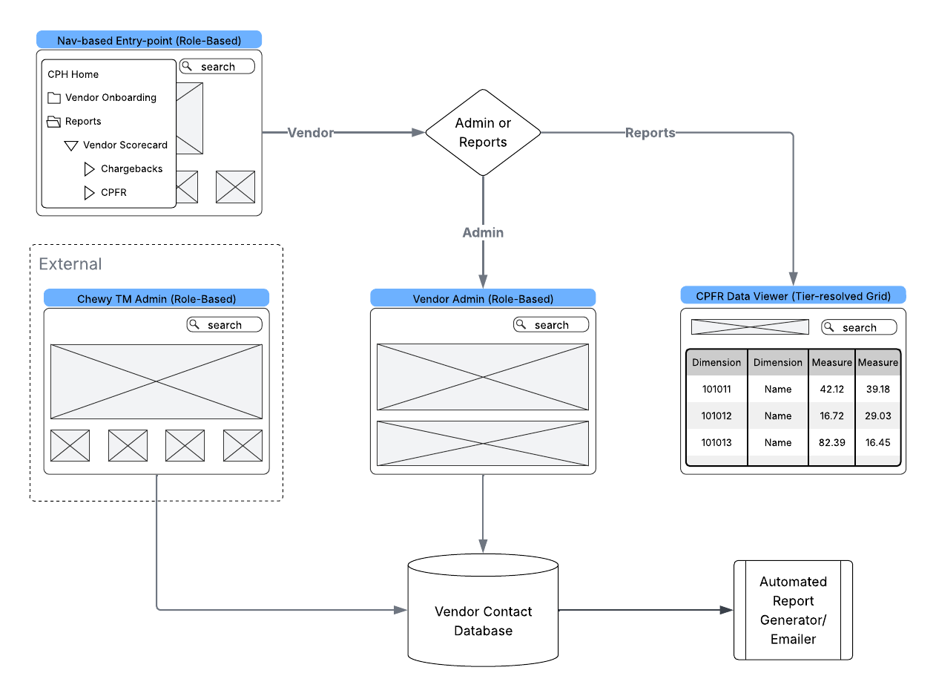
Figure 1 — CPFR in CPH Wireflow (MVP scope)

Figure 2: CPH Viewport Wireframe (MVP CPFR Data Viewer)
The MVP CPFR viewer is a dedicated CPH page that iframes a Tableau dashboard published by SC-BIE. CPH renders the page shell and vendor metadata display (Vendor Number | Vendor Name | Tier Level). All interactive controls — date selector (daily calendar picker matching SSOT date grain), search field, column-level sort and filter, and Download (.xlsx export preserving Inventory and Forecast as separate tabs for Tier 2 vendors) — are native Tableau dashboard elements configured by SC-BIE. Tab visibility (Inventory, Forecast, or both) is determined by the vendor's assigned tier and enforced within the Tableau workbook. Historical date depth is also managed by SC-BIE within the published workbook.
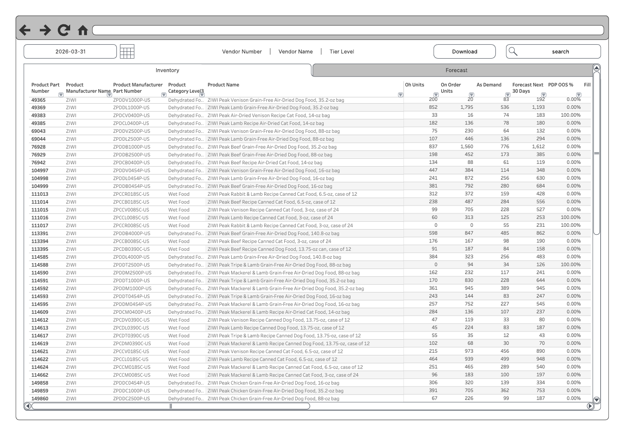
Figure 2 — CPH Viewport Wireframe (MVP CPFR data viewer with Tableau table)

Figure 3: Vendor Admin Screen — CPH 'Edit User' Modal
CPH's existing 'Edit User' modal, from the UX wireframe demonstrated by the CPH design team (Aaron Newman, UX). The 'Enable reports' section — Chargeback, Vendor Compliance, and Demand Forecast — is the vendor-facing report subscription control. For CPFR MVP, the 'Demand Forecast' checkbox is the access control for the CPFR data viewer. No new admin UI is required; this extends CPH's existing user management pattern. This same screen manages VC and CPFR report subscriptions together, fulfilling the non-fragmentation requirement.
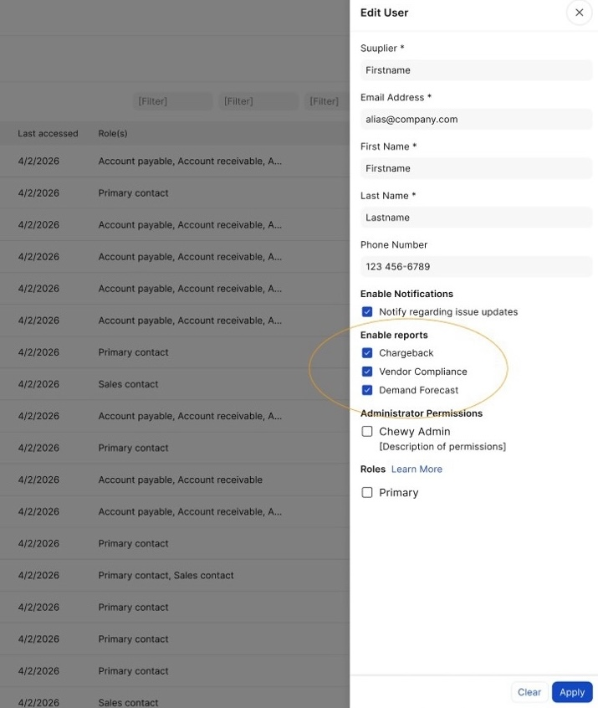
Figure 3 — Vendor Admin 'Edit User' modal (shared VC/CPFR report subscription control; 'Demand Forecast' circled)

1. MVP Scope Boundary

What MVP Delivers
MVP delivers three things: (1) a vendor-facing CPFR data viewer in CPH (Figure 2) — a CPH page that iframes a Tableau dashboard published by SC-BIE; all interactive controls (date selector, search, sort/filter, .xlsx download) are Tableau-native and SC-BIE's responsibility; (2) vendor self-service user management via CPH's existing 'Edit User' interface (Figure 3) — no new UI required; and (3) ISM tier and distribution-list configuration handled externally via the already-live Streamlit-in-Snowflake tool, keeping CPH scope minimal.
This scope delivers the primary vendor pain point — on-demand CPFR data access without ISM intervention — entirely within CPH's existing infrastructure and UI patterns. The new CPH engineering surface is: the Vendor Scorecard navigation section, the iframe page shell, the vendor metadata display, tier-based tab visibility, and the 'Demand Forecast' subscription provisioning extension. No new admin UI design and no changes to the email system are required.

What MVP Does Not Deliver
- ISM/TM-facing views within CPH (ISMs continue to access CPFR data via direct Snowflake queries, Streamlit, or internal Tableau dashboards)
- Chewy TM admin panel within CPH for tier/template configuration (handled via the external Streamlit-in-Snowflake tool)
- Scorecard view with KPI tiles and metric detail (full scope)
- Multi-report selector and batch downloads (full scope)
- Cross-vendor aggregation or analytics views
- ISM-customizable metric selection per vendor
- Email delivery management through CPH
- API access for vendors
- Advanced analytics or ML-readiness features
- VC/Chargeback module features (scoped and delivered separately by the VC workstream — referenced here only because CPFR and VC share CPH infrastructure and a unified admin surface)

Design Constraint: Non-Fragmentation of Vendor Experience
This constraint is stated here because it has direct implications for CPH architectural decisions — specifically, which navigation structure, UI components, and data isolation mechanisms the CPFR module must use — making it directly relevant to LOE estimation. The constraint: per Sr. Director Richard Neely's directive, the CPFR module must be built using CPH's existing patterns so the VC/Chargeback module can sit alongside it without rework or vendor experience fragmentation.
Evidence: Figure 3 (Vendor Admin Screen) shows CPH's existing 'Edit User' modal already includes 'Demand Forecast' alongside Chargeback and Vendor Compliance — the shared admin surface is already designed for both workstreams. Figure 1 (Wireflow) shows CPFR and VC as sibling entries under Vendor Scorecard in CPH navigation. Both mean the CPFR module inherits existing CPH patterns rather than inventing new ones, which constrains and simplifies the LOE.

REQ-4.2 — Unified Vendor Experience / Non-Fragmentation: Ensure a unified vendor experience across VC, Chargeback, and CPFR modules within CPH: consistent navigation, data access patterns, and user interface. Avoid vendor experience fragmentation (critical requirement established by Sr. Director of Retail I.T. Product Management).
REQ-4.1 — CPH Integration: Integrate all CPFR and VC capabilities seamlessly within existing Chewy Partner Hub (CPH) infrastructure; portal development must align with CPH architecture and Replen Tech resources.

2. MVP User Stories & Acceptance Criteria (LOE Estimation Input)
These five stories define the complete CPH engineering ask for the MVP LOE spike. Acceptance criteria are written at engineering precision. BRD requirements are included below each story. Open questions flagged inline are consolidated in §3 with owners and resolution paths.

V-1: Access CPFR Data On-Demand via Portal
As a vendor partner, I want to access my CPFR data on-demand, 24/7, through the Chewy Partner Hub, so that I can proactively identify and address supply chain issues without waiting for scheduled email reports or requesting data from my ISM.

Acceptance Criteria:
- Vendor can log into CPH and navigate to the CPFR module via Vendor Scorecard → CPFR (per Figure 1 wireflow). Note: 'Vendor Scorecard' is a new CPH navigation section, not yet in production. CPH has prototypes and prior art to draw from; estimate this as a discrete line item during the spike.
- CPFR data displayed reflects the most recent daily refresh from the CPFR SSOT (Snowflake). Data is no more than one business day old.
- Vendor sees only data for their own vendor entity (vendor isolation enforced at both the CPH layer and within the Tableau workbook). [Open: OQ-1 — vendor_id handoff mechanism to be confirmed with Harish; see §3.]
- Portal access operates independently of the existing email report distribution. Email reports continue via the existing parallel CPFR report generator consuming the same Snowflake source.
- Portal availability inherits CPH's existing uptime SLA. [Confirm with Harish.]

Excludes: API access; data export beyond report download (see V-5); custom query capabilities; email delivery management.

BRD Requirements:
REQ-10.1 — Vendor-Facing CPFR Module with Embedded Viewer: Provide vendor-facing CPFR module within CPH: access to CPFR reports (e.g., last 30 days), report selector, and embedded viewer (Tableau- or Plotly-based) for filtering and basic real-time aggregation; CPFR data is time-based with many performance metrics at SKU and location grain. [Note: report selector is deferred to full scope in MVP; viewer is the embedded Tableau table per Figure 2.]
REQ-10.3 — On-Demand Vendor Access Without ISM Intervention: Enable vendors to access CPFR data on-demand, 24/7, without ISM intervention, via portal and email based on vendor preferences.
REQ-4.1 — CPH Integration: Integrate all CPFR and VC capabilities seamlessly within existing CPH infrastructure; portal development must align with CPH architecture and Replen Tech resources.

V-2: View Consistent Data with ISM
As a vendor partner, I want to see the same CPFR data that my ISM references when we discuss performance, so that our conversations focus on actions rather than reconciling conflicting numbers.

Acceptance Criteria:
- CPFR data displayed in the vendor's portal view is sourced from the same Snowflake SSOT that ISM tools (direct queries, Streamlit, internal Tableau) consume.
- Data version consistency is guaranteed by the daily immutable snapshot mechanism — vendor and ISM reference the same snapshot for any given date.
- No transformation, aggregation, or filtering occurs between the semantic layer and the portal display that would cause the vendor's view to diverge from what an ISM sees when querying the same vendor's data for the same date.

Excludes: Real-time or intra-day synchronization. The 'same data' guarantee operates at daily snapshot granularity.

BRD Requirements:
REQ-6.1 — Daily Immutable Snapshots: Provide daily, immutable data snapshots that eliminate time-of-day drift.
REQ-6.2 — Consistent Data Version Across All Access Methods: Ensure all stakeholders (internal and external) reference the same data version across all access methods (portal, email, direct queries).

V-3: Access Appropriate Data Depth (Two-Template Model)
As a vendor partner, I want to access my CPFR data at the depth that matches my business relationship with Chewy, so that I can make informed planning decisions at the right level of detail.

Acceptance Criteria:
- Two data templates are available, patterned after the existing CPFR tier structure:
  - Tier 3 — Demand Forecast: 6-month demand forecast at SKU/Day grain. Vendors assigned this tier see the Forecast tab in the viewer.
  - Tier 2 — Inventory + Forecast: inventory metrics (On Order [OO], On Hand [OH], PDP OOS %, Autoship Demand [AS Demand], Fill Rate, Days of Supply [DoS]) plus the same 6-month demand forecast as Tier 3. Vendors assigned this tier see both the Inventory and Forecast tabs in the viewer.
- Template (tier) assignment per vendor is read from the existing tier-selection lookup table in Snowflake — the same table used by the email report system. CPH reads this directly from Snowflake. No CPH-native admin UI is required for MVP.
- Vendor sees only the tab(s) and columns corresponding to their assigned tier. Tier assignment is not visible to or configurable by the vendor.
- The Tableau table presents all assigned columns with native column-level sort and filter. Date selector controls which report period is displayed (one period at a time).

Excludes: More than two templates. ISM-configurable metric customization per vendor (full scope). Any template management UI within CPH.

BRD Requirements:
REQ-7.1 — Tier-Based Analytical Depth Templates: Support multiple analytical depth levels (tier structure) as templates with customization capability, accommodating different vendor needs from high-level forecasts to granular SKU/fulfillment-center/region breakdowns.
REQ-10.2 — TM-Controlled Tier Assignment — Not Vendor-Visible: CPFR tier/config per vendor is set by Chewy personnel via the combined administration capability; not visible to vendors.

V-4: Manage CPFR Access Among Vendor Personnel (Vendor Self-Service Admin)
As a vendor partner, I want to manage which of my personnel have access to CPFR reports and data within CPH, so that the right people on my team receive relevant information without requiring Chewy ISM intervention for administrative changes.

Rationale — risk mitigation: Under the current model, Chewy TMs manage vendor contact lists, which has resulted in documented incidents of unauthorized data disclosure (vendor data sent to wrong recipients). Vendor self-service removes TMs from the vendor contact management workflow for CPFR, eliminating a proven failure mode.

Acceptance Criteria:
- Vendor admin can view the list of contacts/logins associated with their vendor entity within CPH's existing user management interface.
- Vendor admin can add or remove contacts from their CPFR access list within the boundaries set by Chewy TM authorization. Vendor-level CPFR enrollment — whether a vendor organization is authorized to access CPFR at all — is managed externally via the Chewy TM admin tool. V-4 scope covers only per-user access management within an already-enrolled vendor.
- Vendor admin can enable or disable the 'Demand Forecast' report subscription for each contact via the 'Enable reports' section of the existing 'Edit User' modal (Figure 3). ['Demand Forecast' is CPH's existing production label for CPFR reporting — legacy nomenclature from when demand forecasting was the only CPFR deliverable. Confirm with Harish whether this subscription type is already active in production (CPFR maps to it) or requires activation. This is a specific estimation item for the spike; see OQ-5.]
- Changes made by the vendor admin take effect without Chewy TM involvement.
- Chewy TMs are fully removed from the vendor contact management workflow for CPFR.

Excludes: Chewy TM admin panel in CPH (handled via external Streamlit tool). Unified CPFR/VC admin (full scope). Notification preference management beyond access assignment.

BRD Requirements:
REQ-1.4 — Expand CPH's Existing User Self-Service Admin Facility: Use and expand CPH's existing user self-service admin facility to encompass CPFR (and VC). CPH already has a user self-service admin page that, when opened by Chewy personnel, shows a view across all vendors; when opened by a vendor, shows only that vendor. It lists individuals, email address, and role (e.g., EDI User, Warehouse User) via a pop-out menu; role drives visibility to links/pages, permissions, and triggers for reporting including the outbound email module. The BRD requires expansion of this facility so that CPFR and VC contact, distribution, and reporting are managed through the same facility.
REQ-1.2 — Vendor Self-Service Contact and Report Distribution Preferences: Provide a single vendor self-service experience for contact management and report distribution preferences, with distinct areas or sections for CPFR report recipients and preferences and VC/Chargeback report recipients and preferences.
REQ-1.3 — CPFR and VC Recipient Lists as Separate Manageable Elements: Require that CPFR and VC contact/recipient lists be manageable as separate elements. They may appear on the same page. Many recipients for a given vendor may receive both CPFR and VC content; the system must support assigning specific contacts to CPFR only, VC only, or both, as needed.
REQ-3.1 — Vendor Isolation: Enforce vendor isolation so that vendors access only their own data in CPH and in the CPFR platform; complete access logging for security and compliance.

V-5: Access Historical CPFR Reports by Date
As a vendor partner, I want to access historical CPFR reports by date, so that I can review past data for trend analysis and planning without requesting historical data from my ISM.

Acceptance Criteria:
- Vendor can select a historical report date via the date selector in the Tableau viewer (Figure 2). The date selector is a Tableau-native dashboard element; historical date depth is managed by SC-BIE within the published workbook.
- The selected report is downloadable via the Download button as an .xlsx file (see Figure 2).
- Date is a native dimension of the CPFR SSOT data at daily grain. The Tableau workbook indexes available dates against this dimension; CPH has no separate archival or date-management responsibility.

Excludes: Free-form historical querying. Custom date-range aggregations. Export formats other than .xlsx (SC-BIE's Tableau native export).

BRD Requirements:
REQ-8.1 — Historical CPFR Data Retention: Maintain 2 years of historical CPFR data with daily granularity.
REQ-8.2 — Historical Analysis Capability: Enable time-series analysis, trend identification, and historical comparison for forecast accuracy validation.

3. Reference Documents

Document | Relevance
CPFR Problem Definition & User Stories (.md) | Full-scope problem statements and original user stories
BRD: CPH Portal & Platform Business Requirements — CPFR & Vendor Compliance (2026-02-03) | Numbered requirements, NFRs, constraints, dependencies. Key requirements brought inline in this document.
CPFR in CPH Wireflow MVP (.png) | MVP navigation structure, user-type fork, and data flow. Embedded as Figure 1.
CPH Viewport Wireframe (.png) | MVP CPFR data viewer screen with Tableau table. Embedded as Figure 2.
Vendor Admin Screen — CPH Edit User Modal (.jpeg) | Shared VC/CPFR user management interface. Embedded as Figure 3.
CPFR Portal & Platform Entitlement Rev4 | Financial justification, capacity recapture analysis, and entitlement figures.
CPFR Data-Sharing: Current State & Candidate Alternatives | Data domain context, VDS/CPH platform comparison.

Appendix A: Full-Scope Story Map
Documents capabilities outside MVP scope. For engineering reviewers, this confirms the MVP stories above represent the complete CPH ask for the LOE spike. For stakeholders, it shows the growth path from MVP to full scope. Capabilities are split into two categories: those already satisfied by the SSOT platform (no CPH work needed), and those deferred to Phase 2.

Platform-Satisfied (No CPH Engineering Work Required)
These capabilities are delivered by the CPFR SSOT (SC-BIE / Snowflake) and require no CPH development:

Story | Capability | How It's Satisfied | Notes
P-1 | Single source of truth with governance | Snowflake SSOT with daily immutable snapshots (delivered 3/31/2026) | Confirmed with Stefan 2026-03-16
B-1 | Scale data access without proportional overhead | Platform architecture scales to 3,000+ vendors
B-2 | Unified data access layer | SSOT serves as the governed access point for all consumers
I-2 | Cross-vendor analytics for ISMs | ISMs query the SSOT directly; no CPH-native cross-vendor view required for MVP

Phase 2 / Full Scope (Deferred — Not in LOE Spike)

Story | Capability | MVP Alternative | Phase 2 Adds
I-1 | TM views vendor data in CPH portal | ISMs use SSOT queries, Streamlit, or internal Tableau | TM path in CPH portal with vendor selection panel
I-2 | Cross-vendor aggregation UI | Direct SSOT queries | CPH-native cross-vendor analytics and comparison views
I-4 | ISM-customizable vendor data views | Two fixed templates; TM selects via Snowflake lookup | CPH admin panel for per-vendor metric customization
V-4+ | Full role-based admin with CPFR/VC unification | CPFR-only vendor self-service admin | Unified admin across CPFR and VC content types
P-2 | Definitive audit trails in CPH | CPH confirmed to have module-level access logging; P-2 disposition is covered by existing CPH capability | CPH-level access logging for CPFR already present
P-3 | Advanced analytics / ML readiness | SSOT data structure supports future use | CPH-native analytics, ML model training integration
C-1 | Extend platform to other data types | Architecture allows it; VC coordination separate | VC data surfaced through same platform patterns

