**Module Two Milestone**

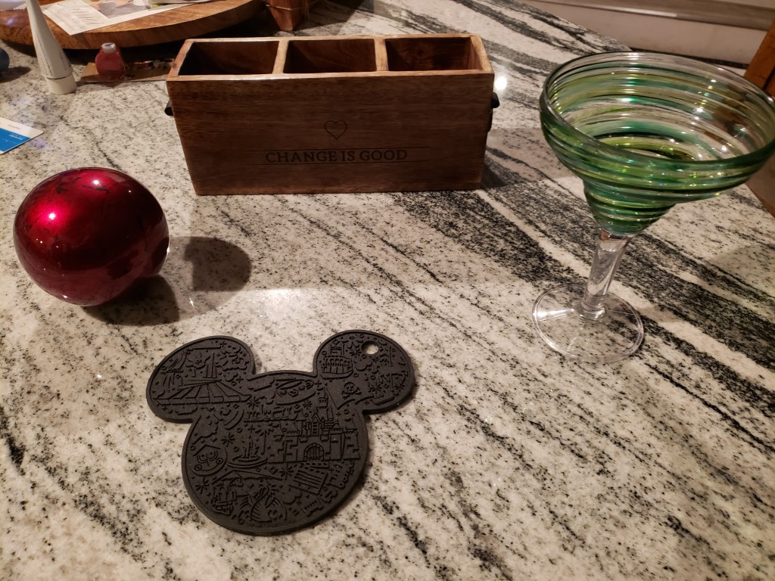

I plan on using the above photo for the final project in this class. I will be creating the orb, the wooden box, the martini glass and the Mickey Mouse shaped trivet in 3D. These objects will give me an opportunity to work with many different types of shapes. I will be working with a plane, cube, multiple spheres and then the martini glass will allow me to use possibly four different shapes within one object.

I will start with the countertop for a plane that the objects will rest on. The wooden box will provide me with an object that is mainly square but does have some storage areas to allow me to work on an item that has some depth to it. I will use cubes for this object and possibly part of a torus for the handles. The orb will allow me to work with a sphere and could be interesting to adjust the shading on. The trivet will probably be fairly basic but will give me a flatter sphere to work with.

The martini glass will be the most challenging as there are many different shapes to it. I plan on using a sphere for the base with a cylinder on top of that. At the top of the cylinder, I will use a pyramid with a torus on the top to give it the rounded rim of the glass. I’ve taken multiple photos of the setup to allow me to try and get a good idea of how it should look in the finished product.