**Survival of the Fittest: HIV Immunity**

***HASPI Medical Biology Lab 22a***

**Background/Introduction**

**History of HIV/AIDS**

**Acquired Immune Deficiency Syndrome**



<http://www.blatantworld.com/feature_pics/adult_hiv_prevalence3.gif>

**(AIDS)** was first seen in 1981 when large

numbers of people with two rare diseases

surfaced: Kaposi's Sarcoma, a form of

skin cancer, and Pneumocystis Carinii

Pneumonia, a form of pneumonia. The

cases were primarily seen in New York

and California. In 1984, Dr. Robert Gallo

identified a retrovirus present in all AIDS

patients. In 1986, the retrovirus that

causes AIDS received its final name

**Human Immunodeficiency Virus (HIV).**

In 1987, the Federal Drug Administration approved Zidovudine (AZT) as the first **antiretroviral drug** to be used as a treatment for AIDS. Additional effective drugs became available as of 1989. By December 1990, over 307,000 AIDS cases had been officially reported to the World Health Organization, but the actual number was estimated to be closer to a million. By 1994, AIDS had become the leading cause of death among Americans between the ages of 25 and 44. In 1999, the first human trial of an **AIDS vaccine** was started. In 2012, 36.1 million people are estimated to be living with HIV/AIDS. Of these, 34.7 million are adults. 16.4 million are women, and 1.4 million are children under 15 *(AVERT 2010)*.

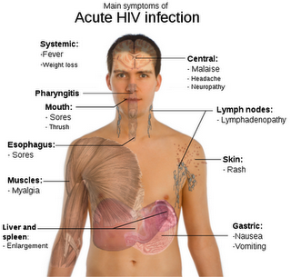 **Symptoms of HIV**

An individual may become infected with HIV, and have no symptoms from a few months to more than 10 years. During this time, the virus is invading and infecting T cells throughout the body. HIV specifically infects a type of T cell called **CD4+ T cells**. These T cells are responsible for “helping” the body respond to an infection. Eventually the HIV infection destroys the number of T cells in the body, which prevents the immune system from functioning. The weakened immune system reaches a point where it is no longer able to recognize or combat an infection.

The Center for Disease Control (CDC) currently defines AIDS as aT cell count that is less than 200 cells per cubic millimeter of blood. Patients with AIDS may contract pneumonia, tuberculosis, brain infections, cancer, and/or other illnesses. Victims normally die a year or two after developing AIDS.

<http://4.bp.blogspot.com/_RIWBU-b-irM/SbghpQe0LPI/AAAAAAAAAAk/R-n4-WCQDM0/s320/572px-Symptoms_of_acute_HIV_infection.svg.png>

**HIV Structure and Life Cycle**

A retrovirus is a virus with RNA as its genetic material. Retroviruses are able to insert their genetic material into a host cell. Once a retrovirus inserts its genetic material, it is able to make it part of the host’s DNA permanently, and can only be destroyed by killing the entire host cell. The process of HIV invasion into a CD4+ T cell is outlined in the diagram below.

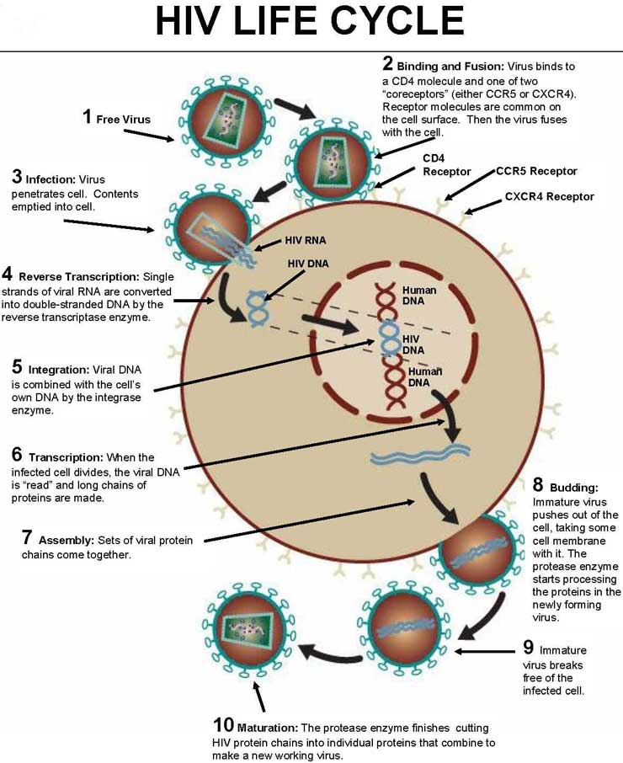

<http://www.bloodindex.com/images/hiv_life_cycle.jpg>

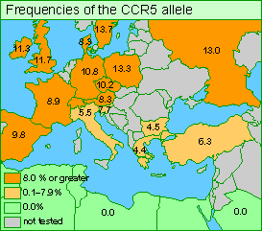**Natural Selection and HIV-1 Immunity**

HIV-1 and HIV-2 are specific strains of HIV, and have a slightly different structure. The protein that HIV-1 uses to enter white blood cells was discovered in 1996. The protein is called Chemokine Receptor 5 (CCR-5), which is produced by a gene of the same name. A mutation in the CCR-5 gene can result in a misshapen protein, or a lack of the protein on the cell surface at all. When the CCR-5 gene is incorrect or absent, HIV is unable to enter the white blood cells to infect the host. Think of cells without the CCR-5 protein as a home without doors. This results in a resistance, or immunity, to HIV-1.

How does immunity to HIV-1 provide an example of natural selection in action? Natural selection occurs only if there is both (1) variation in the genetic information between organisms in a population, and (2) variation in the expression of that genetic information—that is, trait variation—that leads to differences in performance among individuals. In the case of HIV-1 immunity, (1) a mutation occurred in the CCR-5 gene that created genetic variation, and (2) the mutated CCR-5 gene provides immunity to HIV-1 in those who have the mutation, while those who have a normal CCR-5 gene remain susceptible to HIV-1. In an environment where the HIV-1 threat is high, those individuals with HIV-1 immunity would clearly have an advantage. Go to the following website to view a 5-minute video “Surviving AIDS,” that summarizes the discovery of the HIV-1 Immunity gene:

<http://evolution.berkeley.edu/evolibrary/images/relevance/ccr5map.gif>

[**http://www.pbs.org/wgbh/evolution/library/10/4/l_104_06.html**](http://www.pbs.org/wgbh/evolution/library/10/4/l_104_06.html)

**Review Questions** *– answer questions on a separate sheet of paper*

1. How are AIDS and HIV related?
2. The total human population in 1990 was 5.28 billion, and in 2012 it was 7.15 billion. What percentage of the world reported having HIV in 1990 and 2012?
3. Explain why an individual infected with HIV may not know he/she has the disease.
4. What type of cells does HIV infect?
5. Do individuals with HIV actually die from HIV? Explain your answer.
6. Summarize the life cycle of HIV. Use pictures if you would like.
7. How can HIV be contracted?
8. Explain how an individual could have immunity to HIV-1.

**Please use this sheet to record your answers to the Review Questions:**