Argument Driven Inquiry Information for Claim/Evidence/Reasoning & Posters & Gallery Walks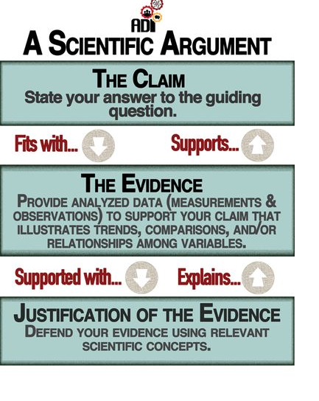

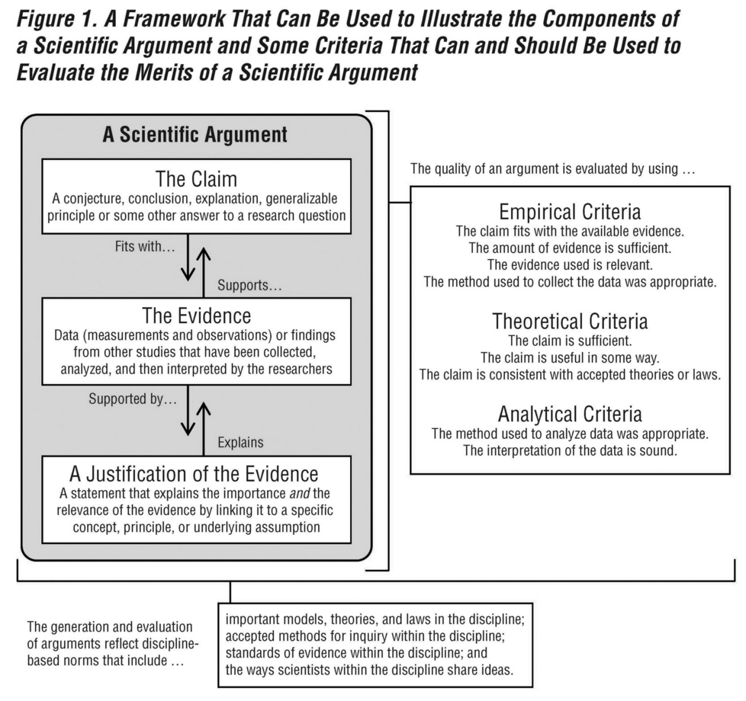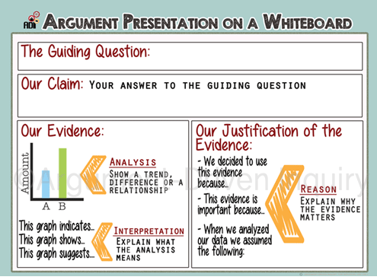

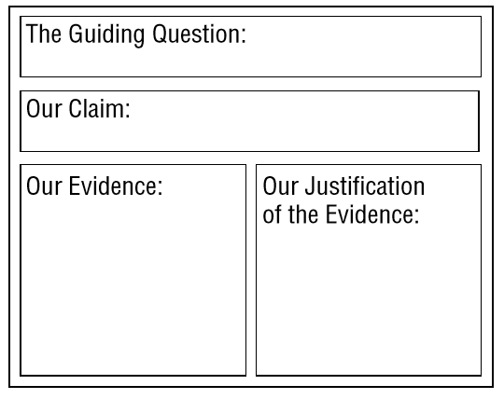

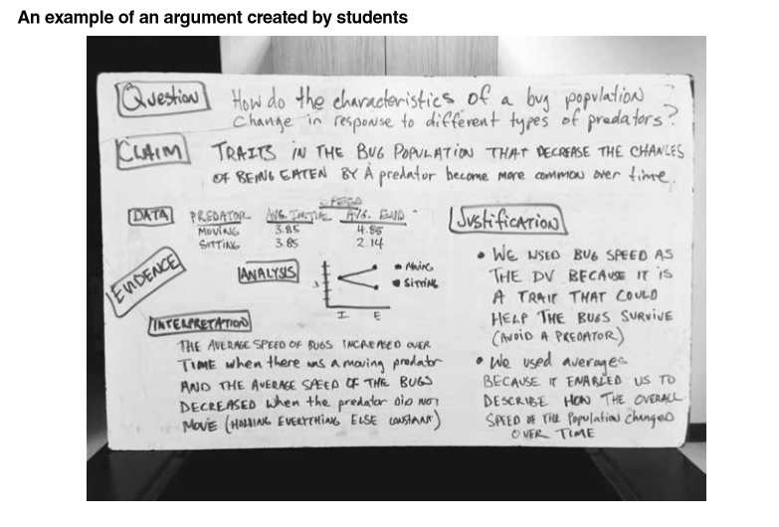

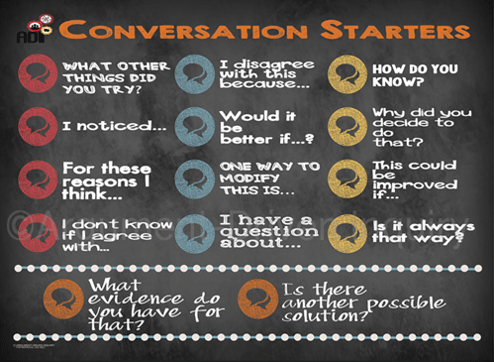

The 4 Ground Rules of Critique

1. Be Respectful: Critique is a fundamental aspect of science. It is how we identify weakness or flaws in our ideas. The person being critiqued is in a vulnerable position and it is easy for critics to get carried away and say hurtful things. We critique ideas not people in science and when we are critiquing ideas, we are always respectful.
2. Be Specific: Even if you are being respectful, you are not doing anybody any favors if you are vague. I think the argument needs more is not critique. We always make specific and detailed comments about what needs to be improved.
3. Be Helpful: Critique is more than identifying flaws or weakness in an idea, it is also about offering suggestions for ways to improve. We always offer specific and detailed suggestions for ways to improve as part of our critiques.
4. Use Scientific Criteria: We may think an idea is unacceptable for wide range of reasons. Scientist, however, rely on scientific criteria to determine if an idea is valid or not. These criteria are empirical or theoretical in nature. We always use scientific criteria to critique arguments and reports.