**Body Systems Unit Test Study Guide**

What are the levels of organization in the body?

Name the process by which organ systems maintain a relatively stable internal environment.

Which system coordinates the body’s response to changes in its internal and external environment?

What begins when a neuron is stimulated by another neuron in its environment?

What is the function of the central nervous system?

Which division(s) of the peripheral nervous system transmit(s) impulses from sense organs to the central nervous system?

What is the function of neurotransmitters?

What is necessary for a neuron to reach an action potential?

What process enables the body to maintain a stable temperature?

Which body system acts in a way similar to a transportation system?

Which is the correct direction of blood flow through the heart?

When an infection occurs, the number of these cells increase.

Which of the following blood cells contain hemoglobin?

Diseases are caused by….?

An infectious disease is one that is caused by….?

How are infectious diseases spread?

What are some examples of a vector and the disease it spreads?

What is the mechanism that some antibiotics use to fight bacteria (how are the bacteria killed)?

What does the inflammatory response cause in the body?

What is the purpose of a vaccine against diseases?

Asthma is an example of….?

Autoimmune diseases result when the immune system is….?

22. HIV weakens the immune system by killing….?

**Completion**

*Complete each sentence or statement.*

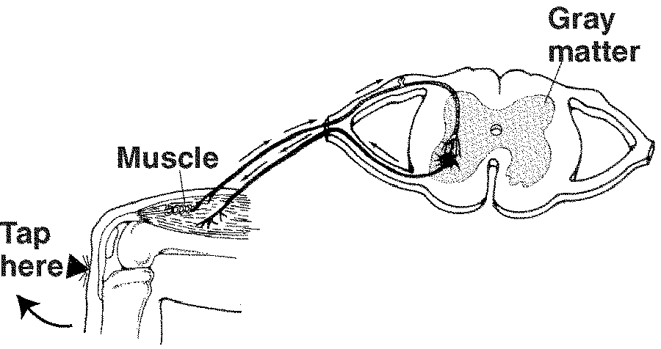

**Figure 35-3**

The process illustrated in this figure above is?

24. The parts of this diagram below are…?

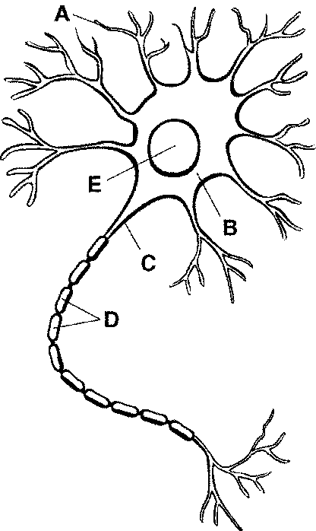

What is homeostasis?

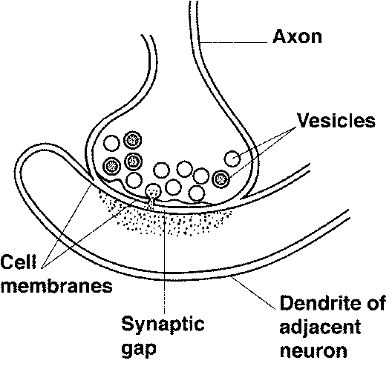

**Figure 35-4**

27. **Applying Concepts** In Figure 35-4, which structures release neurotransmitters?

28. **Interpreting Graphics** In Figure 35-4, into what area do the neurotransmitters diffuse?

**USING SCIENCE SKILLS**

Blood alcohol concentration (BAC) is a measure of the amount of alcohol in the bloodstream per 100 mL of blood. The following graphs illustrate how many alcoholic drinks consumed in one hour result in different levels of BAC in individuals of different masses. In some states, an adult driving with a BAC of 0.08% or higher is considered to be legally drunk.

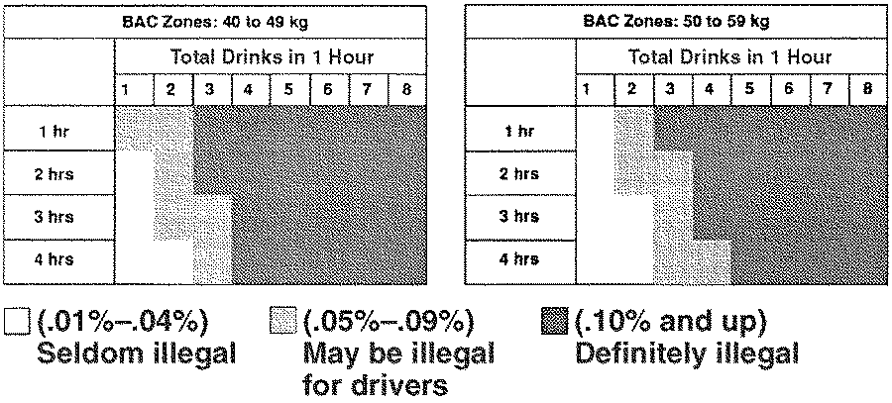

**Figure 35-5**

**Using Tables and Graphs** You are a 48-kg adult and have had four drinks in an hour. According to Figure 35-5, could you drive legally after three hours?

How are the cells of the human body similar to individuals in a society that work in groups to accomplish shared goals?

Based on the process of feedback inhibition, explain how your body maintains a relatively constant temperature.

Describe active and passive immunity and explain how an individual develops each type.

How do white blood cells guard against infection, fight parasites, and attack bacteria?

Before a person receives an organ from another person, he or she is first given very strong drugs to weaken the immune system. Otherwise, the immune system will attack the new organ. What causes the attack? Is this a form of autoimmune disease? Why or why not?

When a person is first infected with HIV, the body produces many antibodies against HIV and the number of viruses in the blood decreases significantly. Although antibody level remains high, the number of viruses in the blood increases over time and the number of T cells decreases. Explain these typical lab results based on how HIV affects the immune system.