Excel 2010 Graphing Help

1)      Open a new Excel spreadsheet

2)    Enter data in columns, information from column A will automatically be on the X-axis of your graph. (see figure below)

3)    Highlight data (all columns, **NO WORDS OR LETTERS!**, see figure below)

4)    Left click the Insert tab

5) Left click Scatter, select the icon WITHOUT lines (XY Scatter Plot, see figure below)

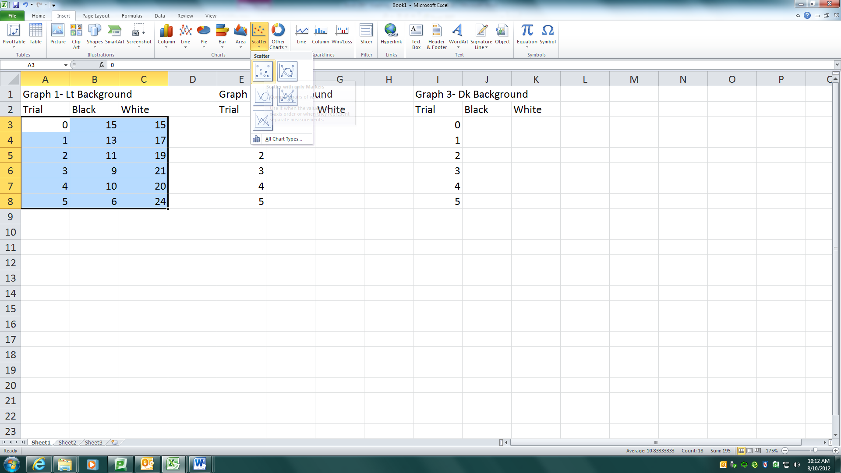

6)    Left click the Layout tab, left click Chart Title, left click Above Chart

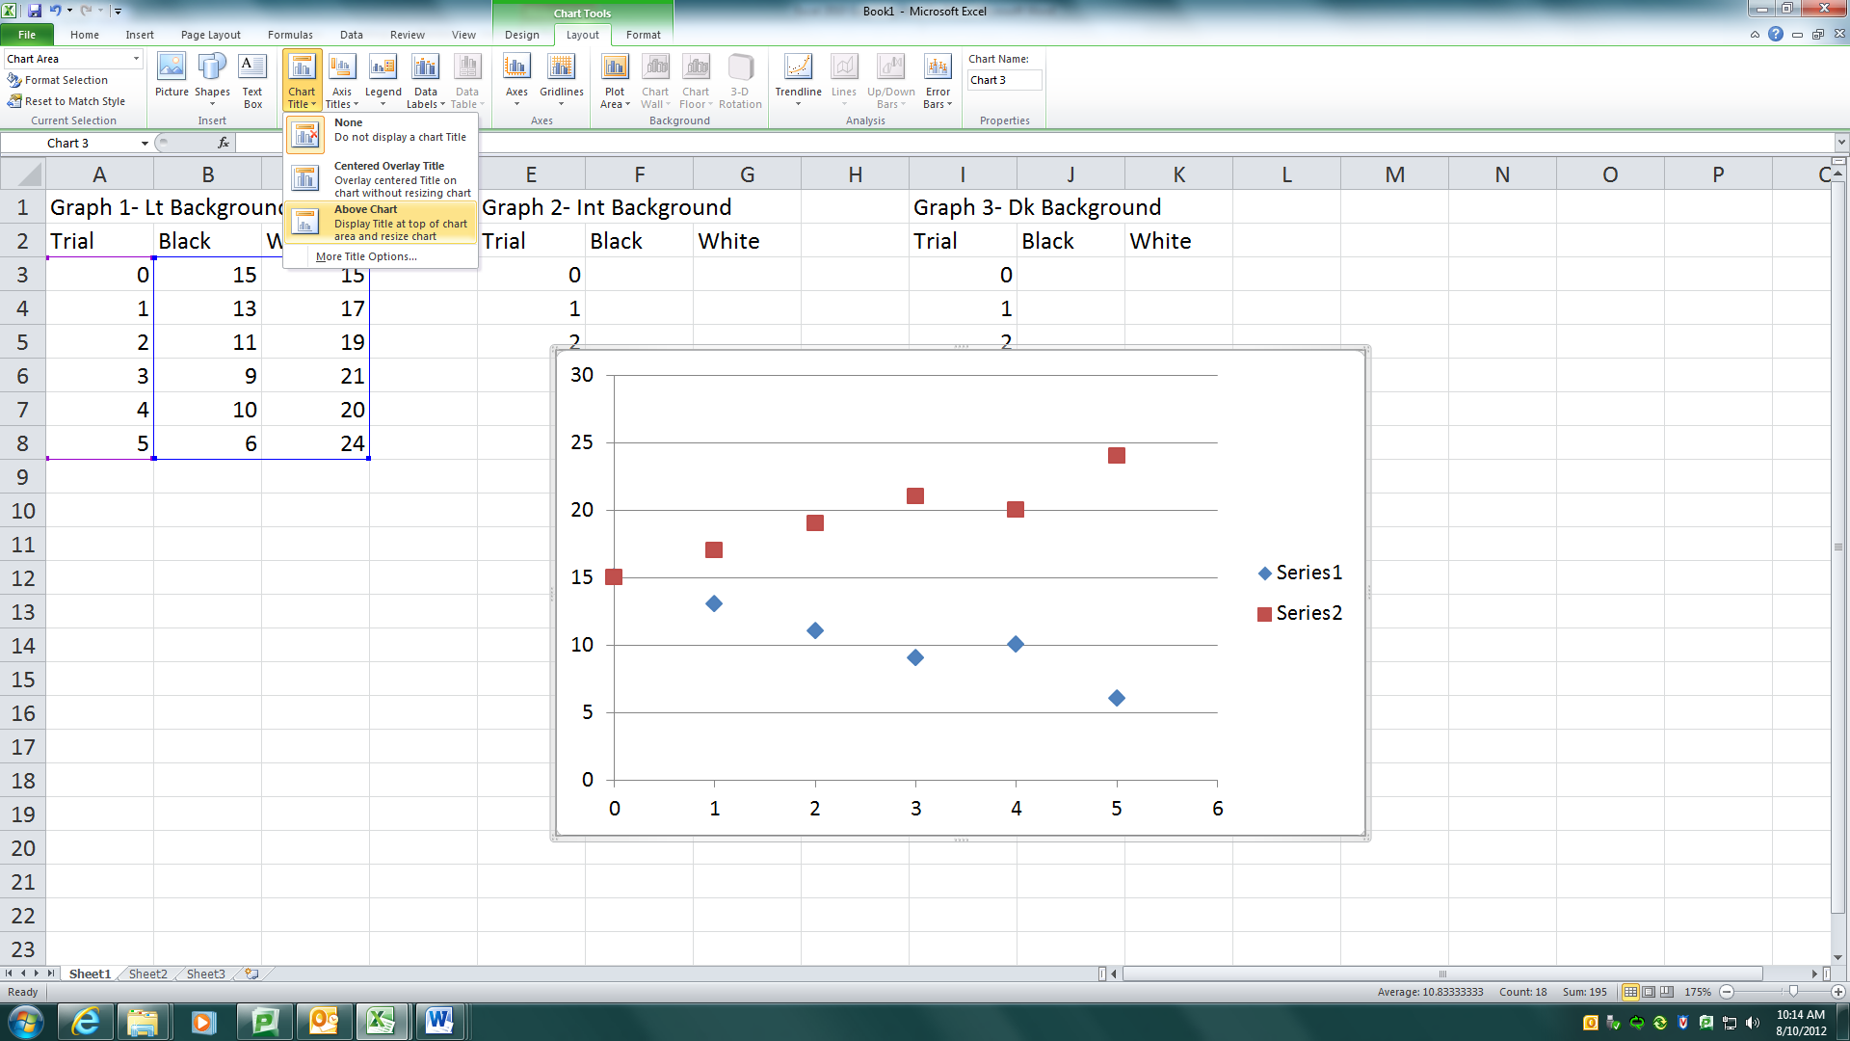

7)    Properly name your graph (The Effect of **X** on **Y**)

8)    Left click Axis Titles, left click title below axis (for horizontal axis) or horizontal title (for vertical axis)

9)    Appropriately name your axes, use units when applicable!

10) Right click the Series box and left click select data. (see below)

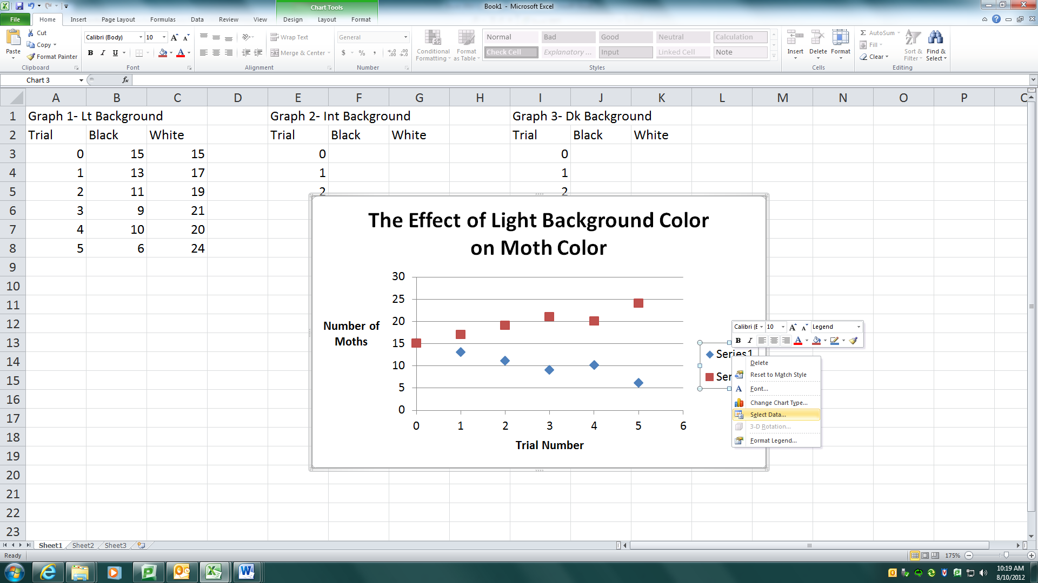

11) Left click on series 1, leftt click edit. Appropriately name your series. Repeat for series 2 if applicable. (see below)

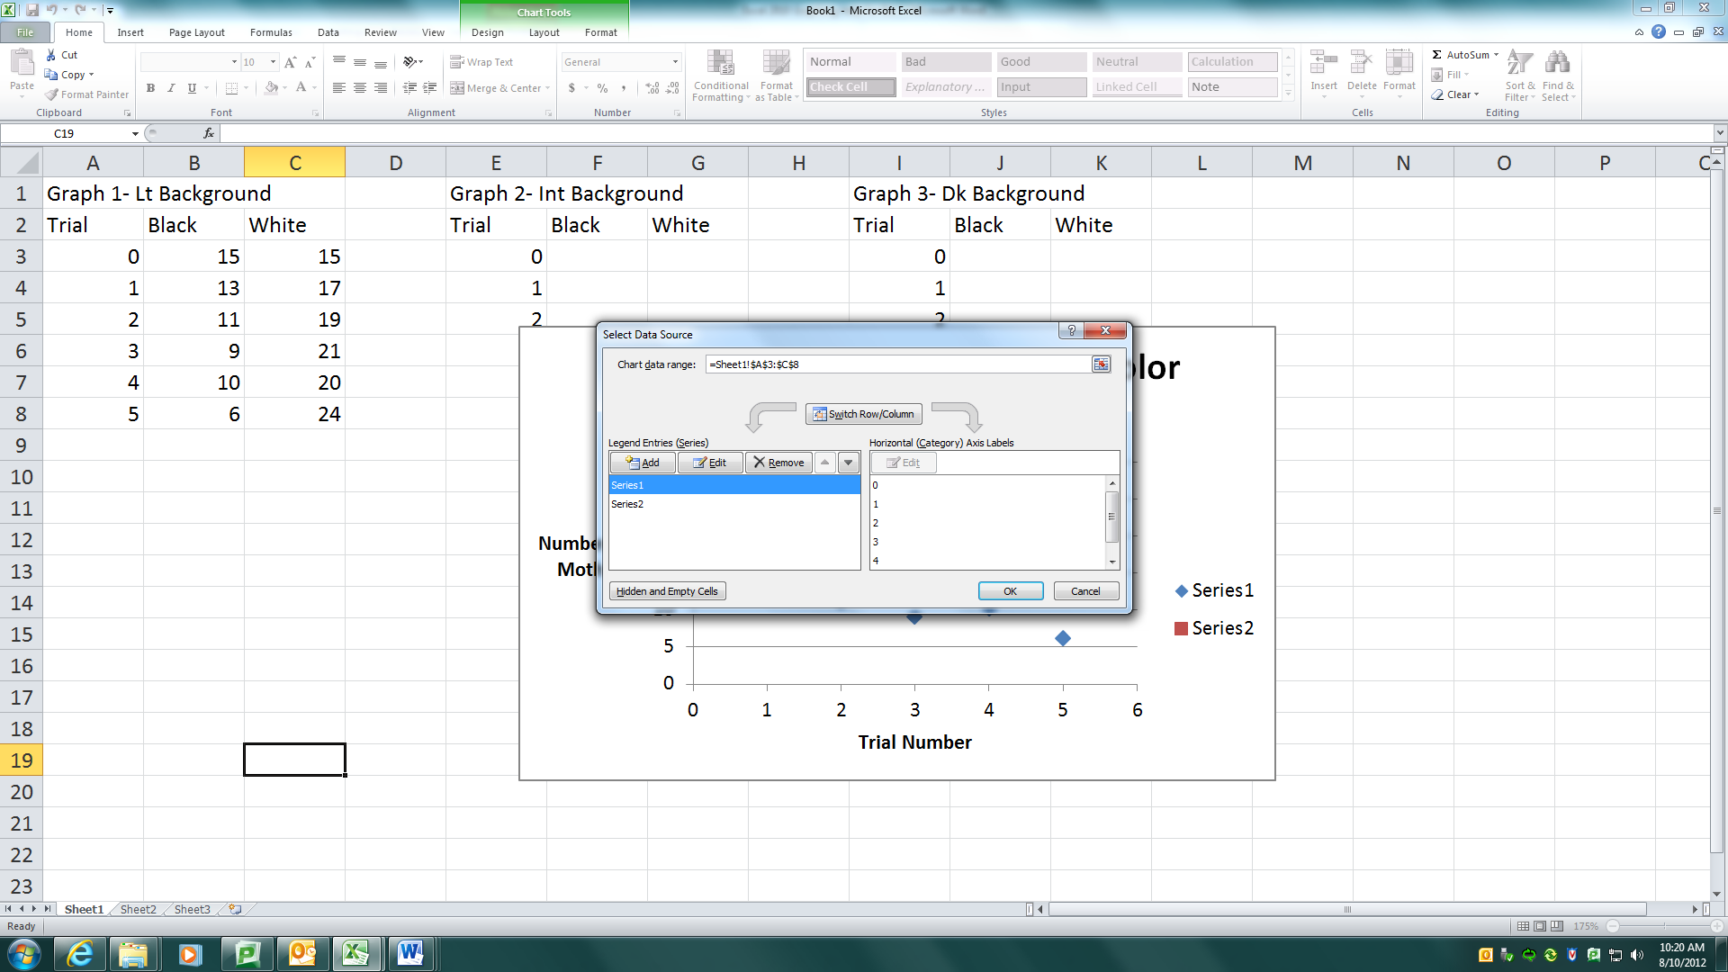

11)  Right click a data plot on your chart and select “add trendline”

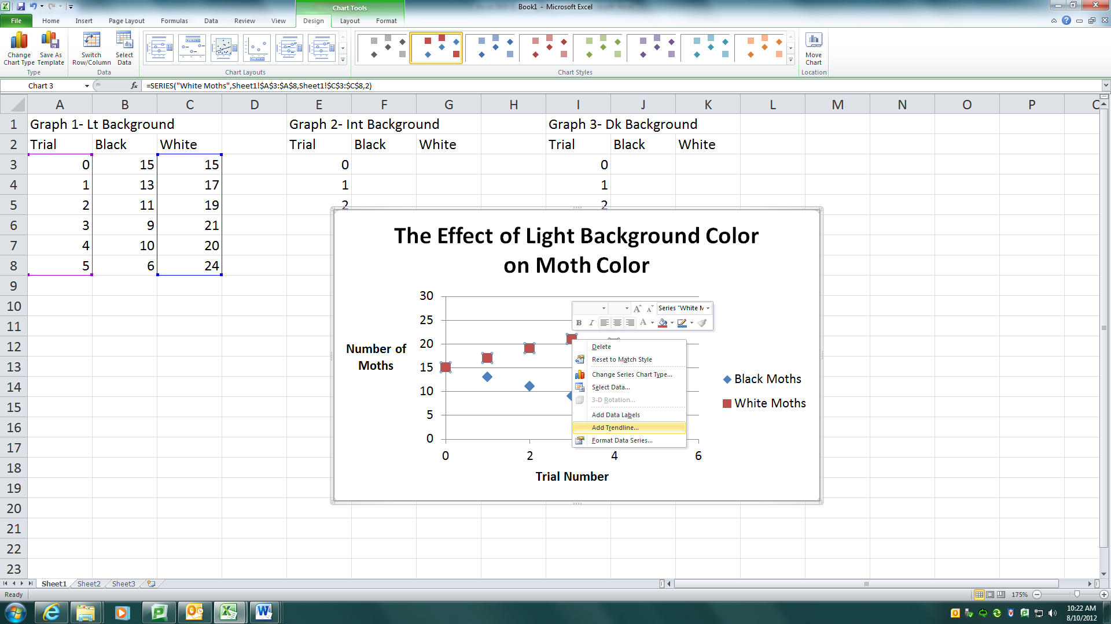

12)  Select the type of line that best fits your data, try different ones to make sure.

      a) DO NOT USE MOVING AVERAGE LINE!

b) Don’t forget to check off adding the equation of the line and and the R2 equation.

13)  Format data points, trendlines and graph as you wish by right clicking and selecting “format data series” or “format trendline” or “format plot area”

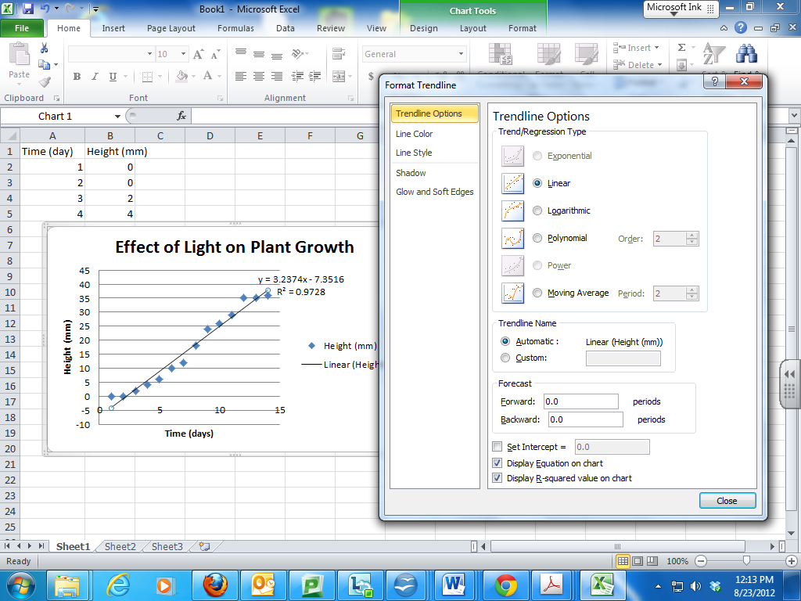

14) Copy your graph and paste it into your word document where appropriate.