**Gene Regulation drives Evolution**

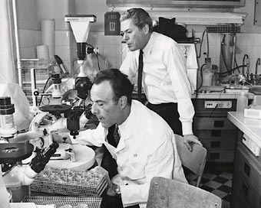Historical side note: The Fundamental Dogma of Genetics was first known as the Jacob-Monod hypothesis. They proposed that DNA was a blueprint and that ribosomes were the factories that worked according to the blueprint. Of course DNA is in the nucleus and ribosomes were in the cytoplasm leading them to first suggest an intermediate mRNA which had not been discovered yet. Their insights were pure genius. Every Biology Class should have their poster prominently displayed! We will be hearing about them a lot during this activity!

<http://www.bookrags.com/research/jacob-monod-hypothesis-wob/>

Jacob & Monod were the first to deduce “operon” gene regulation in bacteria. Their work is elegantly simple but their **BRILLIANT** logic can be difficult to follow. That explains why most introductory textbooks ignore the details of their work – a most terrible injustice.

**Operons in Bacteria**

Definition of an “operon”: _____________________________________________________________________

___________________________________________________________________________________________

Watch the following tutorial. <http://bcs.whfreeman.com/hillis1e/#667501__674151__>

The default setting of the Lac Operon is on/off? Explain: _____________________________________________

___________________________________________________________________________________________

What happens in the absence of lactose: _________________________________________________________

___________________________________________________________________________________________

What happens in the presence of lactose: _________________________________________________________

___________________________________________________________________________________________

The Lac Operon is either inducible or repressible. Explain which one in your own words: ___________________________________________________________________________________________

___________________________________________________________________________________________

Now watch the following tutorial. <http://bcs.whfreeman.com/hillis1e/#667501__674152__>

The default setting of the Trp Operon is on/off? Explain: _____________________________________________

___________________________________________________________________________________________

What happens in the absence of Tryptophan: _____________________________________________________

___________________________________________________________________________________________

What happens in the presence of Tryptophan: _____________________________________________________

___________________________________________________________________________________________

The Trp Operon is either inducible or repressible. Explain which one in your own words: ___________________________________________________________________________________________

___________________________________________________________________________________________

___________________________________________________________________________________________

___________________________________________________________________________________________

|  |  |  |  |  |  |
| --- | --- | --- | --- | --- | --- |
| Operon | Operon status | Default setting | Default Setting | When metabolite binds to Repressor | Metabolite |
| Trp | Inducible/Repressible | On/Off | Repressor binds/releases Operator | Repressor binds/releases Operator | Lactose/Tryptophan |
| Lac | Inducible/Repressible | On/Off | Repressor binds/releases Operator | Repressor binds/releases Operator | Lactose/Tryptophan |

Look at this diagram very carefully and identify whether it is portraying the Lac or the Trp Operon. Explain your reasoning including the terms “default setting” “repressible” vs. “inducible”. _________________________________________________________________________________________________________________________________________________________________________________________________________________________________________________________________________________

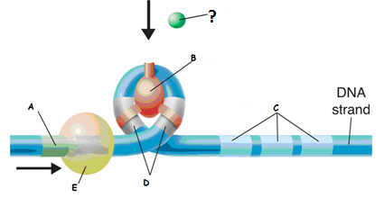

Now fill in all the missing labels



Let’s review some biochemistry: … means “enzyme a” is being inhibited or “shut down”



Meanwhile: … means enzyme d is being activated or “turned on”

All reactions in a cell generally occur by “Feedback (i.e.End Product) Inhibition” or by “Precursor Activation”:

What type of regulation is occurring here and in your own words describe what is happening:

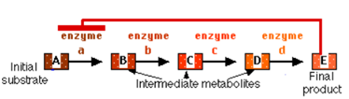

Regulation by __________________________

Explanation:__________________________________________________________________________________________________________________________________________________________

What type of regulation is occurring here and in your own words describe what is happening:

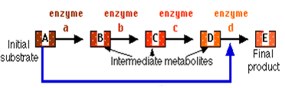

Regulation by __________________________

Explanation:______________________________________________________________________________________________________________________________________________________________

Most metabolic pathways look like this. Describe what is happening:

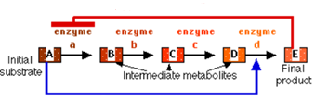

Regulation by ________________________________

Explanation:__________________________________________________________________________________________________________________________________________________________________________

A third option could be “positive feedback control”. Complete the diagram below by indicating positive feedback control:

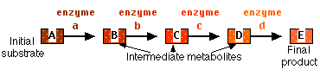

Explain why this mode of control would be unusual:_________________________________________________________________________________________________________________

Textbooks sometimes confuse the terms “precursor activation” and “positive feedback”. Here is an example of one such mistake. <http://bcs.whfreeman.com/hillis1e/#667501__708806__>

Is the text in fact describing “positive feedback” in this activity? Explain your answer: _____________________

___________________________________________________________________________________________

___________________________________________________________________________________________

Is the Lac Operon, as described so far, an example of Precursor Activation, Feedback inhibition or Positive Feedback? Explain your answer: _______________________________________________________________

___________________________________________________________________________________________

___________________________________________________________________________________________

Is the Trp Operon, as described so far, an example of Precursor Activation, Feedback inhibition or Positive Feedback? Explain your answer: _______________________________________________________________

___________________________________________________________________________________________

___________________________________________________________________________________________

The story of Prokaryotic Gene Regulation does not end here!

The word “ligand” is used differently in Biology than in Inorganic Chemistry. In Biology, a ligand is any substance (e.g. hormone, drug, functional group, metabolite, etc.) that binds specifically and **reversibly** to another chemical complex (often but not always a protein) to form a larger complex. Note: “reversible” is emphasized!

Consider Hemoglobin’s binding to Oxygen or to Carbon Dioxide. The protein’s “butterfingers” grip on the ligand is somewhat tenuous and slippery so the ligand can easily slip off. The ligand will only stay bound when driven by a so-called concentration effect. If surrounding oxygen is in high concentration (and surrounding Carbon Dioxide is in low concentration) hemoglobin preferably binds oxygen (and vice versa). Introduce Carbon Monoxide, and all bets are off. The protein Hemoglobin **irreversibly** binds Carbon Monoxide and death quickly ensues. **Reversibility** of binding is an important concept in gene regulation and in Biology in general.

Up to now you should have been wondering how the Lac Operon can ever be turned on. Two of the three genes shut down during the “default setting” are β-galactosidase and permease. In other words, Lactose cannot enter the cell unless permease is already being expressed; meanwhile Allolactose (the inducer) also cannot be produced unless the β-galactosidase is already being expressed. But the default setting is off - Catch-22!

Understand that Repressor binding is not “all-or-nothing”. Slippery or butterfingers hold onto Operator DNA permits some leakage of expression. The Lac Operon is not totally shut down… at least, not so far. The story now gets even better!

The Lac Operon in fact uses two complementary regulatory systems: (lactose induces expression of the Lac Operon) while excess glucose shuts down expression of the Lac Operon. In the case of the bacterium E coli, the presence of glucose shuts down the Lac Operon for two possible reasons:

[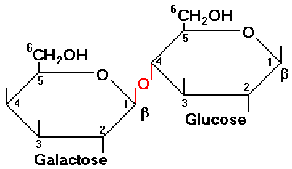](http://www.google.ca/url?sa=i&rct=j&q=&esrc=s&frm=1&source=images&cd=&cad=rja&docid=3yDy249nPwuclM&tbnid=Y0bYz3avWTGVFM:&ved=0CAUQjRw&url=http://www.rpi.edu/dept/chem-eng/Biotech-Environ/IMMOB/lactose.html&ei=9xpfUs7PGYjq8gSJy4HQBw&bvm=bv.54176721,d.aWc&psig=AFQjCNHmcAAH_yU3NoD6CRIE4Tk6XLraFA&ust=1382050417591188) When enough Glucose is produced as a result of the lactose dimer breaking down into two monomers including Glucose, the Operon is shut down. Meanwhile, Glucose is the preferred energy source since its metabolism is more energy-efficient. In either case, high Glucose levels shut down the Lac Operon. Glucose is a catabolite (breakdown product of lactose). That explains why Glucose shutting down the Lac Operon is called “Catabolite Repression”.

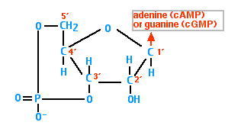**Cyclic AMP as a secondary messenger & Protein Activators in E coli gene transcriptional regulation**

We are going to hear about secondary messengers a lot in this course… especially cAMP. Cyclic AMP is one of our familiar nucleotides where the 5` Phosphate also forms another covalent bond with the 3` Carbon.

Cyclic AMP is a secondary messenger in E coli because its presence responds directly to Glucose levels in the cell. When glucose levels are high, cAMP levels are low and vice versa. High cAMP levels activate CAP aka Catabolite Activator Protein. High cAMP binds to CAP (allosteric interaction) and increases the protein's affinity for DNA. CAP literally unwinds bends and opens the DNA enough for RNA polymerase to bind to the promoter. In the absence of CAP, RNA polymerase cannot proceed. That is why CAP is called an activator, or an activator of transcription.

Check out this video: <http://highered.mcgraw-hill.com/olc/dl/120080/bio27.swf>

Regulation of the Lac Operon has sometimes been described as a “belt and suspenders” model of gene regulation. Explain what is meant by that statement using the words “repressible” and “inducible”:

_________________________________________________________________________________________________________________________________________________________________________________________________________________________________________________________________________________

What happens to the lac Operon when Lactose levels are high and Glucose levels are low? ________________

__________________________________________________________________________________________

What happens to the Lac Operon when Lactose levels are high and Glucose levels are high? _______________

__________________________________________________________________________________________

What happens to the Lac Operon when Lactose levels are low and Glucose levels are high? ________________

__________________________________________________________________________________________

Regulation of the Lac Operon has significant importance in understanding regulation in Biological systems in general not to mention cell differentiation and differential gene expression in Eukaryotes. Commitment steps in Biology often require a second failsafe mechanism to confirm commitment.

For example, a B Cell does not commit to clonal expansion and antibody production unless the T Cell confirms attack. T Cells themselves meanwhile require redundant confirmation of immune response. Think of an Immune Response as a nuclear warhead launched by an offshore submarine. How does one protect against the possibility of a submarine captain going “rogue” as in the movie “The Hunt for Red October”?

In the case of an Immune response an attack cannot be launched without:

•the Submarine Captain’s key (The B Cell), whose key is necessary to launch an nuclear strike

•a failsafe second key carried by the submarine’s second in command (the T Cell) necessary to launch the attack.

If both B Cells and T Cells go rogue – we can have a problem called an auto-immune response.

To continue the metaphor: in Eukaryotes, a core promoter binds RNA polymerase, but transcription does not proceed until an upstream promoter binds cell-specific binding factors to “confirm” transcription by physically contorting and opening the DNA.

Safety deposit boxes in a bank provide a useful metaphor.

You need two keys to open your bank box:

•your key, (cell-specific transcription factors) whose pattern of notches fits only the lock of the box assigned to you (= the upstream promoter), but which cannot unlock the box unless

•a second key (RNA polymerase II) carried by a bank employee which opens the second lock (= the core promoter) but cannot by itself open any box.

The complexes of hormones with their respective receptors binding to DNA represent one class of transcription factors controlling eukaryotic gene expression.

We will discuss eukaryotic gene control in more detail in the next worksheet; we still need to establish at the outset commonalities between prokaryotes and eukaryotes.

One very important commonality between prokaryotes and eukaryotes is how CAP binding contorts and opens the DNA Helix. This is yet another very important concept that must be emphasized. Control of DNA expression often requires physical bending and untwisting of the DNA helix. We will see this again in our next worksheet, especially when discussing enhancers.

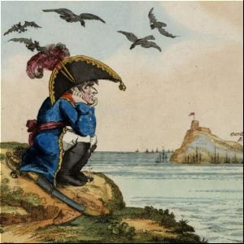

Let’s define palindrome: Following the Treaty of Fontainebleau, French emperor Napoleon I was exiled to Elba after his forced abdication in 1814.

A palindrome was composed on his behalf:

“Able was I ere I saw Elba”

… notice how it reads the same forwards and backwards.

One recurring theme the eukaryotes share with eukaryotes is the importance of palindromes and inverted repeats. This occurs when a 5` -> 3`sequence of nucleotides is repeated in the complementary strand slightly downstream allowing the same sequence to be read forwards and backwards.

For example, 5'---GACTGCGCAGTC---3' is a palindrome.

Write its complementary sequence and confirm it reads the same in both directions.

Let’s try another example, 5'---GACTGC…TCAGACAG…GCAGTC---3' is an inverted repeat. Notice the flanking 6 nucleotides are identical to the palindrome with some intervening sequences that do not read the same forwards and backwards.

[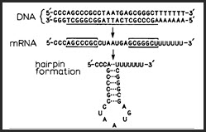](http://fx.damasgate.com/wp-content/uploads/4-5-2011-1-46-59-AM.jpg)

Palindromes and inverted repeats are very important in gene regulation. When mRNA contains inverted repeats, “stem & loop” structures can arise. These can differentially regulate ribosome binding and translation termination. (Take my word for it – let’s leave something for university) They can also regulate RNA polymerase binding. In the Trp Operon, the phenomenon is referred to as attenuation. [video](http://pages.csam.montclair.edu/~smalley/TrpAttenuation.mov)

Again, let’s leave details for university, not AP Bio.

Meanwhile, sauce for the goose is sauce for the gander; DNA too can form stem and loop structures either with palindromes or with inverted repeats.

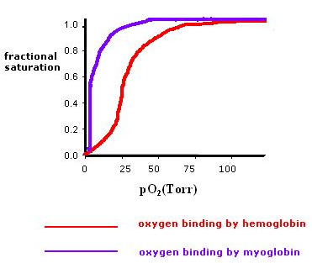Back to hemoglobin, the quaternary structure of Hemoglobin permits cooperative binding and release of Oxygen and Carbon Dioxide in a very reversible manner, as discussed above. Hemoglobin is more efficient than Myoglobin by its superior ability to release Oxygen even though it is less efficient at binding Oxygen. Similarly, DNA binding proteins exist either as dimers or tetramers that both bind and release DNA, again exhibiting the same kind of kinetics as Hemoglobin.

But if DNA binding proteins exist as mirror-image dimers or tetramers, the DNA being bound must present sequences that are mirror image repeats, our so-called palindromes or inverted repeats. Hold that thought!

The Long Terminal Repeats that flank transposons and retroviruses also contain (inverted repeats) like those found in the CAP protein. Long Terminal Repeats turn on transposon and retroviral genes as well as enhancing the expression neighboring host genes. The “enhancer story” starts with bacteria!

What is a transposon and explain why they sometimes called “jumping genes”? __________________________

___________________________________________________________________________________________

___________________________________________________________________________________________

What is a retrovirus and describe any similarities to transposons. ______________________________________

___________________________________________________________________________________________

___________________________________________________________________________________________

Retroviruses and Transposons are evolutionary game-changers! Genomes are no longer stable but quite fluid. Meanwhile Retrovirus can be vectors for foreign genes permitting horizontal gene transfer between different species. That is exciting!

Horizontal Gene Transfer? Explain what that is and give an example: __________________________________

______________________________________________________________________________________________________________________________________________________________________________________

**This where the story gets really interesting!**

When the Jews were expelled from Spain in 1492, a majority went to the Ottoman Empire where they settled. There was an apocraphyl anecdote that the Ottoman sultan, Bayezit II was heard to remark: “How can you call Ferdinand of Aragon a wise king, the same Ferdinand who impoverished his own land and enriched ours?”

History repeated itself as Europe’s best scientific minds sought refuge in America during the Nazi years. Forgive me for going on a tangent here – but I strongly feel that modern texts and curricula are missing something important here!

Today’s Geneticists and today’s Molecular Biologists are standing on the shoulders of intellectual giants whose work remains forgotten because modern textbooks cannot dumb-down their intellectual tours des forces! Intergenic Recombination, Genetic Complementation, Intragenic Recombination and gene regulation were all figured out FIRST in VIRUS systems leading ultimately to the resolution of the Fundamental Dogma of Genetics by Jacob and Monod of lac-operon fame. That would be because viruses have co-opted host regulatory machinery and vice versa. That constitutes the acme in molecular host-parasite coevolution. Check out the following: <http://blogs.discovermagazine.com/loom/2012/06/14/we-are-viral-from-the-beginning/>

How many fragments of endogenous retroviruses exist in the human genome? _________________________

What per cent of our total DNA would that be? ________________________________

Americans have every right to be proud of their great accomplishments such as the Manhattan Project and the race to the Moon but in my opinion these achievements pale in significance to the accomplishments of the Phage Group of Cold Spring Harbour Laboratories.

**Restriction Enzymes crucial to understanding Epigenetics**

Restriction Enzymes are homodimers that recognize their sites recognize specific stem-loop structures permitting site-specific endonuclease cutting of DNA. In other words, they recognize palindromes or stem-loop DNA. That is only half the story. Every restriction enzyme is paired with a methylase enzyme that methylates exactly the same DNA palindrome thereby making it immune to restriction enzyme cleavage.

The restriction-modification system of bacteria is employed as a defense against invading bacteriophage DNA which will cleave (and subsequently destroy) unmodified (i.e. unmethylated DNA) of invading bacteriophage phage. OK – that is the quick and easy version of a much more complicated story.

So why is host-bacterial DNA immune to restriction-endonuclease cleavage while invading phage DNA is so sensitive to restriction endonucleases? Bear in mind that bacterial host DNA is constantly undergoing replication, which means that bacterial host DNA is constantly presenting unmodified DNA to its own restriction endonucleases. Werner Arber worked that story out: <http://library.cshl.edu/oralhistory/speaker/werner-arber/>

Modification (methylating) enzymes that protect host DNA are not part of the host’s DNA replication machinery. Modification and Restriction enzymes independently compete for the same “restriction” sites on both host and phage DNA. It would appear that host DNA is continually providing far more substrate for restriction-endonuclease cleavage than any potential invading virus. So why is host DNA not getting chopped up?

Imagine now Phage infection of some bacterium actively replicating its own host DNA. Both strands of phage dsDNA are completely unmethylated and prone to restriction endonuclease cleavage. Meanwhile, the bacterial host dsDNA (undergoing replication) is by definition a heteroduplex. The “parental” bacterial DNA strand has already been methylated, while the “daughter” strand has yet to be methylated. However, this “partial methylation” STILL leaves the host bacterial DNA immune to restriction endonuclease cleavage!

Werner Arber determined that partially-methylated DNA is NOT a substrate for restriction endonucleases. Parental strands are always protected, leaving invading unmethylated virus vulnerable to restriction enzymes.

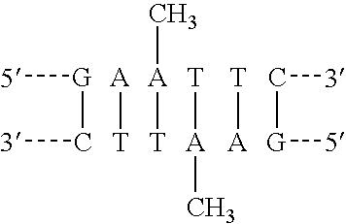On January 2011, Pope Benedict XVI appointed Arber as the first Protestant to hold the office of President of the Pontifical Academy of Sciences… go figure!

Here is a sequence of methylated DNA.

Notice that two nucleotides have been methylated.

Is it a palindrome or inverted repeat?

Explain: ________________________________________

_______________________________________________

Use the internet to identify any restriction/methylase enzymes.

Using identical logic as employed in the [Meselson-Stahl experiment](http://highered.mcgraw-hill.com/olcweb/cgi/pluginpop.cgi?it=swf::535::535::/sites/dl/free/0072437316/120076/bio22.swf::Meselson%20and%20Stahl%20Experiment):

draw how two strands of DNA are methylated after one round of replication

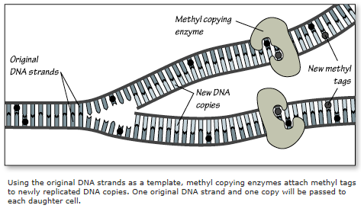but before laggard methylase arrives at the scene.

Very soon, you will be completing a worksheet on Epigenetics.

This diagram could as easily apply to Prokaryote gene regulation as to Epigenetics.

**Antisense RNA in Bacteria**:

In the last decade there has been an information explosion cataloguing small, regulatory RNAs (sRNAs) encoded on bacterial chromosomes that regulate gene expression. They regulate gene expression

1. by binding to and modulating protein activity,
2. by base pairing with target mRNAs.

These base pairing sRNAs fall into two categories:

1. cis-encoded: or antisense RNA which inactivates mRNA by binding to it. Double double stranded RNA mimics double stranded viral RNA and would be targeted by endogenous enzymes
2. trans-encoded: The trans-encoded sRNAs are encoded at genomic locations distant from the multiple mRNAs they regulate. This type of base pairing requires the RNA chaperone protein. This story is looking very similar to miRNA found in Eukaryotes (on our next worksheet) <http://www.ncbi.nlm.nih.gov/pubmed/20707673>

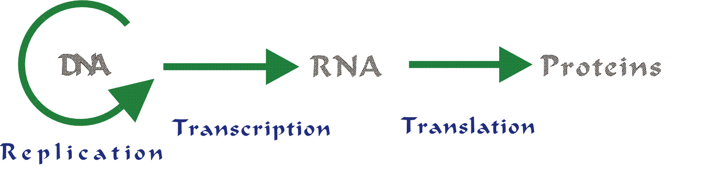**Riboswitches**:

Consider the Central Dogma of Genetics

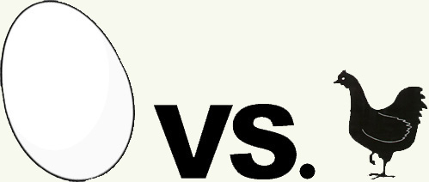The emergence of life for the first time on this planet constitutes the classic question of what came first; the chicken or the egg?!

Did a self-replicating DNA system occur before transcription or translation evolved (the DNA World) or did a self-replicating RNA system first emerge (the RNA world) or did self-replicating protein system first emerge (the Protein World)…or did replication, transcription and translation emerge together all at once?

We will consider the question of how life first arose on this planet on another worksheet. It appears that the very first enzymes were not protein but rather nucleic acids. These are called “ribozymes”. Remember the cell’s Über-enzyme, the ribosome is made of rRNA! It appears that some prokaryotic gene regulation constitutes proof-positive of the RNA-world hypothesis.

<http://users.rcn.com/jkimball.ma.ultranet/BiologyPages/L/LacOperon.html#Riboswitches>

It turns out that the regulation of the level of certain metabolites can also be controlled by “riboswitches”. A riboswitch is section of the 5'-untranslated region (5'-UTR) in a molecule of messenger RNA (mRNA) which has a specific binding site for the metabolite (or a chemical on the same metabolic pathway).

The riboswitch regulates transcription of genes involved in the metabolism of that molecule. The metabolite binds to the growing mRNA and induces a structural change to the mRNA that

•for some genes causes further synthesis of the mRNA to terminate (Remember attenuation in the TRP Operon)

•for other genes, enhances completion of synthesis of the mRNA.

In other words, the metabolite is either engaging in precursor activation or feedback inhibition.

It has been suggested that these regulatory mechanisms, which do not involve any protein, are a relic from an "RNA world". Check out the list of metabolites found on this [link](http://tinyurl.com/l4ap5q9).

How does this list support the suggestion “Riboswitches” are relics of an “RNA-world”? _________________________________________________________________________________________________________________________________________________________________________________________________________________________________________________________________________________

**Quorum Sensing:**

Bacteria can talk to each other by cell signaling mechanisms! That came as a big surprise. Bacteria can use quorum sensing to coordinate a variety of behaviors such as biofilm formation. There is evidence that interspecies communication via Quorum Sensing can occur. This is referred to as “quorum sensing cross talk”.

Such bacterial behavior whispers the first hints of cell differentiation (…to produce capsule or not to produce capsule; that is the question!) Many bacteria rely on Quorum Sensing to control the expression of the genes which cause disease. If we can block the QS systems we may be better able to cure disease!

Quorum sensing can be described in ecological terms as density-dependent responses by a population. In your own words describe what that means _________________________________________________________________________________________________________________________________________________________________________________________________________________________________________________________________________________

… and provide another example of a density-dependent response typically understood in ecology. ___________________________________________________________________________________________

Is surprising for yet another reason; it often involves positive feedback control. That is significant; more about that on a later worksheet.

**In conclusion:**

The year 1961 witnessed a particularly famous Cold Spring Harbor Symposium. All the intellectual giants were present including the famous CSH phage group mentioned earlier. The stars of the show were François Jacob and Jacques Monod. They dared to suggest that eukaryotic signal transduction systems would prove to be little different than in bacteria. They were the first to postulate Cis-regulatory elements as gene regulators no different than the "Operator Gene" of the lac-operon. Citing the λ phage lysis/lysogeny switch and the Escherichia coli lac operon Jacob & Monod suggested straightforward double-negative and even positive feedback loops might all that is required to cause cell differentiation in eukaryotes. Recent advances in technology have given rise to a whole new generation of “DNA–chompers” who have had little, if any, training in classical genetics.

This recent paper deserves our attention: <http://www.pnas.org/content/110/18/7101.full.pdf> Mark Ptashne’s question is right on target! Are we essentially re-inventing the wheel? Perhaps if we paid greater attention to bacteria and bacteriophage gene regulation; we could better elucidate the secrets of Biology?

In our next worksheet, we will discover that Eukaryotic gene regulation has remarkable commonalities with Bacterial Gene Regulation.