How to Evaluate Claims using Evidence (adapted from Jeremy Conn <http://www.clearbiology.com/helping-students-make-evidence-based-claims/> )

**How do we gather information about the world around us?**

* First hand experiences
* What other people tell us
* Observations
* Experimentation

**What conclusions can we draw from observations?**

* A carpenter, a school teacher, and scientist were traveling by train through Scotland when they saw a black sheep through the window of the train.
* "Aha," said the carpenter with a smile. "I see that Scottish sheep are black."
* "Hmm," said the school teacher. "You mean that some Scottish sheep are black."
* "No," said the scientist glumly. "All we know is that there is at least one sheep in Scotland, and that at least one side of that one sheep is black."

(Source: Unknown)

**What do observations and experimentation provide us?**

* Data

**What can a person do with data?**

* Draw conclusions
* Make predictions

**What is a claim?**

* A statement of something as a fact; an assertion of truth. (TheFreeDictionary.com)

**Consider the Following Claims**

In the United States…

* More than twice as many males die in motor vehicle crashes than females.
* More fatal motor vehicle crashes occur during the night time.
* More fatal motor vehicle crashes occur when it’s raining than when it’s snowing or sleeting.
* A majority of fatal motor vehicle crashes occur when the weather is “normal” outside.
* Fewer older people die in motor vehicle crashes than younger people.

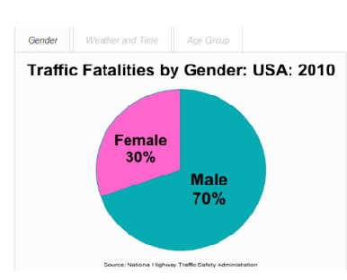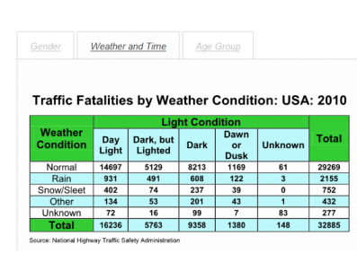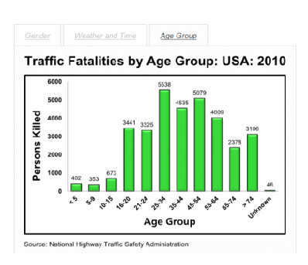

How many people will believe a claim even though there is a large volume of research that rejects the claim?  As an illustration,

For example: how many students support:

* 1. That human blood is blue in our veins and turns red when it leaves the body and encounters oxygen.  OR
  2. That human blood is always red, even inside our bodies.

Can you name other examples?

**Why do people believe claims? (How many are true?)**

* They trust the source.
* It sounds believable.
* They hear the claim made from various sources.
* The claim is supported by experimental data (evidence).

Using data to make claims (with evidence):

Use the National data provided keeping in mind that:

* The claims can indicate difference in and between demographic categories.
* Then number of deaths in each demographic group varies.  It is therefore important to use percentages as opposed to numbers of individuals.
* Claims should be clearly supported by the data.  Indicating differences between demographics is sufficient.  Do not offer suggestions as to why the differences exist.
* Exclude any assumptions that are not directly supported by the data
* Avoid unclear pronouns in your claim (e.g. it, he, they…).

Pick some data and use the following t chart and graph to represent your data and make a claim.

[Mortality Data](http://www.grochbiology.org/NationalVitalStatistics.pdf)

[T chart](http://www.grochbiology.org/Making-a-Claim-Based-on-Data-T-Chart.pdf)

[Graph](http://www.grochbiology.org/Mortality-and-Age-Line-Graph.pdf)

Present your claims to the class.