Instructions for Reflections (see rubric suggestions below):

Reflections can be made very simple if you just understand a basic point and can share that point in writing. The teacher wants to know that you have actually learned from the chapter (or lab, or Case Study, etc.), so it is your job to write down all the new knowledge you have learned and link to the concepts introduced in the unit. New information learned could come from notes, the chapter in the text book, any class-time movies, labs completed, or any classroom lectures. The next step is citing what you have written. If you say “The art of classifying organisms is called taxonomy”, the teacher would know that information was not just an inspired thought from your own brain. So, you need to cite the exact source of that information. The cited sentence would look like this: “The art of classifying organisms is called taxonomy1.” The reader/teacher then knows where they can look to find the source of that information. Lastly, remember to put your references at the end of your paper, to track the citations. The references can easily be made at [www.bibme.org](http://www.bibme.org) Be sure they are in scientific citation: APA. Awesome! You are done.

Requirements:

* At least one page covering new information learned in an article, a chapter or lab or videos or Case Study… (always add supporting details, examples, and elaborate).
* Link your new knowledge back to the broad concept of the unit.
* Include Citations
* Include References

Suggestions for Formatting Your Reflection to Ensure You Include All Necessary Information:

Paragraph 1- Background information regarding concepts from the media A summary of the purpose, key concepts, claims, hypotheses and/or questions being addressed by the author(s) of the media)

Paragraph 2 (or 2-3)- Present the evidence from the text the authors used to support their claim (use citations!) What experimental design was used (if applicable), what data was collected as the basis for support of the claim or hypothesis

Paragraph 3 (or 4) - Relate the information from the newly investigated media with prior knowledge or learning (use more citations!)

What conclusions can be drawn from the evidence presented in the media, how does it relate to topics previously explored in science class or reading (reference your textbook and any other sources your knowledge has come from!)

Paragraph 5 (or 6)-Describe possible rebuttals, contradicting or lacking evidence or controversy regarding the key concepts or evidence presented in this media (use more citations if necessary!)

This section may either be acknowledged by the authors in the media (which must be cited!) or desired by the reader…that’s you

Does the experiment or data collected by the authors support their claim (is the view valid based on the evidence presented)? Is the evidence lacking or did the experimental design leave room for large errors? Does the evidence in this media contradict evidence from another source (cite other sources!)

What does the grading rubric look like? [Rubric link](http://www.grochbiology.org/RubricforReflections.pdf)

The rubric is divided up in sections with values from 4 (excellent) to 0 (not there).

In order to earn full credit the reflection must show evidence of an informative title, reflective thinking, analysis, making connections, citations, and references.

Common errors:

1. Title: just restating the assignment name (e.g. Corn Lab) instead of an informative title such as: Using Corn Kernels to Determine Parental Genotypes.
2. Reflective thinking: students just provide a summary of the activity, there is no personal reflection on material, no evidence or explanation of what prior knowledge was used and how new knowledge was integrated or added. No evidence linking new knowledge to what future use this knowledge might lead to or why this knowledge is important.

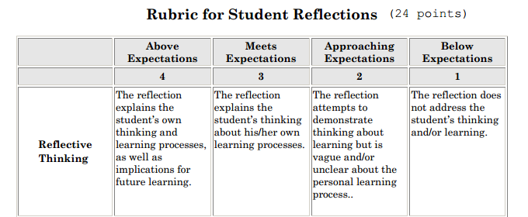

1. Analysis: students just provide a summary of the information without any analysis of the activity (lab, article, reading, etc).

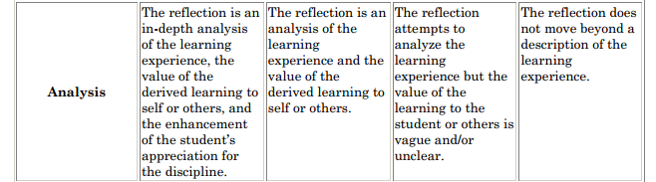

1. Making Connections: students do not bring in new, outside information to support the learning experience to specific and broad concepts. (Very obvious if there are no citations and references to material outside the textbook or material supplied in class).

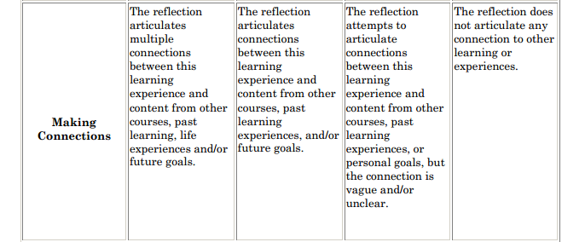

1. Citation & references: students do not use superscripts of the reference numbers to materials within the document. Students put the superscript (or parenthesis) in front of the period. Students do not number the references below the reflection. Students do not use APA style. Students do not use or cite additional materials appropriately (e.g. wrong edition of the textbook). ([www.bibme.org](http://www.bibme.org))