**Meiosis Webquest: Let’s Talk About Meiosis, Baby!**

Go to the following page, “How Cells Divide,” and answer the questions below:

<http://www.pbs.org/wgbh/nova/body/how-cells-divide.html>

1. Read the information below the image to complete the first three rows of the following chart:

|  |  |  |
| --- | --- | --- |
|  | Mitosis | Meiosis |
| Type of reproduction (sexual or asexual) |  |  |
| Type of cell created  (identical, somatic, sex-egg/sperm, etc.) |  |  |
| # of chromosomes in cell |  |  |
| # of cells created |  |  |

Click “Launch Interactive.”

2. What is the difference between mitosis and cytokinesis?

3. How many cells are produced at the end of mitosis and meiosis?  Add this to the chart above in the last row.

4. Use the images on the next page of this packet to document what is happening during each phase. **Sketch** what the cell looks like in each phase, **labeling** organelles involved. Focus on the differences in meiosis and include them in your **captions**. You only need to include the phases in the diagrams (not every phase mentioned on the website.)

5. As you are reading through each page, make a list of any words you do not know the meaning of and add them to the table below. Complete the blanks for the words already entered; you may have to look them up on another website.

|  |  |  |
| --- | --- | --- |
| Word | Definition (in your own words) | Picture/drawing (if applicable) |
| Diploid |  |  |
| Haploid |  |  |
| Homologous |  |  |
| gamete |  |  |
| zygote |  |  |
|  |  |  |
|  |  |  |
|  |  |  |

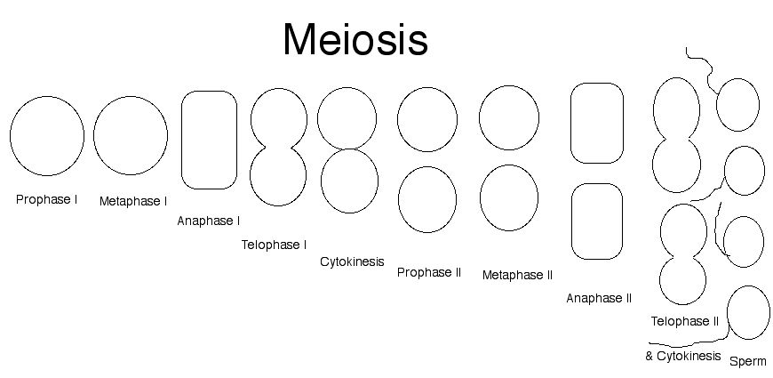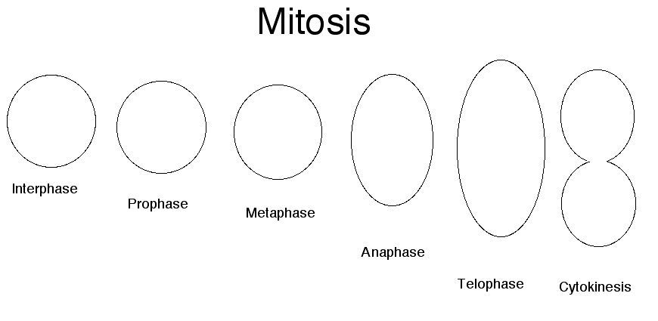

6. How do chromosomes line up differently in Metaphase I of meiosis compared to Metaphase in mitosis?

7. Which phase of meiosis is most like anaphase in mitosis?

8. Contrast how the two different gametes/sex cells (sperm and eggs) form differently at the end of Telophase I.

9. How is Interphase II different from Interphase I?

10. How many cells are produced at the end of mitosis?_______ End of meiosis?________

11. How many female egg cells are created by the end of meiosis?

12. Contrast the difference between daughter cells created from mitosis and those created from meiosis. How are they different?

Now let’s delve a little deeper. Go to the following page to complete the next set of questions:

<http://www.sumanasinc.com/webcontent/animations/content/meiosis.html>

Read the introduction, then click “Step Through”. Read the captions to the right before clicking play to watch the animation. After watching the animation, click “Continue” and read the next caption before watching the next animation. Continue this way, answering the questions below, until it is over.

13. Step 3: Where is each chromosome of a pair derived from?

14. What is the synapsis? And how does relate to a *tetrad*? (Look this up on the internet. Helpful link: <http://www.biologyaspoetry.com/terms/tetrad_chromosomal.html>)

15. What is “crossing-over” and how do you think this may affect variation? (That is, how does crossing-over allow for genetic differences in an offspring?)

16. Describe how chromosomes assort themselves randomly during Metaphase I. This is known as the law of independent assortment.

Take the quiz at the end of animation and record your answers below in complete sentences.

1.

2.

3.

4.

Finally, visit this last page to answer the remaining questions. Read through the “Meiosis Tutorial”. <http://www.biology.arizona.edu/cell_bio/tutorials/meiosis/main.html>

18. What are the two types of gametes?

19. What are some examples of meiotic errors?

Complete the “Test Yourself” questions and record your answers below.

1.

2.

3.

4.

5.

6.

7.

8.

9.

10.

Write a 3-5 sentence paragraph describing how we are unique from our parents. (Include which phases of meiosis variation occurs and what is happening in these phases to create four uniquely different haploid cells.)­­­__________________________________________________________________________________________________________________________________________________________________________________________________________________________________________________________________________________________________________________________________________________________________________________________________________________________________________________________________________________________________________